30 Sept 2021

TO: BLM (NW Oregon District) and USFS (Willamette NF)

VIA: <https://cara.ecosystem-management.org/Public//CommentInput?Project=60604>

**Subject: Elkhorn Creek River Values Report — comments**

Please accept the following comments from Oregon Wild concerning the Elkhorn Creek River Values Report, <https://www.fs.usda.gov/project/?project=60604>, and <https://eplanning.blm.gov/eplanning-ui/project/2015173/570>. Oregon Wild represents 20,000 members and supporters who share our mission to protect and restore Oregon’s wildlands, wildlife, and water as an enduring legacy. Our goal is to protect areas that remain intact while striving to restore areas that have been degraded. This can be accomplished by moving over-represented ecosystem elements (such as logged and roaded areas) toward characteristics that are currently under-represented (such as roadless areas and complex old forest).

The public notice gave the wrong link to submit comments. The link that was provided goes to the comment reading room, not the comment submission form.

The notice poses the following questions:

* Are there additional river-related natural, cultural, and recreational resources that are rare, unique or exemplary within the designated segments of Elkhorn Creek?
  + We propose that vegetation and geology be added to the list of outstanding river values. The existing list of values mentions bedrock and old growth as part of the scenic values and fisheries & wildlife values, but geology and vegetation should be separately identified, so they can be properly conserved. Water quantity and quality also deserve recognition. It is worth noting that geology, vegetation, and water are foundational attributes of Wild and Scenic Rivers, and are essential to conserving other values such as scenery and fish & wildlife.
* What observations or concerns do you have about the baseline conditions (pre-fire) within the river corridor that may be impacting these river values?
  + Past logging and road construction (and mining) have had an adverse effect on river values.
* What concerns about the Beachie Creek Fire do you think are the most important to be incorporated into the environmental assessment and comprehensive river management plan?
  + Wildfire is a natural process that has affected this landscape for thousands of years. In fact, wildfire is an integral part of the natural processes that created the conditions that make this landscape worth protecting as a Wild and Scenic River. Ensuring that natural disturbance processes and natural recovery processes continue to operate without significant interference should be a primary goal of the river values report and the management plan for this Wild and Scenic River. See more below.

The river values report should recognize that lamprey may use habitat in this area.

ODFW’s 9-22-2021 comment letter noted the beneficial effects of wildfire:

Impacts to fisheries resources from the Beachie Creek fire may be significant in the short-term. These are likely to include higher summer maximum temperatures based on stream aspect (east-west) and higher solar inputs. In addition, we would expect to see increased scour induced by higher bedload transport from hillslope erosion in the confined reaches. On the other hand, wood inputs are likely to increase in the short-term as well, which may allow for some sedimentation to accumulate in the alluvial reach in the bottom 0.6 miles, which can provide important habitat benefits for fish, such as increased amounts of spawning gravel, cover for juvenile fish, and groundwater mixing and recharge.

The River Values Report should recognize the significant ecological values of natural disturbance and natural recovery, including retention of all large woody material on-site. Set forth below is a collection of scientific evidence supporting this important river value.

In October 2013, 250 scientists signed a letter urging greater attention to the conservation of complex early seral forests and natural recovery after fire. These scientists conclude that the

“current state of scientific knowledge, … indicates that [salvage logging] would seriously undermine the ecological integrity of forest ecosystems on federal lands. … This post-fire habitat, known as ‘complex early seral forest,’ is quite simply some of the best wildlife habitat in forests and is an essential stage of natural forest processes. Moreover, it is the least protected of all forest habitat types and is often as rare, or rarer, than old-growth forest, due to damaging forest practices encouraged by post-fire logging policies. While there remains much to be discovered about fire in our forests, the scientific evidence indicates that complex early seral forest is a natural part of historical fire regimes in nearly every conifer forest type in the western U.S. (including ponderosa pine and mixed-conifer forests) … Numerous studies also document the cumulative impacts of post-fire logging on natural ecosystems, including the elimination of bird species that are most dependent on such conditions, compaction of soils, elimination of biological legacies (snags and downed logs) that are essential in supporting new forest growth, spread of invasive species, accumulation of logging slash that can add to future fire risks, increased mortality of conifer seedlings and other important re-establishing vegetation (from logs dragged uphill in logging operations), and increased chronic sedimentation in streams due to the extensive road network and runoff from logging operations.”

Della Sala, D. et al (2013) Open Letter to Members of Congress from 250 Scientists Concerned about Post-fire Logging. October 30, 2013. <http://geosinstitute.org/images/stories/pdfs/Publications/Fire/Scientist_Letter_Postfire_2013.pdf> or <http://www.scribd.com/doc/181401520/Open-Letter-to-Members-of-Congress-from-250-Scientists-Concerned-about-Post-fire-Logging-October-30-2013>

The River Values Report must account for the natural range of variability and existing rarity of complex young forests (e.g., young forests that are unsalvaged after disturbances). Since large snags are outside the natural range of variability across the landscape, the agency must retain all large snags to start moving the landscape toward the natural range of variability, or the agency must carefully justify in the NEPA analysis every large snag it proposes to remove. See Jerome J. Korol, Miles A. Hemstrom, Wendel J. Hann, and Rebecca A. Gravenmier. Snags and Down Wood in the Interior Columbia Basin Ecosystem Management Project. PNW-GTR-181. <http://www.fs.fed.us/psw/publications/documents/gtr-181/049_Korol.pdf>. This paper estimates that even if we apply enlightened forest management on federal lands for the next 100 years, we will still reach only 75% of the historic large snag abundance measured across the interior Columbia Basin, and most of the increase in large snags will occur in roadless and wilderness areas.

The River Values Report must account for the evidence that young forests recovering from fire can provide habitat for a wide variety of wildlife, including those often associated with old growth. Daniel C. Donato, John L. Campbell & Jerry F. Franklin 2012. FORUM Multiple successional pathways and precocity in forest development: can some forests be born complex? Journal of Vegetation Science 23 (2012) 576–584 <http://people.forestry.oregonstate.edu/john-campbell/sites/people.forestry.oregonstate.edu.john-campbell/files/Donato_2012_JVS.pdf>

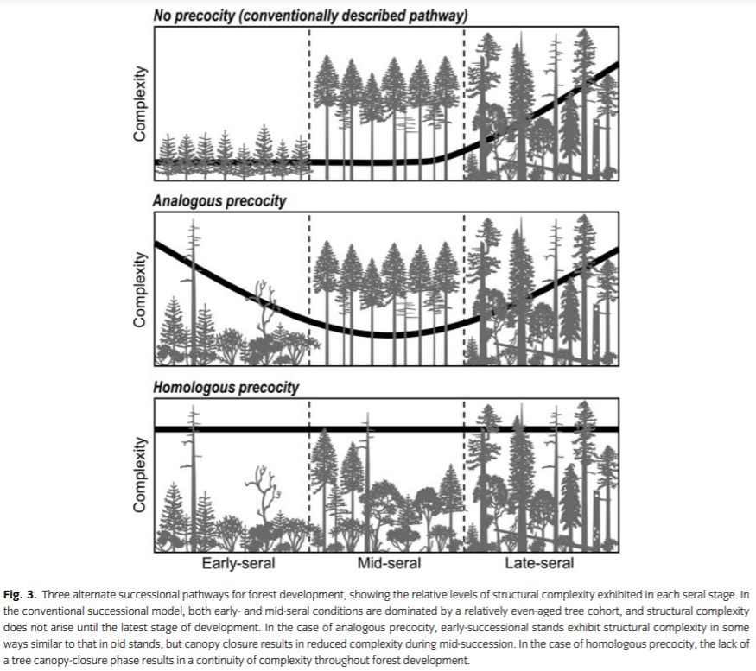

The River Values Report must account for ecological values (such as wildlife habitat) associated with snags, dead wood, and complex young forests. See Rose, C.L., Marcot, B.G., Mellen, T.K., Ohmann, J.L., Waddell, K.L., Lindely, D.L., and B. Schrieber. 2001. Decaying Wood in Pacific Northwest Forests: Concepts and Tools for Habitat Management, Chapter 24 *in* ***Wildlife-Habitat Relationships in Oregon and Washington*** (Johnson, D. H. and T. A. O'Neil. OSU Press. 2001) <http://web.archive.org/web/20060708035905/http://www.nwhi.org/inc/data/GISdata/docs/chapter24.pdf>;

Given the regional deficit of young complex forests and the fact that many species, such as woodpeckers and secondary cavity users, appear to be adapted to exploit the structure and resources available within disturbed forests, the agencies should retain complex early serval habitat and snags to support species associated with young complex forests. The Forest Service has numerous Management Indicator Species whose populations have not been monitored, so the agencies lack the information necessary to show that the salvage logging program will maintain species viability.

The River Values Report must account for the adverse effects of salvage logging on the development of complex forest habitat; “The early post-disturbance period of forest ecosystem development - pre-tree-canopy closure - is profoundly important!” because it is heterogeneous, light-energy rich, structure rich, biodiversity rich, and process rich. “**Removal of legacies is most profound long-term impact**” because of the “Importance of Coarse Wood:

Habitat for species

Organic seedbeds (nurse logs)

Modification of microclimate

Protection of plants from ungulates

Sediment traps

Sources of energy & nutrients

Sites of N-fixation

Special source of soil organic matter

Structural elements of aquatic ecosystems”

Jerry Franklin - What is a 'Good' Forest Opening? – Powerpoint <http://courses.washington.edu/esrm315/Lectures/FranklinEarlySuccession.pdf>

The River Values Report must account for all the new science related to complex early seral forests and dead wood and salvage logging, including but not limited to:

* Beschta R.L., J.J. Rhodes, J.B. Kauffman, R.E. Gresswell, G.W. Minshall, J.R. Karr, D.A. Perry, F.R. Hauer, and C.A.Frissell, 2004. Postfire management on forested public lands of the western USA. Cons. Bio.,. <http://pacificrivers.org/files/post-fire-management-and-sound-science/Beschta-etal2004.pdf>;
* “Conservation of diverse young forests has received little attention in forest policy.” USDA PNW Research Station. *Science Findings #56 - Seeing The Trees For The Forest: Mapping Vegetation Biodiversity In Coastal Oregon Forests.* Sept 2003. <http://www.fs.fed.us/pnw/sciencef/scifi56.pdf>. “[T]here's a looming shortage of diverse young forests - where seedlings intermingle with fallen logs, standing dead snags, and shrubs - that provide specialized habitat for certain animals and plants. … there's a looming gap in diverse, young, early-successional conifer forest, the type of forest that once came in naturally after forest fires. These young forests, up to 10 years old, have a diversity of forest structures - fallen logs and dead snags - and a diversity of plant life. They are important habitat for the western bluebird and other birds that prefer open areas, as well as some shrub species. Today, because of intense timber management on private lands, young forests don't get the chance to develop much diversity.” OSU. 2001. Press Release: Researchers Assess Forest Sustainability. <http://web.archive.org/web/20060914032259/http://oregonstate.edu/dept/ncs/newsarch/2001/Oct01/assess.htm> According to the CLAMS project: “Diverse young forests: also rare but receiving less attention. Legacy tree habitat: uncertain future..” Ohmann, Spies, Gregory, Johnson. 2002. Vegetation Biodiversity in the Oregon Coast Range. <http://www.fsl.orst.edu/clams/download/presentations/j02s_ohmann_10june02.pdf> (slide 24).;
* Hutto, R.L., 2006. Toward Meaningful Snag-Management Guidelines for Postfire Salvage Logging in North American Conifer Forests. Conservation Biology Volume 20, No. 4, 984–993. <http://web.archive.org/web/20090310114517/http://avianscience.dbs.umt.edu/documents/hutto_conbio_2006.pdf> (“Species such as the Black-backed Woodpecker (*Picoides arcticus*) are nearly restricted in their habitat distribution to severely burned forests. Moreover, existing postfire salvage-logging studies reveal that most postfire specialist species are completely absent from burned forests that have been (even partially) salvage logged. I call for the long-overdue development and use of more meaningful snag-retention guidelines for postfire specialists, and I note that the biology of the most fire-dependent bird species suggests that even a cursory attempt to meet their snag needs would preclude postfire salvage logging in those severely burned conifer forests wherein the maintenance of biological diversity is deemed important.”);
* A recent study of birds that use post-fire mosaics highlighted the importance of resprouting shrubs and forbs on the re-establishment of nesting birds following wildfire. “Of the 39 species for which nests were found, 14 (37%) used cavities and 25 (63%) built open-cup nests.... Species that built cup nests used snags, residual live trees, resprouting hardwoods, and other ground vegetation and downed wood. The associations between the presence of breeding species and forb and shrub cover indicate that these are important components of the early establishment of bird populations following stand-replacing fires. These data suggest that post-fire management of resprouting hardwoods and herbaceous vegetation should consider potential impacts to bird species that nest and forage in burned forests.” CFER 2007. Response of Birds to Fire Mosaics. CFER News. Winter 2007. <http://www.fsl.orst.edu/cfer/pdfs/Vol7_1.pdf>;
* BLM’s 2008 Western Oregon Plan Revision (WOPR) DEIS (pp. LI-LII) admits that structurally complex young forests develop old forest characteristics twice as fast as structurally deprived initial conditions. <https://web.archive.org/web/20110524132346/http://www.blm.gov/or/plans/wopr/plan-doc-overview.php> (“The retention of structural legacies in regeneration harvested areas, … would result in structurally complex forests that develop almost twice as fast after harvesting as in Alternatives 1 and 2. [with no green tree retention]”);
* Mark E Swanson, Jerry F Franklin, Robert L Beschta, Charles M Crisafulli, Dominick A DellaSala, Richard L Hutto, David B Lindenmayer, and Frederick J Swanson 2010. The forgotten stage of forest succession: early-successional ecosystems on forest sites. Front Ecol Environ 2010; doi:10.1890/090157, <https://www.fs.fed.us/pnw/pubs/journals/pnw_2010_swanson001.pdf>;
* Bats find favorable habitat in burned areas with abundant and diverse snags and abundant and diverse flying insects. Salvage logging will remove potential roost sites, and food sources. Carol Chambers and Erin Saunders. BATS IN THE BURNS - Studying the impact of wildfires and climate change. BATS. Bat Conservation International. Winter 2013, Volume 3, No. 4. <http://www.batcon.org/index.php/media-and-info/bats-archives.html?task=viewArticle&magArticleID=1154>;
* "Leaving a damaged forest intact means the original conditions recover more readily," says David Foster, … director of the NSF Harvard Forest LTER site. "Forests have been recovering from natural processes like windstorms, fire and ice for millions of years. What appears to us as devastation is actually, to a forest, a natural and important state of affairs." 10-16-2012 Press Release 12-198, In Blown-Down Forests, a Story of Survival To preserve forest health, the best management decision may be to do nothing. <http://www.nsf.gov/news/news_summ.jsp?cntn_id=125744>; Audrey Barker Plotkin, David Foster, Joel Carlson, and Alison Magill 2013. Survivors, not invaders, control forest development following simulated hurricane. Ecology, 94(2), 2013, pp. 414–423. <http://harvardforest.fas.harvard.edu/sites/harvardforest.fas.harvard.edu/files/publications/pdfs/BarkerPlotkin_Ecology_2013.pdf> ;
* “Unmanaged early-seral stages of forest development are now considered to be among the most threatened habitat types in coniferous regions of the western United States (Noss et al. 2006, Thomas et al. 2006). Not surprisingly, concern has arisen over viability of populations that use broadleaf vegetation in early-seral forest, particularly as this habitat type contributes disproportionately to forest biodiversity (Halpern and Spies 1997). In the northwestern United States, a number of bird species thought to be strongly associated with early-seral broadleaf habitat have declined and are considered conservation priorities (Altman 1999, U.S. Fish and Wildlife Service 2002). Because the PNW represents a substantial portion of the ranges of these species, loss of quality early-seral habitat could increase risk of extinction.” M. G. BETTS, J. C. HAGAR, J. W. RIVERS, J. D. ALEXANDER, K. MCGARIGAL, AND B. C. MCCOMB. 2010. Thresholds in forest bird occurrence as a function of the amount of early-seral broadleaf forest at landscape scales. Ecological Applications, 20(8), 2010, pp. 2116–2130. <http://www.fsl.orst.edu/flel/pdfs/Betts%20et%20al%202010%20Ecol%20Apps.pdf>;
* Salvage logging after disturbance is detrimental to old-growth indicator species, has a homogenizing influence on the forest, and hinders future development of structurally complex forests. Orczewska, A., et al 2019. The impact of salvage logging on herb layer species composition and plant community recovery in Białowieża Forest. Biodiversity and Conservation (2019) 28:3407–3428 <https://doi.org/10.1007/s10531-019-01795-8> <https://link.springer.com/content/pdf/10.1007%2Fs10531-019-01795-8.pdf>. (“We conclude that continuous deterioration of the forest habitats via clearcutting of stands afected [sic] by insect outbreak, followed by tree planting, substantially reduces the chances of successful, natural regeneration towards deciduous, structurally complex and diverse forests. ... [S]alvage logging breaks the natural ecological processes of forest dynamics and facilitates colonization of forest ecosystems by light-demanding, competitive species, associated with disturbed forest sites but hinders the number and cover of late-successional, shade-tolerant forest species.”);
* Abundant dead wood not only benefits numerous wildlife, but also supports fish habitat, and enhances numerous ecosystem services related to fish, water quality, sediment storage and routing, watershed function, etc. Rose, C.L., Marcot, B.G., Mellen, T.K., Ohmann, J.L., Waddell, K.L., Lindely, D.L., and B. Schrieber. 2001. Decaying Wood in Pacific Northwest Forests: Concepts and Tools for Habitat Management, Chapter 24 in Wildlife-Habitat Relationships in Oregon and Washington (Johnson, D. H. and T. A. O’Neil. OSU Press. 2001) <http://web.archive.org/web/20060708035905/http://www.nwhi.org/inc/data/GISdata/docs/chapter24.pdf>;
* Many bird species benefit from fire that leaves a rich mix of plants and complex structure of snags and dead wood, but salvage logging removes the complex structure and truncates the early seral vegetation by planting conifers. The quality of habitat that results after fire often depends on the successional stage of the forest pre-disturbance, because much of this structure is carried over after the fire into the future forest. Salvage logging removes most of the trees and with it the structural legacies that bind the past and future forests. Dick Hutto said:

In a new paper, we show that fire effects cannot be accurately assessed through a simple comparison of recently burned and unburned forest plots. This is because the same species that show negative responses through simplistic comparisons of burned and unburned forests reveal strong POSITIVE responses to more restricted combinations of successional stage and fire severity. With 10 years of post-fire data, we show that the majority of bird species (60%) benefit from fire (as evidenced by greater abundances in burned forest patches belonging to a particular successional stage/fire severity combination than in forest patches that have been long unburned). With data from even longer times-since-fire (say, 15, 20, or 30 years after fire), the percentage of species that clearly benefit from fire is probably closer to 80%!

*Describing* Richard L. Hutto, and David A. Patterson 2016. Positive effects of fire on birds may appear only under narrow combinations of fire severity and time-since-fire. International Journal of Wildland Fire. <http://dx.doi.org/10.1071/WF15228>.

## Salvage logging reduces water quality, vegetation recovery, and retards recovery of River Values

Watersheds affected by wildfire are already at increased risk of erosion and water quality degradation. Salvage logging (and associated road building) will set back vegetation recovery, reduce the sediment holding and soil building services of dead wood and makes a bad situation worse with regard to water quality, including drinking water, and other watershed values. See Monica B. Emelko, Uldis Silins, Kevin D. Bladon, Micheal Stone 2011. Implications of land disturbance on drinking water treatability in a changing climate: Demonstrating the need for “source water supply and protection” strategies. Water Research, Volume 45, Issue 2, 2011, Pages 461-472. http://staticweb.fsl.orst.edu/bladon/publications/Emelko_WaterResearch_2011.pdf

“Stand structure and fuel mass were measured in 2011, 13 years after logging of a seasonally dry, ponderosa pine-dominated forest that had burned severely in the 1996 Summit Wildfire, Malheur National Forest ... By 13 years after logging (2011), density of regeneration averaged higher overall for unlogged stands, ...” McIver, J.D., R. Ottmar 2018. Fuel mass and stand structure 13 years after logging of a severely burned ponderosa pine forest in northeastern Oregon, U.S.A. Forest Ecology and Management 424 (2018) 505–518.

Burned forests are able to re-establish conifers without replanting. Kemp et al (2016) studied a large dataset of conifer establishment after wildfires in the northern Rockies and found the vast majority of areas affected by high severity fire were still close enough to seed sources to ensure reforestation.

**Methods**

… predict the probability of establishment and abundance of conifers 5–13 years post-fire.

**Results**

Seedling densities varied widely across all sites (0–127,500 seedlings ha−1) and were best explained by variability in distance to live seed sources (β = −0.014, p = 0.002) and pre-fire tree basal area (β = 0.072, p = 0.008). Beyond 95 m from the nearest live seed source, the probability of seedling establishment was low. Across all the fires we studied, 75 % of the burned area with high tree mortality was within this 95-m threshold, suggesting the presence of live seed trees to facilitate natural regeneration.

**Conclusions**

Combined with the mix of species present within the burn mosaic, dry mixed-conifer forests will be resilient to large fires across our study region …

Kerry B. Kemp, Philip E. Higuera, Penelope Morgan 2016. Fire legacies impact conifer regeneration across environmental gradients in the U.S. northern Rockies. Landscape Ecology. March 2016, Volume 31, Issue 3, pp 619–636.

<https://link.springer.com/article/10.1007/s10980-015-0268-3?wt_mc=alerts.TOCjournals>.

In short, by adding another stressor to burned watersheds, postfire salvage logging worsens degraded aquatic conditions accumulated from a century of human activity (CWWR 1996,NRC 1996, 2002,McIntosh et al. 2000). The additional damage impedes the recovery and restoration of aquatic systems, lowers water quality, shrinks the distribution and abundance of native aquatic species, and compromises the flow of economic benefits to human communities that depend on aquatic resources (Beschta et al. 2004).

Karr, J. R., J. J. Rhodes, G. W. Minshall, F. R. Hauer, R. L. Beschta, C. A. Frissell, and D. A. Perry. 2004. The effects of postfire salvage logging on aquatic ecosystems in the American West. BioScience 54:1029-1033.

<http://www.sierraforestlegacy.org/Resources/Conservation/FireForestEcology/SalvageLoggingScience/Salvage-Karr04.pdf> *citing* Beschta, ,R.L., J. J. Rhodes, J. B. Kauffman, R. E. Gresswell, G. W. Minshall, J. R. Karr, D.A. Perry, F.R. Hauer, C. A. Frissell. 2004. Postfire Management on Forested Public Lands of the Western United States. Conservation Biology 18: 957–967. Downloadable at:

<https://www.researchgate.net/publication/227654964_Postfire_Management_on_Forested_Public_Lands_of_the_Western_United_States?ev=prf_pub>

Robichaud et al (2016) looked at the effects of salvage logging on run-off and erosion and found that salvage logging exacerbates fire effects.

Runoff volume, runoff velocities, and sediment concentrations increased with increasing levels of disturbance. The burned only plots had lower runoff rates and sediment concentrations than any of the other disturbances. The salvage logged plots had greater responses than the burn only plots and the mitigation treatment had a marginal effect on runoff ratios, runoff velocities and sediment concentrations. These results suggest that additional disturbance after a wildfire can increase the erosional response …

Robichaud, Peter; Wagenbrenner, Joseph; Brown, Robert 2016. Rill Erosion in Post Wildfire Forests after Salvage Logging. Geophysical Research Abstracts

Vol. 18, EGU2016-17814, 2016. EGU General Assembly 2016, held 17-22 April, 2016 in Vienna Austria, p.17814. <http://adsabs.harvard.edu/abs/2016EGUGA..1817814R>

Joseph W. Wagenbrenner, Lee H. MacDonald, Robert N. Coats, Peter R. Robichaud, Robert E. Brown 2015. Effects of post-fire salvage logging and a skid trail treatment on ground cover, soils, and sediment production in the interior western United States. Forest Ecology and Management. Volume 335, 1 January 2015, Pages 176–193. <http://www.fs.fed.us/rm/pubs_journals/2015/rmrs_2015_wagenbrenner_j001.pdf> (“Highlights: Post-fire salvage logging increased soil compaction and decreased vegetative cover. Salvage logging greatly increased sediment production from more disturbed plots. Salvage logging delayed post-fire recovery of vegetation and sediment production.”)

Wagenbrenner et all (2016) found that salvage logging increases erosion and reduces vegetation cover.

We found that ground-based logging using heavy equipment compacted soil, reduced soil water repellency, and reduced vegetation cover. Vegetation recovery rates were slower in most logged areas than the controls. Runoff rates were higher in the skidder and forwarder plots than their respective controls in the Montana and Washington sites in the year that logging occurred, and the difference in runoff between the skidder and control plots at the British Columbia site was nearly significant (p = 0.089). Most of the significant increases in runoff in the logged plots persisted for subsequent years. … [R]ill sediment fluxes were 5 to 1900% greater in logged plots than the controls in the year of logging … Our results indicate that salvage logging increases the risk of sedimentation regardless of equipment type and amount of traffic, and that specific best management practices are needed to mitigate the hydrologic impacts of post-fire salvage logging.

Wagenbrenner, Robichaud & Brown 2016. Rill erosion in burned and salvage logged western montane forests: Effects of logging equipment type, traffic level, and slash treatment. Journal of Hydrology. DOI: 10.1016/j.jhydrol.2016.07.049

Marañón-Jiménez et al (2013) found that salvage logging harmed natural forest regeneration processes.

salvage logging has a detrimental effect on the ecophysiological performance and growth of naturally regenerating pine seedlings, compared to alternative post-fire management practices in which burnt logs and branches are left in situ. Improved seedling growth and performance is associated with the amelioration of microsite/microclimate conditions by the presence of residual burnt wood, which alleviates seedling drought stress and improves nutrient availability through the decomposition of woody debris.

Sara Marañón-Jiménez, Jorge Castro, José Ignacio Querejeta, Emilia Fernández-Ondoño, Craig D. Allen 2013. Post-fire wood management alters water stress, growth, and performance of pine regeneration in a Mediterranean ecosystem. Forest Ecology and Management 308 (2013) 231–239.

Leverkus et al (2014) also found that salvage logging sets back vegetation recovery after fire.

Post-fire salvage logging was associated with reduced species richness, Shannon diversity, and total plant cover. Moreover, salvaged sites hosted different species assemblages and 25% lower cover of seeder species (but equal cover of resprouters) compared to the other treatments. Cover of trees and shrubs was also lowest in Salvage Logging, which could suggest a potential slow-down of forest regeneration.

Alexandro B. Leverkus, Juan Lorite, Francisco B. Navarro, Enrique P. Sánchez-Cañete, Jorge Castro 2014. Post-fire salvage logging alters species composition and reduces cover, richness, and diversity in Mediterranean plant communities. <http://www.californiachaparral.com/images/Leverkus_et_al_Salvage_logging_Med_climates_2014.pdf>

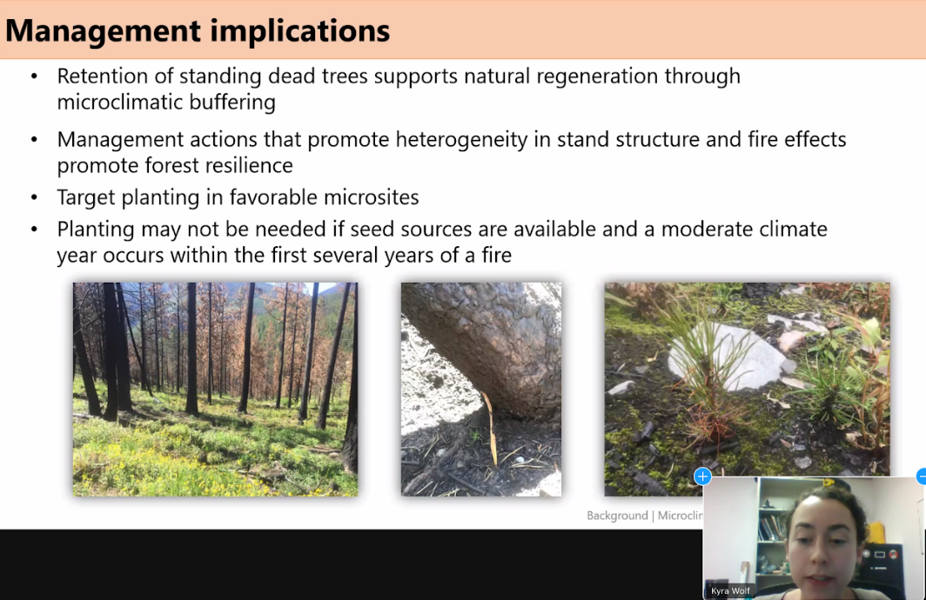

<https://www.nrfirescience.org/event/wildfire-effects-microclimate-conditions-and-seedling-regeneration-northern-rockies-mixed>

The quantity, quality, and rate of revegetation has a direct contribution to controlling erosion and sedimentation. USGS has described the role of vegetation in slope stability and erosion as follows:

In a watershed, vegetation provides five major physical functions that help control soil erosion during rainfall events (Spittler, in press):

* Interception of rainfall, which extends the time for water to reach the ground surface and absorbs raindrop impact energy.
* Mulching of the ground surface to provide temporary water storage and slow release, slope roughness, and energy absorption.
* Structural support of loose, surficial material.
* Reinforcement of the deeper soil by roots, which increases the natural slope stability.
* Maintains conditions necessary for soil micro-organisms that provide soil structure.

<http://web.archive.org/web/20040218052053/http://landslides.usgs.gov/html_files/ofr95-508/skrep2.html> *citing* Spittler, T.E., in press, Fire and the debris-flow potential of winter storms, in, Proceedings of the Symposium on Brush Fires in California Wildlands: Ecology and Resource Management: International Association of Wildland Fire.

Wagenbrenner et al (2015) found that -

* Post-fire salvage logging increased soil compaction and decreased vegetative cover.
* Salvage logging greatly increased sediment production from more disturbed plots. (“Sediment production from the skidder plots was 10–100 times the value from the controls.”)
* Salvage logging delayed post-fire recovery of vegetation and sediment production. (“The relative differences in sediment production between the disturbed plots and the controls tended to increase over time as the controls exhibited more rapid regrowth.” Data were taken 2-8 years post-harvest.)

Joseph W. Wagenbrenner, Lee H. MacDonald, , Robert N. Coats, Peter R. Robichaud, Robert E. Brown. 2015. Effects of post-fire salvage logging and a skid trail treatment on ground cover, soils, and sediment production in the interior western United States. Forest Ecology and Management. Volume 335, 1 January 2015, Pages 176–193.

<http://www.nrel.colostate.edu/assets/nrel_files/labs/macdonald-lab/pubs/Salvage-logging-Wagenbrenner%20et%20al-ForEcolMgmt-2015.pdf>

Salvage logging will set back vegetative recovery that has already started and thereby retard attainment of riparian and aquatic management objectives. In research on post-fire logging on the Winema NF, Sexton (1998) found that salvage logged sites produced only about 38% of the understory biomass of that on the unlogged site; and one year later produced only about 27% of the understory biomass of that on the unlogged site. In fact, Sexton’s (1998) study comparing salvaged and unsalvaged areas of a fire on the Winema NF one and two years after logging showed:

|  |  |
| --- | --- |
| **Salvage Areas** | **Unsalvaged Areas** |
| reduced vegetation biomass | greater vegetation biomass |
| reduced species diversity | greater species diversity |
| reduced species richness | greater species richness |
| reduced growth of planted seedlings | greater growth of planted seedlings |
| reduced survival of planted seedlings | greater survival of planted seedlings |

Sexton, Timothy O. 1998. Ecological effects of post wildfire activities (salvage-logging and grass-seeding) on vegetation composition, diversity, biomass, and growth and survival of *Pinus ponderosa* and *Purshia tridentata*. MS Thesis Oregon State University. Corvallis, OR. 121p

Monitoring after the School Fire on the Umatilla NF showed that “High severity plots that were salvage logged and not seeded with native grasses had the lowest species richness, diversity, and cover.” Penelope Morgan, Marshell Moy, Christine A. Droske, Sarah A. Lewis, Leigh B. Lentile, Peter R. Robichaud, Andrew T. Hudak, and Christopher J. Williams. 2015. Vegetation Response to Burn Severity, Native Grass Seeding, and Salvage Logging. Fire Ecology Volume 11, Issue 2, 2015. doi: 10.4996/fireecology.1102031. <http://fireecologyjournal.org/docs/Journal/pdf/Volume11/Issue02/031.pdf>

Similarly, Dan Donato, looked at the effects of salvage logging at the Biscuit fire in SW Oregon and found that cutting down dead trees and hauling away logs killed 71 percent of the naturally established seedlings which were abundant after the fire but scarce after logging. D. C. Donato, J. B. Fontaine, J. L. Campbell, W. D. Robinson, J. B. Kauffman, B. E. Law. Post-Wildfire Logging Hinders Regeneration and Increases Fire Risk. [www.sciencexpress.org](http://www.sciencexpress.org/). 5 January 2006.

Shatford and Hibbs recently found similarly encouraging results of natural regeneration.

Over the 2005 field season, natural regenerating conifers were sampled in 38 plots within 11 historic fires in the Klamath-Siskiyou Region … Years since stand replacing wildfire ranged from [18 years to 9 years] … The density of natural regenerating conifers ranged over three orders of magnitude … Although the abundance of natural regeneration was frequently high, the age and size of saplings ranged considerably … Frequently, the regenerating saplings were overtopped by shrubs and hardwoods. There was no evidence of recent conifer mortality (i.e. no dead or dying saplings) caused by competition … Saplings were generally in good condition with dominant trees having live crown ratios of 50% or greater.

Shatford, J., Hibbs, D.E. 2005. Predicting Post-fire Regeneration Needs: Spatial and Temporal Variation in Natural Regeneration in Southwestern Oregon and Northern California. Pp 29-32 *in* Cooperative Forest Ecosystem Research Program (CFER) 2005 Annual Report. <http://www.fsl.orst.edu/cfer/pdfs/CFER_ar05.pdf>. This data reveals that natural regeneration is not only demonstrably successful but also species diverse and variable both spatially and temporally. All of these attributes are highly beneficial in terms of both wildlife habitat and fuel hazard.

Birds serve essential roles in post-disturbance seed dispersal.

Seed dispersal mutualisms with scatter-hoarders play a crucial role in population dynamics of temperate large-seeded trees. These behaviors shape seed dispersal patterns, which can be applied to conservation of populations, communities, and even ecosystems dominated by large-seeded trees. We draw on a growing body of literature to describe the ecological context and consequences of scatter-hoarding as a seed dispersal mechanism. We synthesize the quantitative literature on the interaction between members of the avian family Corvidae (crows, ravens, jays, magpies, and nutcrackers) and nut-bearing trees such as pines (Pinus spp.) and oaks (Quercus spp.) to examine unique aspects of avian scatter-hoarders as seed dispersers. During the scatter-hoarding process, seed selectivity, transportation distance, hoarding frequency, and cache placement affect seed dispersal effectiveness, a measure of the quantity and quality of dispersal. Case studies from around the world highlight the role of corvid seed dispersal in population dynamics of trees, and how the birds' scatter-hoarding behavior can be facilitated for the restoration of oak- and pine-dominated habitats.

Mario B. Pesendorfer, T. Scott Sillett, Walter D. Koenig, and Scott A. Morrison (2016) Scatter-hoarding corvids as seed dispersers for oaks and pines: A review of a widely distributed mutualism and its utility to habitat restoration. The Condor: February 2016, Vol. 118, No. 2, pp. 215-237. <http://dx.doi.org/10.1650/CONDOR-15-125.1>

The adverse effects of salvage logging on vegetative recovery described by Sexton are not unique to the Ponderosa pine forest type. The results are in fact quite consistent with the results found by Michael Grifantini et al after salvage logging in Douglas fir forests in northwestern California. Grifantini, M.C., Stuart J.D., and L. Fox III, 1992. “Deer Habitat Changes Following Wildfire, Salvage, Logging and Reforestation, Klamath Mountains, California,” Proceedings of the Symposium on Biodiversity of Northwestern California, Oct 28-30, 1991, Santa Rosa, CA. UC Wildland Resource Center Report 29. December 1992.

The adverse effects described by Sexton appear to be long lasting. Busse at al 1996 found that the annual growth rate of pines was reduced by almost 20% where understory vegetation had been removed thirty years earlier. In addition, research has shown a direct relationship between the level of on-site coarse woody debris and the amount active ectomycorrhizal root tips. Graham, R. T., Harvey, A. E., Jurgensen, M., F., Jain T. B., Tonn, J. R., and Page-Dumroese, D. S. 1994. Managing coarse woody debris in forests of the Rocky Mountains. Res. Pap. INT-RP-477. Ogden, UT: U. S. Department of Agriculture, Forest Service, Intermountain Research Station, 13 p. See also Russell T. Graham, Theresa Benevidez Jain, and Alan E. Harvey FUEL: LOGS, STICKS, NEEDLES, DUFF, AND MUCH MORE. The Joint Fire Science Conference and Workshop <http://web.archive.org/web/20060829024013/http://jfsp.nifc.gov/conferenceproc/T-10Grahametal.pdf>

Salvage logging and associated activities such as site prep, fuel treatment, and planting kills understory vegetation which will significantly reduce site productivity.

Salvage logging will increase soil erosion and sedimentation through the following mechanisms, each or which must be addressed in detail in the NEPA analysis:

1. Soil disturbance,
2. damage to live and dead roots,
3. removal of organic material,
4. delay of revegetation,
5. construction of roads and landings,
6. increased channel erosion from peak flow caused by
   1. loss of large logs that help anchor snowpacks,
   2. mobilization of fine soil particles that seal the soil surface and increase
   3. loss of dead tree canopy;

See McNabb and Swanson, “Effects of Fire on Soil Erosion,” Chapter 14 *in* Natural and Prescribed Fire in Pacific Northwest Forests, Walstad, Radosevich, and Sandberg, editors, OSU Press.

Note: If any of these web links in this document are dead, they may be resurrected using the Wayback Machine at Archive.org. <http://wayback.archive.org/web/>

Sincerely,



Doug Heiken

[dh@oregonwild.org](mailto:dh@oregonwild.org)