May 23, 2023

Dear Forest Supervisor Sherman,

I am writing to oppose Alternatives B C and D in the Greens Creek North Extension Project Draft Supplemental Environmental Impact Statement until the US Forest Service can show the existing mining operation is not causing irreparable harm to Admiralty Island National Monument. Greens Creek Mine is an important economic engine for Southeast Alaska, producing valuable silver, lead, and zinc. Congress has allowed the mine to operate in Admiralty Island National Monument with US Forest Service oversight assuming the specific condition that it does not cause irreparable harm.

The burden of proof in demonstrating that the Greens Creek Mine is not causing irreparable ecological harm is on the mining company itself; the USFS in turn is required to provide careful and objective regulatory oversight and, if appropriate, approval, regarding how the mine is run, how pollution is monitored, and how potential environmental contamination events are evaluated and addressed. This does not appear to have occurred. The recent Friends of Admiralty clam shell study is the most recent example that indicates the current monitoring protocols are not sufficient to determine whether irreparable harm is occurring or not to Monument lands.

Before expansion of the tailings disposal facility is permitted the following should be required:

The fugitive dust issue has been acknowledged for several years, but has not been resolved to date. A plan on eliminating this issue must be developed and implemented. A plan to expand the FOA clam shell study to determine with better accuracy what is the extent of the impacts of fugitive dust to the water, soil and biological resources of the surrounding area. Reducing tailings quantity or toxicity through either polymer cement techniques or additional milling to reduce metal content of tailings should also be considered.

Given the technological advances since this mine was permitted, a plan to eliminate the mixing zones at all effluent outlets into Hawk Inlet must be developed and implemented prior to tailings expansion facilities. This will include end of pipe monitoring with clear penalties for exceedances.

A plan should be developed and implemented to determine if there is irreparable harm occurring in the Monument. This should include, but not be limited to replicating the original baseline studies. This plan should be developed and/or reviewed by an independent expert with experience in Southeast Alaska, such as the University of Alaska or other qualified entity. This plan should include recurrent sampling to determine the extent of seasonal variations.

I understand that technically this SEIS review assumes all previous permit conditions are being met and only expansion of the tailings disposal facility is under review. However, there is compelling evidence that is an inaccurate assumption. No expansion of the tailings facility should be allowed until the above conditions are met. Interested entities such as Friends of Admiralty, Rivers Without Borders or Southeast Alaska Conservation Council should be included in the development of the above plans.

Thank you for considering these comments and protecting the Admiralty Island National Monument values as designated by Congress.

Ben Kirkpatrick

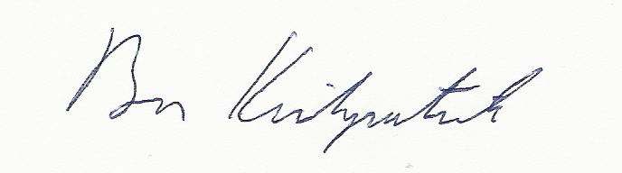

Box 727

Haines, 99827