# Comments on Forest Service Bears Inventory

Arian Pregenzer ([apregenzer@gmail.com](mailto:apregenzer@gmail.com))

November 19, 2014

## Magdalena Ranger District

### Bear Mountains and Environs

1. **Inventoried Roadless Area at NE corner adjacent to D3_5K7 that was left out of FS inventory:** 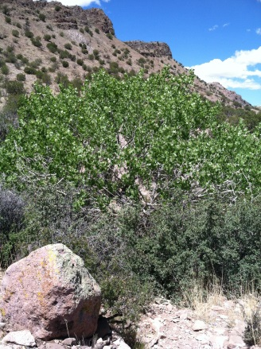 This beautiful, remote area should be included as part of the wilderness inventory. CR12A, CR12B and CR12C are accessible only by an ATV, and are slated to be closed in the TMP "proposed action." I hiked throughout this area in the summer of 2014 and found it to be free of vehicle tracks and human development, except for a couple places where the permitee has put PVC into a spring at the end of CR12C. The permitee accesses areas on horse because of the impassibility of so-called roads. Access to this area from 354E is behind a locked gate, making it easy to prevent unauthorized access. Access from the north is very difficult, up very rugged arroyos. Would be easy to lock the gate at the forest boundary on CR12A. I saw no people during several days of hiking in the area, other than the permittee at his house (small private area about half a mile W of 354 on 354E). There are stunning canyons and springs toward the end of CR12A (see picture), and the ruins of a homestead at the end of CR12B.
2. **Area north of my property, bordering BLM WSA:** This remote and 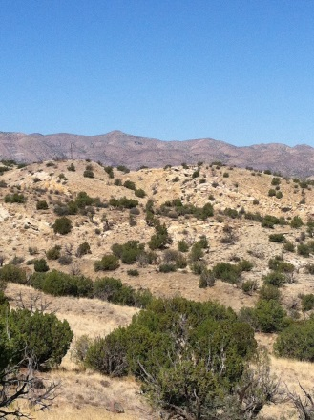undeveloped area should be included as part of the Forest Service inventory as it would connect the BLM Sierra Ladrones WSA and the Bear Mountains. The only current human development in the entire area is an active stock tank and solar panel one mile up 354XA in Baca Canyon, at the point where the TMP proposed action suggests closing 354XA, but nothing beyond that. There is a disconnected, rusted out windmill about a mile up 354U that is not in use. 354U would only be accessible by ATV after about the first half mile. Baca Canyon is a rare riparian area to the east of 354, with ruins of an old homestead. There is no sign of vehicle tracks (except along one fenceline for less than half mile) in the entire area south of Baca Canyon to my property and 354O. Very remote, with sandstone canyons, beautiful views of the Bears and Sierra Ladrones. I own the only private property in the area and have stipulated in my will that it be treated as wilderness after my demise.
3. **Area south of my property bordering 354O and 354:** This small area should also be included in the wilderness inventory. I own the property to the north would consider donating part of my land so as to provide contiguity. There is no development in this area, no vehicle tracks, and the land is in good condition. 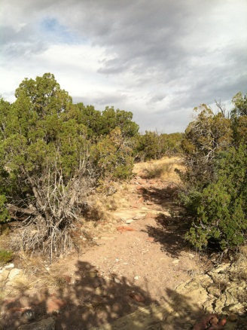
4. **General D3_5K7:** This area is rightly included as part of the Wilderness Inventory. It includes the heart of the Bear Mountains, Hell’s Mesa and countless rugged, wild canyons, especially on the eastern side. There are mountain lion, bear, elk, deer and countless birds at the many riparian areas. I’ve spent many hours over the last 20 years hiking and wandering in this area and have never seen a single person. It is a perfect place for solitude and experiencing the vastness of New Mexico.
5. **D3_5K7 East Side: north of 354P, west to Bears ridgeline, south of CR12E:** This 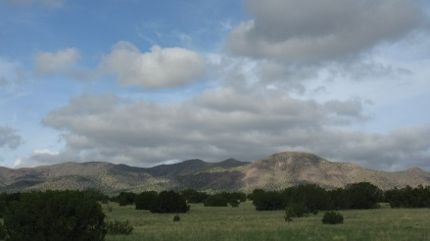eastern area of the Bear Mountains is clearly worthy of wilderness consideration. It has rugged canyons, many riparian areas, and countless havens for wildlife. The picture shows the beautiful and iconic Hell's Mesa. The roads suggested for closure in the Travel Management Plan Proposed Action are not used, and most are not accessible except by ATV.
6. **General D3_5K6:** This area is rightly included as part of the Wilderness Inventory. It includes the southern section of the Bears as well as many foothills. In my opinion, it is also right to include areas for consideration that are not part of the “inventoried roadless area” as they are contiguous to it, and free of viable roads. I’ll provide more detailed comments on particular areas, but want to voice general support for including this area. The photo shows some of the lovely foothills of the Bears, just N or 506.
7. **Triangular Area between 354, 354L, and 506 (D3_5K6)**: I support including this area for consideration as Wilderness, with cherry stems for 354L and 354LL. The photo shows the Bears from the end of 354L. The little hills are almost untouched, beautiful, and have no development in them except as noted below. I drove and hiked all "roads" in the summer of 2014, and found that 354L becomes too rough for anything but an ATV just above the spot shown as the end of 354L on the Forest Service maps. At that point there is some significant development -- corrals, stock tanks, etc. There is also a stock tank at the end of 354LL, but nothing past that point. I also hiked 354J and K, and found no development. After hiking, I drove up 506 and found the exit of what could have been the continuation of 354LL. However, it was so badly eroded I couldn't drive in from 506. It looks like the Bear Springs Ranch uses Bear Canyon as a shortcut to their development at the end of 354L, even though it is not a designated forest service road.
8. 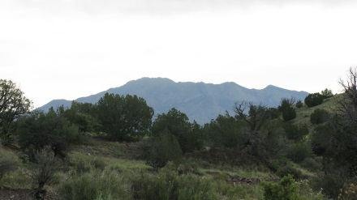**Area from the ridge of Bears, south to 506, and south of 354N**. This eastern portion of the Bears is rightly included as worthy of consideration for wilderness. South of 354N (the northern boundary) there are no roads and no development. The photo shows a view of the Sierra Ladrones from a typical canyon in the Bears -- green after the monsoons.
9. 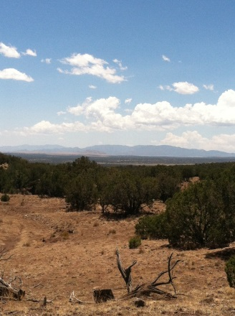**Area Immediately S and E of 24**: This section is definitely worthy of consideration for wilderness. I hiked and drove this area in the summer of 2014 and there is essentially no human development other than about 100 feet from 24. There is a stock tank, solar panels, and corral at the end of 24. I could find no evidence of 24B or 24BJ. 24A had some vehicle tracks, but no development, no PVC, excepting a bermed stock pond about 1.6 miles from 24. Vehicular traffic is not possible past this point. The photo shows a view of the San Mateo Mountains from the bottom of 24A.
10. 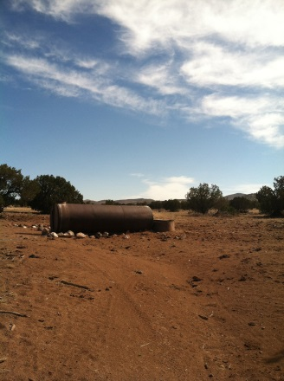**Area between 169 and 506, to origin of 24**: There is quite a lot of development associated with the Bear Springs ranch in this area near 169, including many new tracks and roads. 24C as shown on the FS map does not intersect 169, but it is definitely a track, although the only human development is a large stock tank at the SW end (shown in photo). I could find no evidence of 24CB or 24CE or 24 CA*B. However, there is a track about 200 feet in from 169 that parallels it. 506 L has a stock tank near 169 and about 2 miles in, but no other development. I’m hesitant to recommend this area for consideration of wilderness.
11. 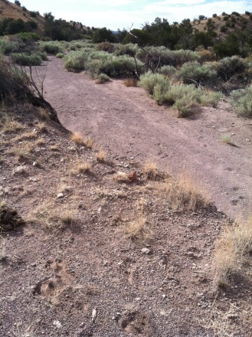**West side of Bears above 24:** The western slopes and watersheds of the Bears are appropriately designated as having wilderness potential. Other than 123F, there is very limited access to any of this territory except through private property and behind locked gates. I hiked this area in the summer of 2014, and saw no evidence of development along 24CA, or 123F after the intersection with 123FAB, nor on 123FB. 123B is completely washed out by an arroyo at 123 (shown in photo), and there is no evidence of any vehicle traffic. 123 GB is behind a locked gate, and there is no evidence of vehicle traffic where it meets 123. I can see no reason not to close 123GB and GB within the national forest, 123B, and 123F after intersection with 123FAB.
12. **D3 5K5:** This area, which is the Goat Springs inventoried roadless area, should be thoroughly assessed for wilderness potential. It has numerous archaeological sites, and the hills are largely unscathed by human development.
13. **D3 5K4:** This area should be thoroughly assessed for wilderness potential. There is little evidence of human development and the Forest Service TMP proposed action recommends closing the tracks/roads in this area.
14. **D3 5K8 and D3 5K9 / Gallinas Mountains:** These large areas of pinon-juniper woodland should be thoroughly assessed for wilderness potential. There appears to be little human development, and few tracks or roads.

### Datil Mountains

1. **D3 5K10 and D3 5K11:**  I agree with the detailed comments noting that these areas are correctly delineated and that the small parcel near the base of 100A be included as part of the parcel 5K11.
2. **D3 5K12 and D3 5K13:** These areas are appropriately delineated as appropriate for evaluation for wilderness. These vast and remote areas include some of the highest points in the Datils, and have very little human impact. The Travel Management Plan recommends closing all tracks leading off the main roads shown in green on the interactive map, as they are no more than tracks.
3. **D3 5K14 and D3 5K15**: It is very difficult to tell from the map on the website, but these two areas include the high country of the Crosby Mountains, and are correctly delineated as appropriate for wilderness. There is very little human impact away from the roads
4. **Area just east of above**: I would suggest that this area be included as worthy of study for wilderness. The roads to private property could be cherry-stemmed.
5. **Sawtooth Mountains**: The Saw Tooth Mountains are a spectacular area that deserves classification as wilderness or as a special area. It is correct to have this area included.

### San Mateo Mountains

1. The San Mateo Mountains contain some of the most spectacular scenery, opportunities for solitude and untrammeled land in the Magdalena Ranger District. I support including all of the additional areas, including those adjacent to existing wilderness and the inventoried roadless areas, outlined on the map as worthy of thorough evaluation in the next stage of the process. The negative comments tend to focus on private property – which would not be impacted by wilderness designation. I cannot comment on the specifics of stock tank and drinker locations, but in many cases, these can be accessed by horse and do not constitute enough impact to disqualify the area as being more thoroughly evaluated as wilderness.

### Magdalena Mountains

1. **D3_571, D3_5K3, and D3_5K2**: I had always thought that the Magdalena Mountains were already designated wilderness. The few mines and ruins of mines could easily be avoided, or cherry-stemmed. For the most part the Magdalenas are devoid of human development and provide wonderful opportunities for hiking, backpacking, and unsurpassed solitude. Please include this area as part of the wilderness assessment. (For some reason, the interactive map would not accept this polygon / comment. I entered it twice, and it doesn’t appear.)

## Sandia Ranger District

1. All of the areas adjacent to the Sandia Mountain Wilderness (D5_ADJ1 - D5_ADJ0) deserve to be included in this wilderness inventory. They should also be monitored more closely. I would also support clarifying the trails that are accessible to bikes in the area bordering Albuquerque Open Space, as each year more “ad hoc” bike trails are added. Designating as wilderness would be a great step forward.

## Mountainair Ranger District

### Manzano Mountains

1. **D4_ADJ1 – D4_ADJ8**: All of the areas designated for consideration for potential wilderness are appropriate. The small sections on the west are obviously candidates for wilderness. Access to the Manzanos from the west is notoriously difficult because of the terrible conditions of the roads, and the area is very seldom visited. The larger sections on the eastern and southern boundaries would add significantly to the wilderness without causing additional restrictions to access. I’ve hiked trails in this area over the last 40 years and was never able to tell the difference between wilderness and regular national forest. Please take to the next stage of evaluation.

### Gallinas Mountains / West of Corona

1. **General Comment D4_5K1 and D4_5K2**: The Gallinas mountains are unique in the central plains: isolated from the Lincoln National Forest and the Manzanos, they are a forested haven for wildlife and solitude, and are a prime candidate for wilderness consideration. Gallinas Peak presides over the entire area and is a beacon to travelers. Historically, this area was connected to the archaeological sites further west, such as Gran Quivera. Please take this area to the next stage of analysis for a thorough evaluation.
2. **D4_5K1:** This area should be taken to the next stage and needs to be assessed thoroughly for wilderness potential. I have read the comments entered on the interactive map, and wonder why fence lines cannot be maintained on horseback, as they are in many parts of the national forest. Fence and PVC maintenance are not valid reasons for excluding an area from wilderness consideration. In some cases, if the developments are close to borders, they may be excluded or cherry-stemmed without damaging the integrity of the wilderness area.
3. **D4_5K2:** This area between FR99 and FR161 includes Red Cloud Canyon and some of the most remote parts of the Gallinas. It is rightly included as having wilderness potential and should be thoroughly evaluated in the next stage of analysis.