Subject: Response to Draft Forest Plan Revision and Draft Environmental Impact Statement

My comments are provided in two parts:

Part 1: Objections and support in response to specific items contained in the documentation

Part 2: Comments about accuracy of documentation

Part 1 – Objections and Support

1. National Forest Access Systems (AS):

a.1. Draft Forest Plan page 61 under Desired Condition (lines 1647 – 1647) it states “Trails accessible from populated areas are available for non-motorized opportunities in blocks of forest that are free from the sights and sounds of motorized recreation.”

a.2. I do NOT concur with this statement as it is in conflict with current conditions as there are already several motorized Jeep trails in the Colville: # 98 (Mack/King Mountain); # 102 (Owl Mountain); # 107 (Thompson Ridge); # 109 (Twin Sisters); # 12060 (unnamed); # 12110 (South Huckleberry Mountain); and # 12600 (US Mountain). Plus there are also the two motorcycle series of trails plus the single ATV trail system.

a.3. Recommendation: Change wording to include statement that trails are accessible for BOTH motorized AND non-motorized sights and sounds.

b. Draft Forest Plan page 62 under Objectives (lines 1665 – 1669) it states “Within 15 years of plan implementation, designate 45 miles of motorized mixed-use roads . . .”. I do NOT concur with this statement as it unnecessarily limits the number of miles that can be designated. This statement should be changed to reflect “a minimum” number of miles. That way if budgets allow, additional miles could be designated without violation of the Forest Plan. This is also referenced in table B-1 on page 147 of the draft Forest Plan Revision.

c. Draft Forest Plan page 62 under Objectives (lines 1670 – 1673) it states “Within 15 years of plan implementation, improve drainage, water crossing and trail layout on 5 percent of the Forest’s trail system designed for mountain bikes, motorized use, and pack stock.” I do NOT concur with this statement as it unnecessarily limits the number of miles that can be improved. This statement should be changed to reflect “a minimum of 5 percent”. That way if budgets allow, additional miles could be worked on without violation of the Forest Plan. This is also referenced in table B-1 on page 147 of the draft Forest Plan Revision.

d. Draft Forest Plan page 63 under Objectives (lines 1699 – 1701) it states “New trails or additions to existing trails should include destinations and loops to provide for a variety of opportunities.” I concur with this statement as this is what was done with the recent South End project. Creating destinations and loops presents the forest user with a better recreational experience.

2. Kettle Crest Recreation Special Interest Area (SIA): I support the creation of this SIA as this will allow continued motorized recreation on the existing Mack/King Mtn (#98) trail, the Twin Sisters (#109) trail, as well as continued use of the road/trail that leads to US Mountain (road 2030600; trail12600). (reference: draft Forest Plan Revision, page 107)

3. Wilderness – Recommended (RW): Table 35 on page 123 shows three recommended wilderness areas:

a. Abercrombie-Hooknose: I object to this recommendation for the following reasons:

(1) “The Abercrombie-Hooknose PWA is impaired by light pollution from the Metaline and Trail, British Columbia, areas.” (reference: Wilderness Evaluation Abercrombie-Hooknose – 621011, May-June 2009, page 3 of 17).

(2) The proposed wilderness area is also used by mountain bikers (reference: Wilderness Evaluation Abercrombie-Hooknose – 621011, May-June 2009, page 4 of 17). If this designation is approved by Congress, mountain bikers will have to go elsewhere and increase use of the area(s) they move to.

b. Bald-Snow: I object to this recommendation for the following reasons:

(1) There are three permanent water developments and the Snow Peak shelter with corrals and water development within the area. (reference: Wilderness Evaluation Bald-Snow – 621007, May-June 2009, page 3 of 16). Public occupancy of the Snow Peak shelter would no longer be permissible, and the shelter would need to be removed to comply with provisions of the Wilderness Act of 1964. (reference: Wilderness Evaluation Bald-Snow – 621007, May-June 2009, page 4 of 16). This would result in additional expenditures of USFS funds – which are already extremely limited!

(2) Highway noise from Highway 20 can be heard on the north end of the PWA. (reference: Wilderness Evaluation Bald-Snow – 621007, May-June 2009, page 3 of 16).

(3) The Bald Snow PWA is partially impaired by light pollution from the Republic area. The southern portion of the PWA (87 percent of the PWA) rates a Class 2 on the Bortle Scale, whereas the northern portion (13 percent of the PWA) rates as a Class 3. A Class 2 Typical Truly Dark Sky represents the darkest skies viewed in the continental United States. The summer Milky Way is highly structured to the unaided eye. Any clouds in the sky are visible only as dark holes or voids in the starry background. No light domes from population centers are visible. A Class 3 Rural Sky has some indication of light pollution on the horizon. Clouds may appear faintly illuminated in the brightest parts of the sky near the horizon, but are dark overhead. The Milky Way still appears complex. Light domes from population centers may appear on the horizon (10-15 degrees above horizon). Visual observing is still relatively unimpaired. Time lapse photography could be impaired by light pollution. (reference: Wilderness Evaluation Bald-Snow – 621007, May-June 2009, page 3 of 16).

(4) The northern boundary follows Highway 20, which affects solitude into the Bald Snow PWA due to sights and sounds associated with the highway. (reference: Wilderness Evaluation Bald-Snow – 621007, May-June 2009, page 4 of 16).

c. Salmo-Priest Adjacent: I object to this recommendation for the following reasons:

(1) This portion of the Salmo-Priest Adjacent PWA is impaired by light pollution from the Metaline and the Trail, British Columbia areas. The northeastern portion of SPA/B rates a Class 2 on the Bortle Scale. The central portion of SPA/B (approximately 50 percent of SPA/B PWA) rates a Class 3 on the Bortle Scale, whereas the southwestern corner rates as a Class 4. (reference: Wilderness Evaluation Salmo-Priest Adjacent – 621981, May-June 2009, page 5 of 23). Class 4 skies are those with the most light pollution rendering this proposed wilderness area as unsuitable for wilderness designation – if Congress should desire to do so.

(2) Noise from adjacent logging is noticeable in the northern part of the area. (reference: Wilderness Evaluation Salmo-Priest Adjacent – 621981, May-June 2009, page 6 of 23).

(3) There is one known cultural resource within the Salmo-Priest C area. This site is the remnants of a lookout. This site has not been evaluated for eligibility to the National Register. (reference: Wilderness Evaluation Salmo-Priest Adjacent – 621981, May-June 2009, page 7 of 23). The presence of this lookout (similar to the existing lookout in the Bald-Snow recommended wilderness area) would require removal if Congress decides to designate this area as wilderness – again requiring expenditure of limited USFS funds.

(4) This entire area (Salmo-Priest Adjacent) is subject to the noise of motorized forest activities because the two sides (east and southwest) face areas that are currently under intensive multiple use management. (reference: Wilderness Evaluation Salmo-Priest Adjacent – 621981, May-June 2009, page 7 of 23).

d. Comments on all three recommended wilderness areas:

Capability: “. . . Many areas are within sights and sounds of human activities. This affects the visitor’s experience of isolation and solitude.” (extract from “Preliminary Administrative Wilderness Recommendation Information for Proposed Action, June 30, 2011, Colville and Okanogan-Wenatchee Forest Plan Revision, page 10)

This statement adds to my objecting with designating ANY of these recommended areas for wilderness consideration.

4. Road Density:

a. I object to the road densities being used in this proposal. My reasoning for objecting is that road density should not be a factor. If a road is properly placed, i.e., is designed to minimize resource damage, why does road density matter? Road decommissioning should NOT be an evaluation tool. It should be whether the road is properly protecting forest resources.

5. Road decommissioning. I object to decommissioning roads for the following reasons:

a. Why decommission a road? Why not change its maintenance level or re-designate as a trail?

b. Comment: Decommissioning a road costs money! I cite the following from the Idaho Panhandle National Forest (IPNF), in their "Travel Analysis Report For Idaho Panhandle National Forest" dated July 24, 2015. Appendix E ("Financial Analysis") contains a section titled "Why We Decommission Roads - Economic Implications of Removing Forest Roads". Here is a comment on reasons for not decommissioning roads:

"You can store the road forever cheaper than decommissioning" (Case 1 - Decommission vs. Maintain Forever) and "Storing the road is about one third of the cost" (Case 2 - Access is Needed in 25 Years) and "It will always be cheaper to store the road rather than rebuild a new one" (Case 3 - Access is Needed a Long Time from Now).

Part 2 – Comments About Accuracy of Documentation

6. Recreation (REC):

a. Draft Forest Plan page 72 under Desired Condition (line 2060) it states “Inventoried roadless areas (IRAs) maintain their overall roadless character.” Is this the correct wordage? Throughout the draft Forest Plan and draft EIS it appears the words “Inventoried Wilderness Areas” (IRAs) and “Proposed Wilderness Areas” (PWAs) may not be correctly used as there is a significant difference between the definitions of IRAs and PWAs. See the following screen shot from Google Earth showing differences between the PWAs (green) and the IRAs (beige) in the Kettle Crest area:
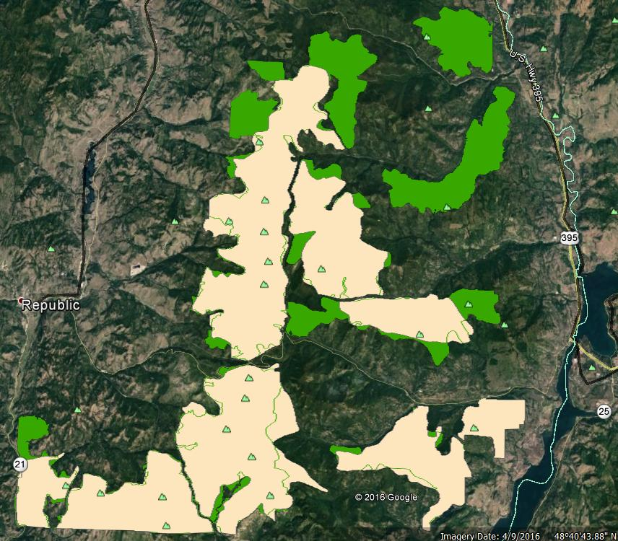

Because of the obvious differences, it is important to ensure the documentation is using the correct terminology - especially since a given PWA may include existing motorized use where the similar IRA may NOT allow motorized use.

b. Draft Forest Plan page 72 and/or 73: There are no Standards or Objectives listed for Recreation (REC). Is this intentional or an oversight/omission error?
7. Management Area Descriptions and Desired Conditions:

Table 16, Colville National Forest special areas (page 79 of the draft Forest Plan) contains an asterisk after the words “North Pend Oreille Scenic Byway”, yet there are no asterisked notes near the table. Without the appropriate note, it is impossible to tell what this particular row in the chart is telling the reader.

8. ATV trail systems: On page 565 of the draft EIS (and page 20 of the draft Specialist Report titled “Recreation”) it states “The Forest supports two small ATV trail systems that do not meet the desired riding distance and loop requirements of most ATV users.” I am questioning the accuracy of this statement as everyone I talk with is aware of only ONE small ATV trail system in the Colville – the Middle Fork Calispell ATV Trails system.

9. Listing of Collaboration and Public Involvement Meetings and Discussions (appendix A of the draft EIS):

In this listing, there are two errors regarding meetings:

a. The “Wilderness Collaboration Integration Meeting” listed as being held on 11/15/2008 was actually held on 11/22/2008.

b. An informational meeting held on 8/1/2011 in Spokane is not listed. The topic of discussion was the forest plan revision. Since it was only an informational meeting, I am not aware of any summary that was distributed afterwards.

Submitted by: Paul Yelk
Spokane WA
(509) 489-0440

