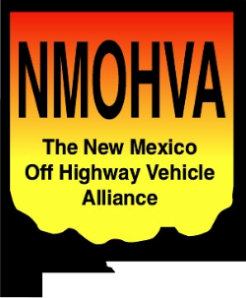

New Mexico Off Highway Vehicle Alliance

13170-B Central Avenue SE

PMB #322

Albuquerque, NM 87123

Elaine Kohrman, Forest Supervisor

Cibola National Forest

2113 Osuna Road NE

Albuquerque, NM 87113

November 17, 2014

Dear Supervisor Kohrman,

I am submitting these comments on the Potential Wilderness Inventory and Evaluation Process for the Cibola Forest Plan Revision on behalf of the New Mexico Off Highway Vehicle Alliance (NMOHVA). NMOHVA is a statewide incorporated alliance of motorized off-highway vehicle enthusiasts that promotes responsible OHV recreation through education, safety training, land conservation and access, in cooperation with public and private interests, to ensure a positive future for OHV recreation in New Mexico. NMOHVA represents motorized recreationists in New Mexico including 4WD enthusiasts, dirt bike riders, and ATV/UTV users.  The Cibola National Forest (CNF) subject to this Inventory and Evaluation Process provides important recreational resources to the members of the public we represent.

We assert that the CNF is illegally applying the draft Planning Directives to this activity. Per the CNF’s web page as of this date:

“The proposed directives to support the new planning rule have guided the Cibola’s efforts thus far.”[1]

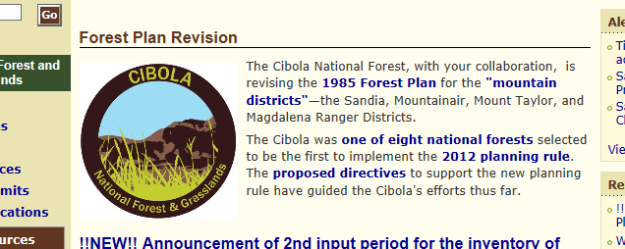

We remind the CNF that the planning directives identified are called “**proposed** directives” and the reason for that description is that they have not yet been approved. The 2012 Planning Rule Proposed Directives web page states (emphasis added):

“The proposed directives are a key set of agency guidance documents that, **once finalized**, direct the implementation of the 2012 Planning Rule.”[2]

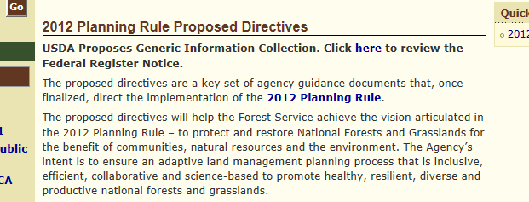

And, indeed, the link furnished for the proposed directives takes the user to a document that very clearly shows that the proposed directive document is not yet approved[3]:

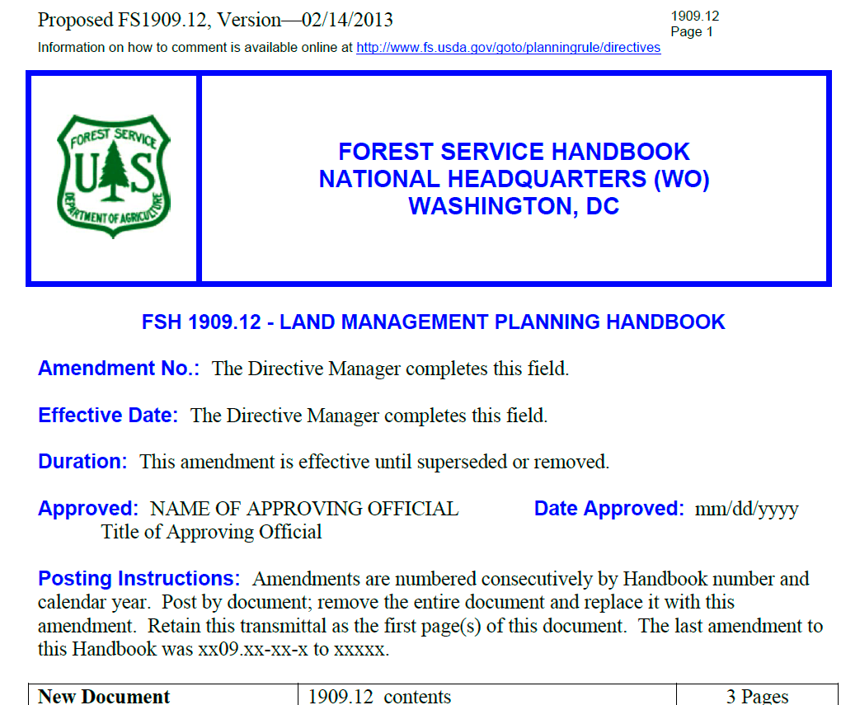

If one goes to the currently valid Planning Directives document[4], it clearly defines under “Duration” that:

“This amendment is effective until superseded or removed.”

Until such time that the proposed directives are finalized and appropriately approved, the CNF is bound to use the existing planning directives. This is an important distinction as the proposed directives differ greatly and materially from the current, existing planning directives.

Specifically, the inventory criteria in the proposed planning directives differ substantially and significantly from the currently legal planning directives. As a specific example, the current planning directives state that the areas qualify for placement on the potential wilderness inventory if (emphasis added):

“Areas **do not contain forest roads** (36 CFR 212.1) or other permanently authorized roads, except as permitted in areas east of the 100th meridian (sec. 71.12).”[5]

The proposed directives are materially and significantly different (emphasis added):

“1. Include in the inventory, areas that contain the following improvements:

a. **Areas that contain forest roads maintained to level 1**;

b. Areas with any routes that are unauthorized or temporary, or forest roads that are identified for decommissioning;

c. **Areas with forest roads that are anticipated during other planning processes for disinvesting future road maintenance activities to a level 1**;

d. Areas with historical wagon routes, historical mining routes, or other settlement era transportation features considered part of the historical and cultural landscape of the area.

2. Except as provided in (1)(b) or (c) above, exclude from the inventory areas that contain:

a. Permanently authorized roads validated by a Federal court or the Department of the Interior for which a valid easement or interest has been properly recorded, or

b. Forest roads maintained to levels 3, 4, or 5.

3. **Evaluate areas that contain forest roads maintained to level 2, or levels 3, 4 or 5 where those roads are anticipated to be disinvested to a level 2**. Include such areas in the inventory unless they are clearly unsuitable for inclusion in the NWPS, based on one or more of the following factors:

a. The road has been improved and is maintained by mechanical means to ensure relatively regular and continuous use.

b. **Road density is so high that either wilderness character is clearly not present, or future preservation of the area as wilderness would not be possible**.

c. A project level decision supported by NEPA analysis has been made in favor of continuous public access to and use of the road.

d. Other on-the-ground knowledge of the level 2 road that would preclude evaluation and consideration of the area during the public participation process as potentially suitable for wilderness recommendation.”[6]

Inventory criteria that changes from not allowing any Forest Service roads to one that includes allowing Operation Maintenance Level (OML) 1 and 2 roads is a huge change, materially and significantly changing the qualification of many areas for placement on the potential wilderness inventory.

The public was then provided false, inaccurate, and misleading information upon which to base their comments:

“The Cibola has developed a map for viewing and comment. It will be available on the Cibola’s collaborative mapping tool located on the forest plan revision website, and at collaborative workshops. It is intended to stimulate discussion and comment from the public to the Cibola planners and decision makers.”[7]

Here is a specific example of where the “proposed criteria” mapping presented to the public for comment is markedly different than the results would be of mapping the existing criteria. The map on the left was furnished to the public for comment as part of the potential wilderness inventory process.[8] The map on the right was furnished to the public as part of the ongoing Travel Management planning process for the Magdalena RD.[9]

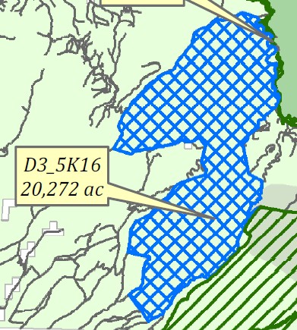 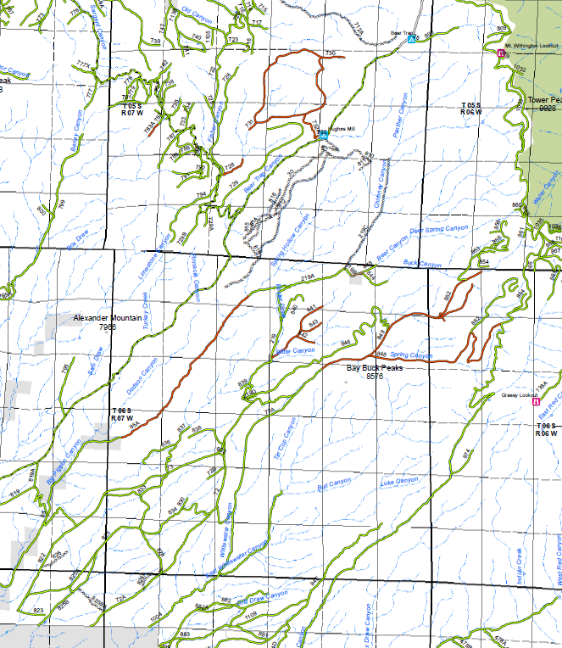

OML 1 roads that materially and significantly impact the qualification of an area for potential wilderness inclusion.

Per the legend for the agency provided map on the right, the routes represented in red are OML 1 roads. It can clearly be seen that if OML 1 roads were excluded from the inventory per the existing and legal planning directives, it would dramatically change the size, shape, and character of the proposal provided to the public on the left. This is but one specific example drawn from the multitude of instances where the same issue has been identified. The public has clearly been furnished with inaccurate map information drawn from illegal criteria on which to base their comments.

The CNF has irrevocably tainted the public input and comment process by:

1) Using the wrong (proposed, but not yet finalized and approved) planning directives and the included criteria for identifying areas of inclusion in the inventory and,

2) Providing the public proposed inventory maps for comment based on that erroneous criteria.

The agency has no choice but to withdraw the illegal and erroneous planning directive information and the resulting maps, furnish the public with the accurate inventory criteria from the existing and legal planning directives, furnish the public with accurate maps reflecting the existing legal inventory criteria, and re-start the initial public input process. Failure to do so will provide an unassailable foundation for subsequent administrative and legal challenge.

Thank you for the opportunity to comment.

Sincerely,

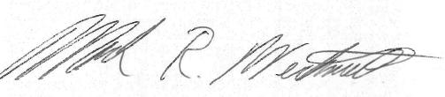

Mark R. Werkmeister, P.E.

Board of Directors

New Mexico Off Highway Vehicle Alliance

15 Camino de Verdad

Santa Fe, NM 87508

505-321-3155

[trailwerks@comcast.net](mailto:trailwerks@comcast.net)

1. <http://www.fs.usda.gov/detail/cibola/landmanagement/planning/?cid=fsbdev3_065627>, 11/16/14
2. <http://www.fs.usda.gov/detail/planningrule/home/?cid=stelprdb5403924>, 11/16/14
3. <http://www.fs.usda.gov/Internet/FSE_DOCUMENTS/stelprdb5409973.pdf>, 11/16/14.
4. <http://www.fs.fed.us/cgi-bin/Directives/get_dirs/fsh?1909.12>!.., 11/16/14
5. FSH 1909.12, Section 71.1(3)
6. Proposed FS1909.12, Chapter 70, Version—02/14/2013, Section 71.22a
7. <http://www.fs.usda.gov/detailfull/cibola/landmanagement/planning/?cid=stelprd3816114&width=full>, 11/16/14
8. http://www.fs.usda.gov/Internet/FSE_DOCUMENTS/stelprd3816212.pdf
9. https://fs.usda.gov/Internet/FSE_DOCUMENTS/stelprdb5409314.pdf