19 March 2020

TO: Lookout Mountain Ranger District, Ochoco National Forest

VIA:   <http://cara.ecosystem-management.org/Public/CommentInput?project=47019>

**Subject: Walton Lake Restoration Project 2020 Revised EA — comments**

Please accept the following comments from Oregon Wild concerning the Walton Lake Restoration Project 2020 Revised EA, <https://www.fs.usda.gov/project/?project=47019>. Oregon Wild represents 20,000 members and supporters who share our mission to protect and restore Oregon’s wildlands, wildlife, and water as an enduring legacy. Our goal is to protect areas that remain intact while striving to restore areas that have been degraded. This can be accomplished by moving over-represented ecosystem elements (such as logged and roaded areas) toward characteristics that are currently under-represented (such as roadless areas and complex old forest).

These comments supplement previous comments on this project submitted by Oregon Wild dated July 6, 2015, April 17, 2017, and Sept 6, 2019.

The proposed action alternative involves:

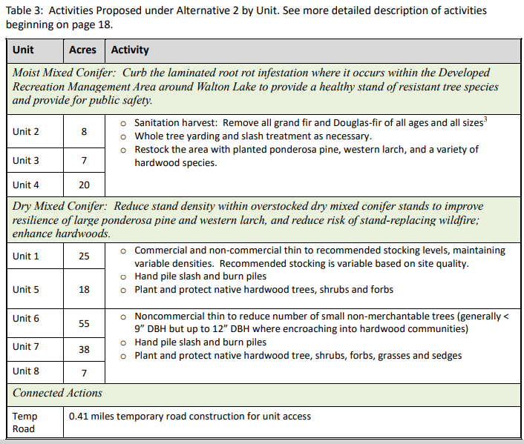

489 large trees to be removed are outside of the permitted recreation special use area and require a plan amendment .

An additional plan amendments will allow reduction of LOS forest.

Oregon Wild continues to urge the Forest Service to adopt a lighter touch in this project area that is the most popular recreation area on the Ochoco National Forest.

We do not support the plan amendments that allow loss of LOS forest and removal of large trees. The forest plan should be regarded as the best approach to balancing competing objectives. It’s not like root rot evolved after the forest plan was adopted. The authors of the Forest plan already knew about all the various forest health risks when the plan was written and adopted standards that balanced all the known considerations.

The EA says the plan amendment is justified because “Forest health experts recommend that sanitation harvest and planting with more resistant species is a more effective approach.” Forest health experts are just one source of information to inform a sound decision. Each expert is trained to see problems and solutions through a selective lens that does NOT consider all the alternative viewpoints. Forest health experts may not be trained to consider and balance the needs of wildlife, recreation, carbon storage, etc. The FS should choose An alternative that does not amend the forest plan and does not retain large trees.

Flush cutting stumps for scenic purposes conflicts with wildlife goals. Consider high cutting some stumps to create “short snags” that increase the chances that recreationists get to view and enjoy snag associated wildlife.

Signage to warn the public of dangerous conditions created by root rot is a viable alternative to cutting large valuable wildlife trees, especially in areas that are not too crowded. This also presents an opportunity for public education about the value of natural processes and deadwood habitat.

Whole tree yarding results I large slash piles that are unsightly and severely damaging to soil when burned. It is also inconsistent with the natural processes that retain woody material and nutrients onsite when and where trees experience mortality.

The analysis of effects to cavity species is misleading. It says “any loss would be expected to be minimal because snags are not targeted for removal.” Whether snags are targeted is of minor consequence compared to the loss of green trees that are no longer available for snag recruitment as a result of logging. The analysis also says “retained in thinned stands would be expected to stay healthy longer, and thus will not provide snags in the short- to mid-term, reducing future snag and down wood recruitment.” This admits some adverse effects on snag habitat, but importantly also fails to capture the most significant effect that logging reduces the population of green trees available for snag recruitment. The description of Alt 4 does not disclose that it would be better for snag associated wildlife because it retains a larger population of large green trees for snag recruitment.

The EA tries to minimize effects to snag associated wildlife by saying that snags are generally not retained in recreation areas, but a lot of the large trees to be removed under Alt 2 (or retained under Alt 1 and 4) are not so close to developed sites that they will need to be felled for safety.

Each substantive issue discussed in these comments should be (i) incorporated into the purpose and need for the project, (ii) used to develop NEPA alternatives that balance tradeoffs in different ways, (iii) carefully analyzed and documented as part of the effects analysis, and (iv) considered for mitigation.

Note: If any of these web links in this document are dead, they may be resurrected using the Wayback Machine at Archive.org. <http://wayback.archive.org/web/>

Sincerely,

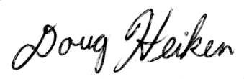

Doug Heiken

[dh@oregonwild.org](mailto:dh@oregonwild.org)