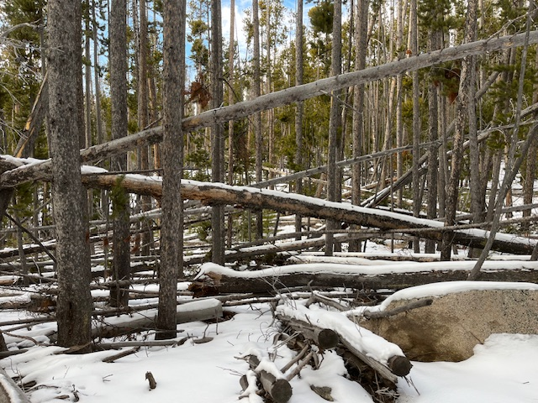

Picture of what the new Old Growth definition includes. Dead and down timber.