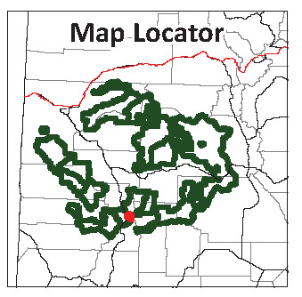
Bear Creek Addition to Uncompahgre Wilderness

Proposed Wilderness Designation  Uncompahgre National Forest  Ouray Ranger District | 6,000 acres
General Description

The Bear Creek addition to the Uncompahgre Wilderness brings the wilderness boundary closer to Highway 550 – the Million Dollar Highway -- incorporating the entirety of the Bear Creek watershed, from the highway to the alpine tundra atop Engineer Pass. It includes seven miles of the Bear Creek National Recreation Trail, so designated owing to its extraordinary scenery and the uncommon nature of its construction – literally dynamited out of the cliff along the lower reaches of Bear Creek.

The wilderness addition extends north to include the entirety of the Bridge of Heaven and the Horsethief Trail along Cascade Mountain, a hiking route with incomparable views and dramatic drop-offs.

Land acquisitions have consolidated federal ownership along Bear Creek, with the majority of remaining patented claims on the most precipitous cliffs at the lower end of the creek, near the highway. The rugged nature of Bear Creek precludes constructed road access to these inholdings, making conflicts with future wilderness management unlikely.

Bear Creek is a superlative wilderness candidate and adds seven miles of roadless valley to the wilderness. The trail is for hikers only owing to the long, horizontal shelves blasted out of the cliff faces and the sheer drop-offs to the creek below. Two historic mining camps add historical flavor and interest to the adventure. A myriad of waterfalls from trickles to thundering cascades enhances both the scenery and the auditory appeal of the wilderness.

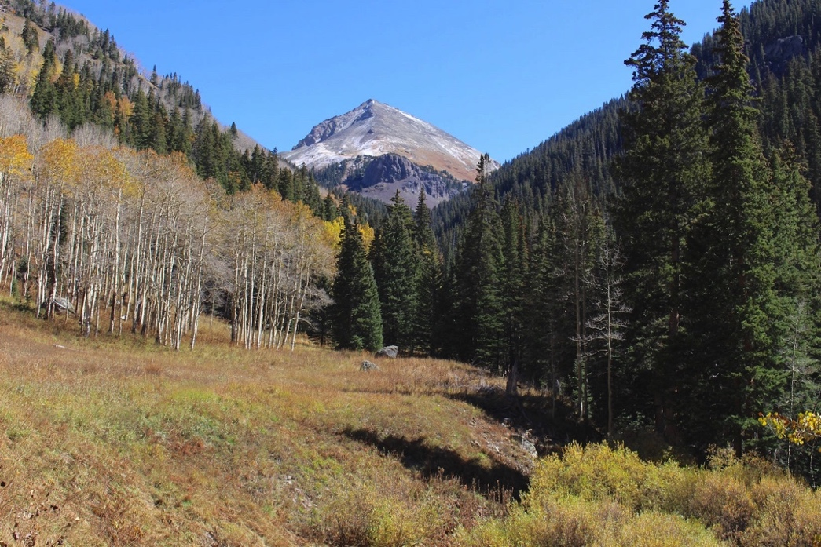
Naturalness

The Bear Creek trail was originally developed by miners starting in the 1870s, and remnants of historic activities occur at several locations. These dilapidated cabins and rusting mining equipment add historic value and do not detract from the larger undeveloped character of the valley. The historic mining relics are similar in scale to those frequently encountered in other wilderness locations, including Chicago Basin in the Weminuche and Silver Jack Mine in the Uncompahgre.

The Bridge of Heaven and Horsethief Trail addition is in superlative natural condition. It includes the steep slopes above various historic mines, such as the Portland Mine and the Chief Ouray Mine, all of which are excluded from the wilderness addition.

Outstanding Opportunities for Solitude or Unconfined Primitive Recreation
The Bear Creek valley and trail offer outstanding opportunities for solitude. The trail rapidly gains elevation from Highway 550, creating a substantial elevation separation from the highway. Once the trail wraps around into the entrance of the valley, the steep walls close in and create a sensation of complete isolation. The Horsethief Trail offers outstanding opportunities for solitude, seclusion and tranquility.

The Bear Creek National Recreation Trail was designated in recognition of its unique and spectacular nature. The trail was established initially by miners in the late 1800s, and required blasting a ledge into cliff faces to skirt the most precipitous canyon segments. This creates a remarkable and scenic experience unlike any other in southwest Colorado. The trail and surroundings offer outstanding opportunities for unconfined primitive recreation. The Horsethief Trail leads to Bridge of Heaven, one of the classic hikes in the Ouray area that leads to phenomenal views high above treeline.

Size and Roadlessness

Bear Creek is about 6,000 acres in size, but is contiguous with the adjacent 102,214-acre Uncompahgre Wilderness. There are no roads within the unit.

Supplemental Values

Relics of hardrock mining provide historic interest. The Grizzly Bear Mine and Yellow Jacket Mine were established in the late 1800s, with both ceasing operation by 1915. The ruins of several cabins, a tunnel, and mining equipment mark the location of the Grizzly Bear Mine. The Yellow Jacket mining camp is better preserved, with an intact bunk house and assorted mining equipment. Both sites make for intriguing trip destinations.

Bear Creek provides significant wildlife habitat, particularly as bighorn sheep summer and winter range, and as a bighorn sheep production area. The area is also a winter concentration area for elk.

Manageability

Bear Creek’s rugged lower end precludes the possibility of motorized access from Highway 550 to the patented mining claims that dot the valley’s cliffs. There is no vehicle access from the top, from Engineer Pass. For safety reasons, the trail is limited to hikers only. There is no oil and gas potential, and apparently limited potential for hardrock minerals since the last production ceased in the early 1900s.

The Horsethief Trail portion is steep, which precludes unauthorized motorized incursions. The boundary excludes all of the developed and patented mining claims in the lower portions below the wilderness boundary in Cascade Creek, Bridalveil Creek, and Dexter Creek.

Information Resources

Item | Data Source
Roadlessness | Colorado Roadless Rule at 36 CFR xx
 | Forest Service inventory pursuant to FSH 1909.12,chapter 70, section 71
Naturalness; Outstanding Opportunities for Solitude or Unconfined Primitive Recreation | Forest Service inventory pursuant to FSH 1909.12,chapter 70, section 72
 | USDA Forest Service, R2, Profiles of Colorado Roadless Areas 2008
 | GMUG Roadless Inventory & Evaluation for Potential Wilderness Areas, 2005
Supplemental Values
Connectivity | SREP Wildlands Network 2003,  USDA Forest Service Southern Rockies Lynx Amendment, 2008  Aplet et al, Indicators of Wildness 2000,  Belote et al, Identifying Corridors among Large Protected Areas in the United States, 2016
Bighorn Sheep Production Area | Colorado Parks and Wildlife Species Activity Mapping 2017
Elk Winter Concentration Area | Colorado Parks and Wildlife Species Activity Mapping 2017
Lynx Potential Habitat | Colorado Parks and Wildlife Species Activity Mapping 2017
Dexter Creek Potential Conservation Area with Moderate Biodiversity Significance | Colorado Natural Heritage Program Potential Conservation Areas 2017
Historic | David Day, Colorado's Incredible Backcountry Trails, 2009

