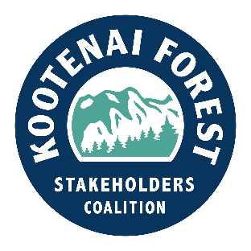

Michael Feiger

District Ranger

Cabinet Ranger District

2693 Hwy 200

Trout Creek MT 59874 January 2, 2024

**Re: Tuscor Proposed Project**

Dear Mr. Feiger,

On behalf of the governing board of the Kootenai Forest Stakeholders Collaborative (KFSC), thank you for the opportunity to comment on this proposed project. Thank you also for organizing the field trip to the Tuscor project area on September 19th.

We appreciate your efforts to inform and involve the public regarding projects like this, which are in the wildland urban interface (WUI) and located near numerous homes on nearby private lands. During the field trip, discussions about rationale for proposed treatment of different sites within the project were helpful and clarified project goals and likely outcomes. The opportunity to view stands near the project area that had received similar earlier treatments was beneficial. Those stands appeared to be in good condition, with more species and age class diversity, and less density of stems compared to untreated areas.

We found the *Tuscor Project Proposed Action for Scoping* document to be thorough and helpful in understanding the proposed project and support your decision to designate the project as a CE under Section 603 of the HFRA.

We support the thinning, harvesting, and fuels reduction treatments proposed in the project. These treatments are expected to reduce fire risk in the project area and on nearby private lands. Implementation of this project supports goals outlined in the Forest Plan to increase species and age class diversity, and reduce the preponderance of high density stands of 70- to 100-year-old Douglas Fir. We suggest tethered harvesting systems be considered for use on some of the steeper ground in the project area.

Under the discussion of “Issues Identified in Project Development,” beginning on page 10, we feel “Road Management Issues” (page 18) qualify as potential issues of concern for this project. We suggest additional issues of concern include potential impacts to threatened and endangered species, as well as weed management during the life of the project. We support weed management as a component of planning and implementation for all forest projects.

Also, we feel using the term “clear cut” in NEPA or other sale documents is potentially detrimental to educating the public about the project. Too often, the term brings images to mind of the large rectangular harvest blocks, devoid of trees, that were typical of treatments many years ago. We do understand that, based on Forest Service standard definitions and the fact that the unit will be planted, the term “clear cut” is used. However, the term often has a negative connotation and may not help build general support for the project. Nor does it reflect today’s cutting units, which are generally smaller in size, with irregular edges and clumps of leave trees, and designed to promote diversity.

We propose the agency consider using different terminology to replace this potentially misleading label and reflect conditions where tree planting is required in regeneration harvest areas with limited availability of desired seed tree species. (This is no different than an under burn that is too hot, where seed trees are killed, and the harvest area needs to be planted.) We support the goal to replace stands in some situations but suggest there may be a better way to express what is proposed.

Sincerely,

Shawn Morgan Tim Dougherty Doug Ferrell

Shawn Morgan Tim Dougherty Doug Ferrell

KFSC Project Team Leader KFSC Co-Chair KFSC Co-Chair

.