Attached images from the personal comments of John Gatchell

Stars over the Crazy Mountains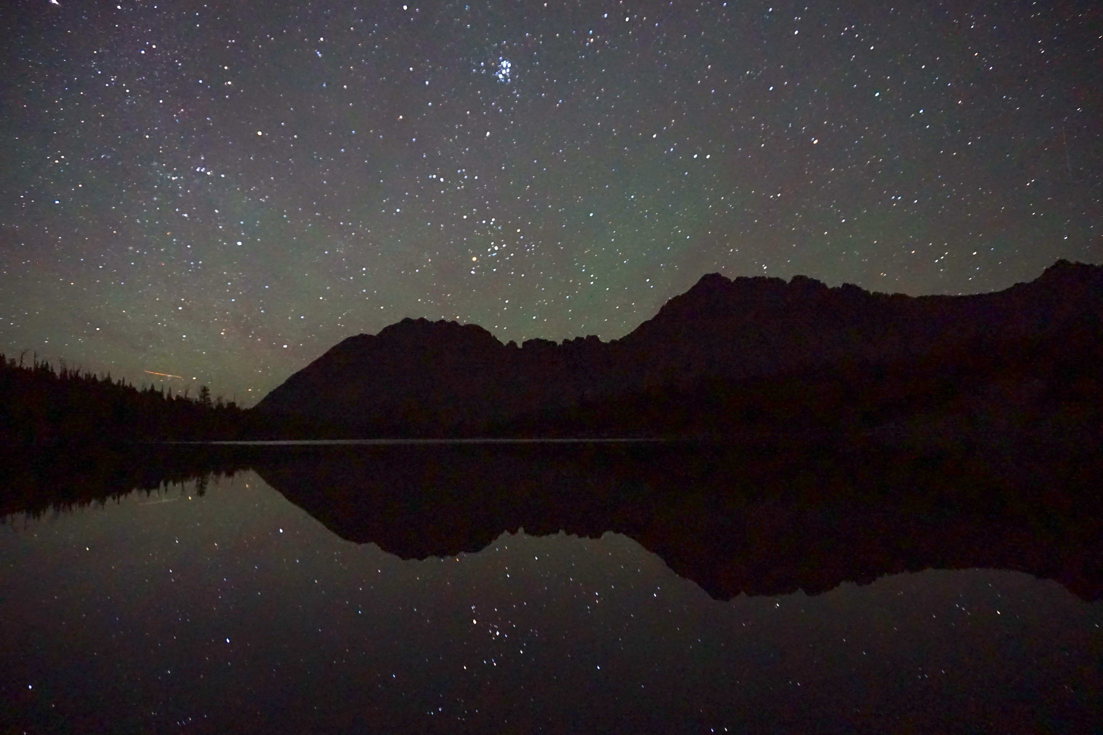

The Crazies are brimming with trail-less cirques and isolated basins. Protect it as RWA. Nothing less.
