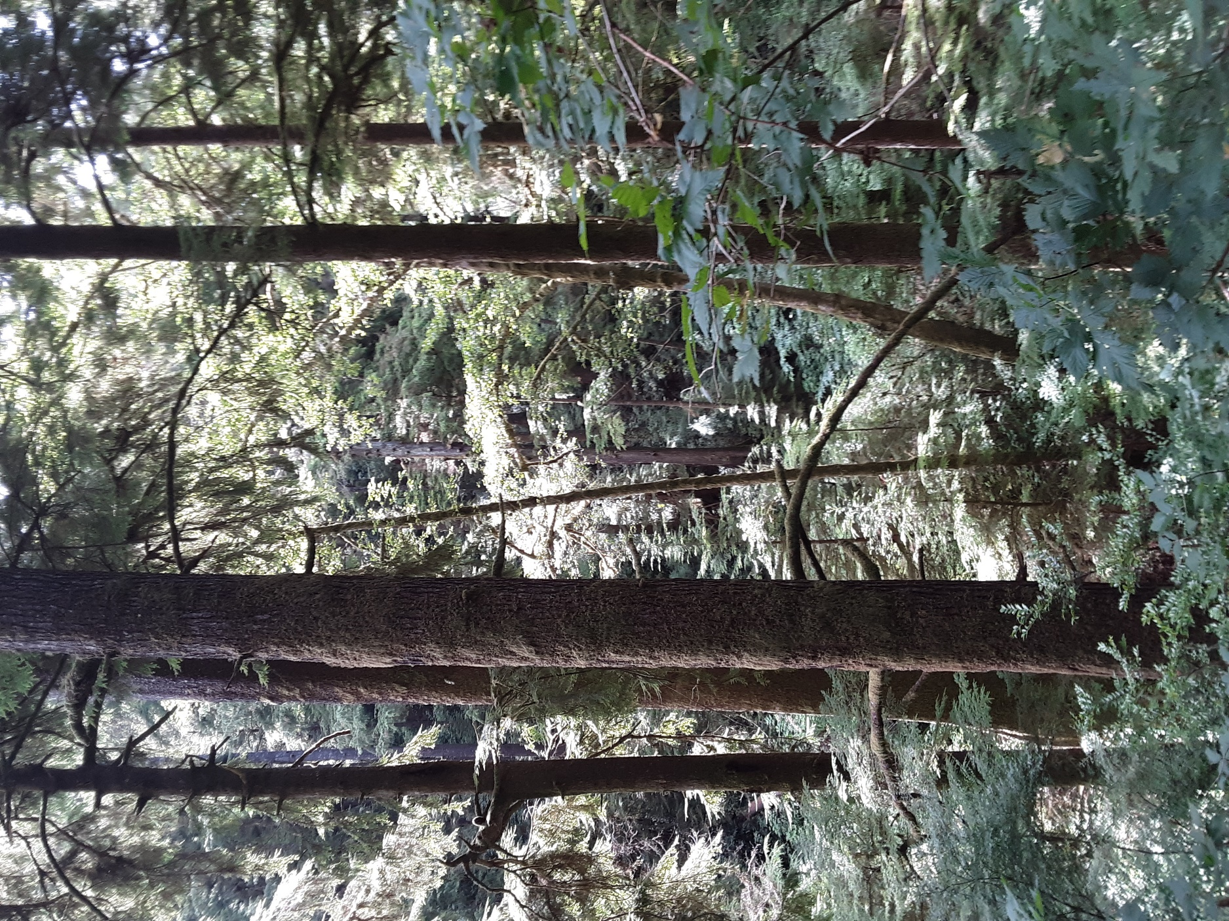 This is a Story about a Plan to remove excess Carbon Dioxide from the atmosphere. Requires Funding!

The Indigenous People living west of the Cascade Mountain Range in Oregon Territory that survived the diseases and genocide brought by the first European immigrants were promised a Reservation of 1.1 million acres, along the coast and in the Coast Range of Northwest Oregon in exchange for over 15 million acres of land ceded to the United States Government. [1] Four days before Christmas 1865 President Andrew Johnson signed an Executive Order opening the center of the Reservation, from the Willamette Valley to Yaquina Bay, for white settlement and all the Native inhabitants were removed. In March 1875 the Annual Appropriations Bill for Fulfilling Treaty Stipulations passed with a “rider” attached by Oregon Senator John Mitchell that opened an additional 700,000 acres for private ownership. The US Congress passed the Dawes Act (or General Allotment Act) in 1887 and in 1892, 551Tribal members were assigned individual Allotments of 80 acres and the remainder of the Reservation was declared “Surplus” and sold. The US Congress did not Ratify a Treaty. The majority of land ownership was Private and the theft complete. [2]

In 1836 President Andrew Jackson, in a battle with the Bank of the United States over land speculation and issuance of unbacked paper script, ordered all US Government funds withdrawn from the Bank and the General Land Office only accept specie (gold or silver) be paid for Public Land. By the summer of 1837 Financial Panic spreads throughout the East and the country is plunged into a Depression. Throughout the 1840’s as more and more people came West with dreams of a better life, the US Government worked to claim clear Title, mainly from the British, and settlers formed a Territorial Government to stabilize their claims. The US Congress passed what is known as the “Donation Act” in September 1850, to increase American settlement, giving Title of 2.5 million acres of land to individual settlers already on the land before Official Survey. [3] Oregon becomes the 33rd State in 1859 and the Federal government opened millions more acres of the Public Domain for Private Ownership through Land Grants for “Military” Wagon Roads and Railroads, the “Swamp Lands Act”, and other legislation along with the continued Sale of Land. The Oregon Legislature and other white men often profited helping transfer Title to wealthy individuals and companies. [4]

Americans and Europeans interested in settlement in Oregon’s Coast Range, quickly learned travel was limited to river valleys and ships along the coast until rails could be laid from the Willamette Valley to further capitalists resource extraction and sales. The main resource would be Timber, for the Coast Range had MORE CARBON per acre as any Forest on Earth. [5] A Temperate Rain Forest, the reason people had not traveled overland, it was covered so densely by massive ancient Western Red Cedar, Sitka Spruce, Hemlock, Fir, Maple, Alder, and Yew (with many more mixed tree and shrub species in the understory vital to Forest Health) that a horse could not be ridden a hundred feet into the impenetrable undergrowth. Giant Rhododendron, Huckleberry, Salmonberry, Devil’s Club and an astoundingly diverse connected Plant Communities, evolved over millennium to THRIVE in the moist, mild, maritime Climate. Going off trail was foolish and could be deadly. [6] In the beginning, to cut them down, it took two strong men working most of a day with axes and a crosscut saw, sometimes on spring boards 20 to 30 feet above the ground to avoid the added labor of cutting through the buttressed base. The first trees were next to a river or tideland to float them for easier handling. That would all change rapidly, first with railroads and steam then with diesel trucks and gasoline chainsaws.

As soon as the Public Lands were Officially Surveyed and opened for sale and settlement by the General Land Office, entire Townships (23,000 acres) of the Ancient Forest were quickly acquired by the Super Rich Liquidators of the Original Forests in the East and Midwest, for as little as $1.50 an acre. With a Title and a Timber Cruise (a Professional Appraisal of the Volume of Merchantable Standing Timber usually expressed as board feet per acre) could easily be sold for $100 or more an acre without ever seeing the property or removing a log. In 1900 Frederick Weyerhaeuser and his millionaire buddies (known as the Weyerhaeuser Syndicate) purchased 900,000 acres of Forest from James J. Hill (Railroad Tycoon) and began the conversion of a balanced complex diverse ecosystem into the stand replacement monocrop fiber plantations that dominate the landscape today. [7] They promoted this as sustainable by replanting the clearcuts. After the fires in the 1930’s that burned the massive piles of slash (along with everything else) left after logging the Ancient Forest, some of the burned over land was abandoned by the corporate owners to avoid taxes to the counties, and given to the State of Oregon, replanted by volunteers, convicts, and natural regeneration to become the Clatsop, Tillamook and Elliot State Forests. All using the intensive financial forestry management model until this year (2022), when the State of Oregon paid $221 million (Appraised Value) to the State School Fund to create the 91,000-acre Elliot State Research Forest, the Largest Research Forest in North America.

WWII ending dramatically increased the demand for lumber just as the last patches of Original Forest on Private Land were being cut and the earliest plantations began to be sent to the mills to fulfill huge housing and construction needs. Federal Timber, if allowed to enter the market earlier would have reduced the value of the Private Timber, began to be harvested in ever increasing amounts. The Siuslaw National Forest; created in 1908 from Federal Forest Reserves made by Executive Order; like large swaths of the Coast Range, was heavily forested with even aged stands of mature Douglas Fir and Western Hemlock and very desirable for Lumber. Tight, straight grain with few knots, growing in dense stands over 200 feet tall, capable of producing 200,000 board feet of Lumber per acre. In less than 30 years, trillions of dollars were extracted by selling off these irreplaceable 150+ year old trees (a Public Asset) to the highest bidder for an incredibly small amount of money because the Timber Sales; road building, harvest and transport to processors was subsidized by taxpayers in exchange for some jobs and a bit of funding for schools and roads. Many of the premium logs were shipped Overseas without processing, through the Ports of Oregon and Washington. By the mid 1980’s scientists, foresters, ecologists and environmentalists were sounding the alarm; this Federal Forest under the US Department of Agriculture and surrounding lands managed by the US Department of Interior, Bureau of Land Management, were the ONLY HABITAT LEFT for a large amount of once abundant species, both aquatic and terrestrial. [8]

Weyerhaeuser and the other Wall Street owned corporate robber barons blamed the Owl, Murrelet, Fisher, Salamander, and Salmon for reductions of logs to their mills; and quickly shortened the length of time between harvest on their Private Timberlands to supply their new automated milling and processing facilities with fiber. There is very little Lumber produced anymore (mostly small dimensions 2X4,4X4,2X6, …). There are wood products made by gluing wood chips together under pressure (LDL, I-Joist, Oriented Strand Board, …). In less than a decade they dramatically reduced their workforce and increased production. They actually promote themselves as stewards and seek ESG (Environmental, Social, Governance) certification at every opportunity. Everyone knows planting trees is good for the Planet, right? Weyerhaeuser alone grows from seed and plants millions of seedlings every year in Oregon on the 1,453,000 acres it owned at the end of the decade 2020. What they are NOT telling anyone is what is actually happening behind the locked gates of the “working forest” lands and to the communities of people connected to this mismanaged corporate owned land.

The absentee Wall Street ownership with their financial forestry management model is the largest contributor of Greenhouse Gases to the atmosphere in the State of Oregon. The average amount of Carbon stored as wood products for a long period (100 years +) from the trees cut is 20%, the rest ends up in the atmosphere. For the first 13 years the seedlings planted store zero Carbon and then gradually begin to store more. The problem is they will be harvested before they store much Carbon at all, let alone sequester what was there before colonization. The average harvest at 45 years growth yields 35,000 board feet per acre with the loss of the future growth as the trees are just beginning to grow vigorously given adequate precipitation and sunlight. Compounded by the fact that in a Natural Forest more than 50% of the Carbon stored is not in the trees (even the Ancient Giants) but in the other vegetation and underground in the roots and soil mycorrhizae which is almost entirely absent in an industrial forest plantation. [9] It should surprise no one that ONLY older trees store water in significant quantities. The small young conifers covering the Coast Range have none of the fire resistance of an Older Forest and in an ever drying and warming Climate are a Fire Storm waiting to happen; as made REAL on Labor Day weekend 2020. Weyerhaeuser quickly salvage logged 125,000 acres, the worst thing you can do for a fire ravaged site [10], then wrote off an $80,000 loss. In 2010 Weyerhaeuser reorganized the company into a REIT (Real Estate Investment Trust) to better reflect their business model and avoid paying taxes by giving ever greater Dividends to Shareholders (84.3 % owned by Institutional Investors like Vanguard, Black Rock, T. Rowe Price, State Street, JPMorgan Chase, …) and in 2015 merged with Plum Creek Timber Company (created from Burlington Northern Railroad government land grants) to become the largest Private Forest Land owner in North America. [11]

After Weyerhaeuser the next three largest Forest Land Owners in Oregon are Hancock Natural Resource Group (owned by Manulife Investment Management), Greenwood Resources (owned by Nuveen Natural Capital / TIAA), and Campbell Global (owned by JP Morgan Chase). These corporations with a few others, buy and sell their acreage, mostly between themselves, increasing the Market Value, while paying only Property Taxes and a very small Severance Tax in Oregon, impoverishing the rural communities and counties with their controlling interest and continued removal of all the monetary value added daily by NATURE! The predatory capitalist business model continues to exploit labor and land with devastating results to the rural counties and communities economically, physically and emotionally, while the corporate owners/investors see profits set a new record each Quarterly Report.[12] The Climate Crisis Emergency mandates immediate monetary investment to Purchase, Restore and Protect as much of this Life-Giving Ecosystem as we are capable of; not only for the benefit of the local communities, flora and fauna, but the State, Country, Hemisphere and Planet. [13]

What is the Price? At 2021 Assessed Value $5 million could purchase 4600 acres of the Big Creek Watershed (the City of Newport, Lincoln County, Oregon) from Weyerhaeuser. This could apply to all of the cities, towns, communities and counties to the north, south and east. Clatsop, Columbia, Tillamook, Polk, Benton, Lane, Douglas and Coos Counties; every place presently suffering from the Greed of financial forest ownership. The City of Rockaway Beach recently spent millions to replace drinking water infrastructure damaged by silt from clearcutting their Watershed (owned by Nuveen). Restoring an Old Forest (termed “proforestation”) will also provide meaningful stable employment (with the majority of any revenue generated remaining in the local area, county, state, region), restore water quality and quantity, air quality, fire resistance, habitat quality and quantity, a sustainable source for many resources including yet undiscovered benefits and begin immediately the long-term sequestration of immense quantities of Carbon! [14] If we can negotiate a reduced price because of the obvious environmental damage caused by decades of over harvest, herbicide use, road building, etc. this may not be as costly as we could imagine. A project like this could be an example as a way to Reclaim the Commons, Restore Equity to Rural Economies and Reparations for some of the Past Injustice to the Descendants of the First Humans to call Western Oregon home. A Better World is Possible!

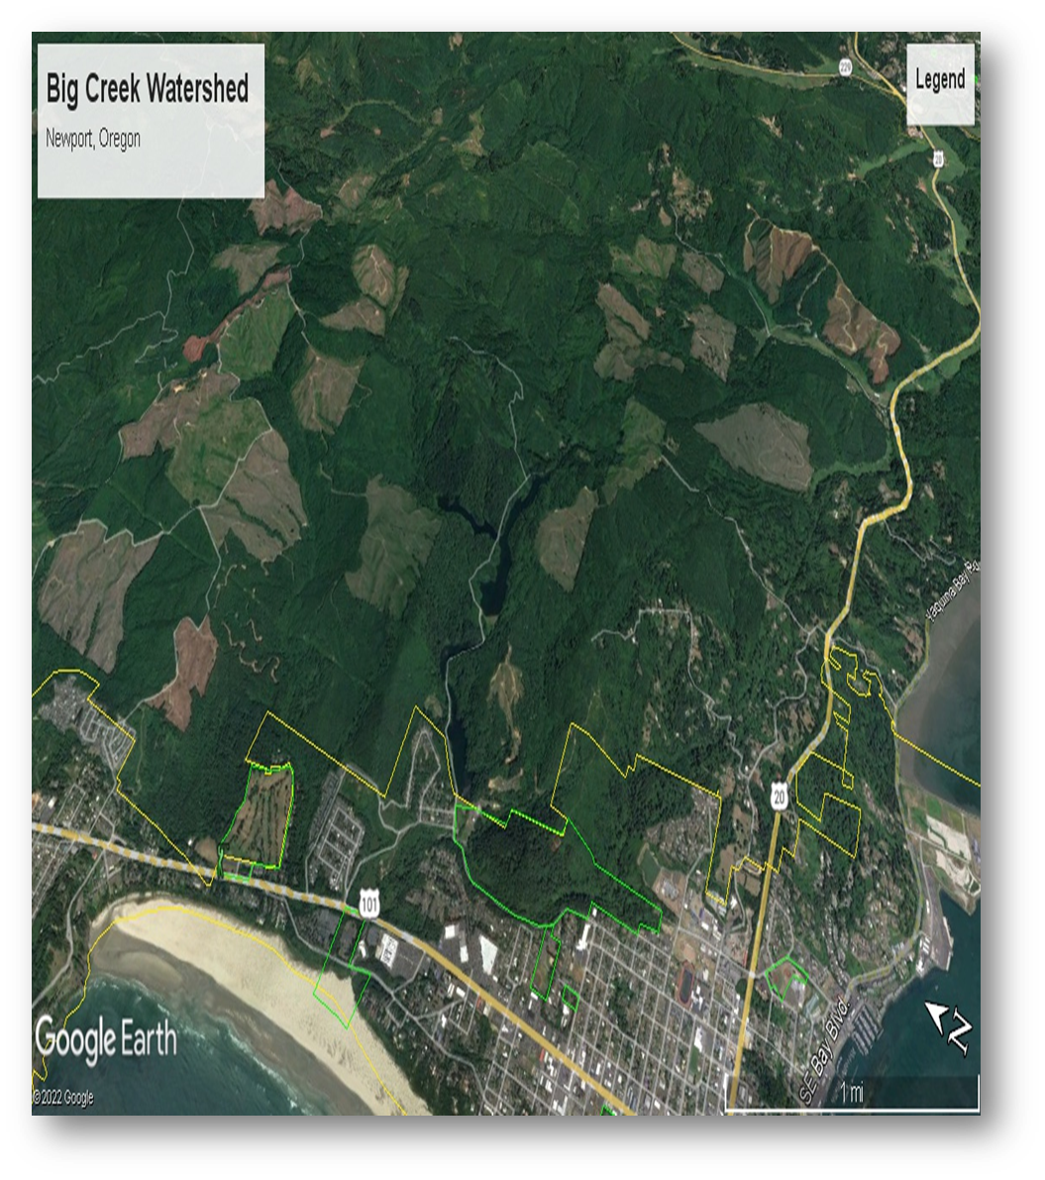

1. <https://www.ctsi.nsn.us>
2. Atlas of Oregon Second Edition University of Oregon Press 2001
3. A Casebook of Oregon Donation Land Claims by C. Albert White 2001
4. Looters of the Public Domain by Stephen Puter and Horace Stevens 1908
5. POTENTIAL UPPER BOUNDS OF CARBON STORES IN FORESTS OF THE PACIFIC NORTHWEST

   Ecological Applications 12(5), (2002) pp.1303- 1317 by the Ecological Society of America
6. Historical Forest patterns of Oregon’s central Coast Range

   Biological Conservation 93 (2000) pp. 127-133
7. <https://www.weyerhaeuser.com/company/history/>
8. <https://www.fs.usda.gov/r6/reo/>
9. OREGON FOREST CARBON POLICY Scientific and technical brief to guide legislative intervention

   V1.0 12-11-17 Prepared by John Talberth, Ph.D. Center for Sustainable Economy
10. RUNNING BACKWARDS A Report from John Muir Project and Center for Sustainable Economy

    Version 2 October 2021
11. WY 2020 Annual Report and Form 10-K
12. <https://projects.oregonlive.com/polluted-by-money/>
13. <https://coastrange.org/gnd-proposal/>
14. <https://doi.org/10.1002/eap.2039>