January 31, 2024

Regional Forester

U.S. Forest Service

1220 SW 3rd Avenue

Portland, OR 97204

**FOREST PLAN AMENDMENT FOR PLANNING AND MANAGEMENT OF NORTHWEST FORESTS WITHIN THE RANGE OF THE NORTHERN SPOTTED OWL; DOCUMENT NUMBER: 2023-27742**

Regional Forester:

The California Department of Fish and Wildlife (CDFW) has reviewed the Notice of Intent for the Northwest Forest Plan (Plan) published on December 18, 2023, and appreciates the opportunity to provide the U.S. Forest Service with comments. CDFW participates on the Northwest Forest Plan Federal Advisory Committee State Agency Subcommittee and intends to work with the Subcommittee to discuss the Plan development and review the draft Environmental Impact Statement when complete in June 2024.

If you have questions about this letter or would like further information, please contact Mr. Elliot Chasin, Timberland Conservation and Fire Resiliency Program Supervisor, at (916) 206-0384 or [TimberFireHQ@wildlife.ca.gov](mailto:TimberFireHQ@wildlife.ca.gov).

Sincerely,

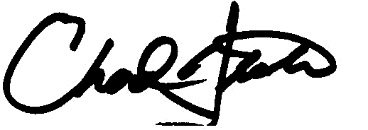

Chad Dibble, Deputy Director

Wildlife and Fisheries Division

California Department of Fish and Wildlife

ec: Joshua Grover

Deputy Director

Ecosystem Conservation Division

Kevin Thomas

Deputy Director

Regional Operations

Tina Bartlett

Regional Manager

Northern Region

Scott Gardner

Branch Chief

Wildlife Branch

Jeff Drongesen

Branch Manager

Habitat Conservation Planning Branch

Isabel Baer

Environmental Program Manager

Habitat Conservation Planning Branch