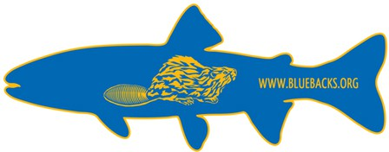

Blueback Chapter of Trout Unlimited

Trout Unlimited Chapter #196 [bluebacksTU@gmail.com](mailto:bluebacksTU@gmail.com) <http://www.bluebackstu.org>

March 17, 2025

Comment on NW Forest Plan Amendment Alternatives

Trout Unlimited (TU) is a national organization dedicated to caring for rivers and streams so our children can experience the joy of wild and native trout and salmon. Our chapter of Trout Unlimited, the Bluebacks, has several hundred members in the Mid-Willamette Valley from Salem to Eugene, and from the Cascades to the ocean. As volunteers we conduct anadromous fish surveys on the North Santiam and the Luckiamute Rivers, monitor water chemistry in Corvallis area streams, annually clean trash from the South Santiam River, and participate in youth education about salmonids (i.e., Linn-Benton Salmon Watch, Clackamas Chapter Youth Flyfishing Camps). The fish that live in the rivers in our region depend implicitly on healthy forests.

**The Blueback Chapter of Trout Unlimited supports either Alternative A or C of the NWFP Amendment Draft Environmental Impact Statement released by the Forest Service in November 2024.**

These alternatives are the best options for forests such that requirements for fish and water quality aren’t degraded. Either of these alternatives would protect Oregon’s forests and streams, water quality, wildlife, recreation and cultural values that we and other Oregonians value.

Thank you for considering our input. Please contact me if I can answer any questions.

Sincerely,

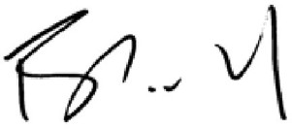

Frederick Colwell, current President

Blueback Chapter of Trout Unlimited, Chapter #196

[rickcolwell@gmail.com](mailto:rickcolwell@gmail.com)