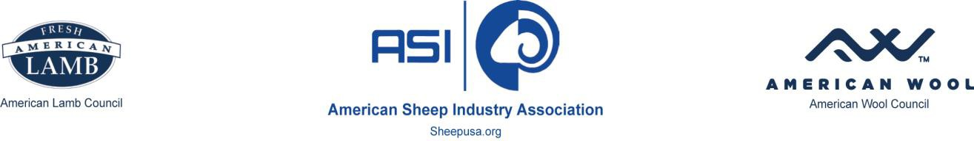

March 10, 2023

Okanogan-Wenatchee National Forest Domestic Sheep Grazing EIS

215 Melody Lane

Wenatchee, WA 98801

*Submitted via Federal eRulemaking Portal and US Mail*

Re: Notice to Prepare an Environmental Impact Statement (84 FR 22432) – Okanogan- Wenatchee National Forest; Washington; Forest Plan Amendment for Planning and Management of Domestic Sheep and Goat Grazing Within the Range of Bighorn Sheep

Comment opportunity published February 17, 2023 (FR Doc. 2023-03354)

The American Sheep Industry Association (ASI) appreciates the opportunity to comment in the matter of the above referenced Notice to Prepare an EIS. Since 1865, ASI has been the national trade organization representing the interests of the over 90,000 sheep ranchers located

throughout the country who produce America’s lamb and wool. ASI is a federation of forty-five state sheep associations representing a diverse industry. ASI and its affiliate the Washington State Sheep Producers represent the interests of not only the greater sheep industry, but also individual sheep producers directly impacted by the Agency’s decision(s) in this matter.

ASI has supported Appropriations language as cited in the Federal Register notice, specifically directing the Forest Service and other land management agencies to use the best scientific understanding of pathogen transmission in cooperation with the USDA Agricultural Research Service to guide decisions to ensure both the health of the domestic sheep industry and state bighorn sheep herds. ASI believes that bighorn sheep conservation and the legacy of domestic sheep operations are mutually compatible and that land management planning should recognize the role of each in underpinning our rural economies.

Pathogen transmission and the potential resultant disease is a complex issue. While the Notice cites scientific research supporting a relationship between disease in bighorn sheep and contact with domestic sheep or goats when in close proximity, that does not represent the entirety of scientific understanding on the topic. On review of modeling the risk of pneumonia epizootics in bighorn sheep, it was concluded that factors associated with risk of pneumonia epizootics are complex and may not always be from the most obvious sources (Sells et al. 2015). Similarly, looking at *mycoplasma ovipneumoniae* in wildlife species beyond subfamily caprinae, these pathogens were documented in species that also frequently occupy overlapping habitat as bighorn sheep including; moose, caribou, mule deer, white-tailed deer, bison, cattle and antelope (Highland et al. 2018). ASI greatly appreciates the Agency’s efforts in engaging research and researchers, such as its sister agency ARS, which have special expertise in animal diseases.

ASI also appreciates and supports plan direction that would allow for updated versions of the current risk of contact modeling tool. ASI has long held that the current risk of contact modeling tool is flawed in its efficacy, not adapted to varied landscapes, frequently used without necessary and corresponding telemetry data, fails to account for existing physical and temporal contact mitigation, and overly relies on strict adherence to the precautionary principal. ASI strongly supports the inclusion of other factors mentioned in the Notice including topography, temporal separation, and herd characteristics among others to ensure Forest-wide range management.

Finally, ASI supports the consideration of other current and potential measures used to discourage interaction between wildlife and livestock including; the use of livestock protection dogs, experienced sheep herders, efforts to reduce straying, electronic GPS data, and communication and coordination between sheep producers and agency staff. Pathogen transmission is a two-way street and sheep producers strive to minimize contact with wildlife on a daily basis.

America’s sheep producers pride themselves on their stewardship of the range, both private and federal, and rely on those resources for their long-term livelihood. As such, we share in the conservation success and the responsible stewardship of our nation’s federal lands. ASI again appreciates the opportunity to comment and requests to be included throughout the scoping process for the development of this EIS.

Sincerely,



Brad Boner

American Sheep Industry Association