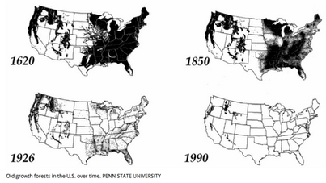

These map images clearly show the devasting loss of old growth forests in the United States and the tiny amount of this precious forest resource remaining.

