Forest Visit Documentation Form
Siuslaw National Forest
08/11/2024
Forest Visit ID Name ____Site 2 (off NF-41)_________________________________________
(Use any name you wish. Followed Forest Service road No.)
Multiple stops on the same road, ID Name followed by 1, 2, 3, etc.)
GPS DM or DMs location: Latitude __43° 41’51.63” N_____________________________
Longitude __123° 51’48.59” W____________________________
(I-Phone compass provides Lat Long location or use the recommended App.)
Latitude typically starts with 44⁰ and ends with a N for north.
Longitude typically starts with 123⁰ and ends with W for west.
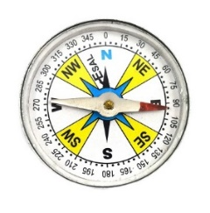
Compass Direction from Road (Check One)
N ____ NE ____ E ____ SE ____ S ____ SW _ X _ W ____ NW ____ 230°

Road Number from Siuslaw Road Map: NF-41
Measured Tree Circumference (inches): 122.5” = Diameter: 39”
(Circumference x 3.141 = diameter)
Estimated diameter of Typical Dominant (tallest) Trees (inches): ~26-30”
Place an X next to tree species present. Doug fir: X Hemlock: X Cedar:
Sitka Spruce: Alder: X Big Leaf Maple: X
Is a shade tolerant understory of Hemlock or Cedar present? Yes: No:
Describe understory:

Plants Identified
Huckleberry: X Salmonberry: X Thimbleberry: Blackberry: X
Elderberry: Vine Maple: Dogwood: Cascara:
Salal: X Ferns: X Moss: X Lichen: X Fungi:

Notes on other plants present:
Large rhododendrons present

Animals observed:
Birds Present:

Scrub jays heard
Notes:

___________________________________________________________________________________
Keeping Track of Your Forest Photos
Option 1: Before you take your forest photos, write down the forest visit name on the form and take a photo of the name. Then take the forest photos. Note that the photos after the forest visit name belong to that name.
Option 2: Take a screen shot while your GPS app is on before your forest and tree photos (I-Phone).

Optional (All information in the form will be viewable by the public)
Your Name:
City: State:

Insert Stand Photo (Optional)
ID/Name
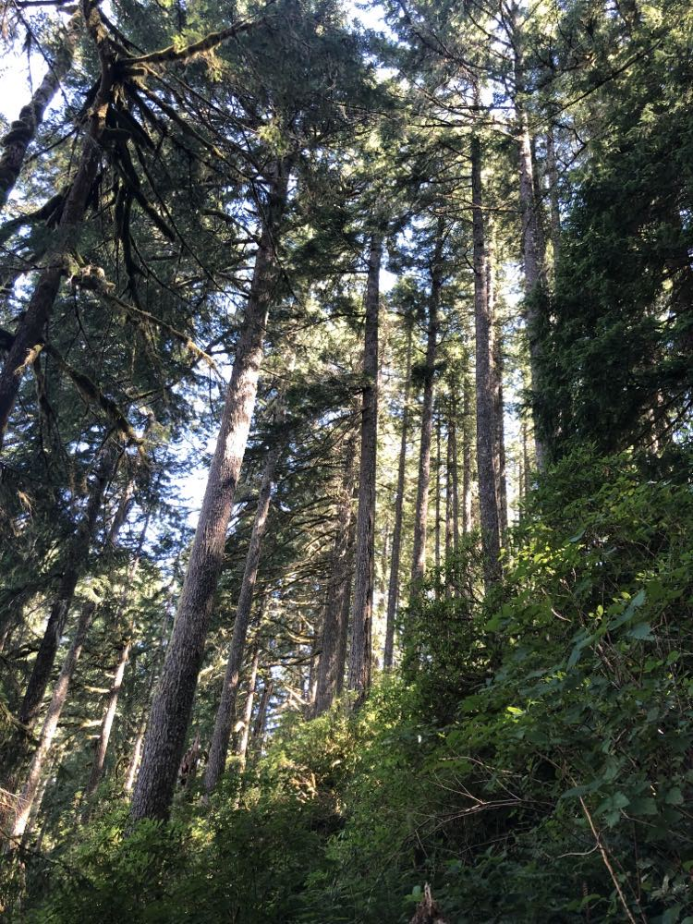

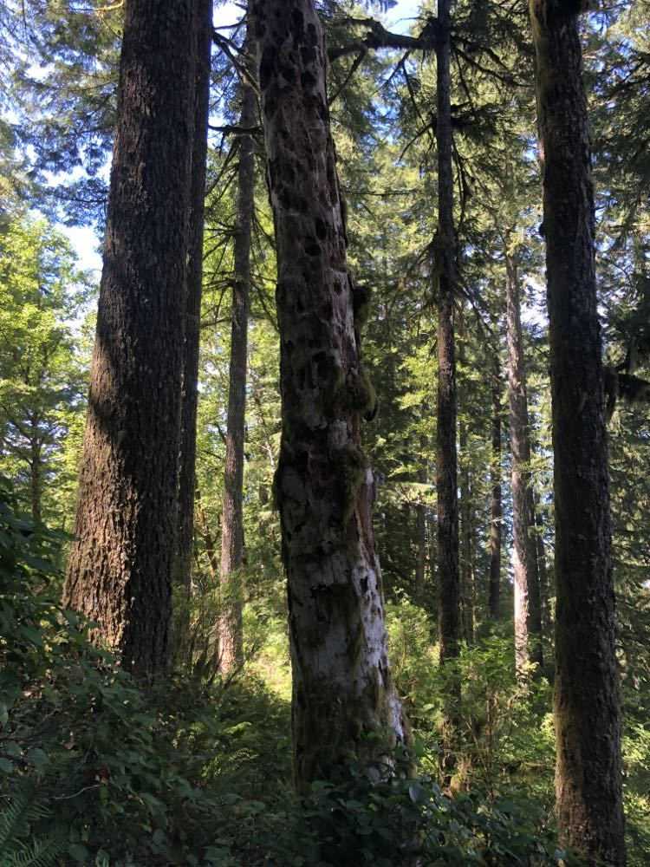
Insert Photo of the typical tree that was measured (Optional)
ID/Name: Note: tree measured is located on left (not the dead center tree)
Save the document as a pdf file for uploading to the Forest Service comment portal.
Wait for guidance from the CRA for writing your text comments placed into the comment portal.

