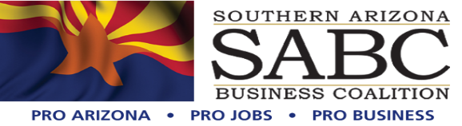

PO Box 57608 Tucson, AZ. 85732

520.247.3268

[www.soazbc.com](http://www.soazbc.com/)

June 10, 2024

Kerwin S. Dewberry, Forest Supervisor

Coronado National Forest   
ATTN: Hermosa Critical Minerals Project   
300 West Congress Street   
Tucson, AZ, 85701

**Subject**: Letter of Support for South32’s Hermosa Critical Minerals Project #65668

Dear Mr. Dewberry,

Thank you and your team in advance for your commitment and integrity to this arduous process on behalf of the over 10,000 employees directly and indirectly impacted by the mining industry here in Southern Arizona. The Southern Arizona Business Coalition (SABC), formed in 2012, stands for the responsible development of our human and natural resources.

SABC supports South32’s Hermosa project as the only advanced mine development project to date in the United States that could produce two federally designated critical minerals – manganese and zinc – both of which are essential minerals for powering the nation’s clean energy future.

By now I’m confident that you have received all the arguments for or against this project, but I want to focus on the human element of sustainability of families and the employment, by not only the mines but the families of vendors, local communities and our society as a whole and the misunderstandings of people opposed.

The endangered environment will not be the vegetation that will be relocated, not the animals that will instinctively more to another area and the safety they will understand as no one will be hunting near the mine and not the sacred lands and archaeological remains that will be preserved. The endangered species is the Americans that will be denied and opportunity to earn a respectable living to support their families in this region and the safety these people will be provided to do their assigned tasks.

For too long the anti-mining audience has projected unreasonable and unwarranted fears onto our society. Mining in the US is not only the most efficient but also the most regulated industry in the world. Importing our much-needed critical minerals from places that show very little concern for the safety of the people who work in their mines and with little or no regard for the environment.

South 32 is committed to people of the surrounding communities with investments in infrastructure and social services and non-profit organizations and education. Further South 32 has already shown their commitment to sustainable development and clean up of a previously mine area to the expense of over $30 million. And their commitment to utilizing the most up to date technology of water recycling, reducing the overall withdrawal of this valuable resource. The implementation of clean and renewable energy. These are just a few of the overall benefits to the population that will be positively impacted by this project.

Regardless of what we do in our professional careers, we are in the people business and the mining industry as evolved over the past 30 years to be one of the safest, most environmentally responsible industries here in the US. It time we all overcome our fears and look at the facts for what they are.

In closing we want to thank you for your consideration of our views as the Hermosa project’s scoping period continues. As we noted earlier, we truly appreciate professionalism and your hard work and efforts and look forward to being available to you should you have any need.

Sincerely,

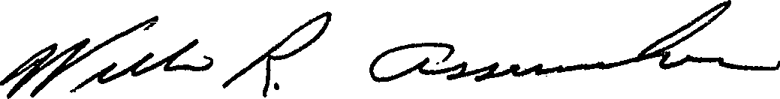 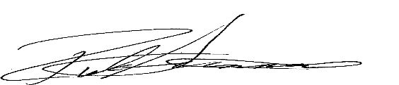

Co-Founder Co-Founder