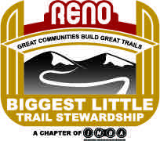

William Dunkelberger, Supervisor

Humboldt-Toiyabe National Forest

1400 Franklin Way

Sparks, NV  89431

[comments-intermtn-humboldt-toiyabe-carson@fs.fed.us](mailto:comments-intermtn-humboldt-toiyabe-carson@fs.fed.us" \t "_blank)

Dear William,

The Biggest Little Trail Stewardship (BLTS), Inc. (formally Poedunks, Inc.) is a Nevada non-profit corporation with a mission to build, maintain and advocate for sustainable trails throughout the greater Reno community. The BLTS Board of Directors voted to send a letter of strong support to Alternate #3 in the EIS Mt. Rose Ski Tahoe Atoma Expansions.

We strongly support **the proposed amendment to the Forest Plan** to restrict all future commercial development on the 3,446 acres of acquired Galena lands in the Carson Range. We support all proposed actions to maintain public access to and dispersed recreation uses, both winter and summer, in the 3,446 acres of acquired Galena lands, as well as, to the Atoma expansion site We believe the USFS preferred Alternative #3 best protects public safely and reduces environmental impacts to the Atoma site.

We thank you for the opportunity to give input on such an important issue in our local area.

Sincerely,

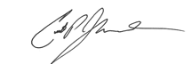

Curtis Johnson-President

poedunknv@gmail.com

775 232-8483