**Rethinking The Northwest Forest Plan:**

**Deteriorating Coastal Forests**

***Abstract***

*there was no viable way the government could meet its environmental obligations without major sacrifices to timber harvesting. President Clinton picked essentially the least bad option, one that would harvest the most timber while protecting the most habitat for native species. But no one really liked it: neither the loggers, the environmentalists nor the tribes.*

[***Roman Battaglia***](https://www.ijpr.org/people/roman-battaglia)Jefferson Public Radio

As a species, humans are thoroughly conflicted in their moral reasoning toward Nature and themselves. The cause of this condition seems to be competition among members of the society for status and resources versus competition among societies that require cooperation within a society. The consequences of these kinds of competition are conflict among competing ideologies within a group and between societies. President Clinton attempted to reduce the intensity of this competition with the Northwest Forest Plan in 1994. It presented a methodology to manage millions of acres across Washington, Oregon and Northern California.

The Plan had ecological and economic shortcomings but it gave both the social and natural sciences a chance to reflect and mature but it also brought a new element into the management problem. The curse of these competing human interests is emerging as a serious threat to the forest’s existence. The introduction of CO2 to the atmosphere by human activities is initiating a climatic warming trend. This brings a new issue to the Plan that is undergoing reconsideration and amendment. In this submission, a process is suggested that replaces the current “colonial unknowing” with an adaptive approach being demonstrated by administration on the Olympic Experimental State Forest in Washington State.

Life continues to exist because it is within and depends upon a changing environment. It makes no sense to consider an area as complex as the Northwest Forest without including human needs and wants into the proposed reconsideration. Isn’t the purpose of stewardship to use research to gain a better understanding of forest attributes so as to better administer its ecological and societal values?

If the goals of management of this vast forest are to sustain or improve the wellbeing of both the forest and related human communities then there has to be learning interactions between the two. If these interactions are to be approached scientifically, they must be defined, measured and monitored. Finally, wouldn’t commercialization be of secondary importance than acquiring knowledge to improve forest management along with the well-being of dependent rural communities?

**A Warning**

*Perverse outcomes can result from government policy decisions based on analyses that use an inappropriate accounting framework or inappropriate data.*

R.J Raison (Australian Forestry, 2024)

The quest for power is not a fertile political atmosphere in which to conceive, understand and implement innovative stewardship approaches. Nowhere is the intermixing of science and politics a more hazardous undertaking and more insight obscured than in the controversies around the stewardship of the public forestlands of the North American West. The task is further complicated by the fact that these administrative approaches must endeavour to understand, adapt with, and/or mitigate the adverse effects of climatic change on a broad range of forests!

The intermixing of science and politics is very serious and dangerous undertaking. Political economic concerns and agendas are almost always dangerous foes of the common interest. It is a risky combination with a bad history. As Alston Chase observed:

*"When the search for truth is confused with political advocacy, the pursuit of knowledge is reduced to the quest for power."*

Forest scientists and professionals should be cognizant of the history of this struggle, and be certain that what it shares with the public as knowledge is both disinterested and honest.

**Introduction**

The Coastal Forest (Pacific Northwest Coastal forests) seems like a mystical place, governed by ancient deities with their own set of rules. It's the House of Danu and Druantia where the magic connection between women, water and wisdom could thrive. Yet, while a mythology is still alive in the administration of the Coastal Forest bioregion, the ancient forest goddesses have been usurped by a doctrine originating somewhere, possibly late, in the Anthropocene Era, a new geologic epoch characterized by apparent human dominance over the Earth’s natural systems and governed by European man’s own unique folklore found in his Northwest Forest Plan.

This paper is a short chapter in the life-history of the West Coast’s great North American forest (Figure 1), which encompasses an area of about 30 million ha (74 million acres). It is not a happy story with a fairy-tale ending but one of ignorant use by the hand of European man. Primary victims in the arithmetic of environmental change in the Anthropocene are forests. Their attributes are at risk as they are a grand carbon sink, absorbing about 12% of total American emissions per year, but vulnerable to deforestation, degradation and disturbances triggered or intensified by climate change. Indeed, along with carbon sequestration, humans are attempting to maximize the benefits that forests provide without undo detriment to water and other ecosystem functions without really caring or understanding the complexities involved in their exploitation.

Temperate forests, which the Coastal Forest is but a sample, are some of the most intensively managed or mis-managed forests in the world. In mankind’s scramble to create modern industrial societies throughout the world, especially in North America, the forests were removed for homes, farms and towns. Orchards replaced them, their streams dammed for irrigation and power, while lakes were drained for farmland.

Confidence in technology redefined the North American landscape while the land was refining the human community itself. During the zeal of capitalist development; while reclaiming water and land from Nature in the creation of a modern state, the arrogance of these new North Americans led them to adopt a unique creed, summed up quite nicely by Maxwell Scott in his answer to Ransom Stoddard in the film, *The Man Who Shot Liberty Valance*.

*“This is the West, sir. When the legend becomes fact, print the legend.”*

**Creating a Myth: Expanding the Legend**

As every generation moved further west and became more American, more democratic, and more intolerant of hierarchy. They also became more violent, more individualistic, more distrustful of authority, less artistic, less scientific, and more dependent on ad-hoc organizations they formed themselves (Turner, 1920). When the North American frontier closed in 1890, another ‘frontier’ had to be created to sustain the American legend. Since the nation could not maintain its image of self without some kind of 'other' to encounter, challenge and/or vilify, the Spanish American War of 1898, then the Philippine-American War and the subsequent Moro Rebellion served these purposes. Then two World Wars almost fatally demonstrated that the American myth required modification, a different kind of “other”. It was President John Kennedy, in 1960, that created another ‘New American frontier’ of “…uncharted areas of science and space, unsolved problems of peace and war, unconquered pockets of ignorance and prejudice, unanswered questions of poverty and surplus”. This frontier, full of economic and social reforms, would serve as controversial targets for future generations of Americans to amend or dismiss.

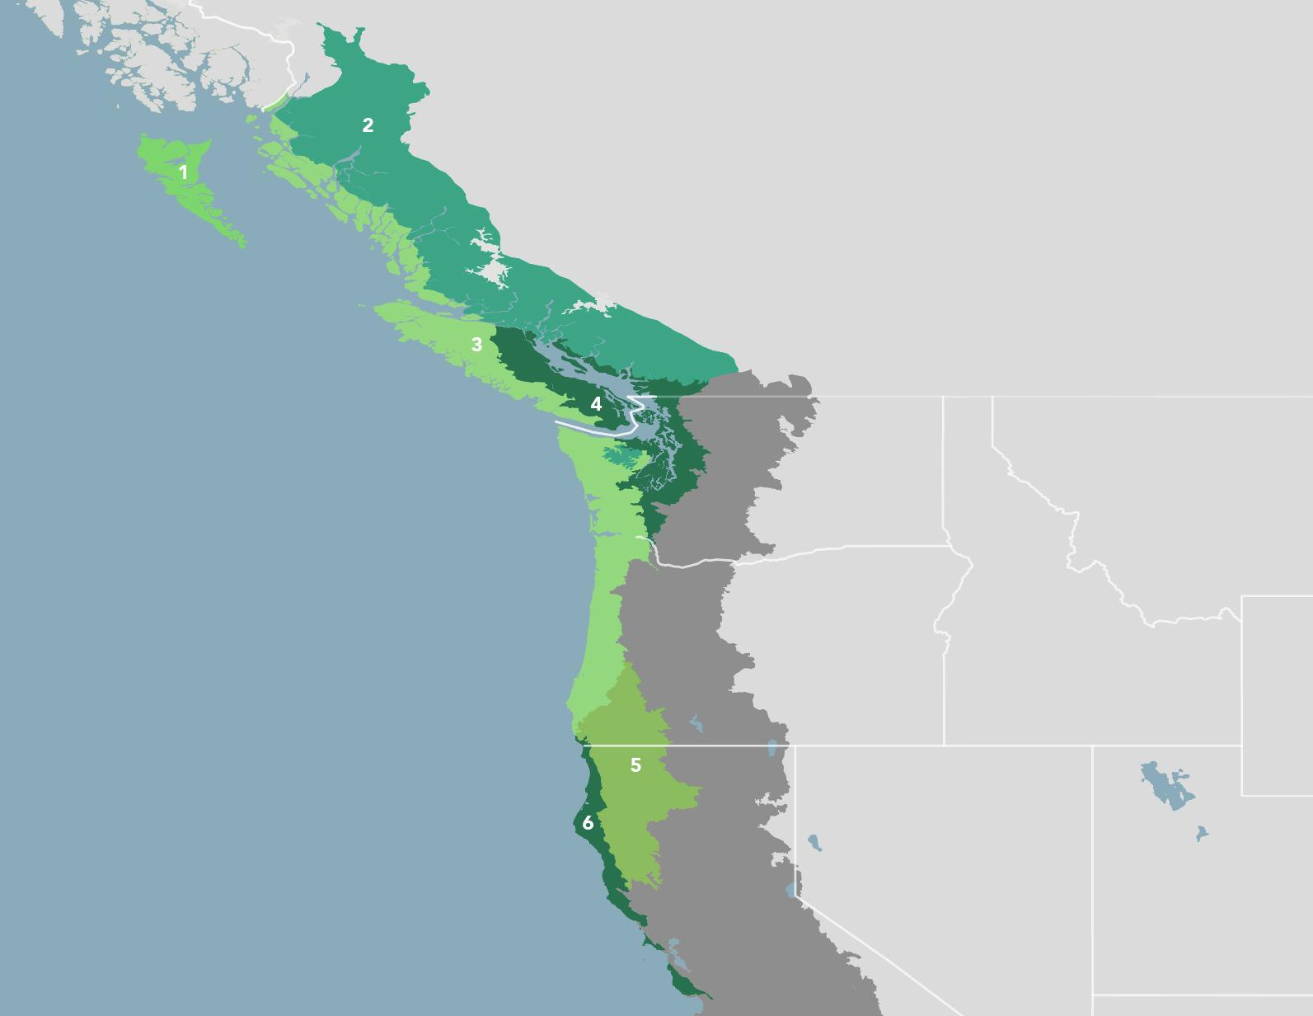

***Figure 1****. The Pacific Northwest Coastal Forests bioregion is part of the North Pacific Coast sub-realm and is made up of six ecoregions: (1) Queen Charlotte Islands Conifer Forests (2) British Columbia Coastal Conifer Forests (3) Central Pacific Northwest Coastal Forests (4) Puget Lowland Forests (5) Klamath-Siskiyou Forests (6) Northern California Coastal Forests.*

The legend of the ‘other’, unfortunately, served to establish even more fallacious beliefs. In the process of ‘civilizing’ the continent, colonists exploited areas containing what they deemed to be unlimited quantities of natural resources. They brought about both a rate and volume of change that proved beyond Nature’s ability compensate. Modern North American societies are destabilizing the Earth’s natural cycles. The process of the exploiting America’s natural attributes of mineral, petroleum and biological natural resources, a large portion of the ecologic dilemma confronting modern North American societies was created and punctuated by the continued over-use of ignorance, faith and false-beliefs. In the rush to re-create the land in the image of this new American frontier, forgotten was the relationship of the human-with-Nature. In the literature, this social exercise is called “colonial unknowing”. This is where the lessons acquired by Indigenous people co-habiting the continent with the land for thousands of years before the arrival of the colonials were ignored then forgotten.

Today, a student of Nature would wordsmith Scott’s quip:

*“This is the West, sir. Nature is reclaiming her own from man.”*

The time of decision is now. Yet, North American societies are just now in the throes of learning how little is actually known about the land and its forests.

**Frontier Forestry**

In a speech given to American Forestry Congress in 1905, Theodore Roosevelt said:

*“In the old pioneer days, the Americans had but one thought about trees, and that was to cut them down…”*

He went on to state:

*“…we have got a working agreement between the forester and the businessman whose business is the use of the forest. We have got them to come together with the understanding that they must work for a common end, work to see the forest preserved for use.”*

“Preserved for use.”  A partnership of short-sighted timber business and slow growing forests. This is the mathematics of a cycle of over-extraction and ultimate ecosystem collapse - frontier forestry. If timber extraction could be restricted to the rate of natural increase of an intact forest ecosystem, such a partnership could be sustainable. Yet, here in North America, a system of regional resource cycles of boom and collapse has historically emerged. It is now disguised as sustainable forestry. Indeed, sustainability may only be achievable only after the collapse of the biosphere and humans have flown away with the passenger pigeon.

The conventional explanation for troubled forest ecosystems has been climate change – hotter summers permitting more atmospheric water coupled with drier winters. In response, policies have been enacted to achieve “net zero”, so that economic activity would either generate zero CO2 emissions, or they are offset by human actions that sequester an equal amount of CO2. The unknown in this arithmetic is the fact that while the rising atmospheric carbon concentration is largely related to human socio-economic activities, archaic forest practices of frontier forestry, associated with the ignorant knee-jerk reaction of environmentalists, are aiding in hastening the processes associated with a warming climate. For example, untouched old growth natural forests are assumed to fix more carbon from the atmosphere than those that are planted or stewarded for multiple purposes. In the short term, the observation seems logical. Yet, as they become warmer and dryer, forest ecosystems, including “untouched” old growth, become less productive, absorb less CO2, which may signal an ecological directional change in vegetation composition.

During one of California’s worst recent fire seasons, the summer and fall of 2020, it was estimated that wildfire released 127 million tons of CO2 into the atmosphere, just behind the amount released by transportation in the state (Jerret et al, 2022). This figure was easily matched by estimates of carbon emissions during the 2025 Los Angeles area fires alone. On July 3, 2024, a wildfire - The Shelly Fire - in Siskiyou County, California, not far south of the Elliott State Forest near Coos Bay, Oregon, spread across about 4500 hectares (11,000 acres) of land owned by Ecotrust Forest Management (EMF). The investment firm stores carbon by protecting the trees on its land from cutting. The stored carbon by the company is used as carbon credits and sold to offset the harmful climate effects of emissions by industry. The fire has burned across about 11,000 acres of EFM’s 18,000-acre carbon storage project in Siskiyou County. The fire raised a number of questions including the viability of carbon storage projects in areas prone to high-severity fire.

For the moment, ignore the presence of Indigenous ecological knowledge and the suppression of its use, then forget the results of aggressive fire suppression, the employment of archaic forest practices and management strategies, then add some questionable carbon sequestration policies. Collectively, these pursuits have collectively produced large build-ups of vegetative fuels and brush-choked forest ecosystems that became warmer and dryer (MacDonald et al. 2023). Now, include the access, use and occupation of these Western forests by humans for any number of reasons that include housing and recreation. The resultant is a situation that could make the “Big Burn” resemble a campfire. Acceptable societal adaptation and mitigation strategies to this carbon-altered forest ecology depends upon the quality and appropriateness of data used to develop a proper societal response. Yet, a large majority of recent carbon mitigation strategies for the Coast Forest, including Oregon’s new so-called Elliott State Research Forest, are based on “leave forests alone” assertions associated with a false belief (Baumhardt, 2024).

**A Progressive Frontier**

The Anthropocene has become an important framework for thinking about the processes and consequences of environmental change. It is an era where the western Coastal Forest, although confronted by serious challenges, is still surviving after a year - 2024 - when the average Earth temperature rose 1.50 Centigrade above the pre-industrial levels of a period between 1850 – 1900. This is the limit set by the 2015 Paris climate accord, when 196 parties agreed to hold the increase in the global average temperature to well below 2°C and pursue efforts to limit the temperature increase to 1.5°C above pre-industrial levels by 2100.

Under an apparent indifferent federal leadership, the United States is no longer a member of this accord and is not bound by its word. Yet, over 1100 scientists from more than 32 countries are calling attention to the deteriorating Earth’s climate. When wildfires have grown so large that they create their own weather patterns; when their wells go dry because groundwater levels have dropped so low that families that have occupied the land for generations abandon their farm; when agricultural corporations take over those farms and drill deeper and deeper, simultaneously, bottling Fiji water into plastic containers produced from fossil fuels and selling them for $3 each to those thirsty farmers; there is an unbridled global human-environmental crisis!

Although the warming trend in the Earth’s climate is sounding the alarm, the world’s economy keeps growing as if ‘it is business as usual’. At the current pace, by 2050, energy demand is projected to be 47% higher than it is today. The demand of 12 different key minerals is also set to increase six-fold. A global economy, growing at the current pace, will be 33% larger after 10 years. In order to serve higher-order corporate, economic and political interests, governments are failing both in stewarding their lands and the trust of their people by ignoring or down-playing the changing trends in climate.

The British Columbian (BC), Canadian and, especially, the American governments are no blinding exceptions. Deforestation, forest degradation and land-use change are important sources of carbon to the atmosphere, resulting in about 15%–20% of current emissions (Katila, 2010). This observation is compounded as is a corresponding shrinkage in the forests’ ability to fix carbon as their area is reduced coupled as a warming, drying climate squelches tree growth and overall forest productivity.

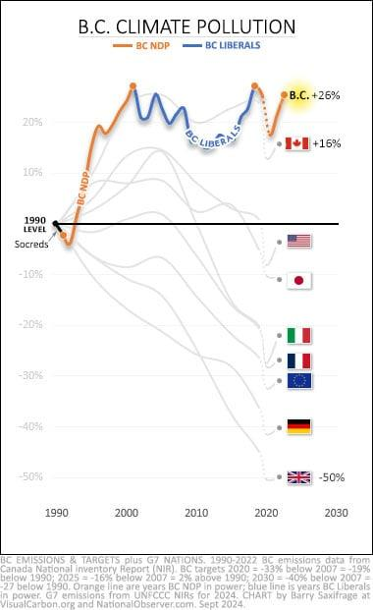

**Figure 2. Change in BC emissions since 1990**.

(Saxifrage 2025)

The figure above illustrates the change in BC emissions since 1990, colour-coded by party in power. It does not show the magnitude of the emissions, only the percentage increase or decrease. Saxifrage (2025) included the G-7 nations for comparison. Not only are governments insincere in their approach to climate, they are hypocritical in their administration of their own people and their natural resources.

Across the Coastal temperate rainforests in Western North America at least 15 tree species are suffering decline or die-back (Betzen et al. 2021). Augmented by out-dated forest administration policies, it seems that the warming trend in climate is contributing to the forests’ contraction. Like any large-scale transformation in a landscape pattern, concerns include reduced stream flows, reduced biodiversity, forest decline and lost local and regional income. These 15 or so tree species are all of ecological importance, but a few have disproportionate regional economic value. In Southeast Alaska and Coastal British Columbia (BC) warming winters are leading to reduced snowpacks and root exposure of Yellow Cedar (*Callitropsis nootkatensis*) which appear to be causing its decline (ABR Inc., 2018). While extirpation of the species is not foreseen in the near future (50-100 years), the questionable future of the species in Alaska and northern Coastal BC has ecologic, economic and social implications (Bisbing et al., 2019).

Further south, coastal studies have determined that Western Red Cedar (*Thuja plicata*) also is under threat from drying conditions. In 2017 and 2018, in BC, Washington, and Oregon, Western red cedar experienced “anomalously high mortality rates” (Andrus et al, 2023).

Closer to the California border, Douglas-fir (*Psuedotsuga menziesii* var. *menziesi*i) in the Klamath Mountains, are also in decline. Increasing Douglas-fir mortality in the Klamath Mountains raise concerns about the long-term resilience of Douglas-fir in the ecoregion along with increased potential for uncharacteristic wildfire. Exploring the physiographic and climate variables to the relationship with Douglas-fir mortality, Bennett et al (2023) show that at the landscape scale, Douglas-fir mortality increased as average annual precipitation declined and average climatic water deficit increased. They give evidence of a decline spiral in which Douglas-fir growing on warm, dry sites are stressed by drought then individuals and stands are subsequently invaded by other biotic opportunists like the flatheaded fir borer (*Phaenops drummondi)*.

Further south, in Coastal California, the iconic Redwoods *(Sequoia sempervirens*) are also undergoing changes. Save the Redwoods League has noted that climate trends seem to be inducing decline in the extreme southern and eastern portions of forest’s range where cutting has not occurred. Unfortunately, there may also be interactionswith other stressors that these ancient giants have never historically experienced. These irritants include invasive species, fire suppression, air pollution and habitat fragmentation.

For the last 50 years or so, when adapting to warmer and drier conditions, trees reacted as Nature intended them to do - they grew slower and less volume to conserve water. Unfortunately, for many individual trees, because drought increased their vulnerability to insects, disease and wildfire, the changing climate proved fatal (Andrus et al, 2023)!

Change and chance are significant features of all forested ecosystems. Still, the rate and direction of much of this current change is related or directly linked to human activities. So, it only follows that humans should act to slow and adapt to the biological transformation on-going in the Coastal bioregion. One would think that challenging and/or verifying the assumptions used in developing policies and procedures to mitigate and adapt to a changing climate would be fertile ground for biological research, especially, in areas where forest ecosystems appear in decline.

Ironically, as the decline in the Coastal Forest is occurring, a National Academies of Sciences, Engineering and Medicine (2002) report identified significant reversals in real forest and land research capacity, fragmented cooperation and poor communication among the principal providers and users of research, inadequate support of both foundation and emerging disciplines, and little strategic planning to address future land conditions both cultural and environmental. Evidence presented by M. Park et al (2023) suggests a stagnation in the number of meaningful papers since 1945, despite considerable annual growth in the rate of papers published. They suggest that scientists are less likely to break with the past to push science in new directions.  They conclude that this lack of disruption in the *status quo*, partially, to narrowing research areas and then argue that scientists are less likely to approach any topic holistically.

This potential shrinkage in holistic approach to problem-solving diminishes researchers’ capacity to bring new ideas and thought processes to evolving problems that could lead to breakthroughs, so familiar with disruptive efforts. Overall, the Academies’ results suggested that slowing rates of disruptive research may be a reflection of a fundamental shift in the nature of Western science and technology.

As forests are undergoing changes unlike any seen since the beginning of colonial human history in North America, the basic field research required for society to mitigate or adapt to this transformation is wanting. While there has been theoretical work on catastrophic shifts in simple ecosystems, it was focused on those far less complex than those found in the Coastal Forest. Knorr et al. (2024) observed that long-term soil warming in a temperate deciduous forest was related to significant soil carbon loss. On the other hand, soil nitrogen enrichment leads to significant soil carbon gain.

This has implications for both atmospheric CO2 emissions and soil fertility. It demonstrates that coupling two important global drivers of forest change results in a response that was not predicted by the behaviour of the single factors in isolation. While research work in simple ecosystems helps demonstrate that abrupt changes in response to stressors do occur, it does not predict results in more complex systems like a forest, nor does it aid society in mitigating, or adapting when negative changes are observed to occur.

The major mechanisms driving an ecosystem response to stress are related to how species interact with each other, with their physical environment along with the spatial structure of the ecosystem. Once a threshold, or tipping point, has been crossed, the collapse or shift is faster and of a greater magnitude than would be expected from past observations in the system.

**The Ecological Disruption**

At the beginning of the 20th Century, science was experimenting with the theories around vegetation succession and climax, its activities tended to support the present political ecologists’ notion that the ideal natural equilibrium occurred in mature forests. Of course, it was believed that this equilibrium had been disrupted on the continent by the arrival and ensuing activities of the colonists. In time, ecologists established that natural ecosystems, species, and populations continuously vary with or without human influence. There is no balance of nature and there never has been.

Yet, the balance of nature belief is still widespread and is at the base of the preservationist’s agenda along with the politics of forest ecosystem-based management (EBM). Subsequently, it was adopted as the reigning philosophy in administering federal forests in the United States and the lands of the Ministry of Forests in British Columbia.

During the 1990s, evolutionary biology demonstrated that the notion of an inherent natural tendency toward stability was mistaken. The view was changing to one of chaos and unpredictability in Nature. Landscape was now perceived as a number of big and little patches changing slowly, unequally, but continually through time, creating and responding to an endless set of perturbations and disturbances. Change and turmoil were now ecological tenets.

By this time, the political ecologic vision of the forest as a large continuous expanse moving toward some perfectly balanced climax condition was entrenched in the national environmental conscience while being institutionalized as policy on federal and provincial lands. “Gridlock”, controversy and the courts became the dominant features of public land administration in Western North America.

In this climate, the Northwest Forest Plan was hatched. It was a sad political baby that had unfortunate consequences: intrinsic rural unemployment and village destroying wildfire. On April 2, 1993, President Clinton made the following proclamation:

* How can we achieve a balanced and comprehensive policy that recognizes the importance of the forest and timber to the economy and jobs in this region, and how can we preserve our precious old-growth forests, which are part of our national heritage and that, once destroyed, can never be replaced?
* This is not about choosing between jobs and the environment, but about recognizing the importance of both and recognizing that virtually everyone here and everyone in this region cares about both.

The President then talked of five principles to be used in guiding the planning process

* First, we must never forget the human and the economic dimensions of these problems. Where sound management policies can preserve the health of forest lands, sales should go forward. Where this requirement cannot be met, we need to do our best to offer new economic opportunities for year-round, high-wage, high-skill jobs.
* Second, as we craft a plan, we need to protect the long-term health of our forests, our wildlife, and our waterways. They are a gift from God, and we hold them in trust for future generations.
* Third, our efforts must be, insofar as we are wise enough to know it, scientifically sound, ecologically credible, and legally responsible.
* Fourth, the plan should produce a predictable and sustainable level of timber sales and non timber resources that will not degrade or destroy the environment.
* Fifth, to achieve these goals, we will do our best, as I said, to make the federal government work together and work for you. We may make mistakes but we will try to end the gridlock within the federal government and we will insist on collaboration not confrontation.”

‘Gridlock’, controversy and the courts, along with decreasing forest health, were fundamental public rationales for enacting of the plan but the over-riding goal of the plan was to preserve old growth while protecting populations of the Northern spotted owl (*Strix occidentalis)* from extinction. Although adaptive forest management was courted in the plan, it was really not applied, even in areas where the approach was the focus. Major problems confronted efforts to undertake adaptive techniques. These derived from a complex set of factors including a risk-averse organizational culture; a restrictive legal-political environment; and inadequate training, staffing, and financial resources (Stankey et al. 2006). Further, did it really matter? Old growth was being protected and its spotted icon was safe. Or, was it?

There is considerable evidence that the northern spotted owl is adapted to a landscape mosaic of successional stages, not just untouched old-growth. While the owl’s use of early - successional forest conditions vary geographically throughout the Northwest, an interloper, the barred owl (*Strix varia*) is not so selective in its choice of habitat. Over the period of the plan, an increasing number of high - severity fires throughout the region appear to have denuded extensive areas of suitable spotted owl habitat and populations of northern spotted owls continue to decline as populations of barred owl flourish (Lesmeister et al. 2018).

Further, thirty years after the Northwest Forest Plan, historically timber-dependent communities in and near national forests continue to struggle. Thus, there is an important need to improve understanding of the interface of land, atmosphere, water, forests and humans. Then, from this knowledge, develop realistic stewardship practices and policies. It seems that was the original intention of developing adaptive management with the Northwest Forest Plan.

**Toward a New Reality**

Forestry and forest research are carried out to bridge the gaps of knowledge in forest science, but also addresses forest-related environmental issues and to provide solutions to conflicts between human economic activities and the ecology of the forest. Long-term studies such as the USDA-Forest Service’s Long-term Ecosystem Productivity network is a start. More is required and it has to be accomplished at the appropriate scale.

Research in Douglas-fir ecosystems suggests that the consequences of reduced precipitation during the growing seasons may be minimal in the southern Coastal Oregon region, but will depend on subsurface water availability, which is determined by soil hydraulic properties and soil and rooting depths. Temperature increases, on the other hand, expected from climate change in combination with increases in Vapour Pressure Deficit are likely to reduce forest productivity along with the ability to absorb atmospheric carbon regardless of soil moisture availability (Jarecke 2023).

Bennett et al. (2023) question the ability of the Klamath ecology to support Douglas-fir now and into the future. They suggest thinning to retain vigouous trees on favourable sites.  This action may improve their resistance to a host of pests along with abiotic damage associated with decline in this species. On harsher sites, they suggest removing declining Douglas-fir and favouring stands with a higher representation of pines, oaks and other more drought and fire-resistant species.

**Elliott State Research Forest**

Apparently, the officials in Oregon’s Department of State Lands could not resist reverting assumptions and allocating the Elliott to fighting ‘climate change’ before determining if it had the proper bio-equipment to engage in such a battle. State officials seemed to have assumed that “leaving the forest to Nature” would be preferable and more cost effective than research and testing Bennett’s et al. (2023) prescriptions on the ground. The decision allows Elliott the possible opportunity to participate in risky carbon trading business and potentially sell some form of carbon credits instead of growing timber for the market (Baumhardt 2024). Of course, decision-makers need to weigh incidents like the Shelly Fire when considering the viability of carbon storage projects in areas that are prone to high-severity fire like that of the Elliott. Another important consideration in forest management is people. Public forests are managed for people as well as trees,

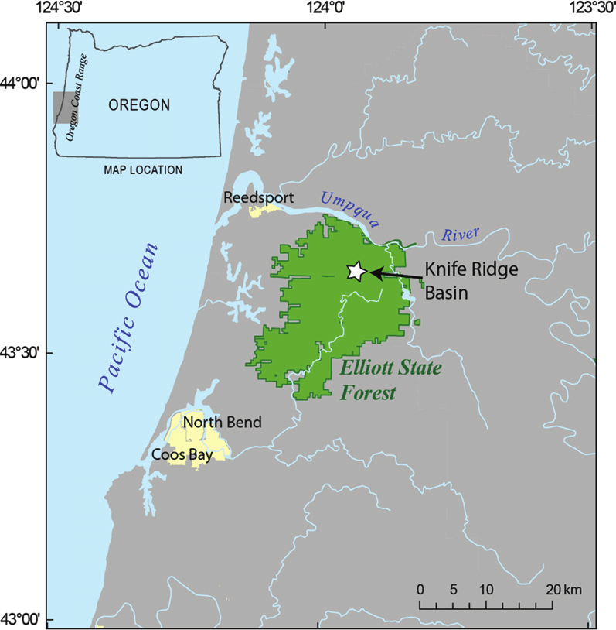

**Figure 3.** **The Elliott State Forest**, now the Elliott State Research Forest. The area of the Elliott has a documented history of catastrophic wildfire with major burns in 1868 and 1879, well before the carbon impacts of the industrial revolution.

**The Olympic Experimental State Forest (Figure 4)**

Although it was an unattained objective of the Northwest Forest Plan, there is considerable literature concerning adaptive forest management. There are only a few examples of successful implementation of the approach in North America. Not only did forest ideology but cost considerations also impeded its development. Further, there are barriers built into institutional and regulatory regimes that obstructed its initiation in most of the forests of the Northwest. Yet, the Olympic Experimental State Forest (OESF) in Washington State is implementing the concept in its research and forest management programs (Teply, 2008).

For adaptive management to be successful in the OESF approach, both practitioners and researchers need to work as a team with others from various disciplines. Further, their work is attempting to be inclusive of the local interested community. Bobsin (2023), a OESF researcher, is using a collaborative learning process where managers, researchers, tribes, and stakeholders engage with one another to ask and answer questions about options and effects of management choices. She used a concept from the field of ethno-forestry, or a people-focused forest management, as methodology to obtain input, knowledge, and feedback gained through a collaborative learning process to develop alternatives to include in the OESF’s T-3 Watershed Experiment.

Considering the escalating demands by people on the benefits of forests, there are a multitude of reasons to integrate environmental issues and economic development into the management process (Bormann et al. 2007). Driven by available funding, administrative efficiencies, and legal challenges by stakeholders on different sides, Washington department of natural resources’ (DNR)’s array of management options is limited. The OESF’s T3 Watershed Experiment was designed to use ethno-forestry to explore if DNR forest management options could be expanded.

Bobsin’s collaborative learning process was applied to bring together knowledge and ideas from participating researchers, managers, tribes, and stakeholders, with several possible innovations that appear to better reflect what people want from forestry without reducing net present value. The ecosystem wellbeing framework described in her research helped broaden the potential goals of management beyond standard conifer rotations and late seral habitat.

Ecosystem wellbeing consists of both community and environmental wellbeing with each given equal weight. Emerging environmental concerns, and the more specific social and economic concerns associated with community wellbeing are brought to the surface during a project’s scoping process. With experiments similar to the T-3 Watershed Experiment, the OESF is expanding reliance on site-specific knowledge and data while decreasing reliance on general data, opinions and assumptions. OESF researchers and stakeholders are learning to listen when the trees speak!

Adaptive management at the OESF is aiding in the movement away from a Frontier forestry, founded in a modern mythology and rules-of-the-thumb, to one grounded in metrics, science and community participation. This is leading toward a forestry where scientific research, community participation and monitoring come together. Knowledge is obtained and applied to improve stewardship through an adaptive management process that uses forestry techniques and practices as sources of learning, which in turn can be applied in subsequent activities.

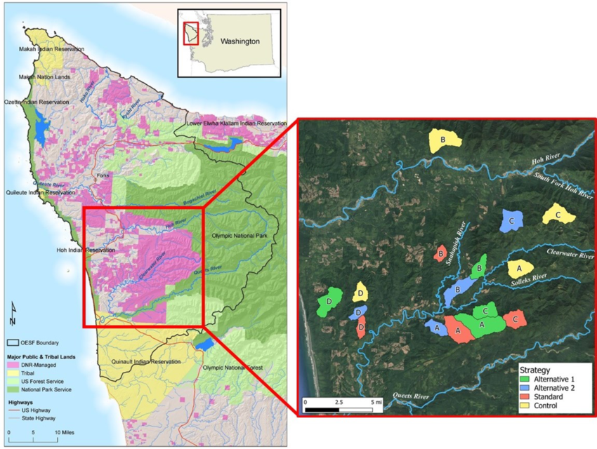

**Figure 4. The Olympic Experimental State Forest** and its 16 experimental watersheds grouped into four blocks with randomly assigned, watershed-scale, strategy treatments.

There seems to be an increasing concern about long-term productivity in our western forests.  The current scarcity of relevant scientific evidence contributes to the skepticism about current forest practices. This potential lack of trust in public land stewardship implies greater control of forestry activities on public lands will be more political and increasingly determined by the courts. Thus, in 1988, some thirty years before Bobsin started her work, the Pacific Northwest Research Station started a new research program concerning the long-term productivity of forest ecosystems (LTEP).

OESF became a partner in the research along with Oregon State University, the Department of Natural Resources of Washington State, Western Ecology Branch of the Environmental Protection Agency, University of Oregon, and Western Washington University. Together, they initiated a program of short- and long-term, basic and applied research, including a 200-year experiment, covering about 120 to 250 ha on each of five sites in western Washington and Oregon (total area of 1650 ha). Three of these sites are in the Coastal Forest: Olympic Peninsula, Oregon Coast and the Coastal Siskiyous.

LTEP was the result of the recognition that some forest processes engage only at the landscape scale and over long temporal scales. This experiment is trying to evaluate the 200-year effects of plant-assemblage and woody-debris changes on soil properties linked to productivity, and on their actual net primary productivity and diversity. The weakness of the study, if there is a weakness, is that the human community element found in the OESF’s T3 Watershed experiment was not part of the LTEP experimental design.

Combining adaptive natural resource management with environmental and livelihood considerations of the concerned public would significantly aid in reducing conflict while improving the understanding the biological and economic implications of large-scale processes brought on by changing climate trends. The blending and extension of the processes being undertaken on the OESF, first to the Coastal Forest bioregion, then to the rest of the Northwest Forest, as knowledge and consensus improves. With this approach, not only would there be a process beginning to address the adverse ecologic and social implications associated with out-dated management practices but adaption and/or mitigation strategies to changing trends in climate would be developing.

**Conclusion**

The Coast Forest is currently facing rapid changes that are tending to push social and ecologic systems towards conditions where their historic relationship with Western society can no longer be sustained. The challenge is to achieve a balance between these systems and, simultaneously, secure ecological resilience while avoiding social disruption and insecurity. The OESF has demonstrated a process that shows an excellent possibility of successfully meeting this challenge.

**Walt Whitman in his** *Song of the Redwood Tree, (1874)* **speaks of the alternative:**

*A CALIFORNIA SONG!*

*A prophecy and indirection—-a thought impalpable, to breath, as air;*

*A chorus of dryads, fading, departing—or hamadryads departing;*

*A murmuring, fateful, giant voice, out of the earth and air,*

*Voice of a mighty dying tree in the redwood forest dense.*

*Farewell, my brethren, Farewell,*

*O earth and sky—farewell, ye neighboring waters;*

*My time has ended, my term has come.*

If Western North America’s forests and their dependent industry are to survive, maybe, even flourish during the second half of the 21st century, not only does society have to reverse the ‘colonial unknowing’ process but build ecological and economic policies founded in scientifically determined facts, tested initially then discarded in the first iteration of the Northwest Forest Plan and now ongoing at OESF through adaptive forest management; not beliefs, assumptions and myths. Employing an adaptive landscape approach, human activities and their institutions are viewed as an integral part of the forest system rather than as separate entities.

The constructive interplay of society and the environment in governance and institutions for both people and Nature depends on both the understanding of ecological science and the perceptions and attitudes between individuals and groups of stakeholders to adapt old or create new and positive solutions. For this to occur, it will require the replacement of the current forest mythology with comprehensive interdisciplinary forest research results. This could prove to be the important foundation from which a progressive relationship with Nature is created and a sustainable forest sector is established.

**References**

ABR, Inc – Environmental research and services.  2018. Population status, threats, and persistence of Yellow Cedar in Alaska. Alaska Department of Fish and Game. 39 pages

Andrus, R.A, Peach, L, Mills, B.R., Cinquini, A.R., Yusi, J.T., Buhl, C., Fischer, M., Goodrich, B.A., Hulbert, J.M., Hotz, A., Meddens, A. J. H., Moffett, K. B., Ramirez, A., Adams, H, D. 2023. Canary in the forest? Tree mortality and dieback of Western redcedar linked to drier and warmer summer conditions. 39 pages

Baskent, E.Z., and Keles. 2005. Spatial Forest Planning [*Ecological Modelling*](https://www.sciencedirect.com/journal/ecological-modelling)*,* [Volume 188, Issues 2–4](https://www.sciencedirect.com/journal/ecological-modelling/vol/188/issue/2), 10 November 2005, Pages 145-173

Baumhardt, A. 2024. Plan for Elliott State Forest would put its 83,000 acres into fighting climate change. *Oregon Capital Chronicle,* August 19, 2024

Bennett, M., Shaw, D.C., and Lowry, L. 2023. Recent Douglas-fir mortality in the Klamath Mountains ecoregion of Oregon; evidence for a decline spiral. *Journal of Forestry* 121:3 Pages, 246 - 261

Betzen, J., Ramsey, A., Omdal, D., Gregory J. Ettl, G.J., Tobin, P.C. 2021. Bigleaf maple (*Acer macrophyllum* Pursh) decline in western Washington, USA. [*Forest Ecology and Management*](https://www.sciencedirect.com/journal/forest-ecology-and-management) [Volume 501](https://www.sciencedirect.com/journal/forest-ecology-and-management/vol/501/suppl/C), 1 December 2021

Bisbing, S., Buma, B.J., Oakes, L.E., Krapek, J., Bidlack, A.L. 2019. From canopy to seed: Loss of snow drives directional changes in forest composition*. Ecology and Evolution* 2019; 9: 8157-8174

Bobsin, C.R., Bormann, B.T., Miller, M.L., Pelach, B.D. 2023. Perspectives: Ethno-forestry, ecosystem wellbeing, and collaborative learning in the Pacific Northwest. *Forest Ecology and Management* 529

Committee on National Capacity in Forestry Research. National Academies of Sciences, Engineering, and Medicine. 2002. National Capacity in Forestry Research. Washington, DC: The National Academies Press. https://doi.org/10.17226/10384.

Dakos V, van Nes EH, Donangelo R, Fort H, Scheffer M. 2010. Spatial correlation as leading indicator of catastrophic shifts. *Theor. Ecol*. 3, 163– 174. (doi:10. 1007/s12080-009-0060-6)

Jarecke, K.M., Hawkins, L.R., Bladon, K.D., Wondzell, S.M. 2023. Carbon uptake by Douglas-fir is more sensitive to increased temperature and vapor pressure deficit than reduced rainfall in the western Cascade Mountains, Oregon, USA. *Agricultural and Forest Meteorology* 329: 1-15

Jerrett, M., Jina, A.S. and Marlier, M.E. 2022. Up in smoke: California’s greenhouse gas reductions could be wiped out by 2020 wildfires. *Environmental Pollution:* Vol 310: open access

Katila, P., Galloway, G., Mery, G., de Jong, W., Hetemäki, L., Alfaro, R.I., Varjo, J. 2010. *Policy brief Making forests work for people and nature – Responding to global drivers of change.*  International Union of Forest Research Organizations’ Special Project on World Forest, Society and Environment

Knorr, M. A., Contosta, A. R., Morrison, E. W., Muratore, T. J, Anthony, M. A., Stoica, I., Geyer, K. M., Simpson, M. J., and Frey, S. D. 2024. Unexpected sustained soil carbon flux in response to simultaneous warming and nitrogen enrichment compared with single factors alone. *Nature Ecology & Evolution* - Volume 8: December 2024: 2277–2285

[Gleason](https://forestnet.com/author/sydney-gleason/), S., [2024](https://forestnet.com/category/timberwest-magazine/2024/). Where did the Northwest Forest Plan go wrong? Oct 29, 2024, [September/October 2024](https://forestnet.com/category/timberwest-magazine/2024/september-october-2024/), [*TimberWest Magazine*](https://forestnet.com/category/timberwest-magazine/)

Lesmeister, D.B., Davis, R.J., Singleton, P.H., and Wiens,J.D. 2018. Northern spotted owl habitat and populations: status and threats. In: Spies, T.A., Stine, P.A., Gravenmier, R, *et al*. (Tech Coord). Synthesis of science to inform land management within the Northwest Forest Plan area. Portland, OR: USFS, Pacific Northwest Research Station. Gen Tech Rep PNW-GTR-966.

MacDonald, G., Wall, T., Enquist, C.A.F., LeRoy S.R., Bradford, J.B., Breshears, D.D., Brown, T., Cayan, D., Dong, C., Falk, D.A., Fleishman, E., Gershunov, A., Hunter, M., Loehman, R.A., van Mantgem, P.J., Middleton, B.R., Safford, H.D., Schwartz, M.W. and Trouet, V. 2023. Drivers of California’s changing wildfires: a state-of-the-knowledge synthesis. *International Journal of Wildland Fire* 32(7) 1039-1058. [**https://doi.org/10.1071/WF22155**](https://doi.org/10.1071/WF22155)

Raison, R. J. 2024. A review of the impacts of sustainable harvesting, non-harvest management and wildfire on net carbon emissions from Australian native forests*. Australian Forestry*, DOI: 10.1080/00049158.2024.2433815

Stankey, G. H.; Clark, R. N.; Bormann, B. T., eds. 2006. Learning to manage a complex ecosystem: adaptive management and the Northwest Forest Plan. Res. Pap. PNW-RP-567. Portland, OR: U.S. Department of Agriculture, Forest Service, Pacific Northwest Research Station. 194 p.

Teply, M., 2008. Olympic Experimental State Forest Research and Monitoring Program. Washington State Department of Natural Resources. <https://www.dnr.wa.gov/oesf>

van Nes E.H., Scheffer M. 2005 Implications of spatial heterogeneity for catastrophic regime shifts in ecosystems*. Ecology* 86, 1797–1807. (doi:10.1890/04-0550)

**About the submittor:**

**William L. Wagner, PhD**

**Education:**

**BSc, Forestry, University of California, Berkeley, CA**

**MA, Forest Resources Management, University of Victoria, Victoria, BC**

**PhD, Forest Resources Management, University of Victoria, Victoria, BC**

**Experience:**

**Worked as a presale forester for a private company in California; as forestry intern for the US Army and timber manager at Fort McClellan, Alabama; as a presale forester for the USDA-Forest Service at Quinault Ranger District, Olympic National Forest; Forest Manager, Makah Indian Nation, Neah Bay, Washington; Economist, T.M Thompson Consultants, Victoria, BC; Owner/researcher, Wild Land Wood, Alert Bay, BC; Model Forest Co-ordinator, Pacific and Yukon Region, Canadian Forest Service, Victoria, BC; Forest Economist, Canadian Forest Service, Victoria, BC. Presently an independent research forester in Victoria, BC.**