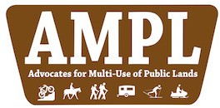
PO Box 11478
Jackson, WY 83002 amye@teamampl.org 307.214.8126
Friday, April 17, 2020

RE: Nez Perce- Clearwater NFs Forest Plan Revision #44089
AMPL strongly supports Alternative X as described in the DEIS. As a non-profit group supporting motorized and mechanized recreation, we advocate for increases in recreation opportunities as outlined in Alternative X.

We also believe this forest has more than enough wilderness already. We do not support increases to the Wilderness Preservation System as it locks far too many users out.

We also believe the creation of special management areas such as the one being created for the Great Burn allows for the greatest amount of flexibility to ensure conservation and recreation can co-exist.

We strongly support the preservation of the Pot Mountain and Rawhide areas for OSV use.

We would also call to your attention the need for more motorized recreation in this forest and agree with statements in the DEIS that there is a need for increased opportunities for the motorized community.

We would also ask you to not decommission any roads or trails within the forest.

As well, we believe the Forest Service should develop a standard providing for the loss of a motorized trail with the addition of a new trail in a different area of the forest.

We thank you for this opportunity to provide feedback on forest.

Sincerely,
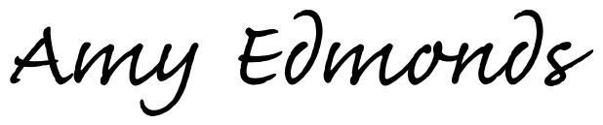

Amy Edmonds, Executive Director, AMPL

