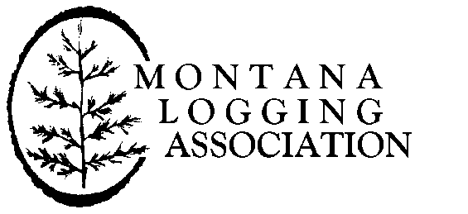

December 22, 2024

Director, Ecosystem Management Coordination

201 14th Street SW, Mailstop 1108

Washington, DC 20250–1124

**RE: Notice of intent to prepare an environmental impact statement (EIS) on Land Management Plan Direction for Old-Growth Forest Conditions across the National Forest System, 88 Fed. Reg. 88,043 (December 20, 2023).**

Dear Sir or Madame:

On behalf of the Montana Logging Association (MLA) and its members, thank you for accepting this comment regarding the Forest Service’s proposed amendment to 128 national forest land management plans to protect old growth. MLA is Trade Association that represents 450 family owned/operated businesses in the harvesting/transporting of wood products in Montana. A number of our member’s partner with the U.S. Forest Service and Bureau of Land Management using their expertise, employees and equipment to achieve forest management goals.

The Forest Service should reconsider the current proposal of amending 128 Land Management Plans through a single Environmental Impact Statement developed in less than a year. This approach risks undermining public trust and confidence in the agency, the science it is relying on to inform its management approach, and any policy outcome around old growth.

Our national forests are dynamic systems, not static. Our forests can change dramatically ecologically across one National Forest, let alone all the forests currently under USFS and BLM management. To implement a blanket EIS covering all national forests is a recipe for disaster. Criteria for old growth vary substantially among forest types and the locally led forest planning process is the most appropriate way for the Forest Service to develop conservation strategies for old growth forests. Major forest policy decisions should be accomplished through robust local engagement and public participation, not through a top-down directive from Washington, D.C.

The direction for old growth has been included in forest plans since the very first plans in 1984 and new direction for old growth management and conservation is being updated as Forest Plans undergo revisions. The Department has demonstrated no compelling need for change that justifies the proposed nationwide plan amendment. There is no evidence that additional “consistent” standards and guidelines for old growth will be more effective than the 2,700 existing plan components in meeting that purpose. The Forest Service has not demonstrated a “need for change” that necessitates an unprecedented effort to revise all 128 Forest Plans in the space of less than 13 months.

The Forest Service has determined that the most significant threat to old growth is wildfire, insects, and disease. So, any national forest amendment process for old growth should focus on increasing science-based, active forest management to address our wildfire crisis, and to make our forests healthier and more resilient. Any final amendment must provide clear direction and specific recommendations for active forest management within and adjacent to existing old growth stands to protect them from these threats.

MLA believes that the extensive system of reserves (Wilderness Areas, Inventoried Roadless Areas, National Monuments, etc.) on the National Forest System and the existing 2,700 distinct plan components dealing with old growth forests is more than adequate to ensure that the Forest Service meets the “distinctive and key role in providing the nation with benefits related to national forests and grasslands within the broader landscape, including old growth forest conditions.”

The USFS and BLM should focus on accelerating active forest management on federal lands to reduce the risks of severe wildfires and to improve our forests’ resiliency to fire, insects and disease, and to adapt these landscapes to the impacts of climate change. At a time when we need more management on fire-prone federal lands, this is a formula for more bureaucracy and red tape that further ties the hands of our public lands managers. The worst thing we could do during a climate crisis is to walk away from our public lands and decide not to use the tools available to help adapt these lands to changing conditions and reduce the risk of catastrophic wildfire.

Thank you for this opportunity to comment regarding the Forest Service’s proposed amendment to 128 national forest land management plans to protect old growth. We reiterate our commitment to working with the Forest Service and BLM to help address our nation’s wildfire and forest health crisis. Our members play an invaluable role in climate change mitigation through science-based, active forest management. We strongly encourage the Administration and federal land management agencies to prioritize and focus on action-based solutions to restore forest health, reduce the risk of catastrophic wildfires, and protection communities and public health.

Sincerely,

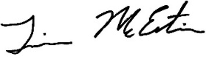

Tim McEntire

Northwest Region Representative

Montana Logging Association