Attn: Russell Bacon, Forest Supervisor for the Medicine Bow-Routt National Forests and Thunder Basin National Grassland.

Comments on the draft environmental impact statement (DEIS) analyzing the effects of a proposed action and three alternatives to change prairie dog management on the Thunder Basin National Grassland, located in eastern Wyoming.

This Forest Service Draft EIS is a more thorough document than what was presented in the past. There are parts that are covered well and in depth. But: The document does not address the same concerns that have caused issues in the past nor does it offer a satisfactory solution to deal with ongoing issues.

The following are the areas the draft EIS is lacking in depth and perception and does not present mitigation for the issues of concern: Protection of Grouse and Big Game Habitat; Minimizing Encroachment and Negative Economic Impacts to the Landowners; Protection of the Grasslands Agriculture; Common Sense on the ground “real” solutions for proper range management; Cost of Implementing the proposed plan amendment; and how is the Viability of a Species determined, what is the population of such to ensure viability of those in short-grass ecosystems, among other issues.

Pages quoted are from the Draft EIS via hard copy not as numbered on a computer.

The proposed plan amendment:

1. Does NOT offer any protection to the **sage grouse** core area nor the Big Game habitat from fragmentation and destruction caused prairie dog (p/d) colonization.
   1. There are no buffers or barriers to protect the outer boundaries from prairie dog (p/d) infestation
   2. There are no buffers, barriers or plans to prevent prairie dogs (p/d) from encroaching upon leks
   3. There are no plans to remove the prairie dogs that currently reside within sage grouse core area habitat. The p/ds are destroying the sage brush habitat to such an extent that the sage brush is forever removed. The rodent kills the roots not just the stem above ground and is much more destructive than fire is for the sage brush ecosystem.
   4. Prescribed fires are still going to be allowed within sage grouse core habitat if it overlaps with the lines drawn for p/d management areas.
   5. The rodenticide the Forest Service prefers to use for treatments is highly toxic to avian species. Just a .1 oz of the zinc phosphide is toxic to a ¼ pound bird and the rodenticide is placed on top of the ground within easy reach of the sage grouse. The anticoagulant (Rozol or Kaput) are placed inside the p/d burrow out of reach of sage grouse and this rodenticide takes 1.1 pounds to kill a ¼ pound bird.
   6. How does the Forest Service proposal-in any alternative-offer any protection for the sage and prairie grouse? Uncontrolled pd colonies will infest grouse core habitat if they are within migration distance so what is the Forest Service actually doing on the ground to protect the sage and prairie grouse habitat from current and future destruction?
   7. Pg. *132* ***``One third of management area 3.67 is designated as greater sage-grouse priority habitat management area in the Grassland plan. There are four active leks currently in management are 3.63; however, plan direction does not conflict with the greater sage-grouse amendment…” “Change in the size, distribution, and total extent of prairie dog colonies has not been shown to have a measurable effect on greater sage-grouse populations on the TBNG.”*** This is NOT true! The Forest Service goes on to state that the total observed extent of p/d colonies is less than 8% of the greater sage-grouse priority habitat management area and typically is less than 6%. The total observed extent of p/d colonies used to be around 1-2% at the most but after the Forest Service’s mismanagement the amount of destruction of grouse core habitat has increased significantly. With the allowance of p/d to continue to colonize within and encroach upon grouse core habitat the increase impaction to the threatened bird will go up annually until the total acreage affected is in double digits and still growing. The importance of the management of the p/d and protection of the grouse core habitat must not be diminished by stating it is ONLY 8 %; as the p/d increase so does the destruction of core grouse habitat which will not grow back! More of this issue is addressed later in this document.
2. There must be the same protection given to Big Game management areas within the TBNG (Thunder Basin National Grassland). The Forest Service continually decreases the Big Game management areas in favor of short grass prairie ecosystem. There used to be many deer, antelope and elk seen throughout the Miller Hills, Rochelle Hills, Red Hills and in the various management areas split up by the Forest Service. One of the main reasons the big game has decreased in the area is the lack of forage available due to the prairie dog infestation. The Big Game management areas should be restored to previous levels and the future fragmentation and destruction of Big Game habitat by the encroaching p/d must be stopped. The removal of all p/d from within existing Big Game areas and the prevention of future destruction by p/d should be included in any TBNG management plan. Hunters spend thousands of dollars within each County and the State of Wyoming. To decrease this utilization for the sake of increasing the colonization of an agricultural pest hurts both the counties and the State of Wyoming’s income levels.
3. How do these plans minimize **encroachment** onto neighboring lands within the entire Grasslands management area?
   1. The Forest Service stated they will not manage p/d Grassland wide but it is because of past mismanagement by the Forest Service there are so many pockets and colonies of p/d throughout the Grasslands.
   2. The Grasslands is approximately 533,000 acres and yet the Forest Service proposes to seek to manage only a small part of the total area in the proposed alternatives.
   3. In the Alternative 2; The other pd colonies throughout the entire Grassland would be ignored and allowed to expand if there were 10,000 acres of pd within 3.67. If the Forest Service needed p/d colonies to add to those in 3.67 in order to achieve the 10,000 acres then satellite colonies would be added-only until the 10,000 acre quota was reached. What about all the other pd colonies outside of 3.67 and not needed for satellite colonies? There is no plan to manage these colonies at any time, boundary management might occur, or density control but ONLY IF the area was deemed a priority for treatment; otherwise the p/d colonies throughout the Grassland would be allowed to expand unmanaged as before. This will cause the landowners to again have to shoulder the costs of managing unwanted p/d that are constantly infesting their lands from neighboring Forest Service managed lands and to deal with lack of forage on their paid for federal allotments.
4. There is no solution for the **economic hardship** that is predicted for the neighboring landowners and allotment lessees if p/d are allowed to encroach upon neighboring lands and desecrate allotment forage. Why are the landowner’s economic costs not itemized and shown with real figures as to a loss and why has the Forest Service not offered compensation, mitigation, real solutions to prevent and minimize the economic loss to the landowners within the Grassland.
   1. If a colony is treated for density control, why only 50% of it will be treated? This is a waste of time and money because if the pd population is so dense as to require treatment then placing rodenticide on only half of a colony will only allow the untreated area of p/d to expand and migrate readily into the treated area which solves nothing. If the p/d are so dense they are migrating onto neighboring lands or eating too much forage then a 50% treatment will not help stop the damage caused or lessen the migration from such a colony. When you have a house or barn with lots of mice does treating ½ of the area really make an impact? Of course not, in a short while everything is back as it was before treatment.
   2. The Draft EIS states in many ways this plan will negatively affect the landowners thru: the loss of AUMS, requirements for extra feed, leasing of other pastures to cover lack of forage on allotments, cutting of herds by the landowners due to lack of feed, rodenticide costs, to mention a few; but where is the breakdown of what it will cost just one landowner where the proposed 3.67 is to be? What about the economic impact throughout the Grassland on all the other landowners where the p/d will not be managed effectively to stop the forage loss and infestation on their lands and allotments? There are no charts or costs associated with these so the public can understand the true loss to the landowners.

**Boundary Control:** When the p/d juveniles migrate twice a year at an average distance of 3-6 miles just how effective is a ¼ mile or 1/8 mile boundary? The proposed boundaries are not continuous and any break in a boundary control area would just funnel more rodents into the area “being protected from” encroaching p/d. When there is an area of non-treatment and the p/d travel thru then the infestation onto the private lands is much greater than a straight frontal assault. Any attempt at boundary control must not have “open gates” of non-treatment areas for the rodents to pass through. The Forest Service will not treat the other infested lands outside of the “conservation” area so the federally managed lands become a three-prong infestation source to invade the neighboring private lands.

Pg 115, ***Discussing Effects to Reintroduction of Black-Footed Ferret: Alternative 1 Current Plan``Requirement 4, resources in place to conduct boundary control efforts:***  ( It has been shown that)***…… boundary control has not been effective during population expansions.“*** So if it has not been effective before how is this actually changing this time around? At this time the only rodenticide cleared for use on federally managed lands within the TBNG is the zinc phosphide. After 2-3 years the p/d will not eat it so then what???



The use of all rodenticides including: zinc phosphide; both anti-coagulants, Rozol and Kaput; and the fumigant, aluminum phosphide should be available for use in any area. This is because the zinc phosphide bait used for p/d causes the rodent to get instantly ill so if they have not eaten enough to kill them the rodent will become bait shy. The Rozol anticoagulant does not cause instant sickness so they do not relate the rodenticide bait with their illness. Also, the Rozol can be used in the same area again during the same treatment window for clean-up after the initial rodenticide use. Zinc phosphide can only be used one time in each area per treatment window or season.

The fumigants could be used as a cleanup in areas set for eradication if no burrowing owls are present.

Pg.19: ***``Encroachment of prairie dogs onto private and State lands could impact forage availability for livestock production on private and State land.”*** Areas outside the 3.67 and any satellite colonies will not be mapped and monitored unless there is left over funding and will not be managed with rodenticide unless the area is prioritized and there are no other species of concern present. Except for the Grassland wide proposal none of the other alternatives address this Grassland wide concern satisfactorily-again assuming all rodenticides could be utilized.

**Eradication:** The only mention of eradication is the proposal to eradicate a colony(ies) within the 3.67 management area if there are over the baseline quota of pd desired within the 3.67 management area. If there are 10,000 acres of pd within the area the eradication of an unconnected colony will not have much long -term effect on the total management because the migration of 10,000 acres of active p/d will continue to re-inhabit the area that was treated for eradication.

The removal of colonies of pd is effective if: there is not another active colony connected to the planned colony for removal ; if there is not another active colony within a short migration distance away from the colony planned for eradication, if the neighboring landowner controls the p/d at the same time for eradication and both parties continue the treatments, as needed thru annual monitoring.

The removal of p/d colonies should be prioritized : 1-those areas that constantly repopulate the 1-mile residence buffer; 2-those areas that constantly infest neighboring lands; 3-those colonies that are within grouse core area habitat and encroaching upon grouse habitat and leks and infesting big game habitat. The removal of large areas of p/d from within the Grassland with these priorities (could occur simultaneously) would allow many p/d to remain and would lessen the economic outflow from the Forest Service budget. If the areas were removed and managed for no future population of p/d the number of issues of concern and costs associated with managing the p/d within the Grassland would decrease dramatically. This would allow the Forest Service to actually budget and manage specific areas of p/d conservation without having to deal with the same issues in the same areas annually. The removal of large areas of p/d would also increase dramatically the economic viability of the ranches utilizing their private lands and state leases as well as the federally managed allotments the landowners use for a forage base.

**Economic Sustainability:** Chapter 1 page 3 states ***``the substantive requirements of NFS land management planning regulations (the 2012 Planning Rule), state that land management plans must provide social, economic and ecological sustainability within Forest Service authority and consistent with the inherent capability of the plan area (36CFR 219.8)…”***

How does this plan actually contribute to social and economic stability of the area? What specific plan components support these areas and how exactly do they help with the stability of the region?

How is the Forest Service providing economic sustainability to the landowners in the TBNG if their livelihoods depend upon forage in allotments as well as forage on their private lands and state leases; when the Forest Service states:

Chapter 3, page 69:

***``At target acreages, and depending on colony distribution, availability of forage on Federal allotments could cause grazing association members to change grazing management, perhaps by grazing for longer periods on their private properties, finding and securing other private pasture and rangeland leases during summer months, or purchasing more hay and grains to replace forage in winter, early spring, or late fall. While individual replacement costs would depend on ranch-level decisions to mitigate forage availability, additional range or supplemental feed would likely be purchased at prices higher than the cost of grazing on Federal allotments.”***

### *FSH 1909.12 Land Management Planning Handbook: Chapter 20: 23.23d – Rangelands, Forage, and Grazing*

***The Planning Rule (§ 219.10(a)) requires that a plan include plan components including standards or guidelines, for integrated resource management to provide for ecosystem services and multiple use [including range].***

***c. Recognize important contributions grazing in the plan area may provide to sustain native people and communities dependent on such grazing opportunities. Public engagement strategies should include the participation of native stock raising communities where applicable, in the development of plan components affecting grazing of livestock.***

***d. Consider current range management (FSM 2200) of existing allotments in the development of plan components that apply to the allotments within the plan area.***

***e. Recognize potential adverse interactions between domestic livestock and native species and provide appropriate plan components to avoid or mitigate these risks.***

How do these alternatives avoid or sufficiently mitigate the risk of loss of forage due to prairie dog infestation? At what density of burrows will the control be authorized-this is very important so the quality and quantity of forage remains sustainable for livestock usage. If the colony treated is connected to or next to another high populated p/d colony then the area treated for density will be re-inhabitated within 4-6 weeks on average so how is the treatment going to be effective and how does this help the livestock forage availability?

The Draft EIS states on Chapter 1, page 17:

***`The purpose of this proposed plan amendment is to:***

***•provide a wider array of management options to respond to changing conditions;***

***•minimize prairie dog encroachment onto non-Federal lands;***

***•reduce resource conflicts related to prairie dog occupancy and livestock grazing;***

***•ensure continued conservation of at-risk species; and***

***•support ecological conditions that do not preclude reintroduction of the black-footed ferret.***

***Specifically, an amendment is needed to:•revise management direction in Management Area 3.63 – Black-Footed Ferret Reintroduction Habitat, •adjust the boundaries of management area 3.63 to be more conducive to prairie dog management; •increase the availability of lethal prairie dog control tools to improve responsiveness to a variety of management situations, including those that arise due to encroachment of prairie dogs on neighboring lands, natural and human-caused disturbances, and disease’***

Why doesn’t this amendment propose to reduce the negative economic impact in the Grassland to the landowners within the area and how is it going to be effective management if it is not Grassland wide? Do the alternatives as far as possible :

***•minimize prairie dog encroachment onto non-Federal lands;***

***•reduce resource conflicts related to prairie dog occupancy and livestock grazing***

I strongly disagree that the alternatives cover these purposes as effectively as they should: One of the best ways to minimize unwanted encroachment is thru elimination of large areas of p/d colonization. One of the best ways to mitigate resource conflicts between p/d occupancy and livestock grazing is to maintain a forage base via controlling the density of p/d to levels less than 10 burrows per acre and even a bigger decrease in p/d populations during drought years.

**Monitoring and Mapping:** The Draft EIS states that the Forest Service will have mapping and monitoring done on those areas where they are actively conserving p/d. What about the rest of the Grassland? With the proposed #2 alterative: the outlying colonies residing outside of 3.67 will be mapped and monitored until they reach the number of satellite colonies the Forest Service needs for a baseline population. All other areas of the Grassland **will not be** monitored and mapped for p/d infestation. What kind of a business manager only studies part of the business? Could you run your business only managing a small part of it and ignoring the rest? The Forest Service is tasked with the job of managing the Thunder Basin National Grassland with all its various entities. It is a very large job but how will the Forest Service know where potential problems may lie and how can they proactively manage to prevent issues from occurring if they have no idea what is in the next allotment?

The Forest Service should not have to monitor and map all areas every year but they must have a baseline to work from that is newer than a decade old. Things change rapidly and to ignore large areas of management is not effective.

One question that must be answered annually: Draft EIS: Plan Evaluation and Monitoring: page 23, #6: ``***How are management activities on the planning unit*** (*this should mean the entire Grasslands not a small area*) ***affecting local employment and income?*** “

Is the management having a negative impact on the neighboring landowners? If there is a negative impact how is the Forest Service going to address this?

Page 24, # 7-8: ``***Effects of each management system to determine that they do not substantially ad permanently impair the productivity of the land 219.12(a)(5)(viii).”***

How does the Forest Service determine they do not substantially and permanently impair the productivity of the land? In what time frame is the decision made?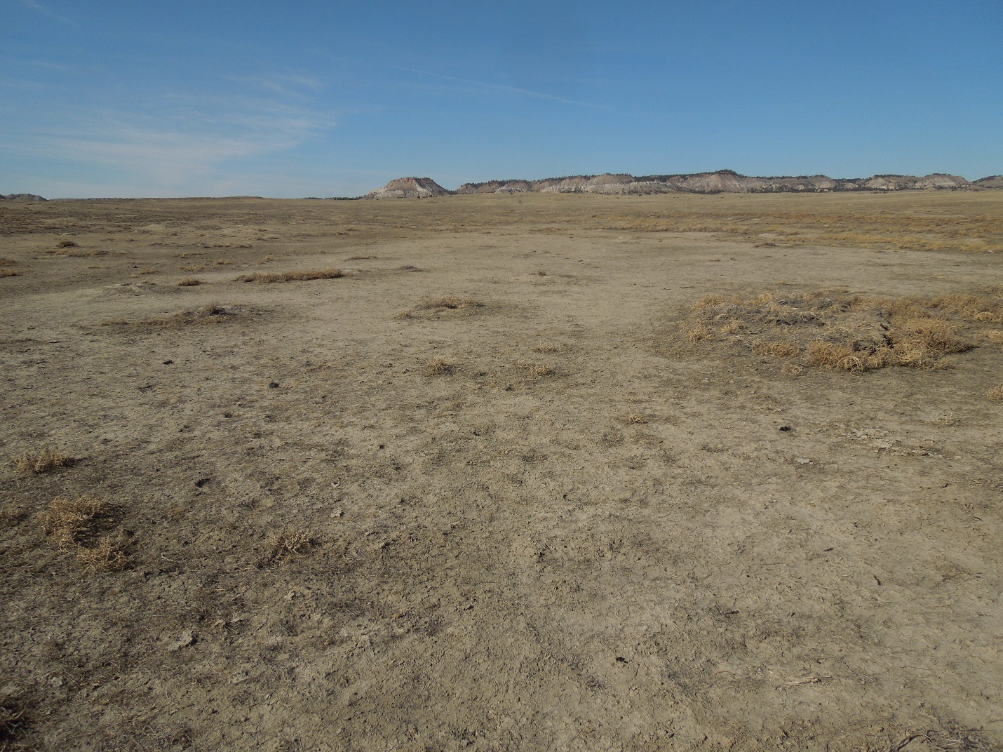

This is supposed to be federal allotment for grazing by livestock and big game!

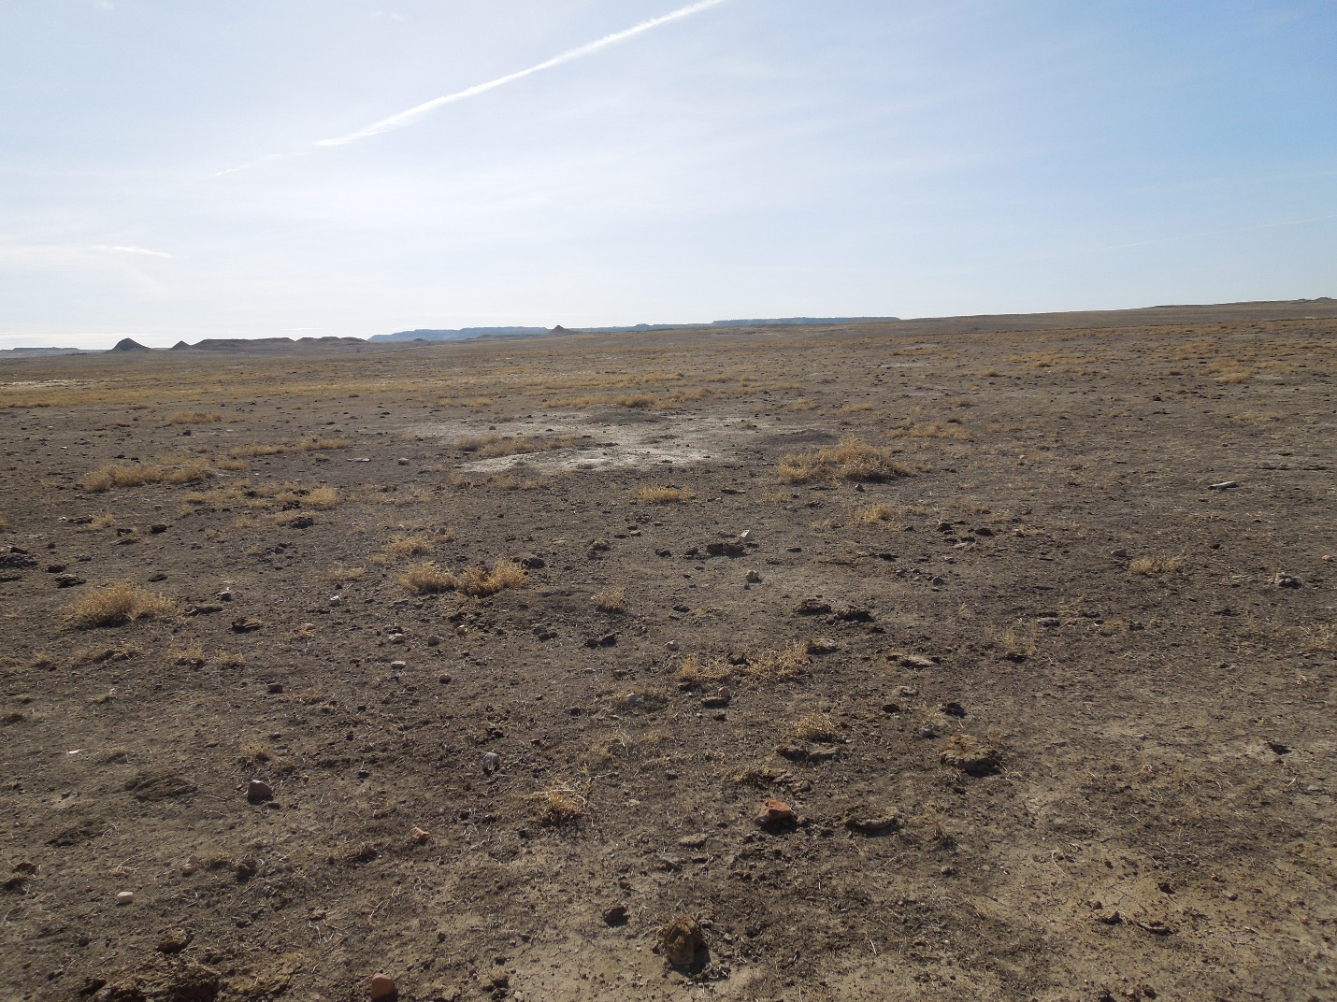The Forest Service did not consider the vast areas of land destroyed thru p/d colonization to be impaired. Pictures showing only a very small portion of the total area devastated give an actual sense of how much forage is left for the livestock to graze AFTER p/d colonization of high density of p/d. The landowners were left to graze dirt. The Forest Service did not cut the AUMS in these areas but the landowners cut their herds. **The Multiple Use Sustained Yield Act states: Multiple use and Sustained yield must occur ``WITHOUT impairment of the productivity of the land”. Wouldn’t you consider this land impaired?**

Ongoing monitoring should have an end point and a decision made of impairment **before** the soil is eroded, forage is lost and ground is mostly bare. In the past this topic has been ignored in vast areas of the Grasslands because a short grass ecosystem was the Forest Service’s desire at all costs. Erosion and poor forage are still found in large areas where p/d were colonized and allowed to expand without proper management. What is going to change this time-how is the Forest Service going to determine impairment **before** the threshold for substantial harm is crossed and does density control over 50% of a detrimental pd colony give a positive long-lasting solution? If a change in management is determined to be needed for density control of the p/d it must occur **before** the forage changes in quality and before there occurs vast areas of bare ground otherwise the forage threshold has already been tipped the wrong way and reseeding might have to occur to restore the Grasslands.

**Fiscal Responsibility:** The plan amendment must follow the provisions of the Forest Service’s 2012 Planning Rule.

### *21.12 – Considerations when Preparing New or Revised Plans*

***``In addition to identifying a need to change the plan and reviewing the assessment, the Responsible Official shall identify and consider a number of resources and issues during the planning process as listed by the 2012 Planning Rule (36 CFR 219.7(c)(2)). The Responsible Official should consider this list of resources and issues before developing a proposed new plan or revised plan or as part of the process of developing the proposed plan. The following list sets forth requirements, along with references for guidance and information. Note that each consideration also may be supported by information generated during public participation or derived from some other source.***

***1. The Responsible Official shall base the plan components on likely budgets and other assumptions that are realistic as required by 36 CFR 219.1(g):***

*(g) The responsible official shall ensure that the planning process, plan components, and other plan content are within Forest Service authority, the inherent capability of the plan area, and the fiscal capability of the unit. “*

This means the amendment proposed must be fiscally possible and responsible. Neither of the alternatives proposed are achievable under the Forest Service Budget allocation from past budget history. Each boundary and buffer control, density control, monitoring, mapping, encroachment, and infestation, issue needs to be addressed as rapidly as possible***. The Forest Service has always used the excuse `` We do not have the time, money or personnel to manage all the p/d on Forest Service allotments!”***  Why submit a proposal they cannot budgetarily support as written? There is one proposal submitted by the landowner group, RCOWS, the Forest Service could afford and manage within the capability of the planning area but the Forest Service did not accept this proposal. Again, a major concern is with all the other areas outside the management zone-they need treatments and pro-active management as well but if they are not prioritized those areas will be ignored.

What is the actual budget breakdown that was calculated before this plan was written? How much is allocated for boundary control around all the homes that require it, boundary control on those areas bordering neighboring lands, density control, mapping, monitoring, keeping sage grouse protected from p/d, and more? On each proposal? They should have a good idea on the no action alternative because their current budget allocation was not large enough. How are the other plans possible to manage under their budget allocation? The Forest Service should have a breakdown of approximate costs associated with each plan.

**Other major issues of concern:**

Under the proposed amendment alternative #2 : ***``To avoid bait aversion, rodenticide application should not occur for more than 3 consecutive years in a given location.”*** If the type of rodenticide is not alternated then what happens the 4th year and thereafter? Does the landowner have to put forth the money to treat all the p/d encroaching upon his land because the Forest Service will not treat the outside area? This is what has happened in the past so the treatment area was a failure, even the State of Wyoming quit treating unless the landowners asked because the treatments were a very short term fix; with the Forest Service raising un-controlled p/d across the boundary the costs became a large loss with nothing to show for the expense.

In the proposed amendment #2: what management is planned for all the pd colonies outside of the management 3.67 area and any satellite colony? Is the Forest Service going to ignore, not try to manage or prevent expansion on all the other colonies within the Grasslands? According to the #2 proposal a small area of the Grasslands will be ``managed” while the rest of the area will be ignored.

Deltamethrin use: This insecticide has been proven to cause plover nest failure and probably has a negative impact on other avian species where it is used because the ``delta dust” kills all insects the birds need for food and has a negative effect for long periods of time. How can the Forest Service state they want to conserve plovers, burrowing owls and other bird species and at the same time place insecticide in those areas that have a large detrimental effect on those and other avian species?

Under each alternative: Will each residence in the Grasslands be treated for a 1-mile buffer if p/d are found within that 1-mile or just residences in the near vicinity of the 3.67.? This should be stated clearly in the chosen alternative; that each residence within the administrative boundary of the Grassland will have a 1-mile buffer treated on federally managed lands if p/d are present. After all, if the Forest Service were truly concerned about the health and safety of the residents then there would be no question all homes would be treated as needed. This has not been the case in the past: as costs went up the # of resident treatments went down and after the 3rd year of treatment the Forest Service did not continue rodenticide treatments due to using only one type of rodenticide.

Alternative #4: Management is not shown to exist on most of the Grassland for p/d but only those areas within and around the chosen categories. The proposal states Category 3 targets would be removed: does this mean eradication or by just not “managing them” so the Forest Service will not treat them for density or boundary management? This is what has happened in the past-ignoring other p/d colonies and allowing them to expand throughout the Grassland is NOT management! There would be a large loss of forage under this proposal as well because drought management does not exist and there are treatment restrictions on when density control could be utilized.

**Viable Populations:**

### *Forest Service Handbook: 1909.12: Land Management Planning Handbook, Chapter 20: Land Management Planning*

### Conservation Concern 23.13c – Species Conservation Concern 23.13c

*Viable population. A population of a species that continues to persist over the long term with sufficient distribution to be resilient and adaptable to stressors and likely future environments.   
(36 CFR 219.19)*

***The following principles must be kept in mind when developing plan components to provide for ecological conditions necessary to maintain a viable population of species of conservation concern in the plan area:***

1. ***The rule only requires ecological conditions to maintain a viable population.***

The plan amendment submitted by RCOWS was fiscally possible under the Forest Service budget constraints. The first 4-5 years would have a large outflow of expense to eliminate large areas of p/d within the Grasslands but in the end would allow a sizeable acreage of p/d the Forest Service could actually budget for and handle. The Forest Service states they want to sustain viable populations of native and desired non-native species but have not submitted any sound science stating why the RCOWS’s proposed amendment would not support viable populations. The RCOWS’s proposed alternative had ecological conditions Grassland wide to maintain viable populations of all of the species of concern as well as all the desired native species.

The Forest Service stated it was essential they need `` 10,000 acres of pd to maintain and support 200 plover”. This is just a ridiculous statement! If you only look for a species within a p/d colony then you will decide that is the only area they exist. Plover and burrowing owls do nest outside of p/d colonies and after hatching a plover takes it young to the taller forage for protection. There are thousands of acres within the Grasslands where the soils will not allow a dense forage to grow, these are soft soil, disturbed areas and ar8/7+e used for nesting by a variety of birds. Plover are found throughout the Grassland so p/d colonization is not required for each plover that exists out there. If you do not seek outside the colonies you have no idea what is viable and where they live. Any statement declaring a proposal will not support a viable population of species; whether it be swift fox, burrowing owl, plover, etc,; must have data to back up what is a viable population, giving numbers, acres, head counts, etc to support such a statement; otherwise it is just an opinion piece.

Page 111, ***Considerations for Determination of Effects:*** ***“Under 36 CFR 219.9(b)(1), the responsible official must determine whether the plan components required by 36 CFR 219.9(a) provide the ecological conditions necessary to “contribute to the recovery of federally listed threatened and endangered species, conserve proposed and candidate species and maintain a viable population of each species of conservation concern within the plan area.”*** So how many (population) of each species for the short grass prairie ecosystem is a viable species: # of burrowing owls, # of ferruginous hawks, # of swift fox, # of plover, # of black tailed prairie dog? You must have these figures specified to actually determine if any alternative will maintain a viable population of a certain species.

Pg 112: ***“ Furthermore, as long as there is enough habitat in the plan area to maintain a viable population , there is no requirement that habitat to maintain all known individuals or the maximum possible number of individuals of a species must be available in the plan areas (Forest Service Handbook 1909.12, section 23.13c(1)(d)).***

Pg. 156: ***“National Forest Management Act (NFMA) regulations define a viable population as one that ‘continues to persist over the long term with sufficient distribution to be resilient and adaptable to stressors and likely future events.”*** So how many exactly do we need of each of the short grass species and where is the documentation to back your facts up?

Draft EIS, page 65, **Why not so many cottonwood trees?** A major reason is that this area does not get the rains we used to, **it is not due to the pumping of water** for agriculture. (It seems that in this paper agriculture gets blamed for many things not their fault!) Very little water is pumped from the creek or river for agricultural purposes –annually, if any--and there is no municipality nearby so those reasons listed are not relevant. The creeks used to flood across the flats and roll the sand and complete trees. The creek bottom was mostly white quicksand and impossible to pass except in small trails with a few trees and willows. We do not get the rains as we used to decades ago with at least 2-3 floods per summer. Since I was raised out in the TBNG I can honestly say lack of water is NOT DUE to agriculture use but an arid climate. The mines pumping water out of their pits has also had a negative impact on the water acquifers. Trees need rain water and a higher water acquifer. That said I think it is nice to see there are many willows and small cottonwood trees in the creek, a variety of forage and a way to get across! Much different than decades ago!

Draft EIS, page 66: **Soils, last paragraph-not true!** There are published references documenting and quantifying comparative erosion rates on and off p/d colonies. **Findings of Cheyenne River Basin Prairie Dog Erosion Study:** Aug. 29, 2005***: “For purposes of this study, the equivalent area management scenario setup for the erosion models was, managed grazing that maintained the ecological site’s health and productivity. In this study the average size of the prairie dog town is about 38 acres and ranges in size from less than one acre to more than 1,100 acres. The managed grazing scenario, when applied to the 411 prairie dog tows has total erosion of about 28,195 tons or 1.8 tons per acres, which is nearly 10 times less than that from prairie dog towns.***

***The soil loss due to erosion that is contributed directly to prairie dog towns is about 241,498 tons or 15.5 tons per acre. When separated into its water and wind erosion components, water erosion is about 97k517 tons soil (6.2 tons per acre) and wind erosion is about 143,791 tons ( 9.3 tons per acre).” Pg. 2***

***`` The erosion from prairie dog towns severely affects the soil, water, and ecological site resources in the study area. The management plans and environmental impact statements prepared by the Forest Service have not analyzed the effects of erosion on the soil, water, and rangeland resources that they administer. Nor, have they taken a serious look at the environmental and economical impacts that result from soil erosion on prairie dog towns.” Pg. 3*** This statement remains true today as well.

Pg 67: **Fire Management**: **``However the plan direction for sage-grouse conservation does not restrict prescribed fire as a management tool to achieve desired conditions for shortgrass prairie ecosystems.”** Why is the Forest Service encouraging prescribed burns *within grouse habitat* to further the short grass prairie ecosystem and encourage the rapid destruction of grouse habitat by burning? The Forest Service should have buffers around grouse habitat and not overlap grouse habitat with prairie dog colonization. The prairie dog habitat and its spread of colonization has always been more important to the Forest Service than the protection of threatened grouse habitat by considering past and present management actions.

Pg. 71: ***``The increased bare ground state represents a state resulting from heavy continuous grazing with overstocking; long-term continuous grazing without adequate recovery; frequent and severe utilization; and fir, brush management, or both with long-term continuous grazing without adequate recovery.”*** The Forest Service continues to overlook the reality that 99% of the landowners do not overgraze and are good land stewards. In fact, it is the Forest Service management in the TBNG that has been pushing over-utilization of the allotments in order to increase the amount of bare ground to expand the prairie dog colonization. Most landowners will move out early, not put as many head in an allotment as permitted, graze an allotment at a different time, even not use an allotment at all for a year in order to protect the allotment acreage from expansion of bare ground. The above statement from the Draft EIS must include the reality that prairie dog colonization does expand, enhance and perpetuate the formation of bare ground. And the statement should also include the reality that the Forest Service **encourages** the formation of bare ground for prairie dog expansion. Most bare ground within the TBNG is due to p/d expansion and over-utilization without proper rodenticide use, the bare ground is not due to over-grazing by livestock as the statement tries to present to the public. The p/d is a stressor that can and does cause reduction in AUM in on the ground utilization. Another term for over-utilization, overstocking, frequent and severe utilization is the prescribed grazing process used by the Forest Service. The federal agency is striving to have ***“Frequent and severe defoliation is the key component, as the prairie dogs prefer areas with low vegetation structure….”* Pg 77**. With prescribed grazing thru the Forest Service’s management bare ground increases and forage dramatically decreases. The other side of prescribed grazing to allow for vegetative increase calls for a decrease in the utilization of the pasture by livestock which is another way of saying cutting AUMS or very short-term utilization of the area. Which leaves the landowner asking where do I go for forage if I cannot utilize the allotment I paid for? Deferment of pasture utilization must also involve deferment of the pasture by rodent colonization in order to actually rest the pasture.

Page 72: ``***Spatial and Temporal Context for Effects Analysis: Monitoring information from the 2018 field season shows prairie dogs currently occupy approximately 625 acres on NFS land in the TBNG, less than 1 percent of NFS land within the administrative boundary of national grassland.”*** This statement is not true and does not give an accurate picture! How many acres were actually monitored? There are tens of thousands of acres the Forest Service “just does not” monitor so in reality if they want to make a statement concerning the entire grasslands then they must actually monitor the entire NFS lands within the administrative boundary. The above statement is purposely misleading and factually not true!

``***Any potential change in number of head of livestock refers only to the number of livestock authorized or actually grazed annually, which may be affected by drought, the extent of prairie dog colonies, and other activities and stressors that can affect competition for forage and forage availability. “*** The adaptive management process described in allotment plans needs to be transparent here-if an allotment has a large loss of forage due to over-colonization of p/d then in the past the Forest Service would ask the lessee to graze less livestock, graze a shorter period of time, or not graze in the allotment while at the same time the Forest Service management encouraged the further expansion of colonization and increased the loss of forage in allotments in order to increase the amount of bare ground. Even during drought when the lessee was forced to cut their herds due to lack of forage the Forest Service never expanded rodenticide use to decrease the p/d colonization within those allotments.

In the proposed alternatives there are no indication this is going to change outside of the “conserved management” p/d colony areas. There is no treatment or management proposed for any area outside of the satellite or 3.67 areas, so all the p/d within the remaining 533,000 acres within the TBNG (Thunder Basin National Grassland) will be allowed to expand without effective treatment—unless money might be available.

DEIS Page 75-76: Again, the Forest Service may **cut AUM** utilization on the ground, not on paper but at the same time do not decrease the % of prairie dog colonization to match the loss of AUM utilization. If livestock usage is cut 50% then so should the p/d utilization be decreased 50% in order not to over graze an allotment by p/d. The large amount of AUMs not utilized within the TBNG during the time period listed was due to extensive drought and expanding p/d colonization. The livestock owners cut their herds to protect the lands but the Forest Service burned acreage and managed the land to allow expansion of p/d throughout the TBNG with no concerns for drought conditions.

DEIS Page 77: Using the documented figures given: `` **6 acres of p/d equals 1 AUM**” then with the baseline proposal-minimum - at 10,000 acres of p/d the TBNG lessees would lose approx. 1,667 AUMS within that specific 10,000 acre area. It is very important to remember the 10,000 acres of active p/d is not a MAXIMUM BUT INSTEAD IS A MINIMUM baseline population quota. Any other untreated rodent infested colonies throughout the Grassland would have a similar effect or actually a more devastating effect on the AUMs because there are no rodenticide treatments proposed for any areas outside of the 10,000 acres of` ``conserved” p/d colonies. The expansion of untreated p/d throughout the Grassland would dramatically increase the loss of AUMS within the administrative Grassland boundary.

Fencing out portions of allotments for vegetation protection has not worked in the TBNG because it is an arid region so lush dense forage is an exception, prairie dogs continue to infest fenced out areas. Therefore any proposed fencing for vegetative barriers will only fence out the livestock and will be breached by the p/d.

Pg 80: ``***Ultimately, prairie dog colonies cause increases in bare ground and in grasses and forbs that are undesirable for livestock (Archer et al. 1987)”*** This is a true statement so where is the mitigation and management to compensate or lessen the impact for this?

Pg 82: `` ***Continued long-term occupation by prairie dogs will result in a transition to the blue- grama sod or blue-grama sod/plains prickly pear/bare ground state. Significant economic inputs, management, and time may be required to move these plant communities toward a more productive stable plant community.”*** This will occur also on the private lands encroached/invaded by neighboring forest service administered lands. Where is there any mitigation or compensation to help private landowners with restoring their native mixed grass prairie lands the prairie dogs have destroyed?

Pg 83: ``***When prairie dogs are removed after long-term colonization, the reversibility of plant community composition and productivity can be slow, with little to no change in vegetation composition for the first 2 to 3 years after removal (Krueger 1986: Cid et al. 1991, Fahnstock and Detling,2002)***

***“When a threshold is crossed, major management changes and monetary investments may be required for restoration (Sedivec and Printz 2010), and plant community shifts are not often linear, making them difficult to predict. Once a plant community transitions from one state to another and crosses a threshold, it may be difficult to revert back toward the reference state.”***

Page 84: ***`` This analysis calculated the impacts to available AUMs for livestock grazing based on predicted differences in available forage (table 10) as a result of differences in productivity and forage consumption across projected future extent of prairie dog colonies.”*** So what was the total of AUMS lost across the landscape; when the Forest Service received mapping information on just a small portion of the Grasslands.? During the years 2016-2107, is when there were over 75,000 acres of active p/d documented in just a portion of the Grassland with thousands of more acres not included in the study. The answer for only a few of the landowners is calculated below:

***A study conducted by the University of Nebraska – Lincoln calculated that six acres of prairie dog colonies are equivalent to one grazing Animal Unit Month (AUM).80 An AUM is the amount of forage that one cow and calf ingest per month during the summer.81 In Western Nebraska where the study was taken, a cow and calf consume 900 pounds of forage per month; however, in the Thunder Basin, a cow and calf consume 780 pounds of forage per month.82When converting the 900 pound equivalent of six acres to 780 pounds, a total of 5.2 acres of prairie dog colonies is equivalent to one AUM.83 Using the information from the partial land survey completed by the TBGPEA, the total AUMs lost in that portion of the Thunder Basin due to the prairie dog infestation is 14,589 AUMs. Pg. 15 RCOWS petition***

What table 11 page 86 DEIS, fails to say is that the loss of AUMS is not complete (not all the Grassland was mapped), is on the low end and is only an estimation for one year with the # of AUMS lost. This figure will progressively increase with the increase in p/d coloization.

Pg. 87, Table 13, This is for the proposed #2 alternative but again this is not the complete picture. The only areas with a boundary will be around 3.67 and any chosen satellite colonies as needed. The rest of the prairie dog colonies will be ignored and allowed to expand at will which will dramatically reduce the available AUMS throughout the Grassland. The figures the table gives are estimated loss of AUMS for basically one landowner or the 3.67 area and does not include the rest of the 523,000 acres of Grassland. The loss of AUMS for all landowners will cause severe economic hardship to those in the ranching community.

Page 88; Table 13 is just not correct for loss of AUMs if you consider the prairie dogs will be spread out Grasslands-wide.

Page 89: Table 14, the Forest Service is only calculating AUM loss on Cat 1 and Cat 2 areas and again the rest of the destruction throughout the Grassland is not included in these calculations so the actual loss of AUMS will be much higher than stated. All tables dealing with the loss of AUMS and loss of forage are not complete for the Grasslands because they do not calculate all the other areas where prairie dogs exist but are untreated on Forest Service managed lands and infesting private lands. So keep in mind for tables 17 and 18 the only acres tabulated for a loss in AUMS is: 33,000 acres, 7500 acres, 10,000 acres, 15,000 acres OR 27,000 acres respectively depending upon the alternative discussed. This tabulation **does not include** the other acreage included within the administrative boundary of 533,000 acres so the tabulations are not representative of the total economic impact to the area landowners and their total loss of AUMS PER YEAR.

Pg.92: ``***Analysis of Socioeconomic Resources***: ***``…cumulative effects of prairie dog management, combined with other activities and stressors such as drought, may require adjustments in herd size, supplemental feed, additional pastures, or other changes to ranch operations, which can have economic impacts at the scale of individual ranch operations, communities, or counties.”***

The Forest Service keeps stating this factual truth but where this addressed in any alternative and where are the landowners compensated for economic hardships and loss?

Page 98***: `` If a boundary management zone is established and actively managed while prairie dog colony extent is low, this could keep costs for maintaining the boundary management zone relatively low in subsequent years”.*** True, but again the boundaries are not going to be maintained in **all areas of need**. If large areas of prairie dog colonization were eliminated now while numbers of the p/d were low then faster and more economical management would result. Remove those areas of p/d continually infesting the 1 mile radius around homes, those areas continually infesting private lands and those areas within and encroaching upon grouse core habitat and leks, and big game habitat. If this aggressive management is done while the numbers of p/d are low, then there will be less areas of concern, the costs in later years would be substantially less and the actual on the ground management would be much easier and more effective.

This brings up the question: *Who and* *what makes the determination that boundary management must occur?* Also, at *what density* of burrows will density management occur? The baseline parameters must be set so everyone understands. A time frame for decision making must be realistic so monitoring before a decision does not continue indefinitely. All of this information should be included in the EIS for public preview.

Pg 101: ***``Although managed differently under each alternative, costs associated with prairie dog control are expected to be limited by available funding each fiscal year and thus be approximately the same across the alternatives.”*** Costs to do effective management will increase each year due to increasing number of prairie dog colonies and their associated negative impacts upon the rangelands administered by the federal agency. Costs turned in for control might be limited but the actual NEED for on the ground control and requests for control will continue to increase as the p/d increase.

Pg.101: ***``It is expected any differences in forage availability and associated AUMs among alternative would have minimal impacts to jobs and labor income.”*** Large loss of forage availability results in less AUMS which results in less income and would have a devastating negative effect upon the income viability of the landowners within the TBNG among all the alternatives.

Pg 103: ***``Treatment could occur outside of management area 3.67 at any time except in designated satellite colonies.”*** What needs to be specified here is: IF the outside colony is prioritized for treatment and IF the Forest Service has any available funding left to do so; as the 3.67 boundary and density control, residence buffer zones and any chosen satellite colonies management issues must be taken care of first.

Pg 104: Under alternative # 2 mapping would be less because only areas would be mapped as needed to reach the 10,000 active acres of p/d. All other areas would be ignored and no monitoring of any other existing p/d colony would occur.

Pg 109: Chapter 3 ***Affected Environment and Environmental Consequences; Sage Grouse: ``No substantial adverse impacts or substantially lessened protections as a result of the plan amendment.”*** This statement is **false!** Prairie dogs are continually fragmenting and destroying grouse habitat with a negative impact that over the years has been substantial: Look at the following pictures of what used to be sage grouse nesting habitat. 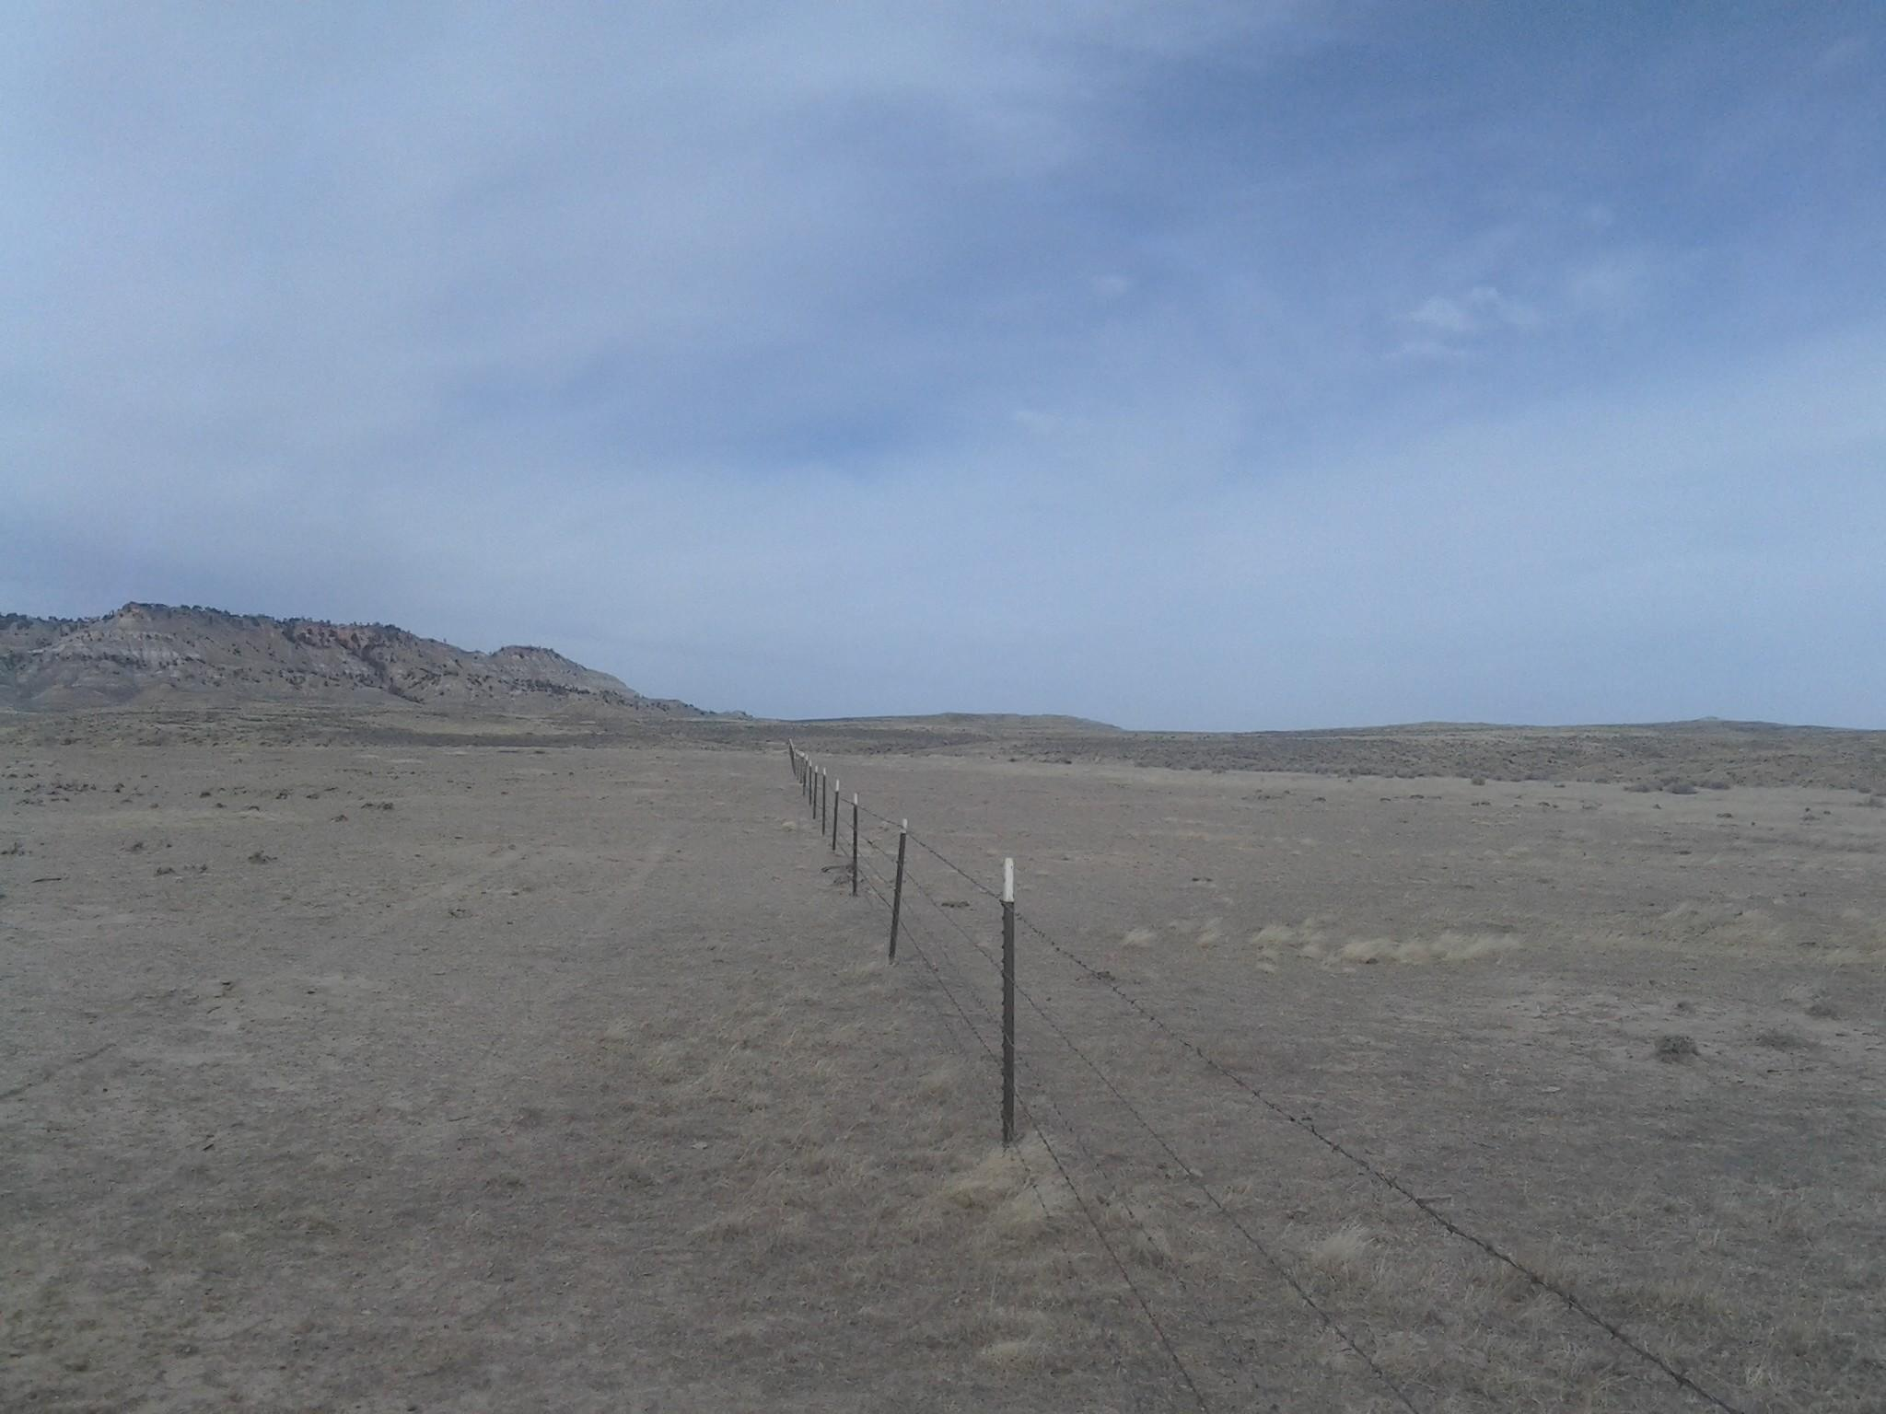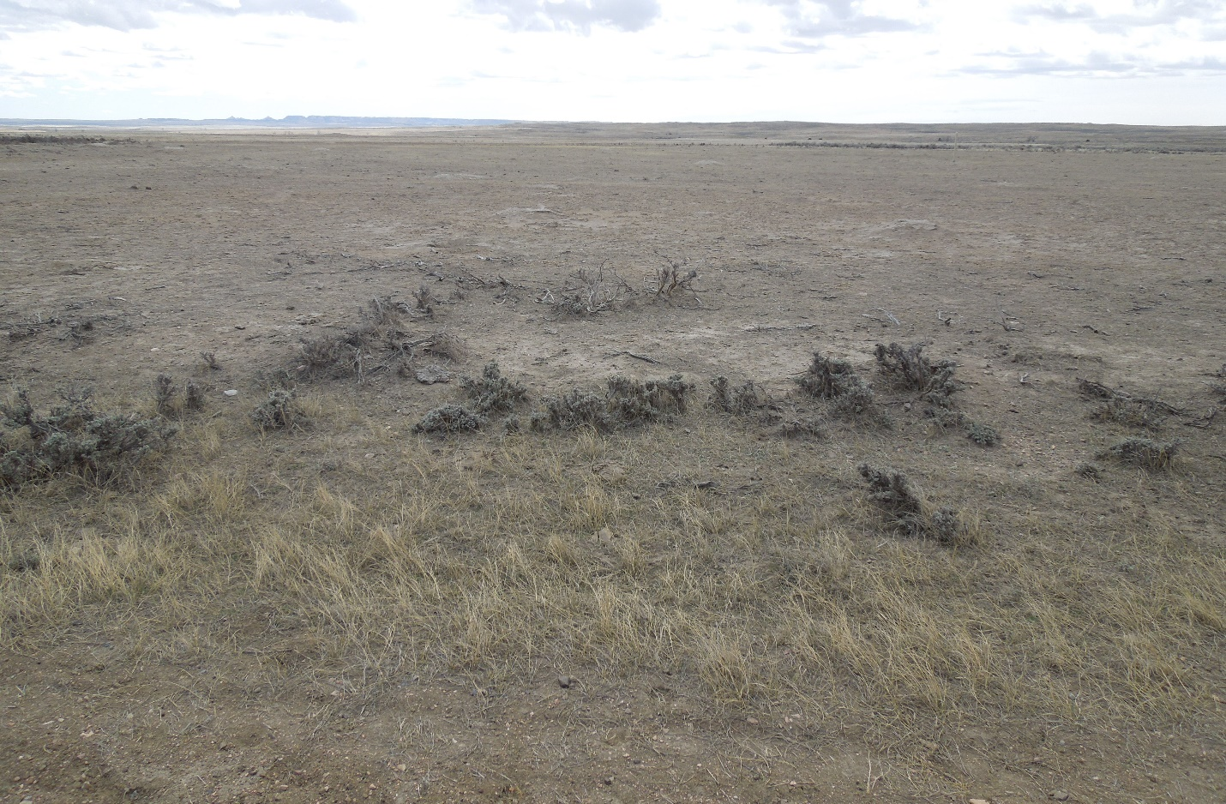

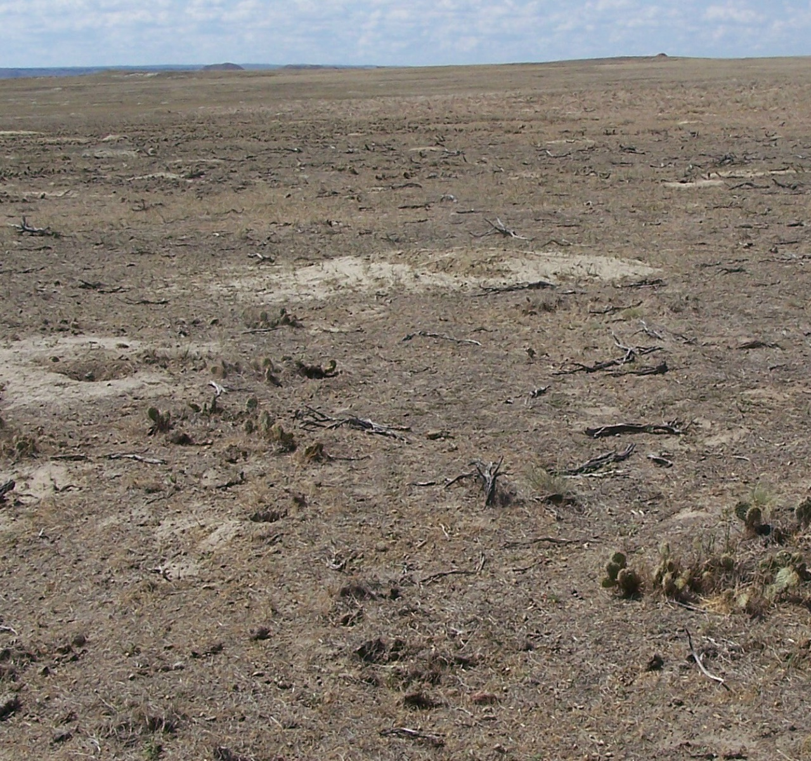

Prairie dogs are encouraged to expand and they do not read sagebrush as much of an obstacle if the p/d are managed for a high density. The USFWS wants bare ground for prairie dogs but at what cost to the Sage Grouse?

Page 133: Why does the plover has to be **politically and biologically sustainable** and the other species do not have this requirement? What is politically sustainable-how many, how is this determined, by whom?

Page 154: ***“Implementation of a plan amendment is expected to have short-and long -term neutral or positive effects on rangeland resources, livestock grazing and socioeconomic issues.”*** This statement is **not true** if you consider what will actually happen on the ground: more bare ground=more erosion, less forage available for livestock and other big game, the loss of AUMs which will increase with the increase of p/d, the statements admitting the landowners will have to find supplemental feed, graze elsewhere, cut herds, and again treat p/d that continue to infest their lands; all of these are a strong negative impact upon the Grasslands, landowners and county economics.

Page 155: Section 213(d) states***``the resources shall be managed so as to maintain and improve soil and vegetative cover, and to demonstrate sound and practical principles of land use for the areas in which they are located.” Section 213.3 addresses protection, occupancy, use, administration and exercise of reservations. This section basically states the rules found in 36CFR section 213 and govern the management of these lands. Section 213.4 addresses prior rules and regulations. It states``”Except as provided in section 213.3, the rules and regulations heretofore issued for land utilization projects are hereby superseded as to all such projects administered by the Forest Service, but not as to such projects administered by other agencies.”***

**Here is the true lawful statement:** (Emphasis is mine)

***§ 213.3 Protection, occupancy, use, administration, and exercise of reservations.***

***(a) The rules and regulations applicable to the national forests as set forth in title 36, Code of Federal Regulations, or as hereafter amended, supplemented, or promulgated, are hereby adopted as the rules and regulations to govern the exercise of reservations in conveyances to the United States and to prevent trespasses on and otherwise regulate the protection, use, occupancy, and administration of the National Grasslands and all other lands administered by the Forest Service under the provisions of title III of the*** [***Bankhead-Jones Farm Tenant Act***](https://www.law.cornell.edu/topn/bankhead-jones_farm_tenant_act) ***insofar as is practical and consistent with said act: Provided, That Forest Service officers may continue under delegated authority to acquire lands, to make exchanges, to grant easements and enter into leases, permits, agreements, contracts and memoranda of understanding involving such lands under such terms and conditions and for such consideration, fees or rentals as authorized by title III of the said Act.***

***(b) Existing valid rights, reservations easements, leases, permits, agreements, contracts and memoranda of understanding affecting these lands shall continue in full force and effect so long as they remain valid in accordance with the terms thereof.***

There is a large and obvious omission on the Forest Service’s plan here. Lands within the Thunder Basin National Grasslands must be administered under the provisions of title III of the Bankhead-Jones Farm Tenant Act ``**insofar as is practical and consistent with said act.**“ and valid existing rights must be recognized!

***§ 213.1 Designation, administration, and development of National Grasslands.***

***(a) The land utilization projects administered by Department of Agriculture designated in*** [***paragraph (e)***](https://www.law.cornell.edu/cfr/text/36/213.1#e) ***of this section hereafter shall be named and referred to as National Grasslands.***

***(b) The National Grasslands shall be a part of the National Forest system and permanently held by the Department of Agriculture for administration under the provisions and purposes of title III of the*** [***Bankhead-Jones Farm Tenant Act***](https://www.law.cornell.edu/topn/bankhead-jones_farm_tenant_act)***.***

***(c) The National Grasslands shall be administered under sound and progressive principles of land conservation and multiple use, and to promote development of grassland agriculture and sustained-yield management of the forage, fish and wildlife, timber, water and recreational resources in the areas of which the National Grasslands are a part.***

***(d) In the administration of the National Grasslands the resources shall be managed so as to maintain and improve soil and vegetative cover, and to demonstrate sound and practical principles of land use for the areas in which they are located. The Chief of the Forest Service shall, to the extent such action is feasible provide that policies for management of the Federally-owned lands exert a favorable influence for securing sound land conservation practices on associated private lands.***

All management must be practical and consistent with the Bankhead-Jones Farm Tenant Act and must “promote development of grassland agriculture and sustained-yield management …. And must be managed to maintain and improve soil and vegetative cover, and to demonstrate sound and practical principles of land use…”

The land in the Thunder Basin National Grassland was acquired for Wyoming (LUP) Land Utilization Projects which is a different reason than the accumulative National Forest System Lands. The Grasslands were designated for specific uses; other projects cannot supersede those uses if they are not in agreement with the Bankhead-Jones Farm Tenant Act and not in agreement with the purpose of acquiring the lands thru the LUP. The primary purpose of the Northeastern Wyoming Land Utilization and Land Conservation Project WY - LU - 1, was for “grassland agriculture”, prevention of erosion, and the stability of productive rangeland.

Upon studying the **geographical reference map**(s) questions come up:

* If you are going to treat a 1-mile buffer around all the homes within the TBNG and propose to do this annually then: a) what is the cost , b) are you actually going to do around all the homes?- in the past the Forest Service stated they would treat around all the homes then did not because it cost too much money. The best solution to this recurring problem is to treat around all homes within the administrative boundary of the TBNG and to treat for elimination of all those p/d colonies constantly encroaching and infesting those areas in a 1-mile radius. If those p/d colonies were removed permanently that continue to encroach into the 1-mile radius then this would remove an issue of contention, protect the safety and health of all residences and allow future money to be utilized elsewhere within the Grasslands. Unless the colonies that continually re-infest the 1-mile radius are removed the same issue, same costs, same techniques are repeated over and over which does not solve any problem but just puts a temporary reprieve on recurring issues.
* In studying the Geographical maps it is pertinent to realize these areas that were infested in the past are not all so severely infested at this time due to plague die offs so now is the time to remove large areas of p/d while the numbers are down; the costs to do so would be much less than waiting 3-4 years in the future.
* Also, it is very important to realize not all the Grassland has been mapped and monitored for plover, p/d and other associated species. It seems very logical there are many more p/d in existence than what is shown as well as other species. Plover are not just nesting upon p/d colonies but are actually found throughout the Grassland as are burrowing owls and other short grass prairie species. There are and always have been large areas with short-grass ecosystems without p/d colonization due to the soil and forage composition within the TBNG.

Appendix A: A-5: p.1-17/F-34:``***… vegetation management techniques that enhance short-stature vegetation communities should be considered for use in projects that occur in identified mountain plover habitat”*** BUT this should not be done within any other geographical or management area if it overlaps with Big-game, grouse habitat, naturally appearing mixed grass ecosystems, etc. Plover are found all over the Grassland so they do not need forage mowed, burned and over-grazed to allow their nesting successes but the treatments could occur only within the current existing short-stature vegetation communities that are not overlapped with other vegetation ecosystems.

A-6, F,XX: Area landowners must be notified in advance of translocation and their mention should be included here.

A-9: If rodenticide is used without alternate rodenticides then what happens the 4th, 5th, and 6th years- A management policy of no treatment will effectively negate any previous positive impacts that were accomplished. The types of rodenticides must be rotated in order for effective management, and again, if an area is constantly having to be treated due to encroachment issues then the intelligent plan would be to eliminate the entire colony to remove the recurring issue. This is for any treatments around homes, boundaries, density control and total removal of p/d within an area.

A-11: H,XX under proposed action: this is another way of saying if there are any burrowing owls, swift fox or plover found in areas causing infestation then that specific area may not be treated with rodenticide and the landowner is stuck handling all rodenticide treatment costs from constantly encroachment of p/d.

### *Forest Service Handbook: 23.12b – Soils and Soil Productivity*

***The rule requirements for soils and soil productivity are listed in 36 CFR 219.8(a)(2)(ii). The development of plan components for soils and soil productivity, including standards or guidelines, should be based on the need to change the plan identified from the assessment   
(FSH 1909.12, ch. 10, sec. 12.22) or information brought forward during the public and governmental participation process.***

***1. In addition to considering information identified in the assessment, the Interdisciplinary Team may consider existing recommendations in Forest Service national best management practices guidance documents (USDA Forest Service 2012a). Additional information is found in FSM 2551.3.***

***2. When designing plan components for soils and soil productivity to sustain the productive capability of the land, its ecological resources, and watershed functions, the*** ***Interdisciplinary Team should consider whether it would be appropriate for plan components to give direction regarding :***

***a. Restoring degraded areas.***

***b. Maintaining the ecological integrity and functions of soils by managing vegetation communities and the type, degree, and amount of disturbance to soils. (See FSM 2550.5 and FSM 2551.5 for definition of soil function).***

***c. Maintaining biological properties of soils, such as an appropriate level of organic matter to sustain biological cycling.***

***d. Maintaining organic matter inputs and avoiding losses, to help maintain or increase net soil carbon storage.***

***e. Mitigating impacts for those soils that have been identified as vulnerable to stressors.***

***f. Mitigating potential impacts of changing climate, such as changes in occurrence of extreme storm events (in other words, do potential impacts affect appropriate uses of soils?).***

***g. Limiting potential impacts on soil physical properties, for example, compaction, rutting, puddling, displacement of the soil surface, and erosion.***

***h. Limiting potential effects on soil chemical properties, such as potential for nutrient depletion, acidification or both.***

Large p/d colonies with high density populations will deplete the soil, water retention and forage. Organic matter is very important to soil health and productivity. Depleting the soil requirements for productivity and not causing impairment to the productivity of the land is a major priority for the land health. Where is this addressed?

What and where are the satellite designations, time frame for these decisions and the time frame for removal of a satellite designation? In the past the Forest Service has kept many areas in limbo-untreated-because they “might” need them at some time in the future-this type of management is not effective for diminishing issues on the Grassland. Rather than place this information on satellite colonies, density control, decision flow sheets in an amendment after the EIS all this information should be included now so the public can comment on it as future decisions will have an impact upon the community.

Here are the estimated treatment costs for the Alt. #2 for just the proposed management area 3.67 and approx. 21 residences impacted throughout the Grassland. **(Note this does NOT include management expense for needed treatments elsewhere within the administrative boundary of the TBNG).**

The proposed 3.67 management area has approx. 20 miles of management boundary or buffer where federally managed lands meet private or state lands. For Alternative 2 the Forest Service has stated they will manage these areas with rodenticide as needed. The 20 miles equates to 3200 acres. Treatment costs for the boundary around the 3.67 area is as follows using the average burrow density of 25 burrows/acre. (In the past the Forest Service has maintained a much higher density than 25 burrows/acre).

20 miles boundary =3200 acres.

1 hectare = 2.47 Acres

Treatment cost per 25 burrow is $ .29 (pre bait & poison combined)

25 burrows per hectare labor =  $ 44.68 (product included)

Total cost for 1295.54 hectares = $ 57,884.73

 Per Acre cost: Labor plus product = 18.09

Total cost for 3200 Acres = 57,884.73 Approx. cost per year as needed.

### The above information was calculated by Weed and Pest Specialist, Converse County, Cheryl Schwartzkopf

Using geographical maps of the TBNG it appears there are approx..21 residences that have been impacted by varying degrees by prairie dog infestation over the years. The Forest Service states they will treat around residences using a 1-mile buffer. So utilizing just 20 of those homes and assuming there are FS lands within the 1 mile radius, then a 1-mile radius equates to a 2-mile linear treatment area +. For the sake of this document we will not consider the full radius just a 2-mile linear treatment which would be 6400 acres of infestation and would be double what is listed above for boundary management= $115,769.46

Again, to start with not all areas would be infested but as the p/d colonies were allowed to expand so would the treatment requirements. On an annual past budget of 20,000 to 40,000( the FS told us the $40,000 was not sustainable) per year where does the rest of the money come for home treatments, mapping, monitoring, density control and more?

The SIA management area along the Cheyenne River and also proposed along Antelope Creek is unmanageable. The p/d will not be kept out of this area and the vegetation will not be a dense enough VOR (due to the arid climate)to restrict their movement so instead the Forest Service should just manage for density of p/d which will supply forage throughout and allow for less p/d migration outside of ``conserved” areas.

This proposed plan amendment #2 and the other proposed plan amendments will all fail as they are written. The amendments fail the Sage and Prairie Grouse because no protections are incorporated into the documents. The proposals fail the landowners and lessees of the allotments because providing for the forage, having a positive impact on neighboring lands and managing for economic stability throughout the entire 533,000 acres of the Grasslands is not addressed; especially when p/d are not managed over the entire area and large areas of colonization are not removed that are causing recurring issues.

The amendments fail the Grasslands: The Forest Service cannot afford to manage any of these plans according to their past budget allocations. According to their own 2012 Planning Rules the Forest Service adhere to: ***1909.12 Land Management Planning Handbook, Chapter 20 #4. 4. The Responsible Official shall ensure an integrated set of plan components that:***

***a. Together provide for sustainability, ecological integrity, diversity of plant and animal communities, ecosystem services, and multiple use;***

***b. Contribute to social and economic sustainability;***

***c. Provide a strategic and practical framework for managing the plan area;***

***d. Are within Forest Service authority, the inherent capability of the plan area, and the fiscal capability of the unit; and***

***e. On balance, best meet the needs of the American people (16 U.S.C. 531).***

***1921.11 Plan Requirements: 3. Plan components should be realistic and achievable. They should reflect the anticipated budget levels, staffing and capability of the Forest, Grassland, Prairie or other comparable administrative unit for the plan period.***

Without money to manage and without **actual long-lasting solutions** for the many issues of concern; the same results will continue to occur. **The Thunder Basin National Grassland will continue to be damaged by an overabundance of p/d, loss of naturally occurring mixed grass prairie,** **loss of grouse and big game habitat and large erosion issues, and a dramatic change in quality of the forage produced and amount of forage available for livestock.**

What needs to happen for a plan to succeed:

* Any successful plan will manage the entire Grasslands not just a small portion otherwise the ignored areas will continue to expand with p/d and cause the same problems in a much larger area than in the past
* Active p/d populate and spread by nature so in order to successfully manage the rodents thousands of acres must be eliminated and managed to keep them gone. No one can manage large areas of active prairie dogs so the areas affected must be decreased until only specific areas remain for effective management to occur.
* Affordability from the Forest Service budget: money can be moved and acquired but costs must be realistic and documented for estimates on each proposal.
* Mapping must be done over the entire Grasslands to have an estimate of what is there.
* Landowners will not tell the Forest Service where active p/d are because in the past whenever the landowners informed the Forest Service of colonies that needed treated (because they were infesting private lands or too dense upon the allotments) the Forest Service decided to keep those colonies as Category 3 or 4 areas for non-treatment. If the Forest Service starts actually eradicating large colonies of p/d the agency will find there are several more areas with unmanaged p/d than they realized. Elimination of large areas of p/d colonization is the key to start a successful management plan:
  + All areas around homes 1-mile radius and all colonies feeding into that 1-mile radius must be removed
  + All areas of p/d infesting private and state lands must be removed and the establishment of a substantial realistic buffer zone (1 mile)
  + All areas of p/d within sage and prairie grouse habitat as well as those colonies expanding into the core area and within 1 mile, at a minimum, from all leks must be removed.
  + All areas of p/d expanding into and within Big Game Habitat to protect future big game viability unless upon protected mine property.

The Forest Service does not have an effective method of control for p/d within and next to grouse habitat or big game habitat to prevent its destruction and fragmentation from the rodent, therefore the best solution would be to remove all p/d from within and next to grouse core and big game habitat. Then the Forest Service could set up p/d free boundary zones (3/4 to 1-mile) around the grouse and big game core area that would be maintained to prevent re-infestation by p/d. Any rodents found thereafter within the core areas would be eradicated to prevent future destruction of the grouse and big game protected habitat.

The treatments outlined above could start immediately while the population of p/d is lower rather than wait for another 3 years before action. All the treatments are legal under the current p/d plan if the colonies were not specified a Cat. 1, 2, 3, or 4 area. Thousands of acres of p/d could be removed while the amendment process continues. This would enable the Forest Service to have more available money to manage the new alternative Grassland wide.

The removal of large areas of p/d will free up more budget for better conservation management under a new alternative. Without large areas of p/d eradicated, actual time and costs would be too large for anyone to manage-**you fail before you even start.** The above removal of large areas of p/d would still leave thousands of acres of active p/d that could be better managed within small area(s)- not just within a proposed 3.67 area. The areas pushed for eradication would have to be monitored for return of p/d but there would not be the large issues over the entire Grasslands as there are now. The private landowners would work with the Forest Service for the removal of entire colonies if their private lands and state leases were within the removal area.

The Forest Service should also take into consideration all the active p/d colonies that currently exist upon the mine property which will revert back to the Forest Service at a later date. The p/d colonies on mine property are under strict management policies and there are short-grass species present on mine property that are managed for viable species populations. The 3000 + acres of p/d colonies should be counted towards the total amount of 10,000 acres the Forest Service feels they must have. They are highly regulated and protected and are there into perpetuity so why not count them?

If the Forest Service will start looking for plover outside of p/d colonies they will find they do not NEED 10,000 acres of p/d for viable populations of plover. They and the other species are currently found over the entire Grasslands in their habitat areas that are not always upon p/d colonies.

***None of the alternatives listed will succeed as written!***  Rethink and do actual management Grassland-wide as the Forest Service is directed to do by the Secretary of Agriculture and under the guidance of Title III of the Bankhead-Jones Farm Tenant Act and you will succeed where others have failed.