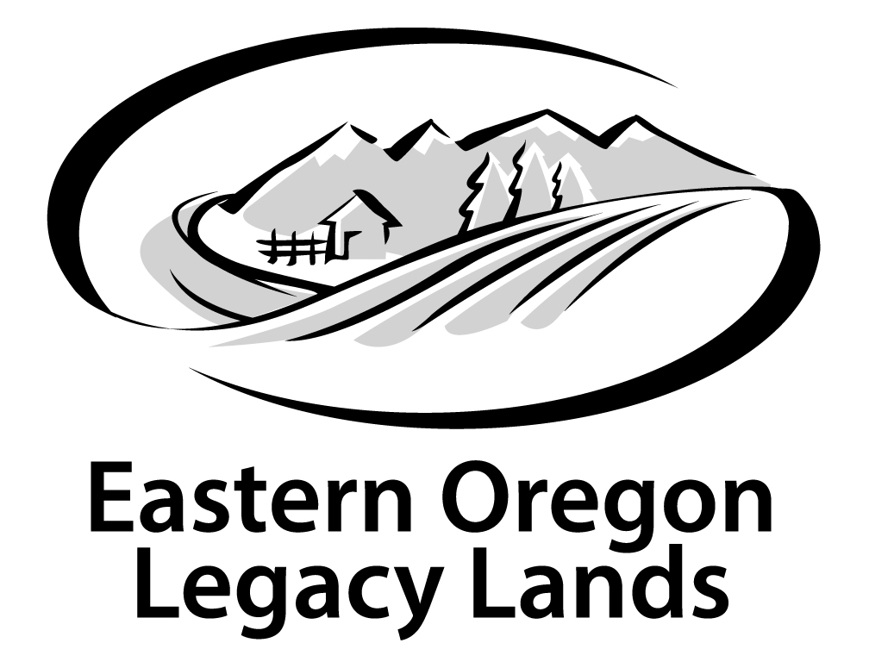

February 2, 2024

Regional Forester,
U.S. Forest Service,
1220 SW 3rd Avenue,
Portland, OR 97204.
Submitted to: https://cara.fs2c.usda.gov/​Public/​/CommentInput?​Project=​64745.

Please accept these comments on behalf of Eastern Oregon Legacy Lands on the Region 5 and Region 6; California, Oregon, and Washington; Forest Plan Amendment for Planning and Management of Northwest Forests Within the Range of the Northern Spotted Owl
Thank you for your work to strengthen the Northwest Forest Plan (NWFP). The high carbon density forests of the Pacific Northwest are well-known globally, as they are among the highest biomass forests on Earth and there simply aren’t many intact forests left in temperate latitudes. Most of these globally-significant forests that remain are on public lands.

The NWFP resulted in a strong carbon benefit for climate mitigation, in addition to protecting sensitive species and riparian systems (Turner et al., 2011). Please consider the following points:
- The greatest benefit of our publicly owned forests is in the ecosystem services they provide to all people, locally, regionally, nationally, and globally. Strong protections for mature and old forests will benefit a broad range of valuable ecosystem services, help mitigate climate change, safeguard species habitat, provide clean abundant water to ecosystems and people, provide jobs in monitoring and stewardship, as well as outdoor recreation and cultural opportunities.
- The National Forests in the NWFP plan area are still recovering from decades of logging of large trees including clear cutting old growth forests. These forests are only 25 years into a 100-year recovery regime as envisioned by the NWFP. There continues to be a deficit of mature and old-growth forests and the landscape in this region is among the most roaded and fragmented in the National Forest System.
- The NWFP is an excellent, science-based regional plan that has successfully helped safeguard the region’s remaining mature and old-growth forests and watersheds. The NWFP – especially its reserve system — is a global model for ecosystem management and wildlife conservation. It is also highly consistent with the Forest Service’s new 2012 planning rule, which requires plans to maintain and restore the integrity of ecosystems and watersheds (36 CFR 219.8(a)(1)).
- In revising the region’s forest plans, the Forest Service should keep the foundational components of the NWFP, including its reserve system, intact as a consistent, regional, interagency whole. All National Forest plans in the NWFP region (including the Okanogan-Wenatchee) should be revised based on a regional science synthesis, NWFP regional planning direction, and the 2012 planning rule. A forest-by-forest approach to plan revisions in this region is inappropriate and unacceptable. There is no scientific basis for weakening the NWFP framework and standards.
- The NWFP should be strengthened by using the best available science regarding climate change, wildlife habitat needs, and other relevant new information, as required by the 2012 planning rule (36 CFR 219.3). In response to climate change, plans should focus on (1) reducing environmental stressors like logging, road building, invasive species, and off-road vehicles; (2) establishing connecting corridors for wildlife migrations; and (3) providing high-quality habitat as refugia for climate-sensitive fish, wildlife, and plants. The plans should also recognize and safeguard the vast amount of forest carbon that makes the region’s National Forests critically important in fighting climate change.
- All mature and old-growth forests should be off-limits to logging, including post-fire salvage logging, to protect wildlife habitat and carbon storage. The Forest Service should continue to focus on thinning of previously logged tree plantations.
- Protecting and restoring riparian areas and watersheds should be a major emphasis of the forest plans, consistent with the NWFP’s aquatic conservation strategy and the 2012 planning rule (36 CFR 219.8(a)). The plans should not reduce the size or protective standards of the NWFP’s Riparian Reserves. Instead, the Forest Service should focus on reducing the harmful impacts of old logging roads on streams, water quality, and fish habitat, while maintaining public access to trailheads, campgrounds, etc.
- The NWFP National Forests provide a wide variety of social and economic benefits for local communities and the region as a whole. Outdoor recreation generates 141,000 direct jobs in Oregon and nearly 200,000 jobs in Washington, most of which are from expenditures associated with outdoor recreation on national forests, parks, and other public lands. In comparison, the timber industry employs about 30,000 workers in Oregon and 40,000 in Washington.
- The NWFP forests should not be relied upon for timber volume. There is an abundance of logging in the region from non-federal forests. Exports of West Coast logs in 2014 were 1.7 billion board feet, while lumber exports were 892 million board feet.

Most Sincerely,

David Mildrexler, PhD
Systems Ecologist
Eastern Oregon Legacy Lands
702 E. Greenwood St.
Enterprise, OR. 97828
davidm@eorlegacylands.org

