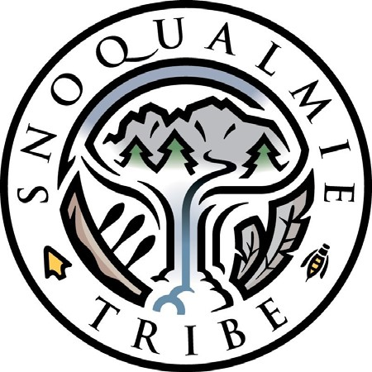

May 2, 2024

Louis “Ted” Neff, USFS

Mt. Baker District Ranger

810 State Route 20

Sedro-Woolley, WA 98284-1263

Re: *Snoqualmie Indian Tribe’s Comments on Proposed Temporary Shelters – Mt. Baker- Snoqualmie National Forest*

Dear Mr. Neff,

The Snoqualmie Indian Tribe (“Tribe”), a federally recognized sovereign Indian tribe and signatory to the Treaty of Point Elliott of 1855, with reserved rights thereunder, submits these comments in response to the Mt. Baker-Snoqualmie National Forest’s proposal to provide four temporary winter shelters for the recreating public. The Snoqualmie Indian Tribe has a vested interest in mitigating adverse impacts within NFS lands, as the Tribe’s Ancestral Forest is situated in lands bordering the Mt. Baker Snoqualmie National Forest in King County, Washington. Please accept these comments.

The Snoqualmie Tribe has stewarded their ancestral lands including the Mt. Baker-Snoqualmie National Forest since time immemorial. The Tribe is concerned because it has observed a significant increase in recreation impacts in the Cascades. Recreation has expanded in scope, volume, and duration – resulting in greater impacts to these areas throughout the year. Advances in technology and equipment means that recreationists can now access remote areas that were once difficult if not impossible to access.[1] The Tribe is concerned that these temporary shelters will result in an increase in recreational use that will have negative impacts to cultural resources including wildlife and water quality.

Winter is an important and unique time for many species. Species such as wolverine, mountain goat, pika, and subnivean dwelling rodents are vulnerable during the winter months, and are highly susceptible to starvation and exposure to the elements. These winter-loving wildlife are well-adapted to tolerate the harsh winter conditions. They have adapted to thermal regulation, metabolic regulation (such as hibernation and torpor), and have adapted physiologically by camouflaging amongst the snow and winter foliage and developing specialized movements for this terrain. These adaptations have occurred in the absence of winter recreation. The Tribe is concerned that encouraging the public to recreate longer and farther in this area could introduce an unnatural stress and burden on these animals.

In the winter months, maintaining a high body fat reserve is critical for survival. With the expansion of winter recreation, an increase in human and wildlife interaction may result in trauma-induced fight or flight behavior. The impact may not be readily noticeable, but the impact may be realized days, weeks, or months later. For example, mountain goats survive by gaining weight in the fall and expending as little energy as possible while they slowly starve their way through winter.[2] A healthy mountain goat in winter may be disturbed by winter recreators causing the goat to flee. This results in a spike in their metabolic rate and the expenditure of precious calories. The goat will appear fine at first, but in the following weeks or months the goat may be forced to forage in unsuitable conditions, subjecting itself to predation, exposure, or starvation. This fight or flight response paired with a spell of extreme cold or heavy snowfall may overcome their ability to survive. These proposed huts will provide a refuge for humans to safely exist in these harsh conditions for longer periods of time, perpetuating recreation pressure throughout the entire year against species such as the mountain goat.

With the recently documented decline in mountain goat population in the Cascades it is crucial to gather data on the population dynamics and potential causes of mortality before more stressors are introduced i.e. the proposed huts and increased recreation. It is unclear what the exact cause of decline is. Mass die offs of mountain goats in the Cascades have been attributed to “recreation, habitat loss, climate change, disease and predation are among them.”3

The Tribe opposes this recreation project plan as it does not address the impacts to wildlife that use this landscape. This project aims to expand winter recreation to multiple user groups by expanding and extending the duration of the inherent recreation impacts. The overuse and saturation of winter recreation venues does not warrant the expansion of winter recreation opportunities further into the backcountry.

Furthermore, the proposed development lacks a robust plan to mitigate the hut site for impacts such as human waste disposal and wildlife attractant issues. It is safe to assume that a dedicated site for human inhabitation will attract rodents and mesopredators leading to more human wildlife conflict as well as introducing a potential hotspot for predator prey interactions. There is additional concern regarding the accountability of the commercial outfitters to conduct operations in a manner that prioritizes the protection of cultural and natural resources as well as wildlife.

Our winter wildlife are specifically adapted to endure the Cascades in the winter time, whereas humans must proceed delicately when expanding our use into these harsh environments. The proposed project exemplifies the hubris of winter recreators while failing to address the inherent impacts on these highly adapted species.

Thank you for the opportunity to comment on this proposal, we hope that the representatives of the Mount Baker-Snoqualmie National Forest will consider our comments and continue to engage with the Snoqualmie Tribe early and often. If you have questions or wish to discuss this matter further, I can be reached at ezekiel.rohloff@snoqualmietribe.us

Sincerely,

Ezekiel Rohloff, Wildlife Biologist

Snoqualmie Indian Tribe

1. *See* Modeling large-scale winter recreation terrain selection with implications for recreation management and wildlife, Lucretia E. Olson, John R. Squires, Elizabeth K. Roberts, Aubrey D. Miller, Jacob S. Ivan, Mark Hebblewhite, , Applied Geography, Volume 86, 2017, Pages 66-91, ISSN 0143-6228, <https://doi.org/10.1016/j.apgeog.2017.06.023>
2. *See* Winter Recreation Impacts: A Comprehensive Survey Environmental Impacts of Winter Recreation, Eisen, H., Morgan, D., Paul, K., and Boyd, K., 2021,. Winter Wildlands Alliance.  [https://winterwildlands.org/wp content/uploads/2021/05/Winter_Rec_Science_2021_EmailWeb.pdf](https://winterwildlands.org/wp%20content/uploads/2021/05/Winter_Rec_Science_2021_EmailWeb.pdf)

   3“Almost All Mountain Goats Died after Airlift from Olympics to Cascades. ” Van Sistine, Ta’Leah *HeraldNet.Com*, 1 May 2024, www.heraldnet.com/news/almost-all-mountain-goats-died-after-airlift-from-olympics-to-cascades/.