Comments: **Trails at Mena – Draft Environmental Assessment**

David Peterson, PhD Applied Math, Michigan State University (1971)

As a frequent paddler, fisherman and hiker in Arkansas I have strong interest in maintaining the quality of, and access to, our wonderful national forests. As past president of the Ozark Society, I have been in many discussions with forest service personnel and have submitted more than my fair share of comments on pending land use proposals. Trails at Mena is one of the largest and confounding such proposal – 154 pages of acronym laden text, with hundreds of more pages in background references.

**Plan preference:** The long list of well-established safeguards in the proposal (p. 21-25) are meritorious on paper, but seem difficult to implement once having turned the 8832 acres over to State Parks in what appears to be a perpetual occupation. The proposal concedes that its normal standards will not be met, so why do it? **This speaks to supporting the first alternative – do nothing**. But supposing that political pressure and well-funded advocacy for pursuing the ”gravity” biking fad is intolerably strong, **alternative 4, or even 3, is next best**. As outlined below, there are serious doubts about the sheer size and scope of the project.

I am supposing that few state parks make money, but this proposal has enormous potential financial downsides for both the Ouachita National Forest and the State. The proposal seems to require annual subsidies from the state budgeting process (an unpredictable prospect) as well as unspecified, but significant, long term private contributions from Friends of State Parks Foundation (the proposal lists no historical track record of stability or size of donations for the latter). Given the uncertainty of predicting the viability of a project of this size it seems prudent to limit the risk by **restricting initial interventions to the Ward Lake Zone** and then proceed with caution if independent studies over several years show long term promise.

**Is the EV bike a viable alternative to lifts in the Ward Lake Zone** for those who don’t want to waste energy climbing the hills (a common justification for lifts)? I support EV bikes in this endeavor in order to make the Trails at Mena project more accessible.

**With any of Alternatives there is a real possibility of lifts and damaged trails being returned to Forest Service responsibility.** The proposal has little means, or apparent interest, of estimating this likelihood. In any case, there is no mechanism given beyond “good will” for accessing state or private money to help with a remediation task that might be more expensive than the initial construction process.

The proposal is vague in many places but to just name a few;

* How does the State or FS protect the objectives of other trails in the area, e.g. Ouachita trail?
* This project will require more FS manpower and costs, even though the proposal seems to shove this into the state/private responsibility box. In the many meetings we have had with FS workers, this is a universal theme. Front money for “development” arrives without continued maintenance resources.
* While shuttling operational control and maintenance costs onto the State, there will be a sizable people handling problem and resource impact on the periphery of the 8832 acres. This burden will seemingly be borne by the FS.
* There are no projections of the impact of lift ticket costs ($50-100) or equipment rental ($80-160), etc. on the viability of these types of projects which seem to be most attractive to affluent, well educated, males (on short supply in the Mena area).
* The climate change section, while sincere and packed with interesting information, misses the main CO2 impact of this project which is not likely viable without substantial out of area visits from affluent metropolitan areas in NW Arkansas and Dallas. Thousands of 400 mile car trips in states like Arkansas which has fewer that 2% hybrid or ev cars?
* While the proposal clearly wants to minimize erosion from the project, it is inevitable that vastly increased trail usage increases the problem, including vegetation damage. The bike park at Cadron Settlement Park in Conway is essentially bare. Good intentions and many written rules don’t necessarily solve the problem, especially with limited enforcement.

**Preliminary Study of 83 bike parks shows Trails at Mena to be an extreme outlier:** The website “A Complete List of Downhill Bike Parks,” contains information on 83 bike parks from 31 states. While probably not really complete, there seems to be no obvious bias in selection, and there is sufficient information for comparing Trails of Mena to the rest of the nation. There is some routine information: 86% of bike parks have bike rental facilities, 76% allow EV bikes. And then 9 parks rely on shuttle service only, while 62% have access to one lift, 28% have two lifts, 6% have three lifts, and the most lifts used, by one park is 4. Most bike parks are associated with existing ski areas or developed recreation areas. They might employ more than one or two lifts but they don’t seem to need them or they are not a cost effective expansion. Trails of Mena, when completed, proposes constructing more lifts (5). This seems like unnecessarily disruptive of Forest Service land, and at great expense. **Conclusion: Trails at Mena is an extravagant waste of pleasant forest land, and probably a sinkhole for state money and resources.**

**But there is more.**  Most bike parks are compact, and don’t need a large number of trail miles to satisfy their clientele who seem to prefer “…steep grades, jumps, drops, artificial rock structure, bridges and other features to create a desirable bike optimized experience that are outside typical Forest Service design and maintenance standards.” [P. 6] This means that **the goal of “multiple use” on the proposed 8832 acres is largely unavailable to hikers, hunters, birders, etc. despite repeated assertions in the proposal to the contrary -** at least in the areas of more intense use.

Trails at Mena, in various locations in this draft, propose 100-125 miles of over developed, and sometimes with severely altered and/or damaged terrain (common bike park examples below).

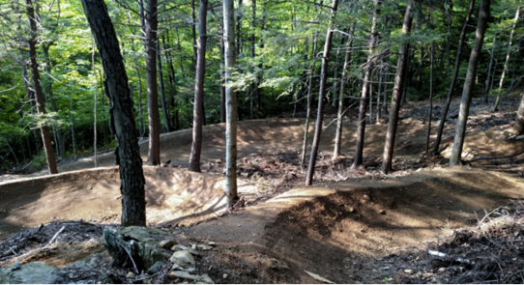 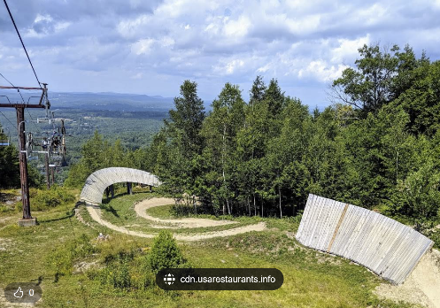

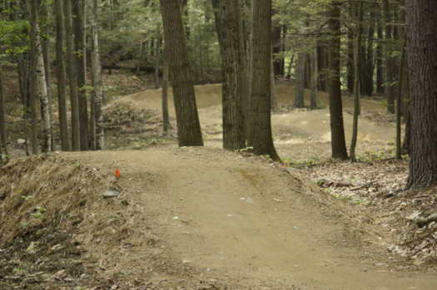

This is a **statistical outlier,** the next largest milage in the survey is 103 miles, and **the median trail milage is 18 miles**, see chart.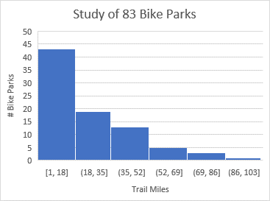 The apparent excessive trail milage might reflect the additional goal of connecting Queen Wilhelmina State Park to Mena, but the proposed trail miles and infrastructure seem unnecessary even for this goal. The proposal emphasizes the need for lifts so riders can lap the steep parts repeatedly even while the trails sprawl over 8832 acres?

**Demographic mismatch:** From the paper, *Economics of Mountain Biking and Bike Trail Events and Festivals in West Virginia,* we find thatIMBA membership has a median age of 44, 76% have a bachelor’s degree or higher (compared to 31% in the US, and 16.3% in Polk County), median household income is $100,000 (compared to $60,336 for the nation, $96,907 in Bentonville, and $46,499 in Polk County). According to this paper Bentonville is now recognized as a cycling mecca with over 100 miles of single track trails and 57% of users from outside NW Arkansas.

**But this does not mean that the Bentonville experience can be transported to Polk County – no convincing evidence of such a transformation is presented in the proposal even though it is apparently used as a model of economic potential.**

Economic projections and visitation patterns established in NW Arkansas such as on p. 66 seem to be mere conjectures, largely without any actual appropriate data (IMPLAN modeling not-with-standing). For instance, the proposal projects 250,000 visitations creating 663 direct and indirect jobs, a ratio of 2.65 jobs per thousand visits by 2036. For comparison purposes, the Buffalo River National Park currently claims 1.5 million visitations supporting 960 FTE jobs, a ratio of 0.64 jobs per thousand visits. A potentially useful study, *Chattanooga Mountain Biking Impact Report*, lists 48,315 visitations and 73 FTE employees in Hamilton County for a ratio of 1.51 jobs per 1000 visitations. The in-house paper *Estimating the Economic and Health Benefits of Bicycling in Northwest Arkansas* produced by the Walton Family Foundation finds 65,000 visitations creating 743 FTE employees for a ratio of 11.4 employees per 1000 visitations. These findings seem to substantiate the conclusion from a review of 33 academic studies, *Mountain Bike Tourism Economic Impacts: A Critical Analysis*, which found “widespread inconsistency … contributing to a fragmented body of knowledge …”

**Conclusion: This project needs to guard against false comparisons demographically and culturally, as well as the tendency to draw conclusions and make projections from limited data, fads and/or narrow based special interest advocacy groups e.g. IMBA.**

An extensive unbiased search of the literature and deep dive into bike park financing might not be able to yield reliable visitation projections up to 2036 (can any economic pattern be trusted 12 years out?)But it is worth a try before spending 40 million dollars or so on lifts and digging up and remanufacturing terrain for 100+ miles of trails.

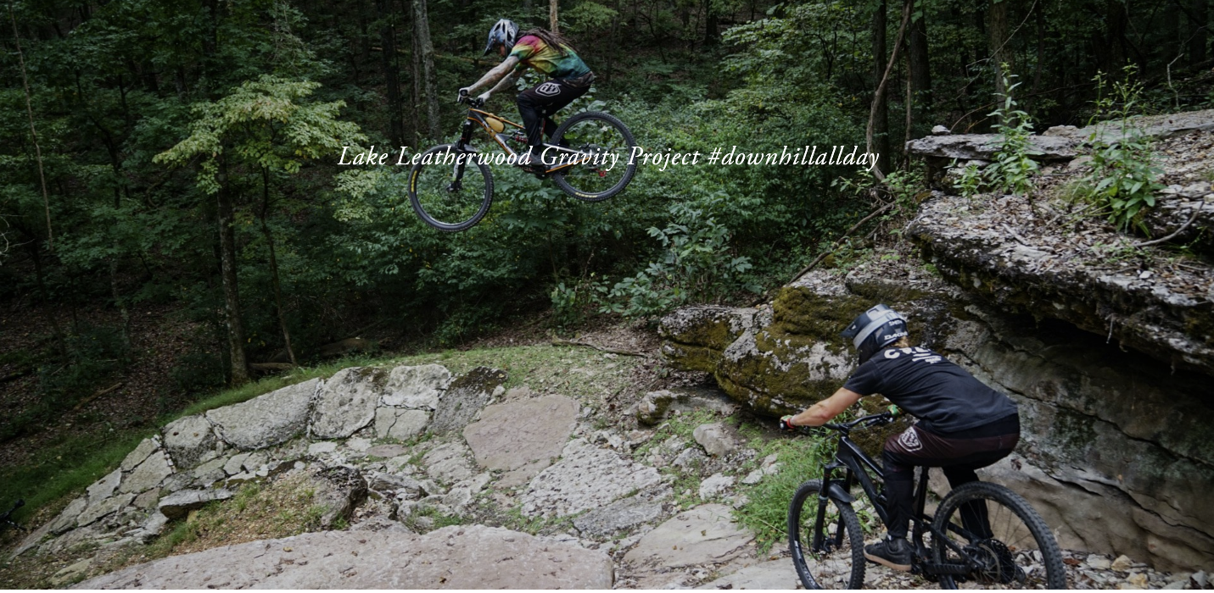

Sharing the trail in NW Arkansas, shuttle service only no lifts.