Comments:

Hawk Inlet Pb paper by FOA

April 2023

The Friends of Admiralty paper on lead in clam shells attempts to connect a suggested rise in clam shell lead to any or all of the following factors: fresh water, saltwater, sediment, and fugitive dust in and around Hawk Inlet. One study referenced in the FOA report is the ADEC 2017 TMDL report for Hawk Inlet. Sample locations referenced in that report are presented below. Screen shots are taken directly from that report. Figure 1-3 [21][1] shows sample locations.

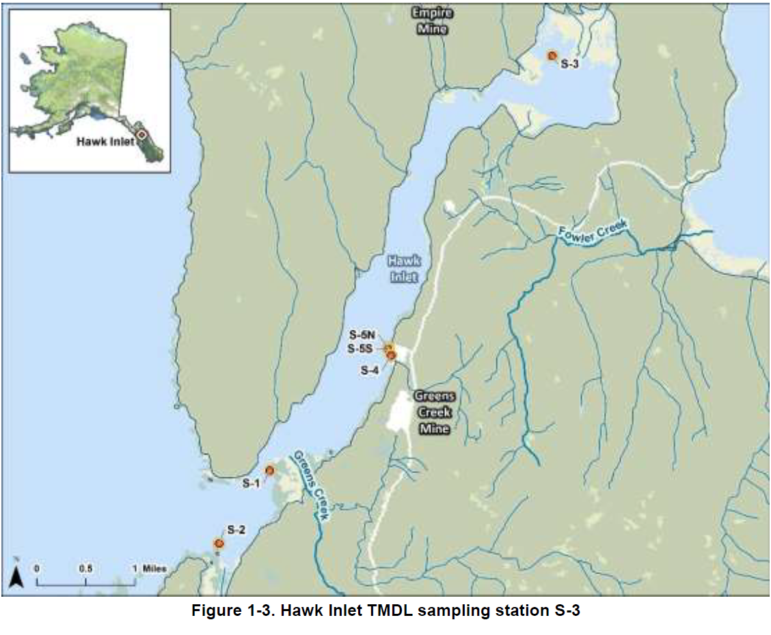

You will note that three of the six sites are immediately proximal to the ship loading facility (S-4, S-5S, S5N). All lead values in sediments are less than the Effects Range Low values (ERL). The sites most proximal to the ship loader – and intended to monitor for its effects – are S-5N and S-5S. Lead values at these sites vary by a factor of 7, only 50 feet apart. Site S-4, 750 feet away is 1/23 the value of S-5N (the higher of S-5S and S-5N). The TMDL report thus highlights that measurable lead in sediment is isolated at the ship loader and is declining with time and subsequent sampling. The TMDL study also shows no exceedances of ERLs for any other metals measured beyond S-5S, S-N, and S-4, which are in the immediate area of the ship loader.

None of the average concentrations of metals in marine sediment exceeded the cadmium, mercury or zinc ERL screening benchmarks at any of the stations pre-mining or production. The production average metals concentrations were typically below the pre-mining average concentrations. The only average metals concentrations that exceeded the ERL screening benchmarks were the pre-mining averages for copper at stations S-3 and S-4 and the pre-mining lead average at station S-4. [21]

It is apparent the sediment metals data from Hawk Inlet are most likely biomodal; that is, there are many non-detects on one hand, and some concentrations above the detection limit on the other – as is noted above for the sites below the ship loader. Calculation of the arithmetic mean of such a data set can be misleading and statistically inappropriate. Use of the arithmetic mean in the FOA paper is not supported by the data, which do not appear to be normally distributed, and thus, meaningless. Use of the T-test in the FOA paper appears to be improper due to the apparent violation of normality of the data. Perhaps a transformation of the data through logarithmic transformation or rank scoring would more closely satisfy a normal distribution or the use of a non-parametric statistic such as the Mann-Whitney U test, respectively.

Thus, there is no reason to place credibility in the supposed different means of the Young Bay and Hawk Inlet lead concentrations in clam shells or sediment unless the underlying assumptions of the statistical analysis can be demonstrated. And they have not.

A separate claim of the FOA paper is that “FOA found the concentrations of all measured metals had increased substantially since mining began.” (p. 8). We could not substantiate this claim. Table 3-28 (p. 105) of the 2017 ADEC TMDL report compares pre-mining (1984-1988) and post-mining (2005-2015) data sets. Our summary of those tabulated data show that almost all metal in sediment concentrations have decreased, not increased.

The FOA paper again references statistics of central tendency for all stations monitored (p. 8) [16][2]. A quick review of tabulated data contained in this reference [16] shows the highest lead in sediment again occurs in the stations at or very near the ship loader (S-4, S-5). All other stations are of lower magnitude. This again illustrates these materials under the ship loader are not mixing into the inlet sediments up basin or down. The use of statistics of central tendency by the FOA report author allows these stations under the ship loader to unrealistically influence the characterization of the stations located up and down basin.

Specific review comments regarding the FOA paper follow:

1. The abstract is really an introduction and only references a “result” in the final two sentences of the paragraph. And that “result” is an untested hypothesis regarding fugitive dust, which is only “suggested” in the paper, but not tested. Thus, by any accepted standard, there are no tested conclusions in the paper that the author has referenced in the abstract, which is – of course – the singular purpose of an abstract.
2. Introduction (p. 4) states erosion is uniform in time. In steep temperate forested environments, this is untrue. In these environments, erosion and sediment production are episodic in location and time. Erosion and sediment transport processes include various mass wasting mechanisms; such as slumping, shallow slides, debris flows and torrents, root wad jacking, bank collapse, channel avulsion, fan trenching, and others. Landform exceedance of geomorphic thresholds as punctuated by energy inputs (precipitation/runoff events) generally determines stability/failure. Erosion as a result of overland flow due to rainfall intensity exceeding infiltration capacity does not generally apply in these environments. Therefore, sources of sediment from the landscape can be spatially and temporally variable.
3. Also, p. 4 states mining firms use leaded gas. Not true – other than aircraft – which is ubiquitous for all travelers in SE Alaska.
4. P. 5 assumes lead in clam shells is conservative. This study does not establish this via evidence as a prerequisite of its use as the very thesis of its study.
5. P. 5 para 3 states physical and chemical weathering have no effect on Pb isotope ratios. If so, mining, which is a physical and hydrochemical process would have no effect and thus no signature other than the parent material, which is the orebody, which has contributed to the watershed runoff for millennia – e.g. the Big Sore.
6. FTFAF found no reference to any Table or Figure in the paper until Table 9, which had no description of data contained therein. This is ambiguous and does not provide a clear, understandable, and repeatable analysis process.
7. P. 8 Young Bay watershed is underlain by a different geologic formation than Hawk Inlet – Gravina-Nuzotin greywacke/mudstone with volcanics and Gambier Bay schist, respectively. The latter contains economic massive sulfide deposit(s). No such rocks have been found in Youngs Bay watershed. These are not the same rocks. Youngs Bay is a poor choice of control for Hawk Inlet.
8. P. 8, final paragraph states ADFG (2016) study and Martin Marietta (1981) studies found different (though unquantified) levels in clams on Greens Creek delta. What was the method of study and level of effort in both cases? Are they present today? Why is this issue raised since the paper makes no further reference to this comparison?
9. P. 9, second to last paragraph, references the ADEC TMDL (2017) study, which purportedly failed to show a source of apparent elevated Pb concentration, yet posited fugitive dust as a source. If so, what was the basis for this supposition and what merit does it have in the current discussion. An accusation twice made is proven?
10. P. 11 discusses EPA use of 1/2 of the MDL as a real number for statistical analysis when results are below the MDL. This is arbitrary and of no use in understanding nature. It is biased, presumptive, and arbitrary. Such interpretation of analytical results must be considered “estimated” and not utilized in computations. This raises the issue of a QA/QC program for this “study” as would properly be done according to ADEC protocol and codified via a QAPP. Without a QAPP and associated analysis of data collected plus the analysis methods and results, there is no means of documenting data quality. As such, all data in this “study” can at best be considered as “estimated” and are only suitable for qualitative analysis. Were there trip blanks, blind samples, duplicate samples, etc? If so, what were the results? If not, why not? Table 6, p. 17 appears to discuss laboratory QA/QC replicate analysis of the same shell – not field methods of shell collection, transport, and processing.
11. P. 12 final paragraph purports to utilize a local rate of isostatic rebound, which is then stated to be uniform through time. Based on what? One isopach map of isostatic rebound does not confer rate.
12. P. 13 suggests human activity could have disturbed shell deposits and then suggests there has been no such disturbance. How was this determined?
13. P. 13 the referenced method of elevation determination is inaccurate. Confidence limits on ages should reflect a lack of same.
14. P. 14 states 70% of the shells were dissolved away prior to analysis. What justifies this practice and what is the expected error associated with eliminating most of the sample?
15. P. 14 final paragraph, author assumes an accuracy for elevation of samples without the benefit of any measure(s) by which such might be determined.
16. P. 16 use of parametric statistics for water and sediment quality data is problematic. These variables, especially in clean environments are highly skewed to non-detect values. Thus, the parameter frequency distributions are highly skewed and non-normal. In order to apply parametric statistics to these data it is first necessary to utilize transforms; such as, logarithmic values, or alternatively shift to nonparametric statistics. Secondly, results from ADEC studies show there is generally non-detect to low values in Hawk Inlet with higher values in the sediment of the 1989 ship loader spill. None of their data show a migration of Pb from these sediments into the greater Hawk Inlet ecosystem. This results in a bimodal distribution of Pb concentrations. That is, (1) either low to non-detect, and (2) values at the ship loader. By utilizing the arithmetic mean, median, mode or some other measure of normal distribution central tendency, the author attempts to portray a normally distributed sample of Pb concentrations with a central tendency highly influenced by the ship loader sediment concentrations. This biases the characterization of the inlet upward. This use of statistics is incorrect and all associated conclusions are non-rigorous and speculative.
17. P. 17 first paragraph, even if parametric statistics were applicable, sample size of 5 allows for few degrees of freedom in the t-test.
18. P. 17 second paragraph, the author eliminates one of the five samples by stating it is an outlier. With such a small sample size and non-normal distribution (assumed), there is no basis to suggest any sample is an outlier.
19. P. 17 paragraph 4, offers an unsubstantiated discussion on Pb in clams. There is no basis for this discussion.
20. P. 17 final paragraph, suggests the predominate wind direction in Young Bay is from the east / northeast, but fails to provide any substantiating evidence or data. Anecdotal observations by others suggest westerlies are common.
21. Table 8, p. 21 again lists a total of 5 or 6 samples of clam shells were obtained from any one location. Thus n=5 or 6 in t-tests referenced. Classically, n=30 is considered appropriate to ensure the sample population is normally distributed. Sample size is too small.
22. P. 23 paragraph 1, makes apparent reference to sediment load, but only discusses concentration. If so, what is the implication?
23. P. 24 paragraph 3, suggest GC has opined dust may be a source of “dissolved” lead in freshwater. There is no basis for this. Perhaps there may be total recoverable results in freshwater, but we would need to see actual dissolved Pb data for freshwater. Total recoverable is a weak laboratory extract and not representative of field dissolved concentration.
24. P. 25 third to last paragraph, proposes that sediment and tissue Pb concentrations are due to historic cannery operations. Based on what? This is an untested assumption.
25. P. 25 second to last paragraph, suggests Pb would not be bioavailable in dissolved organic form, yet then assumes it would be available in this form.
26. P. 27 first conclusion, suggests the baseline study should be repeated, but to what end? Baseline studies are for the purpose of establishing a picture of existing ecosystems and environments in order to help assess potential impacts – not to serve as a basis of comparative study for the actual measurement of impacts over time. Separate monitoring programs of the project – as permitted – have been designed and employed for this purpose. Results of those studies are routinely examined and show little to no impacts.

In conclusion, please reference back to the FOA paper’s abstract wherein the only conclusion is the speculative suggestion that lead levels in clams and/or the environment may be tied to fugitive dust. The FOA paper’s author hypothesizes a dust plume traveling roughly southwesterly and thus directly impacting the Greens Creek fan/delta area (Plate 8, p. 27). This is entirely speculative and lacking any corroborating information. Fugitive dust as a source of environmental lead is not proposed as a testable hypothesis in this paper. This nonexistent hypothesis cannot be and is in fact not tested in this paper, and thus no conclusion can be drawn. It is unclear why the issue of fugitive dust is broached at all.

The exact purpose of the FOA paper on clam shells is unclear. Questions raised therein are not answered, and suggestions (not hypotheses) are proposed, but not tested. This work contributes little if any substantive information on the Hawk Inlet environment or the potential impacts of Greens Creek on that environment.

1. [21]Total Maximum Daily Load for Metals in the Marine Sediments of Hawk Inlet near Juneau,Alaska. Alaska Department of Environmental Conservation. May 2017 (TMDL)
2. [16] M. Ridgway. Trace Metals and Organic Compounds in Seabed Sediments 1978-2016 Hawk Inlet & Young’s Bay, Admiralty Island, Alaska. Oceanus Alaska for Friends of Admiralty. 2016.