November 10, 2023

I am resubmitting my letter from December 17, 2022. At one time, in the POWLLA Recreation Planning discussion, consideration of Class 1 e-bikes on trails closed to motorized vehicles was in the plan. I no longer see it discussed. I may have missed it. I ask that you stipulate that Class 1 e-bikes, of less than 750 watts, equipped with a motor that provides assistance only when the rider is pedaling and that ceases to provide assistance when the e-bike reaches the speed of 20 miles per hour, be allowed to operate on these trails. Thank you…

To whom it may concern:

On March 31, 2022, the US Forest Service published a news release concerning e-bike usage on National Forests and Grasslands. <https://www.fs.usda.gov/news/releases/usda-forest-service-issues-guidance-manage-future-e-bike-use-national-forests-and>. The updated guidance lays out the necessary steps before opening a trail to e-bike use: local Forest Service land managers will analyze the potential effects on the environment and examine trails to ensure e-bikers and other users can recreate safely.

Forest Service Manual 7700, Travel Management, Chapter 10, Travel Planning has been amended to include 7715.03 (9) Consider emerging technologies (such as e-bikes) that are changing the way people access and recreate on NFS lands. For example, where suitable for use, e-bikes may provide new opportunities for individuals who might otherwise be prevented from experiencing an NFS trail without assistance from an electrical motor. Forest Service Manual 7705, Definitions have been amended to include:

Electric Bicycle (E-Bike). Also referred to as an electric mountain bike (eMTB), a type of motor vehicle with two or three wheels, fully operable pedals, and an electric motor of not more than 750 watts that meets the requirements of one of the following three classes:

a. Class 1 E-Bike. An e-bike equipped with a motor that provides assistance only when the rider is pedaling and that ceases to provide assistance when the e-bike reaches the speed of 20 miles per hour.

b. Class 2 E-Bike. An e-bike equipped with a motor that may be used exclusively to propel the e-bike and that ceases to provide assistance when the e-bike reaches the speed of 20 miles per hour.

c. Class 3 E-Bike. An e-bike equipped with a motor that provides assistance only when the rider is pedaling and that ceases to provide assistance when the e-bike reaches the speed of 28 miles per hour.

I am asking you to consider the usage of Class 1 e-bikes on Indian, Cutthroat, and Honker trails. Trails that are now closed to motorized vehicles. I ask that you stipulate that Class 1 e-bikes, of less than 750 watts, equipped with a motor that provides assistance only when the rider is pedaling and that ceases to provide assistance when the e-bike reaches the speed of 20 miles per hour, be allowed to operate on these trails.

Please begin the appropriate environmental analysis and public engagement to determine if e-bike usage on these roads is appropriate.

<https://www.fs.usda.gov/sites/default/files/2022-04/Ebikes.pdf>

Thank you.

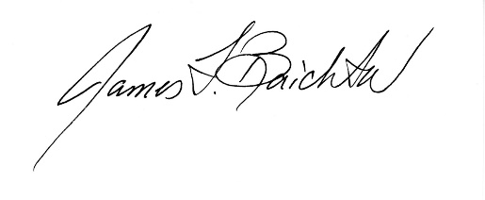

James F. Baichtal, Sc.D. (Hon.)

P.O. Box 19515

Thorne Bay, Alaska 99919 (907)-209-6690 baichtal557@gmail.com