April 20, 2020

**Zack Peterson**

**Forest Planner**

**Nez Perce-Clearwater National Forest Supervisors Office**

**903 3rd Ave**

**Kamiah, ID 83536**

**Mr. Peterson,**

**Please accept my comments on the proposed Nez Perce-Clearwater Management Plan. These wild lands are vital to wildlife.**

The Wild Clearwater Country is the northern half of the largest [undeveloped](https://friendsofthebitterroot.us18.list-manage.com/track/click?u=3dd4f14b16ed787874c44da74&id=295c243903&e=fdce63bc41) watershed complex in the Lower 48. It is also part of the furthest inland temperate [rainforest](https://friendsofthebitterroot.us18.list-manage.com/track/click?u=3dd4f14b16ed787874c44da74&id=5f05fc4167&e=fdce63bc41) in the world. This special place provides crucial habitat for numerous imperiled species such as [wolverines](https://friendsofthebitterroot.us18.list-manage.com/track/click?u=3dd4f14b16ed787874c44da74&id=ca9e6cf1a2&e=fdce63bc41), gray wolves, grizzly bears, [Canada lynx](https://friendsofthebitterroot.us18.list-manage.com/track/click?u=3dd4f14b16ed787874c44da74&id=6b7ddd0fb1&e=fdce63bc41), fisher, salmon, steelhead and [Bull trout](https://friendsofthebitterroot.us18.list-manage.com/track/click?u=3dd4f14b16ed787874c44da74&id=86742a7cfb&e=fdce63bc41).

The Natural Heritage Program provides information on Montana's species and habitats, emphasizing those of conservation concern. This program, NHP, has a listing of sensitive species, SOC and threatened species. Besides listing species, information is given that shows year round residence and other habitation requirements. Also given is elevation specific observation, type of habitat and recent observations.

I looked specifically in the NHP to find SOC, Threatened and Sensitive species in the areas of the Nez Perce and Clearwater National Forests that are in this proposed action. I will not list all, there are too many.

Some of the SOC birds; Great Grey Owl, a permanent resident that requires dense conifer cover near water sources, Lewis Woodpecker, a permanent breeding resident, Pilliated Woodpecker, Black Backed Woodpecker. Woodpeckers generally require large dead trees and snags. Other birds; Brown Creeper, Pacific Wren, Verry, Varied Thrush, Evening Grosbeak, Cassin’s Finch and the Peregrine Falcon reside in the project area.

**Species of Concern (SOC)**

Species of Concern are native taxa that are at-risk due to declining population trends, threats to their habitats, restricted distribution, and/or other factors.  Designation as a Montana Species of Concern or Potential Species of Concern is based on the Montana Status Rank, and is not a statutory or regulatory classification.  Rather, these designations provide information that helps resource managers make proactive decisions regarding species conservation and data collection priorities

I hope that you will use the SOC management recommendations in your management of the project area.

**Sensitive Species**

I looked at Sensitive Species in the project area, and will list a few; Flammulated Owl, a species that migrates through the project area through mature old growth forests, and the Western Toad which requires intact and clean wetlands.

I hope that you will use the Sensitive Species management recommendations in your management of the project area.

**Sensitive Species**

|  |  |
| --- | --- |
|  | U.S. Forest Service Manual (2670.22) defines Sensitive Species on Forest Service lands as those for which population viability is a concern as evidenced by a significant downward trend in population or a significant downward trend in habitat capacity.  **Threatened Species** in the area include the Canada Lynx  **USFS Proposed for listing** in the project area is the Wolverine |

**Recommended Wilderness, Designated Wilderness** The draft plan poses a severe threat to the remaining 1.5-million acres of undeveloped [wildlands](https://friendsofthebitterroot.us18.list-manage.com/track/click?u=3dd4f14b16ed787874c44da74&id=073ffe02bc&e=fdce63bc41" \t "_blank) in the Clearwater. The FS has indicated that any roadless areas not recommended as wilderness in the new forest plan could be developed (logged). These irreplaceable roadless areas, which provide some of the best habitat in the Basin, should instead be recommended as Wilderness. It is incredibly important to leave roadless areas intact and designate them wilderness quality for many reasons. If not left intact there are many ramifications; habitat fragmentation and severing wildlife corridors.

**Habitat Fragmentation**

**The effects of habitat fragmentation were featured in** [**a recent scientific report**](https://esajournals.onlinelibrary.wiley.com/doi/10.1002/ecs2.2380) **prepared by researchers Andrew Hansen and Linda Phillips at Montana State University. They concluded:**

* species to varying degrees will have their range and distribution affected by climate change and development. Hundreds of others could be added to the roster of impacted animals.
* “On private lands, in contrast, vital signs relating to snow, stream flow and temperature, river condition, native fish, and wildlife habitat were rated as deteriorating,” they conclude.
* “Even within designated protected areas, wildlands are being reduced due to downgrading, downsizing, and degazettement. Currently, 33 percent of the global protected area coverage is under intense human pressure,” the EcoSphere article notes.
* The following chart shows different land classifications and the protective values of each. It is clear that National Parks and Wilderness are the most protective. The chart below is quantified and from MSU Hansen, Phillips.
* There are no quantitative standards for protecting watersheds and fish habitat in the plan.

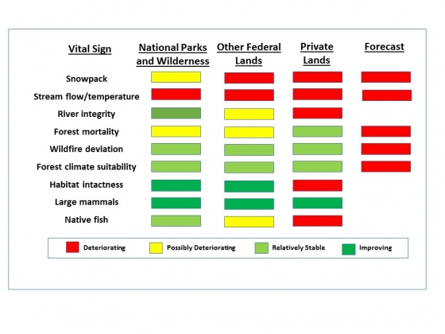

**Wildlife Corridors**

The nation is well aware of the importance of wildlife corridors and the need to protect them. Below is one act that is presently in Congress. Another is the Northern Rockies Ecosystem Protection Act (NREPA). The west Missoula portion of the NREPA map is identified as a wildlife corridor route.

**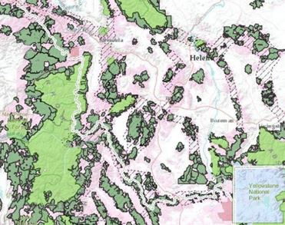**

**Udall, Beyer Introduce Wildlife Corridors Conservation Act To Safeguard America’s Biodiversity**

December 8, 2018 - 8:45am

**U.S. SENATE News:**

* introduced the Wildlife Corridors Conservation Act of 2018 to protect and restore fish, wildlife, and plant species, in particular, those that are at risk to habitat loss and fragmentation--a major factor in species decline and extinction.

**Montana has recognized corridors and connectivity**

Corridors are recognized as a national issue and have long been a Montana issue. Here are excerpts the Montana Connectivity Project: Statewide analysis Executive Summary-October 2011

* the connectivity project was started following the initial work on the Crucial Areas Planning system(CAPS). As one of the first states to begin working on the Western Governors Association's(WGA)Crucial Habitat and Corridors Initative, Montana began examining species and habitat connectivity at the landscape level in 2008...work was largely completed in 2011
* the top five ranked species for each ecotype combination were selected as candidate focal species.
* satisfying the connectivity needs of these species will satisfy the connectivity needs of most vertebrate species in Montana
* Forest generalist black bear, elk, grizzly, mountain lion, mule deer
* Forest specialists lynx, moose, wolverine, Cassins finch
* grassland/shrub pronghorn, swift fox, ferruginous hawk, Baird's swallow, long billed curlew, mountain plover
* riparian piping, rough legged hawk, Townsend big eared bat, trumpeter swan, northern leopard frog

**Connectivity Science is clear about why we need corridors and where we need them. Below is a peer reviewed study.**

Connectivity and corridors are recognized nationally, regionally and by the state, but this is not adequately covered in the project plan. Below is a corridor map that shows the importance of the project area. It is vitally important for wildlife to have corridors that connect large protected areas like national parks and wilderness areas. You can see how little wilderness there is (the dark areas) wildlife must have more and the protected areas must be connected. Below is the study that this map is associated with. In the document are other maps. 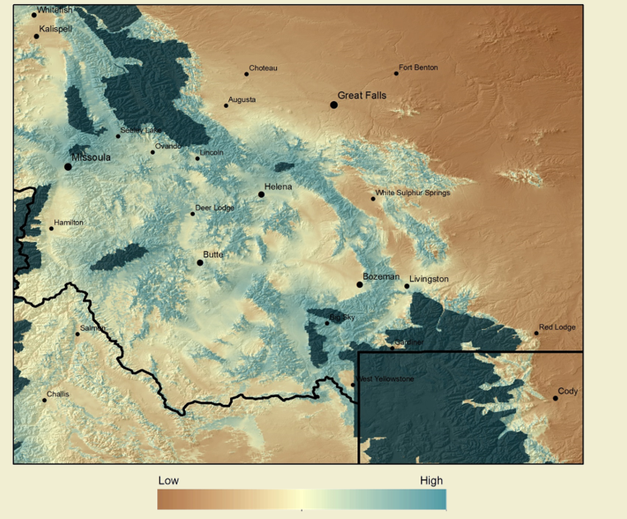

**Identifying Corridors among Large Protected Areas in the United States; Belote RT, Dietz MS, McRae BH, Theobald DM, McClure ML, Irwin GH, et al. PLOS ONE 11 (4):e0154223. doi: 10.1371/journal.pone.0154223; April 22, 2016**

**Economics**

**Economics**

The annual value of nature tourism to the region, for Yellowstone and Grand Teton parks alone and led by growing interest in wildlife watching, is more than $1 billion. Montana data has been gathered for Montana by the University of Montana.

The UM, Institute of Tourism and Recreation Research, conducts yearly non resident tourism data collection. In 2018 over 12 million non residents visited Montana and contributed 5.24 billion dollars to Montana communities and created 58,000 jobs. (11)

It is clear how important tourism is to Montana in both dollars and jobs.

Here are the top three activities that tourists come to Montana for:

* Hiking and trail running 67%
* Camping 66%
* Bird watching and wildlife watching 49%

These activities require intact ecosystems like we have in the project areas. It is in Montanans best interest to support intact ecosystems, that is what visitors come to see. I have traveled through, hiked and camped in this area, I know how special it is.

Montanans also support strong ecosystems like we find in WSAs and Wilderness Areas. This support is documented by the University of Montana's Crown of the Continent and Greater Yellowstone Initiative survey of Montana voters

* the survey is done every two years "to get a clear picture of where Montanans stand...on proposals and policies regarding the management of our shared public lands"
* the UM does not take positions on the results, but "do stand by the integrity of every voter survey"
* the survey showed that only 11% of Montanans supported eliminating protections for WSAs. 84% of Montanans say keep them as they are or add more.
* the survey showed that Montanans are more often on the side of enhancing public lands not removing protections. That support is intensifying and is stronger today than it was four years ago
* Montanans say protect, and the new UMCrown of the Continent poll for 2020 shows the number of those saying protect is even higher.

It is in the economic best interest of the local community, state and the nation to maintain a healthy ecosystem that supports wildlife.

**Wilderness protects our clean, cold water, elk herds, mule deer, grizzly bears, wolverines, birds, forests and landscape. It also provides refuge for people: a place free from light and noise pollution. Wilderness is a place of solitude in an ever increasing world filled with commotion and distraction. It’s our responsibility to protect this special place before it’s too late -- our children will thank us.**

**Standards for old-growth**

The draft plan would allow logging in designated old growth, a departure from current standards that protect old growth habitat from development. This could greatly affect old-growth dependent species like the imperiled [Northern Rockies fisher](https://friendsofthebitterroot.us18.list-manage.com/track/click?u=3dd4f14b16ed787874c44da74&id=952251dd6c&e=fdce63bc41) and other SOC and Sensitive species.

**Grizzly bear recovery**

In 2019, three or four grizzly bears were observed on the Clearwater and Nez Perce National Forests. . Despite the new bear sightings, [grizzly bear recovery](https://friendsofthebitterroot.us18.list-manage.com/track/click?u=3dd4f14b16ed787874c44da74&id=2708128254&e=fdce63bc41) is ignored in the draft plan. Natural corridors on both forests could be fragmented with roads and increased motorized recreation, as well as the permitting of mechanized (mountain bikes) recreation. There would be little-to-no secure habitat for grizzlies outside of designated Wilderness.

Here is an excerpt from a judicial determination from September 24, 2018

**Despite its recognition that continued isolation poses a threat to the Yellowstone**

**grizzly, there is no regulatory mechanism in place to address the threat, only**

**Montana's commitment to "manage discretionary mortality" between populations**

**in order to "retain the opportunity for natural movements of bears between**

**ecosystems." Id. Of course, those natural movements have not yet occurred.**

**Ruling 9/24/2018 Judge Christiansen.**

**The judge will not delist because the populations are not connected, and I fear that if the project goes forward one path of connectivity will be severed.**

**This plan inhibits the grizzly populations in the Greater Yellowstone Ecosystem and the Northern Continental Divide Ecosystems to connect and enable genetic connectivity of the grizzly populations. Mapping of the routes of connectivity for gene flow is in the document below; page 3 shows how close the GYE and the NCDE are, page 10 shows the least cost paths One important area that is required is the NPCW NF planned project.**

Potential paths for male-mediated gene ﬂow to and from an isolated grizzly bear population CHRISTOPHER P. PECK,1,4 FRANK T. VAN MANEN,1, CECILY M. COSTELLO,2 MARK A. HAROLDSON,1 LISA A. LANDENBURGER,1 LORI L. ROBERTS,2 DANIEL D. BJORNLIE,3 AND RICHARD D. MACE2

**Climate Change**

Every alternative in the revised plan increases logging levels for these two forests and eliminates the forest’s potential to sequester carbon, which is sorely needed. Both forests would be largely manipulated to achieve agency “desired conditions.”

**2017 MONTANA CLIMATE ASSESSMENT** Bozeman and Missoula MT: Montana State University and University of Montana, Montana Institute on Ecosystems made the following projections;

* Average temperature Since 1950, average statewide temperatures have increased by 0.5°F/decade (0.3°C/decade), with greatest warming in spring; projected to increase by 3-7°F (1.7-3.9°C) by mid century, with greatest warming in summer and winter and in the southeast. ­ Maximum temperatures have increased most in spring and are projected to increase 3-8°F (1.7-4.4°C) by mid century, with greatest increases in August and in the southeast.
* Extreme heat days are projected to increase by 5-35 additional days by mid century, with greatest increases in the northeast and south. Minimum temperatures Minimum temperatures have increased most in winter and spring and are projected to increase 3-7°F (1.7-3.9°C) by mid century, with greatest increases in January and in the southeast.
* Frost-free days Frost-free days are projected to increase by 24-44 days by mid century, particularly in the west

This management plan needs to use the Montana Climate Assessment and other climate projections into management decisions, there are too many studies coming out on a regular basis that say it is a huge factor to consider and will be more of a factor in the future.