I forgot to include these photos of timberslides and avalanches that happened as a result of the 2007 Cascade Complex Fire. In 2019.

It cost Valley County taxpayers $400,000 to restore this one section of road after Forest fire debris blocked the river,  forcing it over the road.

The Forest Service allowed Valley County to rebuild the road, but not clear the river.

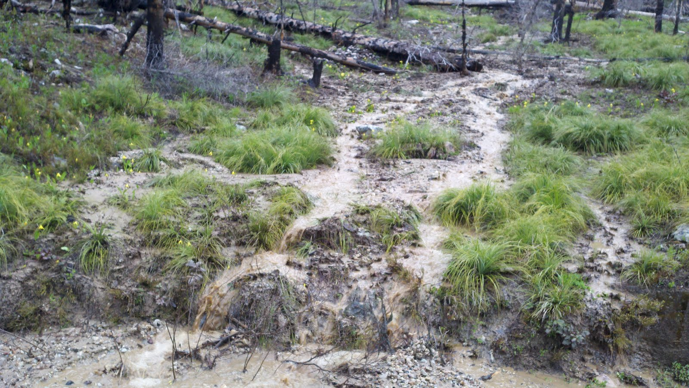

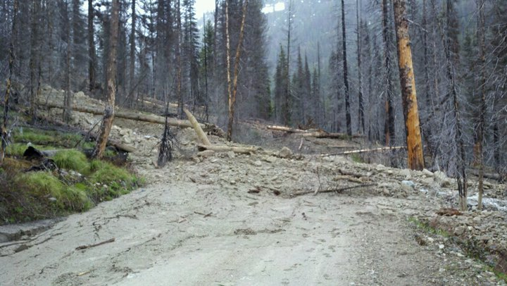

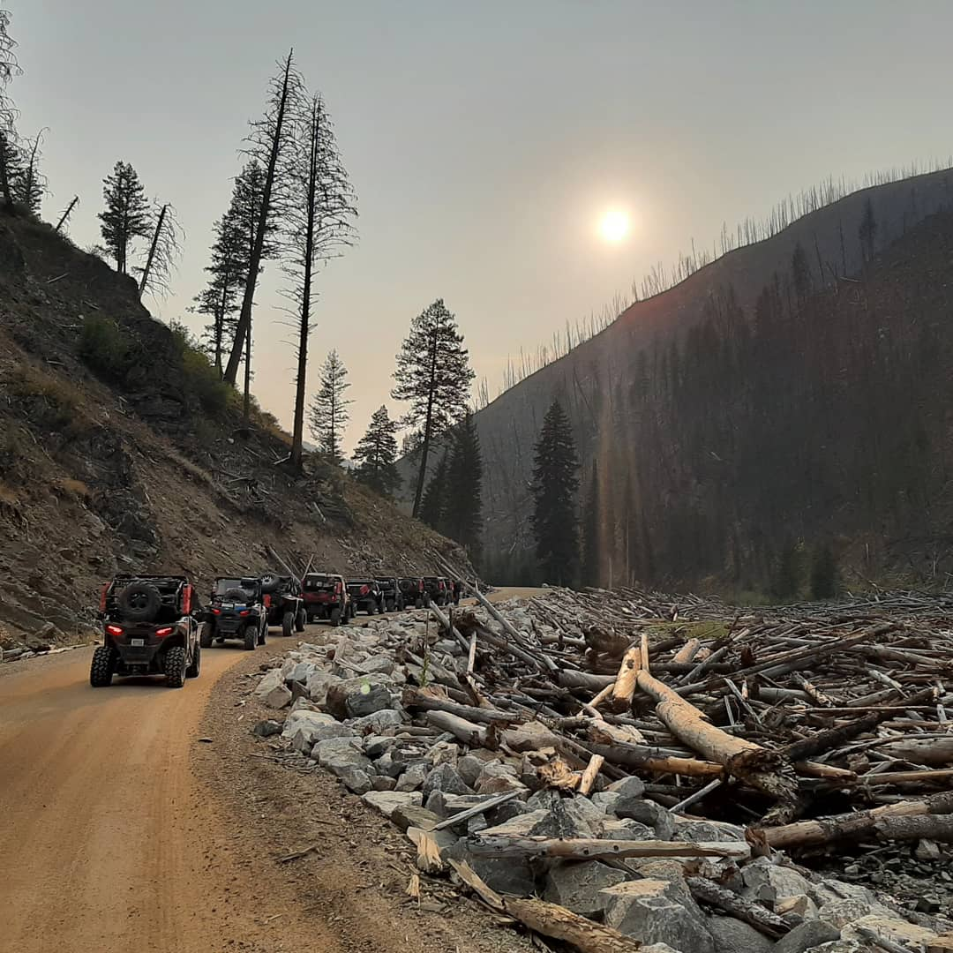

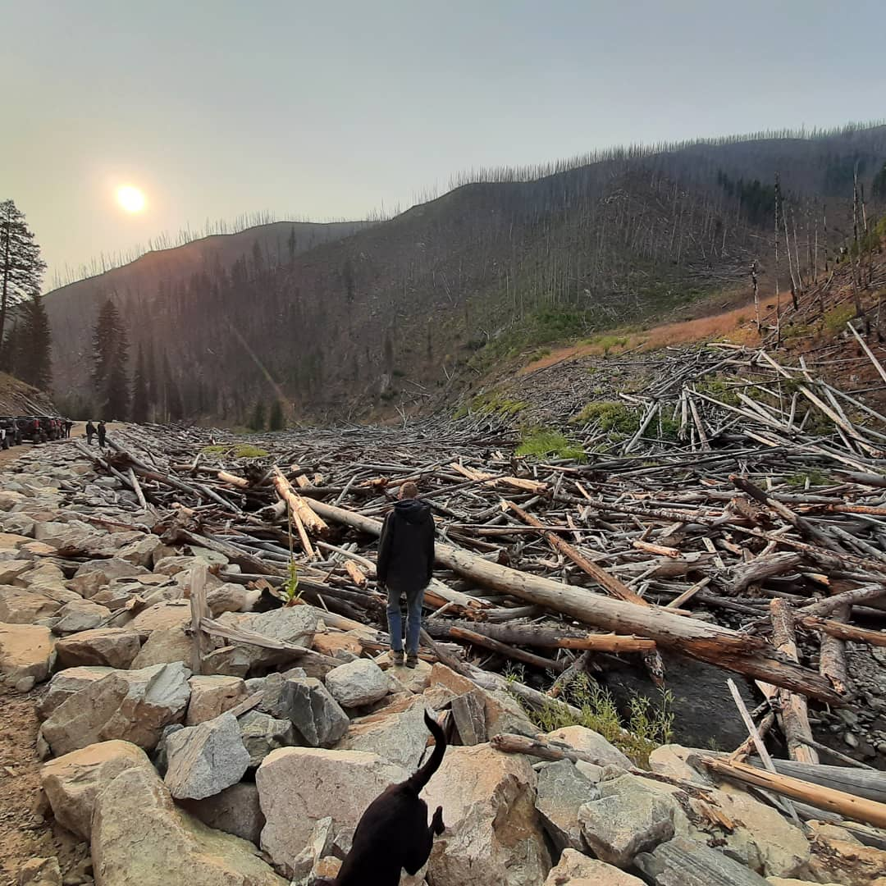

Thank you in advance for considering my comments on the proposed project:

[https://cara.ecosystem-management.org/Public//CommentInput?Project=60889](https://gcc02.safelinks.protection.outlook.com/?url=https%3A%2F%2Fcara.ecosystem-management.org%2FPublic%2F%2FCommentInput%3FProject%3D60889&data=04%7C01%7C%7C72ac25b447a74f813ba808d993d1fbfc%7Ced5b36e701ee4ebc867ee03cfa0d4697%7C0%7C0%7C637703352345926840%7CUnknown%7CTWFpbGZsb3d8eyJWIjoiMC4wLjAwMDAiLCJQIjoiV2luMzIiLCJBTiI6Ik1haWwiLCJXVCI6Mn0%3D%7C1000&sdata=ppng73qcoQWS%2BrYQW%2Fr73z57HKd8DmEv2mSaJ%2B1Xq%2F8%3D&reserved=0)

I have lived, worked and traveled in the affected area mentioned since 1983.

In that time: MOST of the motorized trails I grew up enjoying,  have been closed by the Forest Service under the guise of "protecting the environment". However,  as the continued costs from the 395,000 acre Cascade Complex Fire continues to mount: it is obvious that the Forest Service is taking an ass-backwards approach to land management.

Idaho Department of Lands manages over a million acres of Idaho lands and is able to generate 50% of our annual school budget from those lands. Generating a positive revenue stream to taxpayers from public lands.

The Forest Service has been about $2 billion in the red every year for the last 10 years and hasn't generated a positive revenue for taxpayers since 1993.

Forest Service supervisors, district rangers and even the hired help continually "talk down" to the local community and land managers. As if they have some magical golden knowledge from on high, and AREN'T letting 8 million acres of public lands get incinerated by landscape erasing megafires every year.

Which is why I feel like a broken record saying this to the usual deaf ears at the Forest Service it will undoubtedly fall upon:

Closing and obliterating roads and trails  does more harm than good.

Our forests are overgrown,  infested, diseased and desperately need active thinning.

Moreover:  resource jobs (logging, mining) available to local communities have all but been destroyed,  leaving tourism as the last viable economic opportunity within the bounds of the Payette National Forest.

Instead of closing roads and trails: you should be OPENING more roads to sustain the local economy.

Sugar Creek Road should be OPEN.

Three Mile Road should be OPEN

Quartz Creek,  Parks Creek trails OPEN.

In fact: ALL trails and roads in the encompassing area should be OPEN.