**To: Elaine Kohrman, Forest Supervisor**

[**comments-southwestern-cibola@fs.fed.us**](mailto:comments-southwestern-cibola@fs.fed.us)

[**cibolamtnsplanrevision@fs.fed.us**](mailto:cibolamtnsplanrevision@fs.fed.us)

**Subject: Forest Plan Revision – Cibola National Forest**

**From: Greg Warren**

**Date: March 25, 2015**

**Scoping Comments - 80 FR 6945**

**Forest Plan Revision**

**Cibola National Forest**

Contents

Introduction – Need for Change and Proposed Action 2

Planning Guidance – Recreation, Scenery, and Designated Areas 2

Sustainable Recreation Opportunities and Settings 2

Scenery 3

National Scenic and Historic Trails 4

CDNST Corridor Location and Plan Components 6

Background – Continental Divide National Scenic Trail 9

CDNST Legislative History and Policy 9

Nature and Purposes of the CDNST 17

CDNST Planning Considerations 20

The following comments are being submitted in response the Notice of Intent to revise the

Cibola National Forest Mountain Ranger Districts Land and Resource Management Plan and prepare an associated Environmental Impact Statement, dated February 9, 2015.

# Introduction – Need for Change and Proposed Action

The Notice of Intent to revise the Cibola National Plan (80 FR 6945) states, “Comments on the preliminary needs for change and proposed action will be most valuable if received by April 3, 2015, and should clearly articulate the reviewer’s opinions and concerns… Recreation: There is a need to integrate sustainable recreation management with that of other Forest resources and to provide guidance for managing a sustainable trails program while addressing use conflicts. There is a need to provide management direction on the Continental Divide National Scenic Trail… Designated Areas: There is a need to update direction for managing designated Inventoried Roadless Areas, eligible Wild and Scenic Rivers, designated Research Natural Areas, and for managing designated wilderness… Scoping Process: Written comments received in response to this notice will be analyzed to complete the identification of the needs for change to the existing plan, further develop the proposed action (initial development of the proposed revised plan), and identify potential significant issues. Significant issues will, in turn, form the basis for developing alternatives to the proposed action….”

I support the need for change findings for the Continental Divide National Scenic Trail, Recreation, and Designated Areas. In addition, I agree that, “There is a need for the revised plan to provide direction on the Continental Divide National Scenic Trail (CDNST), [a designated area,] consistent with the 2009 Continental Divide National Scenic Trail Comprehensive Plan.”

The Proposed Action that is presented in the NOI is not detailed to the extent necessary for reviewers to identify and clearly articulate opinions and concerns. However, the information that follows in this document should assist the Forest Supervisor through the planning team in identifying specific direction and actions needed to locate the CDNST corridor and adopt appropriate Forest Plan components to provide for the nature and purposes of this national scenic trail.

# Planning Guidance – Recreation, Scenery, and Designated Areas

## Sustainable Recreation Opportunities and Settings

Plan components need to provide for sustainable recreational settings, opportunities, and access. Sustainable recreation opportunities and settings are those that are economically, socially, and ecologically sustainable. To be sustainable, the established set of recreational settings and opportunities must be an integral part of other resource plan direction and include a compatible scenic character component.

The responsible official needs to use the Recreation Opportunity Spectrum (ROS) system to prescribe (establish) outdoor recreation opportunities in land management planning as described in FSM 2310. ROS classes are defined in terms of its combination of activity, setting, and experience opportunities along with associated indicators and thresholds. Sub-classes and seasonal variations of ROS classes may be defined. Socio-cultural meaningful places may be identified as designated areas. The desired conditions for the plan area need to describe the types of recreational settings, including the mix of desired ROS classes, specific kinds of recreation opportunities, and associated infrastructure. Plans need to have standards or guidelines to ensure consistency of projects or activities with desired ROS classes or other desired conditions for recreation. Plans should include desired conditions that describe the natural, built, social, and managerial environment for sustainable recreation.

The information identified in the assessment provides a starting point to determine the kinds of settings and opportunities to be provided in the plan area. The ability for sustainable recreation opportunities, and the distinctive role of the plan area as a provider of recreation, should inform and create an overall context for adjusting existing recreational settings and opportunities in a new, revised, or amended plan.

Plans should have objectives that describe the intended achievement of modifying the conditions of areas from their inventoried ROS classes toward desired ROS classes where applicable. Objectives may also be designed to alter the condition of recreation areas, dispersed sites, infrastructure, and services to achieve sustainable desired conditions for recreation in the plan area.

Plans should identify suitable uses in a recreational context that is associated with a prescribed ROS class and designated area purpose. Suitability should be described in terms of what types of recreation use and activities are suitable or not suitable within each management area or geographic area should be based on the desired ROS setting and address recreation use conflicts.

Desired recreation settings and opportunities should inform the basis for applying certain plan components to management areas or geographic areas. Plans may identify a specific set of locations or small areas, such as dispersed recreational sites, for some specific plan components without creating management areas or geographic areas.

Plan content should describe the distinctive role and contribution of the plan area to recreational opportunities and the provision of social and economic sustainability in the broader landscape. Plans may describe management strategies to the development of collaborative capacity through volunteers or partnerships to accomplish recreation objectives for the plan area.

## Scenery

The plan must include plan components including standards or guidelines to provide for scenic character integrated with other plan components as described in 23.21a. To meet this requirement the plan:

a. Must include a description of desired scenic character based on the scenery management system, unless an exception is established pursuant to FSM 1921.03. Desired scenic character may be different from existing or potential scenic character identified in the assessment. Depending on the biophysical and cultural attributes of the plan area’s landscape, there may be multiple desired scenic character descriptions associated with specific areas.

(1) Desired conditions describing scenic character should include scenic integrity objectives that describe the degree to which desired attributes of the scenic character are to remain. Scenic integrity objectives should be assigned throughout the plan area. (Note that scenery integrity objectives are not the same as plan component “objectives” under the Planning Rule).

(2) Desired conditions may also describe scenic stability, sustainability, and other measures used in scenery management system. Desired conditions may include maps, graphics, photographs, or visual simulations that give a visual representation of desired scenic character and associated scenic integrity objectives.

b. Should contain standards or guidelines as needed to avoid or mitigate undesirable effects incompatible with desired scenery conditions. Standards or guidelines can also apply to specific scenic integrity objectives, management areas, geographic areas, designated areas or other identified special areas or places. Standards and guidelines can be applied at multiple scales to specific management activities such as timber harvest, utility corridors, trail construction, facility development, or road construction.

## National Scenic and Historic Trails

1. When developing plan components for national scenic and historic trails:

a. The Interdisciplinary Team should review the assessment for relevant information about existing national scenic and historic trails in the plan area, including established rights-of-way pursuant to 16 U.S.C 1246(a)(2) and direction contained in comprehensive plans (CPs) pursuant to 16 U.S.C. 1244(e) or 1244(f). For existing or study national scenic and historic trails that do not have such information published, assessments identify and evaluate other information pertinent to the location and management of national scenic and historic trails.

b. The Interdisciplinary Team shall identify Congressionally designated national scenic and historic trails and plan components must provide for the management of rights-of-ways (16 U.S.C 1246(a)(2)) consistent with applicable laws, regulations, and Executive Orders. Plan components must provide for the nature and purposes of existing national scenic and historic trails and for the potential rights-of-way of those trails designated for study (16 U.S.C. 1244(b)).

c. The Interdisciplinary Team shall use the national scenic and historic trails rights-of-way maps required by 16 U.S.C. 1246(a)(2) to map the location of the trails.

Where national trail rights-of-way have not yet been selected, the Interdisciplinary

Team shall reference the establishing legislation (16 U.S.C. 1244(a)) as the primary source for identifying and mapping the national scenic and historic trails right-of-way.

If the right-of-way has not been selected, either through legislation or publication in the Federal Register, the Interdisciplinary Team should use other information to delineate a national scenic and historic trails corridor that protects the resource values for which the trail was designated or is being proposed for designation (16 U.S.C 1244(b)).

d. The Responsible Official shall consult with neighboring Responsible Officials when developing plan components for national scenic and historic trails that cross unit boundaries and shall strive to maintain or establish compatible management approaches while recognizing diverse resource conditions and needs in the different plan areas.

e. Plan components must be compatible with the objectives and practices identified in the comprehensive plan for the management of the national scenic and historic trail. The objectives and practices include the identification of resources to be preserved and the trail’s [corridor] carrying capacity.

f. The Responsible Official shall include plan components that provide for the nature and purposes of national scenic and historic trails in the plan area. In doing so, the Responsible Official should take into consideration other aspects of the plan related to the trail such as access, cultural and historic resources, recreational settings, scenic character, and valid existing rights.

2. The plan must include plan components including standards or guidelines for a designated area as described in section 24.2 of this Handbook. To meet this requirement the plan:

a. Should include desired conditions that describe the national scenic and historic trail and the recreational, scenic, historic, and other resource values for which the trail was designated.

b. May include objectives for national scenic and historic trails where existing conditions (settings, opportunities, scenic character, cultural and other resources values) are different from desired conditions. These objectives can identify intended activities to improve national scenic and historic trail conditions, mitigate or enhance associated resource values, create or improve connections with communities and visitors, or other desired and measureable outcomes that will improve the national scenic and historic trail experience.

c. May include standards or guidelines to place limits or conditions on projects or activities to protect the trail and associated resource values.

d. May include suitability plan components to limit or prevent incompatible uses and activities.

e. Must identify and map National scenic and historic trails per #1c above.

f. May, to apply plan components unique to the National and Scenic Historic Trail: provide one or more management or geographic areas for a national scenic and historic trail; reference the identified national scenic and historic trail right-of-way, place a corridor around the trail, or use other means to clearly identify where the plan components apply in reference to the trail.

FSM 2350 has more information about national scenic and historic trails—see FSM 2353.42 and FSM 2353.44.

# CDNST Corridor Location and Plan Components

The Forest Plan needs to establish and include a map that displays the extent of the CDNST Management Area to assure that the nature and purposes of the CDNST are promoted and protected.  The Management Area needs to describe nature and purposes desired conditions that are supported by appropriate standards and guidelines.  The following are a few broad CDNST Management Area recommendations:

* The extent of the CDNST Management Area needs to be at least 1/2 half mile on both sides of the CDNST travel route following topographic features where it is reasonable to do so, while additional management direction is prescribed for adjacent areas to assure that the CDNST scenery integrity needs are met. This recommendation is based on ROS criteria that identify remoteness for a Semi-Primitive Non-Motorized setting as:  An area at least 1/2-mile but not further than 3 miles from all roads, railroads or trails with motorized use; can include the existence of primitive roads and trails if closed to motorized use.  More than 3 miles would tend to classify the area as Primitive another desirable setting. The Forest Service Scenery Management System identifies that the middleground begins at 1/2-mile of the travel route.
* Management of activities and uses within this Management Area need to focus on providing for the nature and purposes of the CDNST (FSM 2353.11 and FSM 2353.42).  The nature and purposes of the CDNST are to provide for high-quality, scenic, primitive hiking and horseback riding opportunities and to conserve natural, historic, and cultural resources along the CDNST corridor. Other recreation and resource uses along the CDNST may be allowed only where there is a determination that the other use would not substantially interfere with the nature and purposes of the CDNST.
* Location and management factors must be considered, such as, the CDNST needs to be located in more primitive ROS classes where available and once located the management of the CDNST corridor (rights-of-way) must provide for a primitive or semi-primitive non-motorized experiences to extent practicable.  Related, scenic management objectives of high or very high need to be met along the CDNST travel route where on federal lands to the extent practicable.
* Land management plans need to complete the rights-of-way (NTSA, Sec. 7), Comprehensive Plan (NTSA, Sec. 5), and E.O. 13195 requirements by addressing the following:  (1) establish a rights-of-way (Management Area) that is of sufficient width and so located to provide the retention of natural conditions, scenic and historic features, and primitive character of the trail area, and (2) identify specific objectives and practices to be observed in the management of the trail, including the identification of all significant natural, historical, and cultural resources to be preserved..., and an identified carrying capacity [or visitor use management practices] of the trail and a plan for its implementation.
* **CDNST Management Area recommendations are described on maps in the Appendix for the Proposed Action and/or alternatives.**

Specific and recommended CDNST Management Area Plan Components are identified in the following table.

**CDNST LMP MA Desired Conditions**

|  |
| --- |
| Descriptions |
| Consistent with the CDNST Comprehensive Plan and FSM 2353.4, the MA provides high-quality scenic, primitive hiking and horseback riding opportunities and conserves natural, historic, and cultural resources. Desired conditions are characterized by Primitive and Semi-Primitive Non-Motorized ROS settings. |

CDNST LMP MA Objectives

|  |
| --- |
| Descriptions |
| Complete the CDNST Unit Plan (FSM 2353.44(b)(2)) within five years. |

**CDNST LMP** **MA Standards or Guidelines**

|  |
| --- |
| Descriptions - See FSM 1110.8 for Degree of Compliance or Restriction “Helping Verbs” and “Mood of Verb” Definitions |
| **Scenery Management** |
| Manage the travelway as a concern level 1 travel route. Resource management actions are to meet a Scenic Integrity Level of Very High or High in the immediate foreground and foreground visual zones. Excepted are management activities that contribute to achieving the overall nature and purposes of the CDNST. |
| *Forest-wide Standard: Resource management actions are to meet a Scenic Integrity Level of Very High, High, or Moderate in the middleground as viewed from the existing and potential CDNST travel routes.* |
| **Recreation Management** |
| Resource manage actions and allowed uses must be consistent with maintaining or achieving Primitive or Semi-Primitive Non-Motorized ROS class settings, except motor vehicle use is allowed if such use is in accordance with the CDNST Comprehensive Plan Chapter IV.6 and FSM 2353.44b(11). |
| Manage the CDNST to provide high-quality scenic, primitive hiking and pack and saddle stock opportunities. Backpacking, nature walking, day hiking, horseback riding, nature photography, mountain climbing, cross-country skiing, and snowshoeing are compatible with the nature and purposes of the CDNST (FSM 2353.42 and FSM 2353.44b(8)). |
| The Management Area is not suitable for motorized and mechanized use, except where such use is in accordance with FSM 2353.44b(10) and (11). |
| If the interval between natural water sources is excessive, consider developing and protecting water sources for hikers and pack and saddle stock use (FSM 2353.44b(9)). |
| **Special Uses Management** |
| Activities, uses, and events that would require a permit shall not be authorized unless the activity, use, or event contributes to achieving the nature and purposes of the CDNST. |
| **Minerals Management** |
| Mineral leases are to include stipulations for no surface occupancy. |
| Permits for the removal of mineral materials are not to be issued. |
| Mineral withdrawals should be enacted in areas with a history of locatable mineral findings. |
| **Timber Management** |
| Lands are not suitable for timber production. Timber harvest is not scheduled and does not contribute to the allowable sale quantity. |
| **Vegetation Management** |
| Vegetation may be managed to enhance recreation opportunities, to provide vistas to view surrounding areas, and to conserve natural resources. |
| Vegetation may be managed to maintain or improve threatened, endangered, and sensitive species habitat. |
| **Cultural and Historic Resources Management** |
| Protect cultural and historic resources. |
| **Lands Acquisition** |
| Provide for land acquisitions to protect the nature and purposes of the National Trail or to improve the CDNST location. |
| **Travel Routes** |
| Segments of the CDNST should fall into Trail Class 2 or 3 and have a Designed Use of Pack and Saddle Stock (FSH 2309.18). |
| Road construction and reconstruction is prohibited; excepted are motor vehicle use circumstances described in CDNST Comprehensive Plan Chapter IV.6 and FSM 2353.44b(11). |
| **Other Uses Considerations** |
| Other uses that could conflict with the nature and purposes of the CDNST may be allowed only where there is a determination that the other use would not substantially interfere with the nature and purposes of the CDNST (16 USC 1246(c)). |

**CDNST LMP MA Implementation Guidance**

Partnerships and volunteers are sustained or sought to lead and assist in CDNST programs. Volunteer and cooperative agreements are developed with those the Continental Divide Trail Coalition, volunteers, and private organizations that are dedicated to planning, developing, maintaining, and managing the CDNST in accordance with Sections 2(c), 7(h)(1), and 11 of the NTSA.

The direction in the NTSA, 2009 CDNST Comprehensive Plan, FSM 2310, FSM 2353.4, and FSM 2380 are used to guide the protection, development, and management of the Trail.

# Background – Continental Divide National Scenic Trail

The following three sections describe legislative history and policy, nature and purposes, and planning considerations for the CDNST.

## CDNST Legislative History and Policy

**Trails for America**

Trails for America, a 1966 report prepared by the Bureau of Outdoor Recreation in response to President Johnson’s Natural Beauty Message of February 8, 1965, describes a vision for the Continental Divide Trail: “A Continental Divide Trail would provide a continuous route along the Continental Divide and Rocky Mountains from the Canadian border almost to the Mexican border... The concept was originated by a group of horsemen known as the Rocky Mountain Trails, Inc.... Designed to accommodate riders and hikers, a Continental Divide Trail would pass through some of the most scenic areas in the country in its 3,082-mile route. The 763 miles in Montana, 147 miles in Idaho, 506 miles in Wyoming, 614 miles in Colorado, and 1,052 miles in New Mexico span spectacular, wild, mountain country, rich in the early history of the West. The route affords views of perpetual icefields and of awesome peaks, many over 14,000 feet. It passes hundreds of alpine lakes and streams teeming with trout. The high mountains are home to many species of game, including the bighorn sheep, mule deer, and bear...

Administration of national scenic trails is complicated by the linear nature of the trails and the complex pattern of land ownership along them. Most existing or potential national scenic trails extend through or into several States. Typically they cross some lands that are administered by Federal, State, and local public agencies, and other lands that are privately owned. In the West, the trails cross lands administered largely by Federal agencies—the Forest Service, National Park Service, [and] Bureau of Land Management... In view of these considerations, administration of national scenic trails should be governed by the following principles...

4. The entire length of each national scenic trail, together with sufficient land area on both sides to safeguard adequately and preserve its character, should be protected in some form of public control..., and

9. The responsible Secretary, after agreement with the other Federal agencies involved and consultation with appropriate States, local governments, private organizations, and advisory councils, should:

a. locate and designate the route and width of right-of-way of each trail assigned him. The right-of-way should be wide enough to protect adequately the natural and scenic character of the lands through which the trail passes and the historic features along and near along the trail, and to provide campsites, shelters, and related public-use facilities as necessary. It should avoid, insofar as practicable, established highways, motor roads, mining areas, power transmission lines, private recreational developments, public recreational developments not related to the trail, existing commercial and industrial developments, range fences and improvements, private operations, and any other activities that would be incompatible with the protection of the trail in its natural condition and its use for outdoor recreation. Formal designation should be accomplished by publishing notice of the route and right-of-way in the Federal Register, together with appropriate maps and descriptions. Minor changes in route and right-of-way should be handled in the same manner.

b. define the kinds of recreation use that are appropriate on the trail and in keeping with its objectives, and define the kinds of non-recreation uses, if any, that may be permitted within the right-of-way; issue the necessary regulations; and provide enforcement.

The NTSA establishment and designation of the CDNST provides for the Secretaries of the Agriculture and Interior to manage the CDNST under existing agencies authorities, but subject to the overriding direction of providing for the nature and purposes of this National Scenic Trail. The establishment of the CDNST thus constitutes an overlay on the management regime otherwise applicable to public areas managed by land management agencies. The NTSA (and E.O. 13195 - Trails for America in the 21st Century) limits the management discretion the agencies would otherwise have by mandating the delineation and protection of the CDNST corridor.

c. establish construction and maintenance standards including standards for related facilities that will adequately protect trail values and provide for optimum public use.”

**National Trails System Act**

The National Trails System Act (NTSA), P.L. 90-543, was passed by Congress on October 2, 1968. It established policies and procedures for a nationwide system of trails including National Scenic Trails. The Appalachian Trail and the Pacific Crest Trail were designated as the nation's first National Scenic Trails. “The Act was intended to insure that long-distance, high-quality trails with substantial recreation and scenic potential were afforded Federal recognition and protection” (S.R. 95-636).

The National Parks and Recreation Act of November 10, 1978 established and designated the Continental Divide National Scenic Trail (CDNST) (Pub. L. No. 95-625, 92 Stat. 3467), which amended the NTSA of 1968 (16 U.S.C. 1241-1251).

**Statement of Policy** – Sec. 2 (16 U.S.C. 1241(a)) –

“In order to provide for the ever-increasing outdoor recreation needs of an expanding population and in order to promote the preservation of, public access to, travel within, and enjoyment and appreciation of the open-air, outdoor areas and historic resources of the Nation, trails should be established...within scenic areas and along historic travel routes of the Nation which are often more remotely located.”

**National Trails System** – Sec. 3 (16 U.S.C. 1242(a)(2)) –

“National scenic trails, established as provided in section 5 of this Act, which will be extended trails **so located** (*emphasis added*) as to provide for maximum outdoor recreation potential and for the conservation and enjoyment of the nationally significant scenic, historic, natural, or cultural qualities of the areas through which such trails may pass. National scenic trails may be located so as to represent desert, marsh, grassland, mountain, canyon, river, forest, and other areas, as well as landforms which exhibit significant characteristics of the physiographic regions of the Nation.”

**National Scenic and Historic Trails** –

NTSA Sec. 5(a) (16 U.S.C. 1244(5)(a)) – National scenic and national historic trails shall be authorized and designated only by Act of Congress. There are hereby established [and designated] the following National Scenic and National Historic Trails...

“(5) The Continental Divide National Scenic Trail, a trail of approximately thirty-one hundred miles, extending from the Montana-Canada border to the New Mexico-Mexico border, following the approximate route depicted on the map, identified as 'Proposed Continental Divide National Scenic Trail' in the Department of the Interior Continental Divide Trail study report dated March 1977... The Continental Divide National Scenic Trail shall be administered by the Secretary of Agriculture in consultation with the Secretary of the Interior. Notwithstanding the provisions of section 7(c), the use of motorized vehicles on roads which will be designated segments of the Continental Divide National Scenic Trail shall be permitted in accordance with regulations prescribed by the appropriate Secretary. No land or interest in land outside the exterior boundaries of any federally administered area may be acquired by the Federal Government for the trail except with the consent of the owner of the land or interest in land. The authority of the Federal Government to acquire fee title under this paragraph shall be limited to an average of not more than 1/4 mile on either side of the trail.”

NTSA sec. 5(f) (16 U.S.C. 1244(f)) – “…The responsible Secretary shall...submit...a comprehensive plan for the acquisition, management, development, and use of the trail, including but not limited to, the following items:

1. Specific objectives and practices to be observed in the management of the trail, including the identification of all significant natural, historical, and cultural resources to be preserved,... an identified carrying capacity of the trail and a plan for its implementation;
2. The process to be followed by the appropriate Secretary to implement the marking requirements established in section 7(c) of this Act;
3. A protection plan for any…high potential route segments; and
4. General and site-specific development plans, including anticipated costs.”

**Administration and Development** – Sec. 7 (16 U.S.C. 1246) –

The Secretary of Agriculture is charged with the overall administration of the CDNST. Pursuant to Section 5(a), the CDNST was established and designated on November 10, 1978. Section 7(a)(2) states that the, “...Secretary shall select the rights-of-way for national scenic and national historic trails and shall publish notice thereof of the availability of appropriate maps or descriptions in the Federal Register; Provided, That in selecting the rights-of-way full consideration shall be given to minimizing the adverse effects upon the adjacent landowner or user and his operation. Development and management of each segment of the National Trails System [i.e., National Recreation Trails, National Scenic Trails, National Historic Trails, and Connecting and Side Trails] shall be designed to harmonize with and complement any established multiple-use plans for the specific area in order to insure continued maximum benefits from the land....”

Multiple-use plans that were established in the benchmark year of 1978 when the CDNST was designated by an Act of Congress have been revised. Therefore, in a legal sense, the legislative requirement for the National Trails System segments to “...harmonize with and complement any established in multiple-use plans...” is no longer binding. Nevertheless, a National Scenic Trail optimum location assessment may find that designing the CDNST rights-of-way corridor[1] to pass through inventoried Primitive and Semi-Primitive Recreation Opportunity Spectrum (ROS)[2] settings could insure continued maximum benefits of the land. This would include the recreation and conservation benefits resulting from: (1) locating the National Trail corridor “to provide for maximum outdoor recreation potential and for the conservation and enjoyment of the nationally significant scenic, historic, natural, or cultural qualities of the areas...” (16 U.S.C. 1242(a)(2); (2) avoiding, to the extent possible, activities along the NST that would be incompatible with the purposes of the CDNST for which it was established (16 U.S.C. 1246(c)); and (3) contributing to achieving outdoor recreation, watershed, and wildlife and fish multiple-use benefits (16 U.S.C. 528). The rights-of-way requirement of 16 U.S.C. 1246(a)(2) is directed at selecting the 3,100-mile CDNST rights-of-way corridor and does not modify the nature and purposes values of the CDNST (16 U.S.C. 1246(c)).

The establishment of CDNST MAs could facilitate CDNST comprehensive planning (16 U.S.C. 1244(f)), selecting and publishing the CDNST rights-of-way in the Federal Register (16 U.S.C. 1246(a)(2)), and meet attached NEPA requirements.

NTSA Sec. 7(c) (16 U.S.C.1246(c)) – “National scenic or national historic trails may contain campsites, shelters, and related-public-use facilities. Other uses along the trail, which will not substantially interfere with the nature and purposes of the trail, may be permitted by the Secretary charged with the administration of the trail. Reasonable efforts shall be made to provide sufficient access opportunities to such trails and, to the extent practicable, efforts be made to avoid activities incompatible with the purposes for which such trails were established. The use of motorized vehicles by the general public along any National Scenic Trail shall be prohibited.... Other uses along the historic trails and the Continental Divide National Scenic Trail, which will not substantially interfere with the nature and purposes of the trail, and which, at the time of designation, are allowed by administrative regulations, including the use of motorized vehicles, shall be permitted by the Secretary charged with administration of the trail....” Other uses include recreational and resource uses that may be incompatible with the nature and purposes for which the CDNST was established and designated.

**Executive Orders**

Executive Order 13195 – Trails for America in the 21st Century: *"*By the authority vested in me as President by the Constitution and the laws of the United States of America, and in furtherance of purposes of the National Trails System Act of 1968...and to achieve the common goal of better establishing and operating America's national system of trails, it is hereby ordered as follows: Section 1... Federal agencies will, to the extent permitted by law and where practicable ... protect, connect, promote, and assist trails of all types throughout the United States. This will be accomplished by: ... (b) Protecting the trail corridors associated with national scenic trails...to the degrees necessary to ensure that the values for which each trail was established remain intact....*”*

Executive Order 11644 and 11989 – Use of off-road [motorized] vehicles on the public lands: “...By virtue of the authority vested in me as President of the United States by the Constitution of the United States and in furtherance of the purpose and policy of the National Environmental Policy Act of 1969 (42 U.S.C. 4321), it is hereby ordered as follows: Section 1. *Purpose.* It is the purpose of this order to establish policies and provide for procedures that will ensure that the use of off-road [motorized] vehicles on public lands will be controlled and directed so as to protect the resources of those lands, to promote the safety of all users of those lands, and to minimize conflicts among the various uses of those lands....” (Related: 36 CFR 212.55 and 43 CFR 8351.1)

**Study Report, Comprehensive Plan, and Policy for the CDNST**

The Bureau of Outdoor Recreation, pursuant to 16 U.S.C. 1244(b), prepared a Study Report for the CDNST that was completed in 1976. The Chief of the Forest Service adopted the 1976 CDNST Study Report and 1977 CDNST Final Environmental Statement on August 5, 1981 (46 FR 39867). In 2009 the Chief amended the 1985 CDNST Comprehensive Plan and issued conforming FSM 2353.4 policy—see <http://www.fs.fed.us/cdt>.

Comprehensive plan requirements (16 U.S.C. 1244(f)) for the CDNST are addressed through staged or stepped-down decision processes: (1) the 2009 Comprehensive Plan established broad policy and procedures, (2) land management plans are to provide integrated resource management direction and address programmatic planning requirements as described in the Comprehensive Plan, including providing for the protection of CDNST nature and purposes, and (3) mid-level and site-specific plans (e.g., Forest-level CDNST unit plans (FSM 2353.44b(2)) complete the comprehensive planning process through field-level actions to construct or maintain the travel route and protect the corridor. The following direction is found in the Comprehensive Plan and Forest Service Manual:

Comprehensive Plan – Approved by Thomas L. Tidwell, Chief

Purpose of the Comprehensive Plan: “Preparation of the Comprehensive Plan for the CDNST is required by the National Trails System Act, P.L. 90-543 enacted on October 2, 1968 as amended. The National Environmental Policy Act (NEPA) and the implementing regulations for each of the Federal agencies with responsibilities for the CDNST require assessment of the environmental impacts of locating the CDNST. In addition, each of the Federal agencies is required by various Acts of Congress to prepare and implement land and resource management plans for the Federal lands over which they have jurisdiction... Because of the number of Federal and state land management agency jurisdictions and various political subdivisions traversed by the CDNST the Secretary of Agriculture intends that the Comprehensive Plan provide for a fully coordinated approach by each of the responsible Federal and State agencies for the location, development, and management of the CDNST. It is the goal of this Comprehensive Plan to provide a uniform CDNST program that reflects the purposes of the National Scenic Trail system, and allows for the use and protection of the natural and cultural resources found along the rights-of-way and located route on lands of all jurisdictions... The primary role of the Comprehensive Plan is to serve as an authority for broad based policy and direction for the development and management of the CDNST.”

Land and Resource Management Plans: “Both the Forest Service and the Bureau of Land Management are required to develop land and resource management plans that are designed to integrate all resource management activities that may occur within a land use unit into a coordinated system that reflects the interaction of management activities in achieving long-range objectives and goals for public land management. This is will be accomplished through the development of a series of synergetic management prescriptions developed for specific management areas. Land and resource management plans are to provide for the development and management of the CDNST as an integrated part of the overall land and resource management direction for the land area through which the trail passes. The management direction given in Chapter IV is to be used in the development of specific land and resource management prescriptions.”

Nature and Purposes: “The primary policy is to administer the CDNST consistent with the nature and purposes for which this National Scenic Trail was established. The nature and purposes of the CDNST are to provide for high-quality scenic, primitive hiking and horseback riding opportunities and to conserve natural, historic, and cultural resources along the CDNST corridor.”

**Forest Service**, FSM Policy – Approved by Acting Associate Deputy Chief Richard W. Sowa

FSM 2353.4 – Administration of National Scenic and National Historic Trails

FSM 2353.41 – Objectives

Develop and administer National Scenic and National Historic Trails to ensure protection of the purposes for which the trails were established and to maximize benefits from the land.

FSM 2353.42 – Policy

Administer National Scenic and National Historic Trail corridors to be compatible with the nature and purposes of the corresponding trail. CDNST: The nature and purposes of the CDNST are to provide for high-quality scenic, primitive hiking and horseback riding opportunities and to conserve natural, historic, and cultural resources along the CDNST corridor.

FSM 2353.44b, “Continental Divide National Scenic Trail –

1. The land management plan for an administrative unit through which the CDNST passes must provide for the nature and purposes of the CDNST (FSM 2353.42) and, in accordance with the programmatic requirements of the NTSA, as amended (16 U.S.C. 1244(f)), and the CDNST Comprehensive Plan, as amended, must:

a. Except where the CDNST traverses a wilderness area and is governed by wilderness management prescriptions (36 CFR Part 293), establish a management area for the CDNST that is broad enough to protect natural, scenic, historic, and cultural features;

b. Prescribe desired conditions, objectives, standards, and guidelines for the CDNST; and

c. Establish a monitoring program to evaluate the condition of the CDNST in the management area.

2. A CDNST unit plan must be developed for each administrative unit through which the CDNST passes. Each CDNST unit plan must provide for the nature and purposes of the CDNST (FSM 2353.42), and, in accordance with the site-specific requirements in the NTSA, as amended (16 U.S.C. 1244(f)), and the CDNST Comprehensive Plan, as amended, must:

a. Identify and display the segments of the CDNST that traverse that unit.

b. Except where the CDNST traverses a wilderness area and is governed by wilderness management prescriptions (36 CFR Part 293) and except where delineated in the applicable land management plan, establish a management area for the segments of the CDNST that traverse that unit that is broad enough to protect natural, scenic, historic, and cultural features;

c. Establish the Trail Class, Managed Uses, Designed Use, and Design Parameters for the segments of the CDNST that traverse that unit and identify uses that are prohibited on the segments of the CDNST that traverse that unit (FSH 2309.18).

d. Provide for development, construction, signing, and maintenance of the segments of the CDNST that traverse that unit.

e. Identify and preserve significant natural, historical, and cultural resources along the sections of the CDNST corridor that traverse that unit.

f. Consistent with the provisions of the applicable land management plan and the nature and purposes of the CDNST (FSM 2353.42), establish carrying capacity for the segments of the CDNST that traverse that unit (FSM 2353.44b, para. 1). The Limits of Acceptable Change or a similar system may be used for this purpose.

g. Establish monitoring programs to evaluate the site-specific conditions of the CDNST.”

FSM 2353.44b parts 7 and 8 contribute to defining key landscape characteristics of the CDNST Management Area corridor:

7. “...The one-half mile foreground viewed from either side of the CDNST travel route must be a primary consideration in delineating the boundary of a CDNST management area (para. 2b). [FSM 2380] The CDNST is a concern level 1 route..., with a scenic integrity objective of high or very high, depending on the trail segment...

8. Manage the CDNST to provide high-quality scenic, primitive hiking and pack and saddle stock opportunities. Backpacking, nature walking, day hiking, horseback riding, nature photography, mountain climbing, cross-country skiing, and snowshoeing are compatible with the nature and purposes of the CDNST (FSM 2353.42). Use the Recreation Opportunity Spectrum (ROS) and the ROS Users Guide in delineating and integrating recreation opportunities in CDNST unit plans and managing the CDNST (FSM 2311.1). Where possible, locate the CDNST in primitive and semi-primitive non-motorized ROS classes, provided that the CDNST may have to traverse intermittently through more developed ROS classes....”

**MOU between the CDTC and Forest Service Regions**

A “Memorandum of Understanding between the Continental Divide Trail Coalition and United States Department of Agriculture Forest Service Regions 1, 2, 3, AND 4” was approved by the President of CDTC and associated Regional Foresters in May 2014. The purpose is described as:

I. PURPOSE:The purpose of thisMOU is to document the cooperation between the parties to ensure the development, coordination and completion of the CDNST in accordance with the following provisions.

1. To complete and be stewards of the CDNST to connect people and communities to the Continental Divide by providing high-quality scenic, primitive hiking and horseback riding opportunities. In addition, to conserve natural, historic, and cultural resources along the CDNST corridor… [and]

D. To support the coordination, protection, planning, and management of the CDNST….

## Nature and Purposes of the CDNST

The nature and purposes (NTSA, Sec.7(c)) of the CDNST must be described and used as a basis for determining what activities and resource uses are allowed along the CDNST corridor. The nature and purposes of the CDNST may differ somewhat from those of other national scenic trails. The definition is formulated by extrapolating from the Trails for America report, NTSA, associated Congressional Reports, and CDNST Study Report:

***Trails for America***

Trails for America (1966), a report prepared by the Bureau of Outdoor Recreation in response to President Johnson’s Natural Beauty Message of February 8, 1965, describes that, “the entire length of each national scenic trail, together with sufficient land area on both sides to safeguard adequately and preserve its character, should be protected….”

***National Trails System Act***

NTSA Sec. 3. [16 U.S.C. 1242] (a) (2). “National scenic trails, established as provided in section 5 of this Act, which will be extended trails so located as to provide for maximum outdoor recreation potential and for the conservation and enjoyment of the nationally significant scenic, historic, natural, or cultural qualities of the areas through which such trails may pass.”

NTSA Sec. 5 [16 U.S.C. 1244] (f) … “the responsible Secretary shall...submit...a comprehensive plan for the acquisition, management, development, and use of the trail, including but not limited to, the following items:  (1) specific objectives and practices to be observed in the management of the trail, including the identification of all significant natural, historical, and cultural resources to be preserved....”

NTSA Sec. 7. [16 U.S.C. 1246] (c). “Other uses along the trail, which will not substantially interfere[3] with the nature and purposes of the trail, may be permitted...[To] the extent practicable, efforts be made to avoid activities incompatible with the purposes for which such trails were established. The use of motorized vehicles by the general public along any national scenic trail shall be prohibited....”

***CDNST Study Report***

The Study Report of 1976, prepared by the Bureau of Outdoor Recreation in response to the identification of the CDNST, under the NTSA, as as a potential addition to the national trails system, describes that, “The primary purpose of this trail is to provide a continuous, appealing trail route, designed for the hiker and horseman, but compatible with other land uses... One of the primary purposes for establishing the Continental Divide National Scenic Trail would be to provide hiking and horseback access to those lands where man's impact on the environment has not been adverse to a substantial degree and where the environment remains relatively unaltered. Therefore, the protection of the land resource must remain a paramount consideration in establishing and managing the trail. There must be sufficient environmental controls to assure that the values for which the trail is established are not jeopardized...

The trail experience on or near the Divide is an intimate one, for one can walk or ride horseback across vast fields of wildflowers and contemplate a story dating from the dawn of earth's history. This story began when a portion of the earth was thrust upward, creating the sharp precipitous peaks that were sculptured into rich land forms leaving sparkling lakes, crystal-clear streams, and myriads of cascading waterfalls. Along the way, the tranquility of the alpine meadows, verdant forests and semi-desert landscape overwhelms everyone who passes that way. The trail would provide the traveler his best encounter with the Continental Divide — its serenity and pure air — and would supply for every trail traveler some of the world's most sublime scenes...

The basic goal of the trail is to provide the hiker and rider an entree to the diverse country along the Continental Divide in a manner, which will assure a high quality recreation experience while maintaining a constant respect for the natural environment... The Continental Divide Trail would be a simple facility for foot and horseback use in keeping with the National Scenic Trail concept as seen in the Appalachian and Pacific Crest Trails.”

***CDNST Leadership Council***

The CDNST Leadership Council, in 2004, established a Vision and Guiding Principles for the development and protection of the CDNST. The Vision for the CDNST is: “Complete the Trail to connect people and communities to the Continental Divide by providing scenic, high-quality, primitive hiking and horseback riding experiences, while preserving the significant natural, historic, and cultural resources along the Trail.” The Council’s membership consists of senior Forest Service, Bureau of Land Management, and National Park Service responsible officials.

***Public Involvement in the Formulation of Policy***

The formulation of the nature and purposes direction for the CDNST was developed through a public process (36 CFR 216) and approved by Associate Chief Hank Kashdan as documented in Federal Register: October 5, 2009 (74 FR 51116).[4] The following is the response to nature and purposes comments –

“The amendments to the 1985 CDNST Comprehensive Plan and corresponding directives are to ensure that the nature and purposes of the CDNST track those in the 1976 CDNST Study Report and 1977 CDNST Final Environmental Impact Statement, which were prepared pursuant to the NTSA (16 U.S.C. 1244(b)). The 1976 CDNST Study Report states:

The primary purpose of this trail is to provide a continuous, appealing trail route, designed for the hiker and horseman, but compatible with other land uses. * * * One of the primary purposes for establishing the Continental Divide National Scenic Trail would be to provide hiking and horseback access to those lands where man's impact on the environment has not been adverse to a substantial degree and where the environment remains relatively unaltered. Therefore, the protection of the land resource must remain a paramount consideration in establishing and managing the trail. There must be sufficient environmental controls to assure that the values for which the trail is established are not jeopardized. * * * The basic goal of the trail is to provide the hiker and rider an entree to the diverse country along the Continental Divide in a manner, which will assure a high-quality recreation experience while maintaining a constant respect for the natural environment. * * * The Continental Divide Trail would be a simple facility for foot and horseback use in keeping with the National Scenic Trail concept as seen in the Appalachian and Pacific Crest Trails.

Thus, the 1976 CDNST Study Report states that the primary purpose of the CDNST is to provide a high-quality recreation experience for hiking and horseback riding.

Consistent with the NTSA, the 1976 CDNST Study Report, and the 1977 CDNST Final Environmental Impact Statement, the amended CDNST Comprehensive Plan states that the nature and purposes of the CDNST are to provide for high-quality scenic, primitive hiking and horseback riding opportunities and to conserve natural, historic, and cultural resources along the CDNST corridor. The amended CDNST Comprehensive Plan and final directives implementing the amendments to the CDNST Comprehensive Plan on National Forest System lands provide that backpacking, nature walking, day hiking, horseback riding, nature photography, mountain climbing, cross-country skiing, and snowshoeing are compatible with the nature and purposes of the CDNST.... The amendments to the CDNST Comprehensive Plan and directives ensure consistency with the nature and purposes of the CDNST in the context of right-of-way acquisition, land management planning, scenery management, recreation resource management, motor vehicle use, trail and facility standards, and carrying capacity.’

The 1983 amendment to the NTSA, which added 16 U.S.C. 1246(j), does not modify the nature and purposes of the CDNST. The added subsection simply lists uses and vehicles that may be permitted on National Trails generally.

The NTSA states that all National Scenic Trails must be so located to provide for maximum outdoor recreation potential and conservation of natural, historic, and cultural resources (16 U.S.C. 1242(a)(2)). This requirement is reflected in the nature and purposes statement in the amended CDNST Comprehensive Plan, which states that the nature and purposes of the CDNST are to provide for high-quality scenic, primitive hiking and horseback riding opportunities and to conserve natural, historic, and cultural resources along the CDNST corridor. Where possible, the CDNST will be located in primitive or semi-primitive non-motorized settings, which will further contribute to providing for maximum outdoor recreation potential and conservation of natural, historic, and cultural resources in the areas traversed by the CDNST....

The Forest Service has removed the words `non-motorized’ and `recreational’ from the nature and purposes statement for the CDNST, as these words were redundant. `High-quality scenic, primitive hiking and horseback riding’ are non-motorized recreation opportunities. The Agency has not removed the word `primitive’ from the nature and purposes statement, as it is not redundant and is not ambiguous. It means `of or relating to an earliest or original stage or state....’ Preferred recreation settings, including primitive or semi-primitive non-motorized categories, are delineated in the Forest Service's Recreation Opportunity Spectrum system (FSM 2311.1) and described in the CDNST Comprehensive Plan, Chapter IV(B)(5).

The amendments to the 1985 CDNST Comprehensive Plan apply throughout the document to the extent applicable, not just to the provisions that are specifically referenced in the amendments. The Forest Service agrees that this intent should be expressly stated. Therefore, the Agency has added the following statement to the amendments:

To the extent there is any inconsistency between the foregoing revisions and any other provisions in the 1985 CDNST Comprehensive Plan, the foregoing revisions control.”

*Summary*

In consideration of the language in the NTSA, Congressional Reports, CDNST Study Report and public comments, the nature and purposes policy for the CDNST is: “The nature and purposes of the CDNST are to provide for high-quality scenic, primitive hiking and horseback riding opportunities and to conserve natural, historic, and cultural resources along the CDNST corridor” (CDNST Comprehensive Plan and FSM 2353.42)*.*

## CDNST Planning Considerations

National Trails are administered as trail corridors. Managers should establish plan components that address (1) desired visitor experience opportunities and settings, and (2) the conservation of scenic, natural, historical, and cultural qualities of the corridor. In addition, supporting standards and guidelines need to be established to achieve desired conditions and objectives, and monitoring methods are to be described.

In 2009, the amended CDNST Comprehensive Plan and FSM 2353.4 constituted new information (40 CFR 1502.9(c)). The responsible official must review the new information and determine its significance to environmental concerns and bearing on current Land Management Plan (LMP) direction (FSH 1909.15(18)). In regards to environmental documents for enacted LMPs, determine if Management Area (MA) prescriptions and plan components along the CDNST travel route and corridor provide for the nature and purposes of the CDNST (FSM 2353.42 and FSM 2353.44b(1)). If not, the LMP should be amended or revised following the appropriate NEPA process to address the planning requirements of the NTSA (16 U.S.C. 1244(5)(f) and FSM 2353.44(b)(1)). Furthermore, project proposals may bring the CDNST into the scope of a NEPA process due to potential direct, indirect, and cumulative impacts of past actions and new proposals that may substantially interfere with the nature and purposes of the CDNST (40 CFR 1508.25(c)). This in turn could trigger the need for a land and resource management plan amendment, and on National Forest System lands, the development of a CDNST Unit Plan. Land management plans are to protect potential CDNST rights-of-way and high potential route segments where the rights-of-way is yet to be selected and the travelway officially located (1246(a)(2) and 16 U.S.C. 1244(f)(3)).

The CDNST is administered by the Secretary of Agriculture. Delegation of those responsibilities to Forest Service officials is found in FSM 2353.04. The lead Forest Service official for coordinating matters concerning the study, planning, location, and operation of the CDNST is the Regional Forester for the Rocky Mountain Region (FSM 2353.04(5)(b)).

**Locating the CDNST Corridor and Establishing Management Direction**

The CDNST corridor is to be described through the delineation of a Management Area (MA) with plan components that provide for the nature and purposes values of this designated National Scenic Trail. To provide for the nature and purposes of the National Trail, several location and management factors should be considered; such as and where reasonable to do so, the MA should be located in more primitive ROS classes; once located the management of the MA should provide for a Primitive or Semi-Primitive Non-Motorized experiences to extent practicable. In addition, the CDNST travelway is a concern level 1 travel route and scenic management objectives of high or very high must be met in the immediate foreground and foreground to the extent practicable. The boundary of the MA should follow topographic features to the extent possible, while being at least 1/2 mile wide on each side of the established and potential locations of the National Trail travel routes.  This recommendation is based on ROS criteria that identify remoteness for a Semi-Primitive Non-Motorized setting as:  An area at least 1/2-mile but not further than 3 miles from all roads, railroads or trails with motorized use; can include the existence of primitive roads and trails if closed to motorized use.  More than 3 miles would tend to classify the area as Primitive another desirable setting. The Forest Service Scenery Management System identifies that the middleground begins at 1/2-mile of the travel route.

A comprehensive plan for a National Trail is not a LMP resource plan—36 CFR 219.15(e). Instead, the establishment of the comprehensive plan for the CDNST constitutes an overlay on the management regime otherwise applicable to public areas managed by land management agencies. The NTSA (and E.O. 13195) limits the management discretion the agencies would otherwise have by mandating the delineation and protection of the nature and purposes of the CDNST.

The Bureau of Outdoor Recreation, pursuant to 16 U.S.C. 1244(b), prepared a Study Report for the CDNST that was completed in 1976. The Chief of the Forest Service adopted the 1976 CDNST Study Report and 1977 CDNST Final Environmental Statement on August 5, 1981 (46 FR 39867). In 2009 the Chief amended the 1985 CDNST Comprehensive Plan and issued conforming FSM 2353.4 policy.

Comprehensive plan requirements (16 U.S.C. 1244(f)) for the CDNST are addressed through staged or stepped-down decision processes: (1) the 2009 Comprehensive Plan established broad policy and procedures, (2) land management plans guide all natural resource management activities and establish management standards and guidelines for the National Forest System (36 CFR 219.1), provide integrated resource management direction for special areas (36 CFR 219.2), and address programmatic planning requirements as described in the Comprehensive Plan (Chapter IV), and (3) mid-level and site-specific plans complete the comprehensive planning process through field-level actions to protect the corridor and then maintain or construct the travel route (FSM 2353.44b part 2). The following direction is found in the Comprehensive Plan and Forest Service Manual:

Recreation Resource Management is addressed in the CDNST Comprehensive Plan in Chapter IV.B.5, page 14. Policy is described in Part b as, “(1) Manage the CDNST to provide high-quality scenic, primitive hiking and pack and saddle stock opportunities. Backpacking, nature walking, day hiking, horseback riding, nature photography, mountain climbing, cross-country skiing, and snowshoeing are compatible with the nature and purposes of the CDNST.”

Management direction is described in the Comprehensive Plan, Chapter IV.B.5. Part c, page 16, as, “(1) Use the ROS system in delineating and integrating recreation opportunities in managing the CDNST. Where possible, locate the CDNST in Primitive or Semi-Primitive Non-Motorized ROS classes; provided that the CDNST may have to traverse intermittently through more developed ROS classes to provide for continuous travel between the Canada and Mexico borders.” All ROS classes are summarized in this section of the Comprehensive Plan to assure that identical definitions are used across administrative units; this summary is not to be construed as indicating a desirability or compatibility of managing the CDNST corridor to provide for Semi-Primitive Motorized, Roaded Natural, and Rural ROS class conditions. Primitive and Semi-Primitive Non-Motorized classes are consistent with the nature and purposes (values) of the CDNST. Management direction for Semi-Primitive Motorized, Roaded Natural, Rural, and Urban ROS classes allow uses that substantially interfere with the nature and purposes of the CDNST.

Forest Service directives FSM 2310 and FSM 2380 describe recreation and scenery planning policy.

* FSM 2310.3 - Policy. In addition to general planning policy presented in 36 CFR 219.1, FSM 1903, FSM 1920.3, FSM 1922.03, and FSM 2303:

1. Use the Recreation Opportunity Spectrum (ROS) to establish planning criteria, generate objectives for recreation, evaluate public issues, integrate management concerns, project recreation needs and demands, and coordinate management objectives.
2. Use the ROS system to develop standards and guidelines for proposed recreation resource use and development.

Forest Service directives FSM 2350 and a Federal Register Notice provides important planning direction.

* FSM 2350 [[WORD]](http://nstrail.org/main/fsm_2350_2300_2009_2.doc) - CDNST Policy excerpts [[WORD]](http://nstrail.org/main/fsm_2350_2300_2009_2_cdnst.doc) - Approved by Acting Associate Deputy Chief Richard W. Sowa
* Federal Register - Notice of Final Amendments to Comprehensive Plan and Final Directives [[TEXT]](http://nstrail.org/main/fr_74_191_E9_23873_100509.htm) - Approved by Associate Chief Hank Kashdan, Vol. 74, No. 191, Monday, October 5, 2009
* FSM 2353.42 – Policy
* Administer National Scenic and National Historic Trail corridors to be compatible with the nature and purposes of the corresponding trail. CDNST: The nature and purposes of the CDNST are to provide for high-quality scenic, primitive hiking and horseback riding opportunities and to conserve natural, historic, and cultural resources along the CDNST corridor.
* FSM 2353.44b, “Continental Divide National Scenic Trail –

1. The land management plan for an administrative unit through which the CDNST passes must provide for the nature and purposes of the CDNST (FSM 2353.42) and, in accordance with the programmatic requirements of the NTSA, as amended (16 U.S.C. 1244(f)), and the CDNST Comprehensive Plan, as amended, must:

a. Except where the CDNST traverses a wilderness area and is governed by wilderness management prescriptions (36 CFR Part 293), establish a management area for the CDNST that is broad enough to protect natural, scenic, historic, and cultural features;

b. Prescribe desired conditions, objectives, standards, and guidelines for the CDNST; and

c. Establish a monitoring program to evaluate the condition of the CDNST in the management area.

* FSM 2353.44b parts 2 through 11 provide additional planning and management direction for the CDNST.

CDNST background information can be found on the Forest Service website: <http://www.fs.fed.us/cdt/admin.htm>; and the NSTrail website: <http://www.nstrail.org/>.

Thank you for accepting and considering these comments.

Greg Warren

22 S Juniper Ct

Golden, CO 80401-5002

Appendix – Core locations for the CDNST Management Area

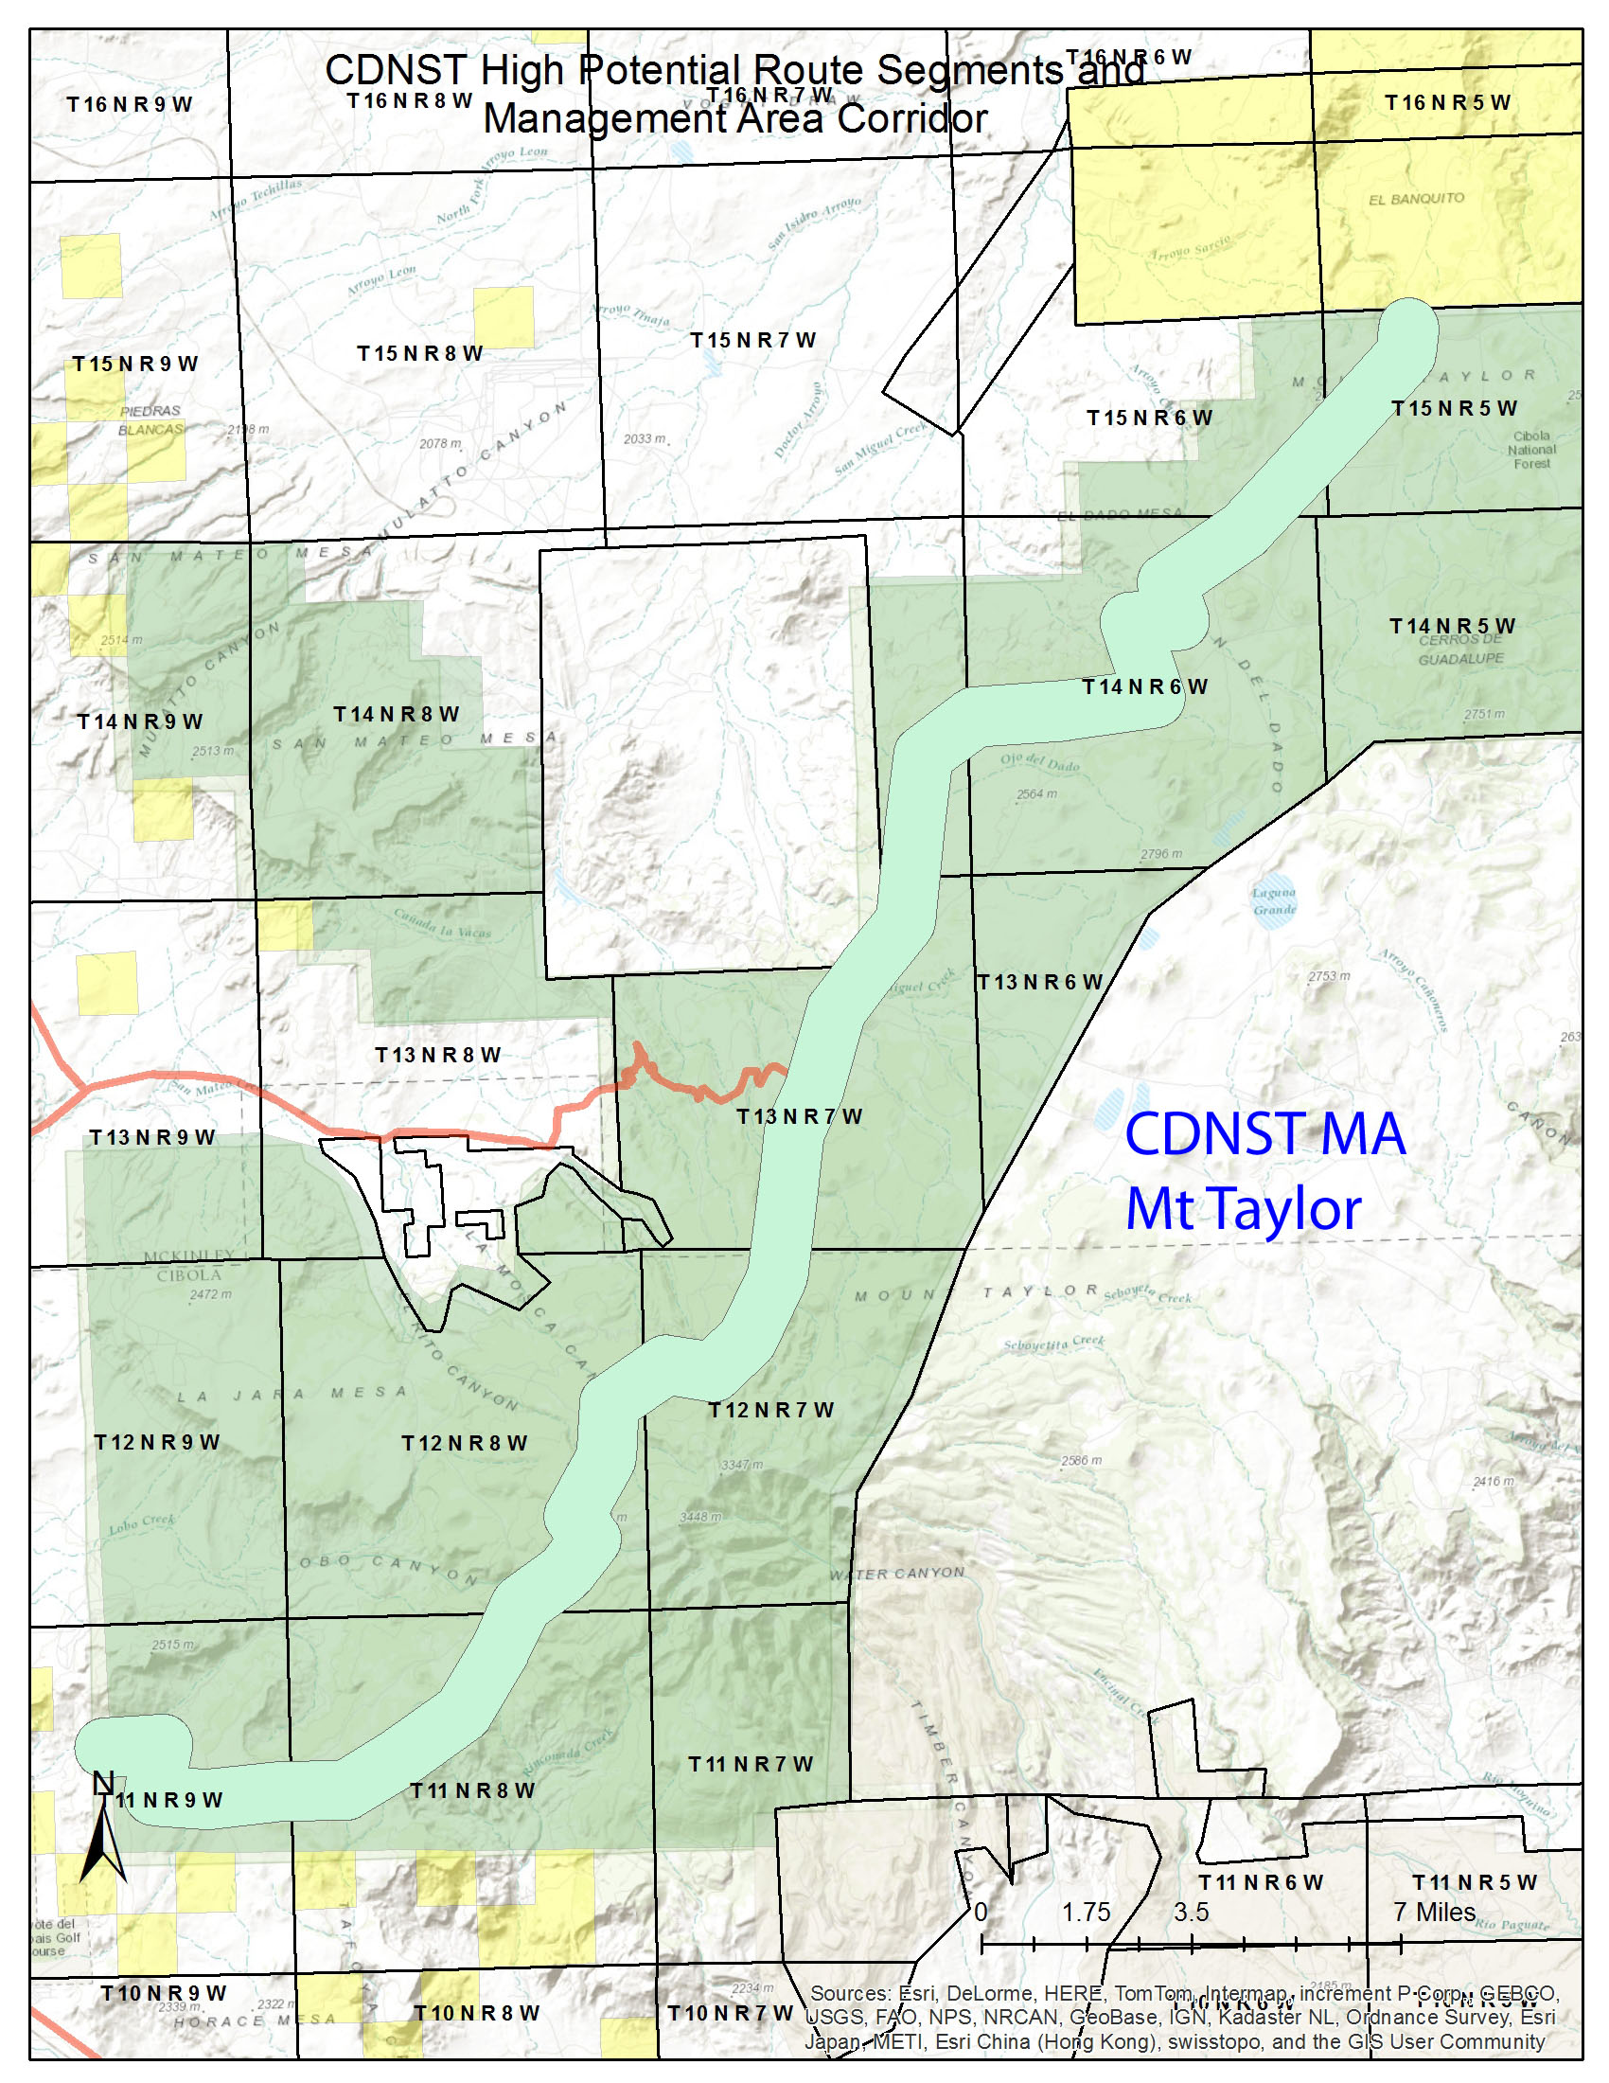

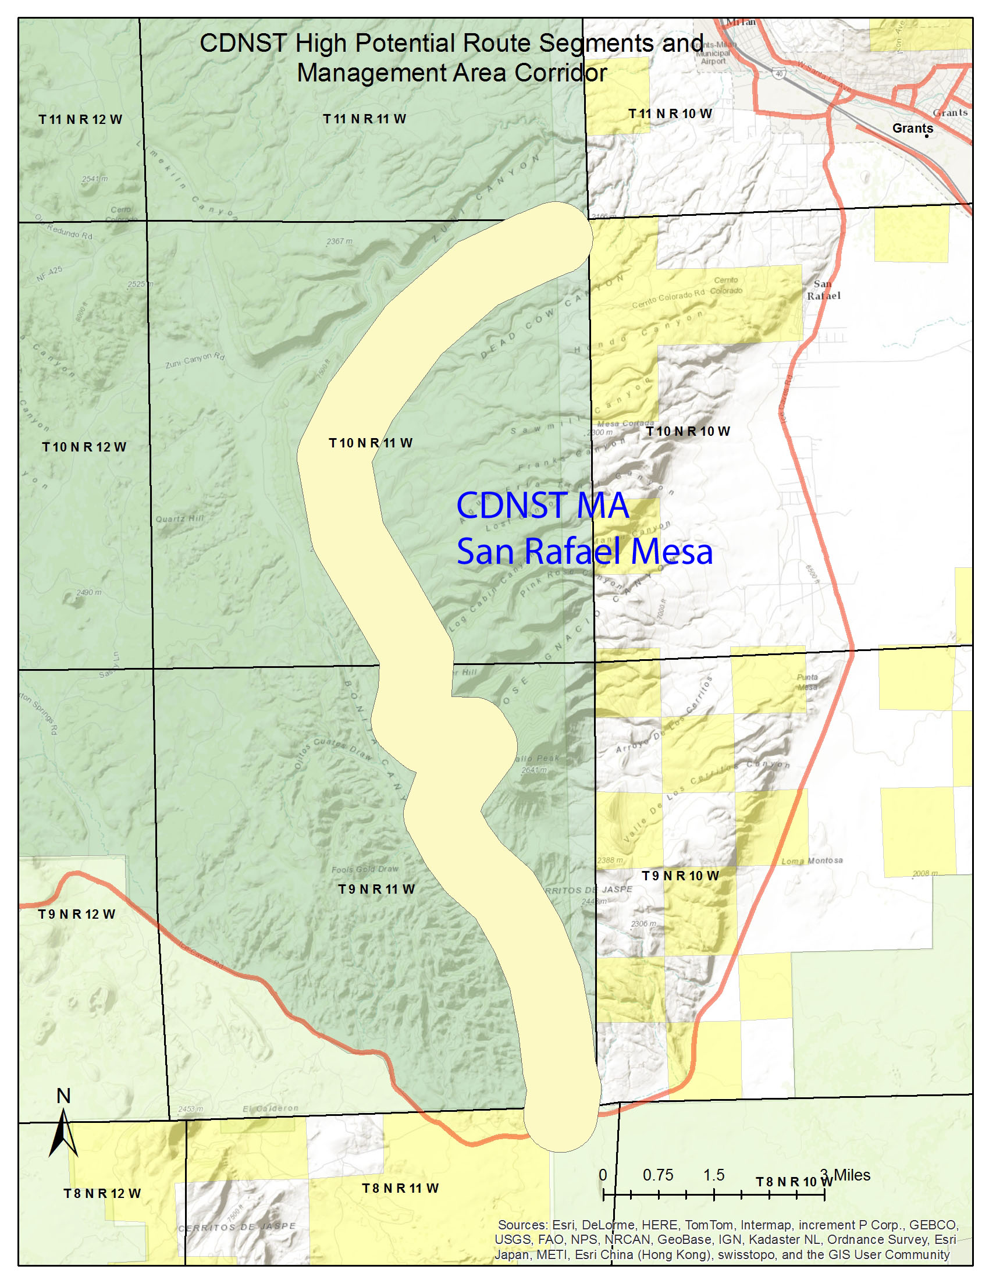

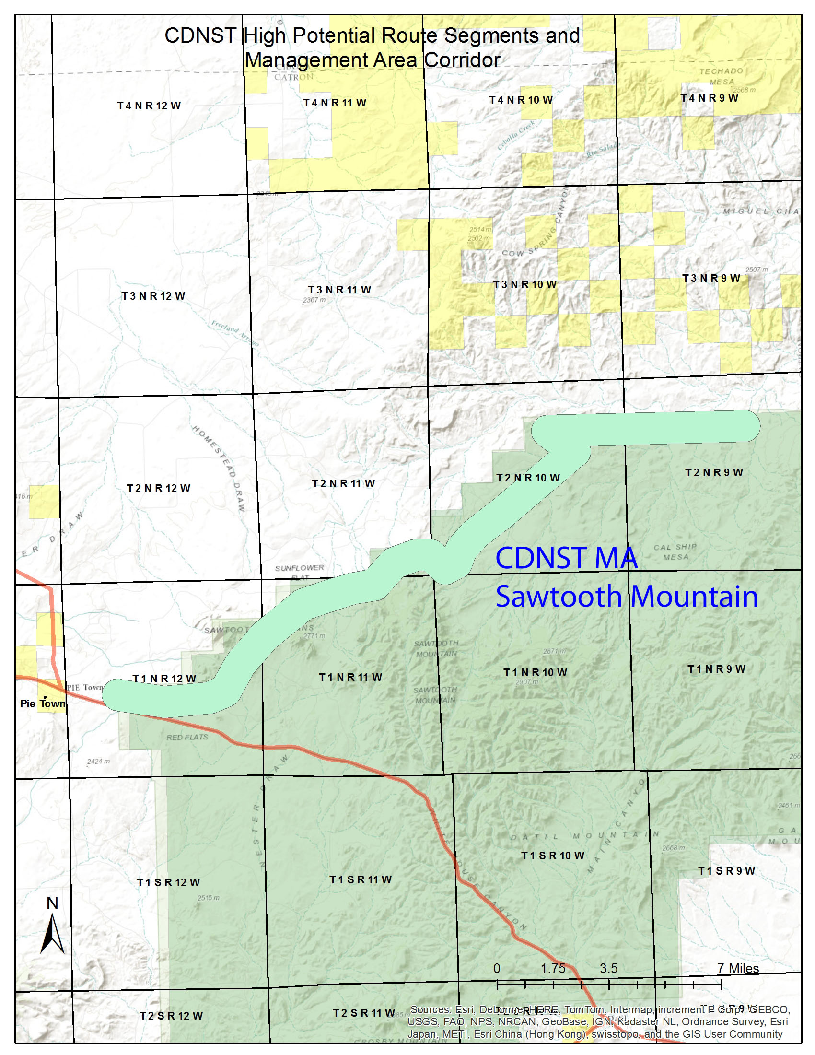

1. The term “corridor” describes an allocation established through the land use planning process, pursuant to Section 7(a)(2) of the National Trails System Act (“rights-of-way”) and E.O. 13195, for a public land area of sufficient width within which to encompass National Trail resources, qualities, values, and associated settings and the primary use or uses that are present or to be restored to provide for the nature and purposes of the CDNST.
2. ROS classes are defined in the CDNST Comprehensive Plan, Chapter IV(5)(c). Primitive and Semi-Primitive Non-Motorized ROS classes are normally compatible with the nature and purposes of the CDNST.
3. The BLM in MS-6280 defines, “S*ubstantial Interference*. Determination that an activity or use affects (hinders or obstructs) the nature and purposes of a designated National Trail (see nature and purposes).”
4. This Federal Register Notice, in part, details direction for “nature and purposes,” “visual resource management,” “recreation resource management,” “motor vehicle use,” and “carrying capacity.”