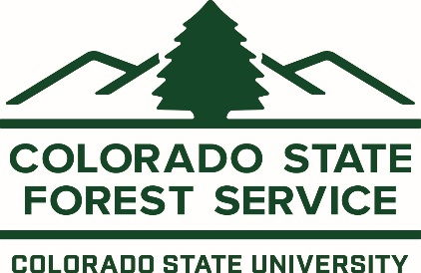

5060 Campus Delivery

Fort Collins, CO 80523-5060

(970) 491-6303

Fax: (970) 491-8645

Scoping comments regarding “Lakeview Project’ Proposed Action on the White River National Forest Dillon Ranger District

3/25/2024

The Colorado State Forest Service strongly supports the USFS White River National Forest’s proposed “Lakeview Project”. This project will improve forest resilience to current and future disturbances through science-based forest management techniques in critical watersheds of the Upper Colorado River. It will also reduce fuels in a key Potential Operation Delineation in northern Summit County, just west of the community of Heeney and the Highway 9 travel corridor.

This proposed action aligns with the Colorado State Forest Service’s Forest Action Plan themes of conserving, protecting, and enhancing our state’s forest conditions, watersheds and wildlife. The Lakeview Project will also provide resilience to climate change by using climate-adapted silviculture methods to promote age-class, structural and species diversity. Lastly, this project will provide critical feedstock to our state’s forest products industry which has several mills/ production facilities in Northwest Colorado.

Sincerely,

Zach Wehr



Supervisory Forester, Granby Field Office

Colorado State Forest Service