Doug Ruppel, District Ranger

Douglas Ranger District

U.S. Forest Service, Coronado National Forest

1192 West Saddleview Road Douglas, AZ 85607

November 23, 2020

Dear Mr. Ruppel,

Thank you for the opportunity to provide comments regarding the draft Chiricahua Public Access Environmental Assessment (EA). We are including by reference EA comments submitted by Amy Harwood and Dwight Metzger.

You have failed to explain the Need for this project. In fact, the EA provides many reasons to pass on this project. Due to unnecessary impacts from these three projects, **we support the No Action Alternative**. Our reasons are discussed below.

The proposed projects do not conform to the goals of the Coronado National Forest Resource Management Plan. **Quite recreation is an overarching goal** of the new forest plan. Current on-the-ground conditions found in John Long Canyon are rare, being one of the few lower elevation canyons on the CNF that does not have motorized access. It is quiet and peaceful with gentle terrain, which is conducive to walking and contemplation. This is what Quiet Recreation looks and sounds like, and very few canyons on the Coronado National Forest (CNF) provide this opportunity. If one has the desire to drive up a national forest canyon bottom, multiple choices exist on the CNF, including many in the Chiricahua Mountains.

In the EA you indicate there are only three access points in the Chiricahua Mountains in which motorized access is blocked. It turns out one of these is open and has been for years. The Chiricahua Ecosystem Management Area is in great shape in terms of motorized access. Why not refocus resources on some of the other 40-50 blocked routes mentioned in the EA? Apparently, according to this EA, there are a number of EMA’s on the Coronado National Forest with a more difficult degree of public access.

According to the EA, these project locations are in three widely separated areas. This makes a strong argument for doing analysis for each of them separately with a site specific EA for each. If these three project areas are to be done collectively, the process should completed as an Environmental Impact Statement. Lumping sites in this EA creates confusion about impacts in each area and how they might be reduced overall. For example, what are the Forest Service sensitive species in each area? Without these being identified it is difficult to determine the true impacts of each of these three projects.

The EA glosses over the important point of access bias. Most members of the public do not understand what Maintenance Level 2 means on-the-ground. We do. If approved, this project will not open John Long Canyon to the general public for motorized access; motorized access will only be opened to those with sturdy four-wheel drive vehicles. We know from the Forest Service’s own surveys this represents less than 5% of the total visitors to the forest. This is a project for a very specific community of forest users, and would exclude forest visitors as a whole, as 95% of them will not be able to access John Long Canyon. The EA indicates public use of these areas is not expected to be heavy, and admits that a road maintained at Maintenance Level 2 would not be inviting to many forest visitors. This contradicts previous statements on providing access to the public. **What the CNF is actually providing access to, is a subset of the hunting community, and to ATV users. The majority of the public will see no benefit at all from this project, and those seeking quiet recreation will be displaced from the area.**

The following sentence is found in the No Action Alternative: *"under this alternative there would be no new addition of roads to the system on the district, therefore there would continue to be high quality wildlife habitat and John Long Canyon and the North Fork of Pinery would continue to serve as a largely undisrupted potential corridor for wildlife."* You acknowledge these are high-value areas for wildlife and wildlife corridors, yet appear to be willing to compromise these values for the wishes of a very small subset of forest users. **This is an unacceptable trade-off.**

The Douglas Ranger District is ignoring their own recent Travel Management decisions. Travel Management Planning was a multi-year project with dozens of public meetings. These meetings occurred in towns and cities scattered throughout the Sky Island Region. A stakeholder group was convened and worked together over many meetings and many months. I was a member of the Travel Management Stakeholder group. This group was tasked with analyzing roads and routes on the forest and making recommendations to the district rangers. I can assure you the stakeholder group was not amenable to reopening the John Long Canyon road.

I will remind you I was on the telephonic Travel Management Objection resolution meeting between the Coronado National Forest (CNF) and Arizona Game and Fish (G&F). Only three years ago, while G&F argued strenuously for motorized access, the Forest Supervisor said NO. Game and Fish indicated a desire to purchase an easement through the Dart Ranch but indicated this would not happen if any of the road in John Long Canyon was closed. The Forest Supervisor stood firm and told Game and Fish no deal. What changed since the above referenced phone call and now, to completely change the Coronado NF’s position on motorized access in John Long Canyon? What analysis can the district provide, which provides the rational for such a dramatic change in a short period of time? The EA does not contain this information but it must exist if you have a different decision. Otherwise, **the forest service pushing this so quickly post Travel Management could only be described as Arbitrary.**

The statement that the public does not have legal access to John Long, North Fork of Pinery Canyon, Horseshoe Canyon areas for recreational and other purposes is incorrect. The EA continuously equates access with motorized access. Legal access is available to all of those areas currently. Our members hiked in all three project areas recently. We can drive into Horseshoe Canyon, a fact confirmed by the EA. These issues were brought up in Scoping by several individuals but this important point does not appear to have been considered in the preparation of the draft EA.

The EA indicates more than 40 Forest Service sensitive species located across the project areas. This is an extremely significant number. The general public might not realize this, but we do, and we know you do. We also know a preponderance of these Sensitive Species are found in John Long Canyon. This begs the question, why are you encouraging motorized access and why would you allow a 300-foot camping buffer on either side of the road? This would create continuous impact to sensitive species far beyond the arbitrary 10-year time Horizon you identify in this document.

The “spatial and temporal bounds of cumulative effects considered in the analysis,” is incomplete. It does not list Peregrine Falcons which nest in the cliffs of John Long Canyon, nor does it address impacts to the Northern Goshawk, for which specific management guidelines exist. It does not identify any analysis done on impacts to the other 39 Sensitive Species found across the project area. Simply stating 40 Forest Service Sensitive Species exist across the project area is not an analysis of impacts but a statement of fact. Each species needs to be identified and analyzed for impacts. Otherwise, the public does not have the totality of information needed to fully assess the project.

The EA fails to identify the degradation in the quality of hunting opportunities with the opening of John Long Canyon to ATV’s and camping. The EA also fails to mention that AZ Game and Fish has a sign-in kiosk in John Long Canyon. **This is solid evidence that access currently exists for the hunting (and other) communities.**

Public motorized access to Horseshoe Canyon is not currently an issue, as one can drive into the canyon with no problems. As currently envisioned by the EA, there would be two open roads going to the same point on the forest. You are in a sense, doubling the impact to private citizens who would end up living between these two roads. It would have the effect of a road on either side of their houses. At the very least, the section of Road 314 from the forest boundary to the juncture of the new access point, should be eliminated. This will eliminate traffic down 314 and reduce the burden on private land owners in the area.

Work in all three proposed projects will disturb the soil, which according to the EA creates favorable conditions for the establishment of invasive plants. What are the impacts to each of the 40 Forest Service Sensitive Species found on this project? **If you can't answer this question, you shouldn't be doing this project.**

The Rural and urban development statement is misleading and is not an argument that supports this project. Much of that growth is in the southern suburbs of the greater Phoenix area in Pinal County, whose population has grown by 591% since 1970. Also, the county in which these projects are occurring (Cochise County), has lost population over the past decade. Hidalgo County, close by and adjacent to Cochise County, has been losing population over an even longer time frame. To use your own reasoning, if population is decreasing in the project area, there should be less of a demand.

The EA states that the Forest Service’s expectation for visitor levels is the same as they were prior to closure. In the case of John long Canyon this was 34 years ago. Does the Forest Service even understand what the visitation was then?

Also, this statement is in direct conflict with earlier statements in which you indicated you needed additional access points due to a large growth in population. Which is it? Is visitation to John Long Canyon going to be as low as 34 years ago, or, will the rapid increase in population (one of the purported Needs for this), lead to a heavy increase in visitation to John Long Canyon? **In reality, there is no way to quantify this and you should not make statements attempting to, unless you can support those statements with data.**

We found of interest your statement that "illegal activity on the CNF continues to result in creation of unauthorized roads and trails, extensive trash and debris piles, and impacts public safety." Currently, we see this mostly with groups of ATV users, and do not understand how opening new areas to this same set of users will not result in continuation of illegal activity. These illegal activities include creating unauthorized roads and trails, expanding trash and debris piles, and the subsequent impact on public safety. **The EA fails to address the history of this user group, which has had a tremendous negative impact on the landscape, and in particular, on other user groups.** Once an area becomes popular with the ATV user groups, other uses tend to stop, pushed out by the noise, accelerated erosion, and reduction in wildlife associated with ATV use areas. We can point to a number of areas on the Coronado National Forest where this has occurred, and where agency response been inadequate to control the expanding impacts.

*"The lack of administrative access also results the (sic) Coronado National Forest being less able to efficiently maintain roads and hiking trails."* This is incorrect. Access cannot be denied to the Forest Service. This just means you have to call the landowners and make arrangements ahead of time. **This is something you should probably do regardless as a courtesy. We do not understand how this makes you less efficient.**

The EA discusses the spread of invasive species and indicates this spread could increase if public visitation increased. There are additional threats in the disturbed areas and adjacent to the road construction itself. Additionally, motorized access greatly increases the risk of invasive species arriving on users’ vehicles and clothing and increases the danger of fire, which is a significant spreader of invasive species as well. The statement indicating the use of best management practices during construction would lower the impacts to acceptable levels is meaningless without being quantified. What is an acceptable level? Is it an increase of invasive species by 10 percent? Is it 30 percent? **If there is an acceptable level for an increase invasive species, the public needs to know what this number is. Otherwise, how can we (or you) assess the true impact from invasive species?**

Anyone who has been in the Rucker Canyon area during hunting season understands that if motorized access is created, John Long Canyon will be filled with dozens of parties at any one time during the more popular hunting seasons for bear and deer. This leads to a **subsequent significant increase in fire danger, something the EA has failed to address.**

The negative impacts of habitat degradation are particularly true when factoring climate change into the equation. Most of these wildlife and plant communities are currently stressed and this stress will continue. Adding additional stressors in terms of large increases in visitors and the subsequent increase of invasive plants and fire danger, does not seem like a good way to address this issue.

The EA concedes this project may affect and is likely to adversely affect the Jaguar. *"The connected action of open public access to areas where it has not occurred since the Jaguar has resided in the Chiricahuas could result in activities that may harm or harass the Jaguar."* You may have noticed jaguars are quite popular with the public. If faced with the choice of more roads or more jaguars, we all know the vast majority of the public would be in favor of fewer roads and more jaguars.

For the proposed John Long Canyon bypass, what is the drop in feet from the top of the terrace to the bottom of the canyon? This would be useful information for the public to understand the steepness of this route and the high potential for erosion. We are skeptical that you can build this road and have it stay navigable over time.

Thank you once more for the opportunity to comment. Please let us know if you have any questions.

Sincerely,

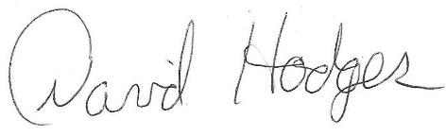

David Hodges

Conservation Director

Natural Allies

dhodges73@gmail.com

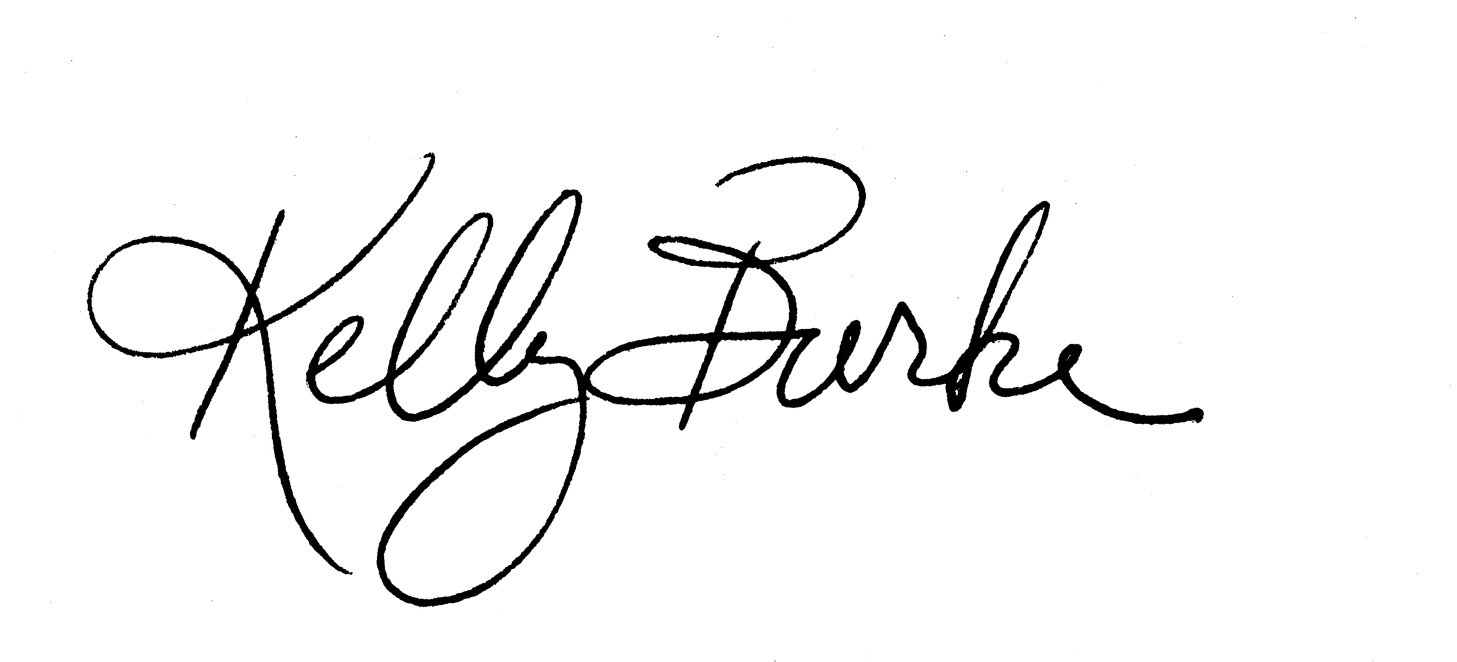

Kelly Burke

Executive Director

Wild Arizona

PO Box 40340

Tucson, AZ 85717