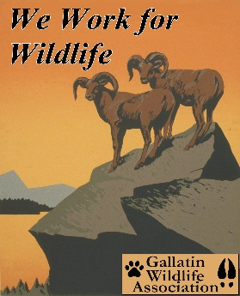

# **GALLATIN WILDLIFE**

**ASSOCIATION**

## P. O. Box 5317

## Bozeman, MT 59717

(406) 586-1729

www.gallatinwildlife.org

August 7, 2022

Deputy Regional Forester

Objections Reviewing Officer

USDA Forest Service,

Northern Regional Office

26 Fort Missoula Road,

Missoula, MT 59804

Re: Objectionable Concerns over the Greenhorn Vegetation Project#51053

Objector’s Contact Information: Lead Objector

Clinton Nagel, President

Gallatin Wildlife Association

Personal contact information: Greenhorn Vegetation Project#51053

406-600-1792 Dale Olsen, District Ranger

[clint_nagel@yahoo.com](mailto:clint_nagel@yahoo.com) Beaverhead Deerlodge National Forest

Bozeman, MT 59718

Dear Reviewing Officer:

The Gallatin Wildlife Association has been engaged in the Greenhorn Vegetation Project (GVP) for many years. Our initial comments were submitted during scoping on October 21, 2017 and then again, March 10, 2022 over the release of the Environmental Assessment. We currently find ourselves submitting comments during the Objection Phase of the project. To begin with, let me once again remind the Beaverhead-Deerlodge National Forest (BDNF) about our affiliation.

Gallatin Wildlife Association (GWA) is a local, all volunteer wildlife conservation organization dedicated to the preservation and restoration of wildlife, fisheries, habitat and migration corridors in Southwest Montana and the Greater Yellowstone Ecosystem, using science-based decision making. We are a nonprofit 501 (c)(3) organization founded in 1976. GWA recognizes the intense pressures on our wildlife from habitat loss and climate change, and we advocate for science-based management of public lands for diverse public values, including but not limited to hunting and angling.

As we begin, we couldn’t help but question the perspective from which this decision and opinion was derived. According to NEPA, § 216.6 Environmental assessments1, section (a) it states the general purpose is to:

*“provide Agency and host country decision makers with a full discussion of significant environmental effects of a proposed action.”*

*“It includes alternatives which would avoid or minimize adverse effects or enhance the quality of the environment so that the expected benefits of development objectives can be weighed against any adverse impacts upon the human environment or any irreversible or irretrievable commitment of resources.”*

It is only then when those adverse impacts or enhancements of the quality of the environment are weighed against any adverse impacts upon the human environment. But the Environmental Assessment (EA) prepared by BDNF seems to have put the cart before the horse. For as it states on page 1 of the EA, this was prepared to:

*“determine whether implementation of prescribed fire, non-commercial thinning, and commercial timber harvest may significantly affect the quality of the human environment and thereby require the preparation of an environmental impact statement.”*

Where is the analysis to see what impacts these alternatives would have on the natural environment? The above-mentioned statement seems to acknowledge this assessment was prepared to determine if any of these alternatives would significantly harm our human environment. Isn’t the whole established purpose of NEPA to analyze impacts upon the natural environment, not the other way around? GWA wants clarification on this for what we believe is a discrepancy over the intent of purpose.

**The Two Alternatives Approach: We Object**

In our March 2022 comments, we made note of our dissatisfaction with the two- alternative approach; the Proposed Action and the No Action alternatives. Some of those comments and concerns will be reproduced here. Even though this may meet the NEPA requirements on the most minimal of terms (some courts seem to indicate that having two alternatives satisfies NEPA requirements) this does not mean we are happy with this approach. We aren’t. In the BDNF release in January of 2022, the EA states there were four (4) other alternatives that were originally considered, but were dismissed. The public never got a chance to see or comment on those proposals.

We realize there is no specific requirement as to the number of alternatives which need to be presented, but NEPA does require that federal agencies consider a “reasonable range” of alternatives. Unfortunately, courts have not defined what that requirement (numerical limit) is. And that diminutive acceptance by the courts denies the public full knowledge and understanding of what the environmental consequences are, thereby denying the public knowing the possibilities and potential of mitigative action.

The Proposed Action is fairly close to the scoping notice of 2017, with a slight decrease in acres for vegetative treatments and a slight increase in miles of temporary roads. But we had issues with the proposed plan then and we do so now. It appears that many of our concerns have gone unaddressed. GWA has continued consternation over this project because of what we believe are flawed assumptions. It seems as if the Beaverhead Deerlodge National Forest (BDNF) does not recognize the cyclic nature of ecological events. This leads us to the following comments.

**Our Involvement in the Collaborative Process: We Object.**

Much has been made about our attempt to become involved in the collaborative process. We would like to say that our involvement, in no way endorses the result of that process. We tried to become involved early on in the collaborative function in order to have input over the issue of the health of bighorn sheep and the potential to improve big horn sheep habitat.

Even though we attempted to become part of the collaborative, we were eventually denied access. Our understanding is that the Gravelly Landscape Collaborative proposed the Greenhorn Vegetation Project. But we question why? Why does a group of special interest get to decide or propose what happens upon our public lands and thereby exclude the actions of others to participate? We were denied access from the collaborative even after we attended some functions and meetings. The reason for such behavior as reported to us said; we did not show the initiative or commitment to collaborate or to seriously take part in the give and take required in such action.

If true, we have no choice but to find fault with this process. There must be a better way to orchestrate Forest Service (FS) projects rather than getting like-minded stakeholders to agree on a project then exclude the remainder of the public out. **We object to that process.**

**Our Historical Concerns, Confusion and Objections over Habitat Enhancement of Bighorn Sheep:**

Since GWA first registered comments on this forest project, we’ve raised more questions than we’ve received answers. In fact, we don’t see an honest attempt by BDNF to seriously address those concerns of which have been many. From day one, our primary concerns have been two-fold; those based upon land resources such as timber and forest management and those concerning wildlife.

In 2017, we saw a potential this project could be used to benefit bighorn sheep. At that time, we said the following:

* *Unless there are benefits to wildlife (specifically bighorn sheep) we oppose timber harvesting in an unsuitable timber base.*

Further on in those comments of 2017, we also stated this.

* *For example, we (members of GWA) suggested removing some areas of conifer encroachment in historic open grassland bighorn sheep habitat for the purpose of increasing visibility, forage availability and connectivity of bighorn sheep habitat, thereby benefiting bighorn sheep. Most of our recommendations were on the west rim or south facing slopes of the Greenhorn Mountain Range.*

Since then, we provided comments in March of 2022 whereby GWA provided comments based upon the January 2022 Assessment. There seems to be very little if any change between the assessment of January 2022 and the release of June 2022.

Our comments of March 2022 are restated here.

*“In GWA’s original discussion on this project four years ago,* ***we had the understanding that one of the potential benefits of this project was the prescribed fire burns which could enhance habitat for bighorn sheep.*** *But there was no analysis pertaining to connectivity of bighorn sheep and there were no objectives listed for improving bighorn sheep habitat at that time.*

*Currently, the EA does a little better in the defining of bighorn sheep improvements, but there is still room for further discussion. Our resident wildlife biologist makes this statement.*

“*the discussion is still vague and lacks a clear description of what exactly is contained within bighorn sheep habitat. We agree that open areas of high visibility, on and near escape terrain, with at least patches of continuous forage are important. However, the issues of juxtaposition and connectivity of these patchy habitat components is ignored. Basically, FWP knows rather little about how the existing (unknown number) of bighorns are using the habitat now. Importantly, lambing areas, or wintering areas, have not been identified - at least not presented in the EA.* *Consequently, FS concludes that tree removals, increasing visibility, are likely to improve habitat for bighorns. They cannot be any more specific than that. --* *The Herd seems to be small, and largely unknown, based on the EA.”*

*The proposed action does proclaim that 12% of the escape habitat would be enhanced and that it also includes 21% of the lambing/winter escape habitat would be enhanced. On the negative side, there are these statements found on page 69.*

*“Implementation of the project may result in impacts to the species as individuals may be disrupted by noise associated with the proposed treatments. The escape habitat described above would be disturbed by project implementation. However, 79 percent of the habitat would be available to these displaced sheep during implementation. It is anticipated that bighorn sheep would be able to move into these undisturbed habitats during implementation.”*

*“The Greenhorn Vegetation Project may impact bighorn sheep individuals or habitat but would not likely contribute to a trend towards federal listing or cause a loss of viability to the population or species.”*

*To the latter statement, we believe this is a low bar and is not very reassuring.”*

Back to present day. With more time and with data provided to us by Montana Fish, Wildlife and Parks (MFWP), GWA would like to amend those previous comments to make them relatable to this Objection Process. Specifically, the data we are referring to is the *“Bighorn Sheep and Mountain Goat Herd Health Assessments”* referred to as W-166-SI, Final Report2, 2016-2021, January 6, 2022. We would like to give credit to architects of this report: Dr. Emily Almberg2, Dr. Jennifer Ramsey, Matthew Becker, Keri Carson, Gina Freund, Justin Guide all of MFWP. The remaining information provided in our analysis was from Montana Fish, Wildlife & Parks unpublished data provided Dean Waltee, Wildlife Biologist for MFWP.

GWA applauds the concern expressed for bighorn sheep habitat management. Established with 69 transplanted bighorns in 2003-04, the Greenhorn herd has languished. Trend counts in June for 2003 – 2009 suggested a declining herd. However, these counts are not comparable with counts during February – March (months vary among years) in 2015-2022. During the last 8 years, between 41 and 48 different bighorns have been counted per year. The sheep have dispersed in recent years and now use 3 separate wintering areas. Importantly, it is not known if somewhat separate breeding populations have been established. Separate breeding populations would contribute to non-random breeding within the herd.

GWA believes a genetically healthy bighorn herd requires an “effective breeding population” (Ne) of 50 animals. However, counting non-breeding (especially young) animals and with non-random breeding, a total population (N) generally must exceed 100 animals to avoid a degree of inbreeding that could seriously limit population growth. Even a few inbred bighorns could place the entire herd as risk because inbred animals have lowered resistance to disease (among many deleterious traits) and can become “carriers” that persistently expose other animals to disease. Trend counts suggest the Greenhorn bighorn herd has never had 100 animals.

The most important, but not only, disease risk for many FS bighorn herds is pneumonia contracted from contact with domestic sheep. Such contacts often lead to all-age dieoffs from which bighorn herds fail to recover for many years, if ever. Domestic sheep occur on private and other lands adjacent to the National Forest, and in a domestic sheep allotment annually used in the southern half of this Forest unit. **A goal of bighorn sheep habitat management by the FS should be to attract bighorn away from these domestic sheep threats toward the interior of the northern portion of the Forest unit.**

While no outbreak of disease has yet been detected in the 19-year-old Greenhorn herd, the herd does not grow in numbers. Predation by mountain lions is a likely limiting factor. Small herds are especially susceptible to being controlled by predation – population trends being affected by a high predator/prey ratio. In other parts of the country, languishing bighorn herds have been released by application of lion control. However, MFWP does not seem interested in lion control. The only remaining remedy is strategic habitat management to enhance habitat security on seasonal bighorn ranges and the migration corridors between these ranges.

Bighorn habitat security is a function of presence or proximity of steep escape terrain and habitat visibility that enhances bighorn ability to visually detect danger and also to visually communicate danger among animals in the bighorn group. For bighorn herds on U.S. Forest Service (USFS) habitat, visibility is often diminished by encroachment of trees or tall shrubs on otherwise open bighorn habitat. **A goal of bighorn sheep habitat management by the USFS should be to enhance bighorn habitat security on and near escape terrain. Habitat treatments to improve visibility should be strategically located to connect and improve security on seasonal ranges and migration corridors**.

(Such habitat management may also increase bighorn forage quality and quantity. However, we have not seen data indicating that forage conditions outside of the winter season, are limiting the Greenhorn herd.) Unfortunately, MFWP does not yet have much information regarding habitats used by Greenhorn bighorns during spring, summer, and autumn. (There may be data from a currently ongoing study with radio-collared animals. USFS should request this information before selecting sites for bighorn habitat improvement.)

A recently compiled map of Greenhorn bighorn observations (shown below), November 2013-May 2022, shows 3 winter ranges off or near the west Forest border and a single cluster of 9 (?) observations, plus scattered lone observations within the Forest east of the winter ranges. Bighorn habitat management, with prescribed fire or mechanical treatments, should (1) enhance habitat security on the east sides (toward the Forest interior) of the southern two winter ranges, and (2) improve habitat security in corridors between these 3 winter ranges, along ridges and/or linear patches of steep terrain. Third, the area with 9 observations within the Forest should be evaluated for a habitat improvement project. If this appears to be a suitable bighorn seasonal range, habitat management should be focused on the area and on strategic areas of steep terrain to connect the area with the middle winter range, and perhaps the northern winter range.

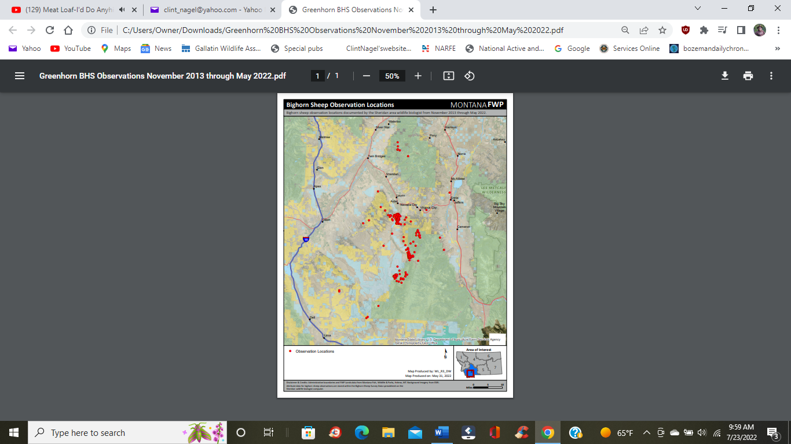

All the observation locations on the above-mentioned map should be evaluated for steep terrain and visibility, with visits or map overlays.

**It is important to strategically locate bighorn habitat improvements**. Bighorn are habitat specialists, often with 6 or more seasonal ranges connected by migration corridors. Non-strategic locating of habitat treatments, perhaps based on access or ease/cost of treatment, may accomplish little or nothing for the Greenhorn herd. Moreover, the USFS should seek to attract the herd well into the Forest interior, away from domestic sheep.

GWA would like clarification over this issue. Our concern remains the same. Questions remain about this project. Just what treatment options are to take place in bighorn sheep habitat? GWA originally stated that we would be in favor of bighorn sheep habitat enhancements if they would be done by prescribed burns. GWA would not favor thinning, logging or road construction in bighorn habitat.

**Objection Over Potential Harm to Endangered, Threatened and Proposed Species:**

GWA will state that portion of the Endangered Species Act (ESA) we think is pertinent to the actions described under the Greenhorn Vegetation Project on the BDNF. There are two species that fall under provisions of the ESA with a third the wolverine, being reconsidered per judges’ decision of this year. GWA challenges and disagrees with decision of the BDNF and the USFWS that the actions proposed under the scope of this project would not be deleterious to the species addressed below.

We remind both the USFS and the U.S. Fish and Wildlife Service (USFWS) that Section 2 requires all Federal agencies to seek to conserve endangered species and threatened species, and Section 7 requires Federal agencies to ensure that the actions authorized, funded, or carried out by them are in consultation with the Secretary and other federal agencies and not likely to jeopardize the continued existence of any threatened or endangered species or result in the destruction of adverse modification of their critical habitats.

Endangered Species Act of 1973, as amended: Section 7(a)

1. *The Secretary shall review other programs administered by him and utilize such programs in furtherance of the purposes of this Act. All other Federal agencies shall, in consultation with and with the assistance of the Secretary, utilize their authorities in furtherance of the purposes of this Act by carrying out programs for the conservation of endangered species and threatened species listed pursuant to section 4 of this Act.*
2. *Each Federal agency shall, in consultation with and with the assistance of the Secretary, insure that any action authorized, funded, or carried out by such agency (hereinafter in this section referred to as an “agency action”) is not likely to jeopardize the continued existence of any endangered species or threatened species or result in the destruction or adverse modification of habitat of such species which is determined by the Secretary, after consultation as appropriate with affected States, to be critical, unless such agency has been granted an exemption for such action by the Committee pursuant to subsection (h) of this section. In fulfilling the requirements of this paragraph each agency shall use the best scientific and commercial data available.*

*(4) Each Federal agency shall confer with the Secretary on any agency action which is likely to jeopardize the continued existence of any species proposed to be listed under section 4 or result in the destruction or adverse modification of critical habitat proposed to be designated for such species. This paragraph does not require a limitation on the commitment of resources as described in subsection (d).*

**Wolverine:** On May 26 of this year, Judge Donald Malloy made the decision3 to give the U.S. Fish and Wildlife Service (USFWS) 18 months to reconsider the agency’s past decision. That decision being not to list the wolverine as either an endangered or threatened species under the Endangered Species Act. As a result, the USFWS provided a Biological Assessment for the BDNF, that assessment dated June 16, 2022. On Table 1, page 1 in that report’s introduction, the assessment entitled NORTH AMERICAN WOLVERINE BIOLOGICAL ASSESSMENT for The GREENHORNS Project, Madison Ranger District, Beaverhead-Deerlodge National Forest states the wolverine is known to occur in the area. That sentiment and fact is also stated in Section 5.1.3 whereas it states the following:

*“Wolverines have been recorded in and near the Greenhorns Project Area and within the action area. Current and past wolverine occurrence across the Beaverhead-Deerlodge National Forest is detailed in section the FEIS for the BDNF Forest Plan and its biological Assessment (USDA FS 2008 and 2009). Surveys using a combination of methods have detected wolverine across the Beaverhead-Deerlodge National Forest.”*

With knowledge and agreement that the Wolverine is considered to inhabit the area, the question then becomes; will they suffer harm from proposed actions. GWA has a problem with several assumptions and/or the interpretations of the science used in the BA analysis. This is highlighted in Table 4 as seen in factor A2, Habitat Impacts due to Human Use and Disturbance. The finding of “Not a Threat” for those 4 categories listed under A2 appear to be misleading if not actually in the scientific minority.

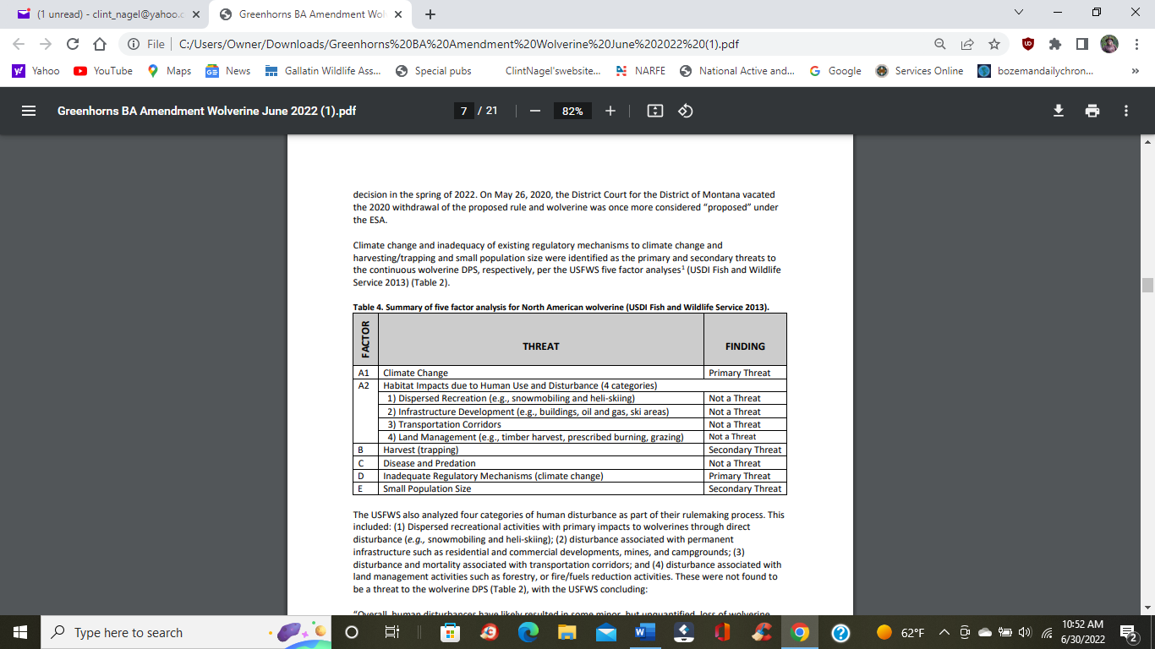

Much of the BA relies on the science found in Heinemeyer, but we found something of particular interest. The Complaint2 filed in Missoula District Court by Western Environmental Law Center also used some of that same science to defend its claim the wolverine needs to be reconsidered for listing under the ESA. This indicates to us that we need to verify and rely on more than just one source. There is a preponderance of science out in the world that indicates the wolverine should be listed. It also highlights the vulnerability of the species to anthropogenic activity. Even though GWA was not party to the litigation filed in Missoula District Court, we are in agreement with the Complaint. For sake of time and space, GWA will not list the arguments in the wolverine Complaint, but urge the USFS, the BDNF and the USFWS to review the Complaint and especially look at paragraphs 55-164. These are our reasons as to why the wolverine should be listed and why we object to this project moving forward as we believe the project would harm the species and their habitat.

GWA finds the conclusions drawn from Heinemeyer in this EA, suspicious in that it tends one to believe that perhaps USFWS cherry picked the data, a charge stated in the Complaint. It is either that or erroneous assumptions and conclusions were drawn from the report. We are willing to present additional science proving further research and references on the subject justify our reasoning. For example, an article in Mongabay dated May 9, 2022 by Grace Hansen4 proclaims these findings.

* *New research finds that when coyotes and wolverines come into contact, the rarer wolverines lose out.*
* *Human impacts, such as roads and fossil fuel infrastructure, are pushing both of these predators into closer contact, harming wolverine populations.*
* *Researchers suggest improving landscape management to take into account wolverines’ needs.*

The article entitled “*Human disturbance is pitting wolverines against an unlikely competitor: Coyotes”* surprisingly states an issue that historically we believe has not received a lot of attention. But it brings up the old idea that our ecosystem is complex and changes in that ecosystem that most likely man has not even recognized can have huge implications in the wild. The article continues on:

*“The study went on to explain that it was competition with other animals, like coyotes, that posed the biggest threat to wolverines. But why do the two species seem to be interacting more often, despite always having shared similar habitats? According to the research led by Gillian Chow-Fraser, the boreal program manager at the Canadian Parks and Wilderness Society, the answer is us. Generally speaking, although coyotes and wolverines inhabit the same area, they don’t often naturally cross paths. However, when humans disturb a wolverine’s habitat by building roads, trails, or pipelines, it drives the two species closer together.”*

Further on, there is this statement.

*“To analyze the landscape shift’s impact on wolverines, the researchers placed camera traps and heat-in-motion digital cameras in 154 spots and gathered data for a total of 35 weeks across the course of several years. They spotted wolverines at 70 sites, and coyotes at 74. After analyzing the results, the team discovered that human activity meant more competition between species, which led to fewer wolverines and more coyotes.”*

*“In fact, wolverines and coyotes were twice as likely to compete with each other for food and resources after humans disturb a natural landscape, according to the paper.”*

The paper continues on, but hopefully the point is made. We don’t know to what extent our actions have on the natural landscape until those actions have happened. It is only our arrogance that makes us assume otherwise.

It is statements like these:

*The project is not likely to jeopardize the continued existence of the wolverine Distinct Population Segment.*

Or:

*“Any disruption of dispersal or other exploratory movements would be temporary and would occur at a small scale when compared to the large home range size of wolverines. Wolverine have been documented to persist and reproduce in areas with high levels of human use and disturbance including developed alpine ski areas and areas with motorized use of snowmobiles (Heinemeyer et al. 2012, USDI Fish and Wildlife Service 2013, and Heinemeyer et al. 2019)”*

Or:

*“When these effects are combined with the temporary disturbance associated with the proposed Greenhorns Project, the cumulative impact on wolverine is expected to be insignificant.”*

is where we find little comfort and trust. They are based upon assumption, arrogance and perhaps misinterpreted science.

In another article, one entitled *“Humans are getting in the way of the wolverine”* by

Niki Wilson5 in the January 20, 2014 release in Earth Touch News Network, there is this statement based upon scientific work by Dr. Jason Fisher and Nicole Heim.

*“Wolverine distribution along the Rockies is unexpectedly close to the border of protected areas,” says Fisher. His research found wolverines are more abundant in the rugged terrain of national and provincial parks, despite what should be good habitat in transitional landscapes between the Rocky Mountains and Alberta prairie.”*

The article continues.

*“Fisher says it is a combination of factors, but has something to do with linear features like roads and seismic lines introduced by industries like forestry, and oil and gas. Biologists call these features linear disturbances.”……*

*“Preliminary results from Fisher and Heim’s research in southern Alberta support this. “What we’re seeing is a lot of activity by foxes and coyotes, and fewer wolverines, in areas with high densities of linear features,” says Fisher, who wonders if these canids are out-competing wolverines.”*

We’ll finally bring one more reference of science-based evidence of the impact of snowmobile use on wolverine. We refer to a paper by Winter Wildlands Alliance6, entitled “Environmental Impacts from Snowmobile Use”. In that paper, it states the following in regard to the impact snowmobiles have on wolverines.

*“There is scientific uncertainty about the exact effects of snowmobiles on wolverines. However, compelling anecdotal evidence suggests snowmobile use displaces wolverines and may reduce reproductive success, especially when it occurs within potential wolverine denning habitat. Wolverine parturition primarily occurs mid-winter during the month of February (WCS, 2007). Six of the seven natal dens located in the Greater Yellowstone Ecosystem by the Wildlife Conservation Society (2007) were in areas without motorized use, i.e., designated wilderness, areas inaccessible by vehicle, or national park.”*

*“Other wolverine biologists have suggested refuge from human activity is important for wolverine reproduction (Banci, 1994; Magoun and Copland, 1996). Female wolverines appear to be quite sensitive to human disturbance in the vicinity of natal and maternal dens, and may abandon dens and move their kits a considerable distance if they detect human presence in the area (Copeland 1996, Magoun and Copeland 1998). In general it appears that wolverines are sensitive to human disturbance and are less likely to occur in areas with anthropogenic activity (Fisher et al. 2013).”*

GWA can provide more scientific research on the subject, research that certainly provides an altered and even a more provisional approach to this subject. The point is, to state that actions may harm specific individuals or a small fraction of habitat or the prey that is contained therein, yet state no harm will befall the population is not assurance enough. We are down at minimum levels when it comes to habitat remaining for this species. Climate change adds to the problem. Therefore, the Biological Assessment asserting that human development is not consequential enough to disrupt or disturb wolverine habitat is false and all to assuming in its arrogance.

**Grizzly bear:** Again, in the words of the Biological Assessment (BA) dated May 16, 2022, the species of grizzly bear is known to be *“year-round residents of the BDNF.”* Such is stated on page 20 of the BA where it further states the *“project area is not located within the Yellowstone Recovery Zone but is identified as within the Demographic Monitoring Area.”* Continuing on, it states that “*the action area is large enough to include a female grizzly bear’s home ranges and is representative of effects from the proposed action.”* As with the wolverine, the next question is how will the actions proposed by this project affect the dynamics of the grizzly bear.

For decades, biologist, scientists and conservationist have longed to establish grizzly bear connectivity between identified ecosystems throughout the west, according to the USFWSwebsite7 show here.

<https://www.fws.gov/species/brown-bear-ursus-arctos-horribilis>

The 1993 Recovery Plan established these areas with this focus.

*“The 1993 Recovery Plan identified six ecosystems, with recovery zones at the core of each, to further recovery efforts.  Each recovery zone represents an area large enough and of sufficient habitat quality to support a recovered grizzly bear population.  The Recovery Plan recognized that grizzly bears will move and reside permanently in areas outside the recovery zones and that connectivity between recovery areas would be necessary for isolated populations to increase and sustain themselves at recovery levels.  The recovery zones identified are:  (1) the Greater Yellowstone (GYE) in northwestern Wyoming, eastern Idaho, and southwestern Montana; (2) the Northern Continental Divide (NCDE) of north-central Montana; (3) the North Cascades area of north-central Washington; (4) the Selkirks (SE) area of northern Idaho, northeast Washington, and southeast B.C.; (5) the Cabinet-Yaak (CYE) area of northwestern Montana and northern Idaho; and (6) the Bitterroot (BE) in the Bitterroot Mountains of central Idaho and western Montana.”*

Yet in reviewing the BA for the Canadian Lynx/Grizzly bear, the document only briefly describes the need for connectivity in terms of the grizzly bear in the most vague and broadest of terms, that found on page 4 of the BA. It states:

*“The purpose of the proposed project is to promote resiliency and ecological function by helping to restore and maintain the structure, function, composition and connectivity of Forest terrestrial and aquatic systems.”*

The concept of wildlife connectivity is expressed 12 times throughout the document of the BA, but 11 of those 12 refer connectivity in relation to Canadian Lynx, not the grizzly bear, other than the example above. Why is that? The advocacy for grizzly bear connectivity has long been heralded by the wildlife community, yet it seems to be ignored within the USFWS’s own BA document concerning the Greenhorn Vegetation Project.

On page 21 of the BA, there is this statement under the heading “Secure Habitat”.

*“While grizzly bears die from natural causes on occasion, human‐caused mortality is the driving force behind grizzly bear survival rates (USDI Fish and Wildlife Service 2011; Mace and Roberts 2011, van Manen et al (IGBST) 2020).”*

This is a sad and disturbing statement and one in which GWA is trying to alter for the betterment of the bear. However, one way to alter that statement is not to allow anthropogenic sources have free and expanding will upon the bear’s habitat. On page 30 of the BA, there are these statements in relation to the *“Determination of the Grizzly Bear”.*

*“The proposed action* ***May Affect and is Likely to Adversely Affect Grizzly Bears****.*

*The proposed action may affect and is likely to adversely affect individual grizzly bears because:*

*• Secure habitat in the project area will be reduced by 190 acres from temporary road building to timber units which is a 0.7% reduction in available secure habitat in the project area (insignificant effects).*

*• There is potential to displace females with cubs during den emergence in the spring from helicopters associated with the prescribed fire units and displace bears from helicopters associated with the prescribed fire units during fall in a very popular hunting area (significant effects).*

*• Approximately 33.7% of the available habitat for denning would be impacted by proposed actions and a majority during spring emergence from dens. A majority of the denning habitat in the prescribed fire units however would remain available because late seral and closed canopy forested habitats are not targeted for treatment (insignificant effect). Approximately 2.7% of denning habitat in the project area would be impacted from timber units (insignificant effect).*

*• Cover will be reduced for bears along Timber Creek Road and Idaho Creek from the timber sale activity by 1,083 acres which is 4% of the forested cover habitat available in the project area, leaving 96% of the forested cover habitat available for bears (insignificant effects).*

*• Foraging habitat effects overall are expected to provide long-term enhancement of this habitat but have short term effects from the prescribed fire until the vegetation regrows. Additionally, whitebark pine habitat is expected to have beneficial long term effects from reducing competition and mitigation measures are designed to minimize effects during timber harvest (insignificant effects).*

*• Impacts to individuals may occur, however it is not expected to limit population expansion or growth in this area of the Forest or the Yellowstone area as the population has continued to increase and expand in this area of the BDNF despite increased annual conflicts and mortalities.*

*• Additionally, most of this project is within the Demographic Monitoring Area of the Yellowstone population. Within the DMA, the population and mortalities are closely monitored and mortalities have a threshold based on the population estimate to ensure the Yellowstone grizzly bear population is maintained through time*.”

GWA finds it interesting that even though the BA states many of these impacts are insignificant, overall, they still describe the project action as likely to affect or adversely to affect grizzly bears**. The BA doesn’t describe or consider the cumulative impacts of how this project, in conjunction with other USFS projects and those impacts outside the USFS’s control, have a long-term or overriding impact on the species itself.** In addition, the BA does not state how this project interferes with the USFWS mission to instill grizzly bear connectivity from the Greater Yellowstone Ecosystem (GYE) and the Northern Continental Divide Ecosystem (NCDE).

In a paper entitled “*Grizzly Bear Denning Habitat and Demographic Connectivity in Northern Idaho and Western Montana*” by Mike Bader and Paul Sieracki8 state the following in reference to grizzly bear survivability.

*“Allendorf and Ryman (2002) estimate 5000 grizzly bears may be needed in a single population or metapopulation to ensure long-term viability. None of the current recovery areas are of sufficient geographic size to independently support that number of bears: the most recent population estimate for the US is ≈ 1800 (USFWS 2021). To achieve long term viability isolated populations must be linked while reestablishing a breeding population in north-central Idaho (Metzgar and Bader 1992, Allendorf et al. 2019, Allendorf 2020, Mattson 2021). The metapopulation has been defined as a collection of populations with some rate of interchange between them and the metacommunity has been defined as a set of local communities linked by dispersal or a “community of metapopulations” (Hanski and Gilpin 1991). Linkage of the isolated grizzly bear populations into a metapopulation would increase the probability of longterm survival (Allendorf et al. 2019).”*

This statement and the culmination of additional science indicated therein reinforces the mission of the USFWS and other federal agencies to allow grizzly bears to reach connectivity. With all that has been said and knowing what we know, GWA has a hard time trying to square the two sets of facts as stated by the Biological Assessment and the Environmental Assessment. The first quote found on page 67 of the Environmental Assessment as stated here:

*“Impacts to individuals may occur, however it is not expected to limit population expansion or growth in this area of the Forest or the Yellowstone area as the population has continued to increase and expand in this area of the Beaverhead-Deerlodge National Forest despite increased annual conflicts and mortalities.”*

And the other being found on page 21 of the Biological Assessment as stated here.

*“While grizzly bears die from natural causes on occasion, human‐caused mortality is the driving force behind grizzly bear survival rates (USDI Fish and Wildlife Service 2011; Mace and Roberts 2011, van Manen et al (IGBST) 2020).”*

One saying the greatest threat to grizzly bears is human-caused mortality and the other stating population expansion and growth in the area will still continue despite the increased conflict and mortality. How is one supposed to square those two statements? This is a classic example of political double speak and why we are challenging the Greenhorn Vegetation Project. We also question the dismissive impacts as stated in the EA and BA over the potential harm to grizzly bear habitat and individuals and ask why this is not a violation of Section 2 and Section 7 of the ESA.

**Canadian Lynx:** GWA is not going to oppose the Greenhorn Vegetation Project based upon presence of Canadian Lynx at this time. According to the “*Species Status Assessment for the Canadian Lynx”*, Version 1.0 – Final, released in October of 2017 by the USFWS9, the agency holds little faith of the GYE supporting resident lynx on a consistent basis. In referring to the GYE, there is this statement found on page 156 of that document.

*“There are no reliable estimates of the historical or current number of resident lynx in this unit. As described in section 2.3.2.2 above, the historical record and recent research show that the GYA has supported resident lynx at least occasionally, but it is unclear whether the area consistently supported a persistent resident population over time or whether it naturally supported resident lynx only intermittently.”*

Even though on page 19 of the BA states:

*“This project area does have small pockets of preferred lynx habitat and habitat for snowshoe hares.”*

The science does not seem to support populated residences of Canadian Lynx and their primary food source, that of the snowshoe hare. For just above that quoted sentence, there is also this phrase.

*“According to Squires et al 2010, dry forest types, like those that occur across most of the project area, do not provide lynx habitat.”*

As a result, the “Determination of Effect and Rationale” opening statement on page 20 precludes the following.

*“The proposed action in combination with the environmental baseline “****may affect and is not likely to adversely affect”*** *the Canada lynx. There is no effect to Canada lynx Critical Habitat because there is**none present.”*

With this being said, GWA reserves the right to object in the future if more information is made known to us that Canadian lynx and/or snowshoe hare are present or are denning and occurring in the area.

**We Object over the Overriding Premise of this Forest Health Project:**

Since scoping began 5 years ago, it appears very little has changed in the project proposal of the Greenhorn Range. Presently, the project area consists of 41,000 acres; of those acres, 17,092 are destined to be treated with prescribed fire, non-commercial thinning and commercial timber harvest. Of that, commercial thinning is planned on 1,047 acres with an additional 36 acres proposed for clearcut. The remainder 16,009 acres are proposed for prescribed fire and non-commercial thinning. The project also includes approximately 24 miles of existing road maintenance with 4.7 miles of temporary roads. That compares to 2.3 miles of temporary roads from the scoping comments in 2017.

GWA has previously stated we find serious fault over the need of the USFS to continue the absurd justification these forests are in need of constant thinning and cutting in order to maintain forest health. Our organization has long stated we need to return fire to the forest. Historically fire has long-been a natural element occurring on the landscape. It has been man who has sought to squelch that natural element, allowing our forests to change over time right before our eyes.

But this change is on us, not the forest. Many environmentalists speak of “conifer encroachment” as if it was some disease, but it is not. It’s simply residual consequences of man introducing his fear and limited understanding of fire upon the landscape, nothing more. We’ve been fighting that misconception for years. Our comments of March 10, 2022 state:

*“Consequently, GWA challenges the premise the forests are unhealthy and we challenge the premise that we have to convert our forests into an agricultural tree farm; an option seemingly to be promoted on page 3 of the EA.*

“*Thinning stands not only increases tree vigor to tolerate defoliation, it can also reduce stand susceptibility when evenly spaced, healthy overstory trees are maintained and understory is removed (Maclauchlan et al. 2009).”*

*….. It is simply a condition that has arisen because of man’s interference of curtailing fire upon the natural cyclic course of events. GWA believes this assertion is only used to justify forest health initiatives such as thinning, logging and vegetative treatments. It should also be said that these treatments do more harm to forest health than what is proclaimed.”*

**We Object to the Introduction of Fire upon Sagebrush Ecosystem:**

**For the Purpose as Stated:**

Before we get into the specific issue of dealing with forest management, we want to address the elephant in the room, the proposal to burn sagebrush/bunchgrass in the lowlands. The argument of reducing conifer encroachment is one proponents use to justify such action, but our organization has a fundamental problem with this rationale. We feel this approach literally undermines the sagebrush ecosystem, the very system they claim wanting to preserve. According to the proposal, (and Table 1 indicates this below) the plan is to burn nearly 5,000 acres of sagebrush and bunchgrass in order to reduce conifer encroachment. There is another 11,000 acres of mixed vegetation (including sagebrush) according to table 1 that is planned for prescribed fire.

GWA would like to refer BDNF to their own agency’s reference material, a published document by Pacific Northwest Research Station’s online magazine10,named Science Findings. In an article entitled, “*Sagebrush in Western North America: Habitats and Species in Jeopardy”* dated March 2007, the following statements are made. We have to remember this article is 15-years old; we must suspect the findings are more dire today.

*“Sagebrush habitats are declining rapidly across western North America, with over 350 associated plant and animal species at risk of local or regional extirpation. The sagebrush ecosystem is one of the largest in the United States, and it is vulnerable to a litany of threats. Chief among them is invasion of cheatgrass into the understory, followed by high-severity fires that cheatgrass promotes. The expansion of pinyon-juniper woodlands into sagebrush habitat and other human impacts, such as overgrazing by livestock and energy development, are also major sources of concern.”*

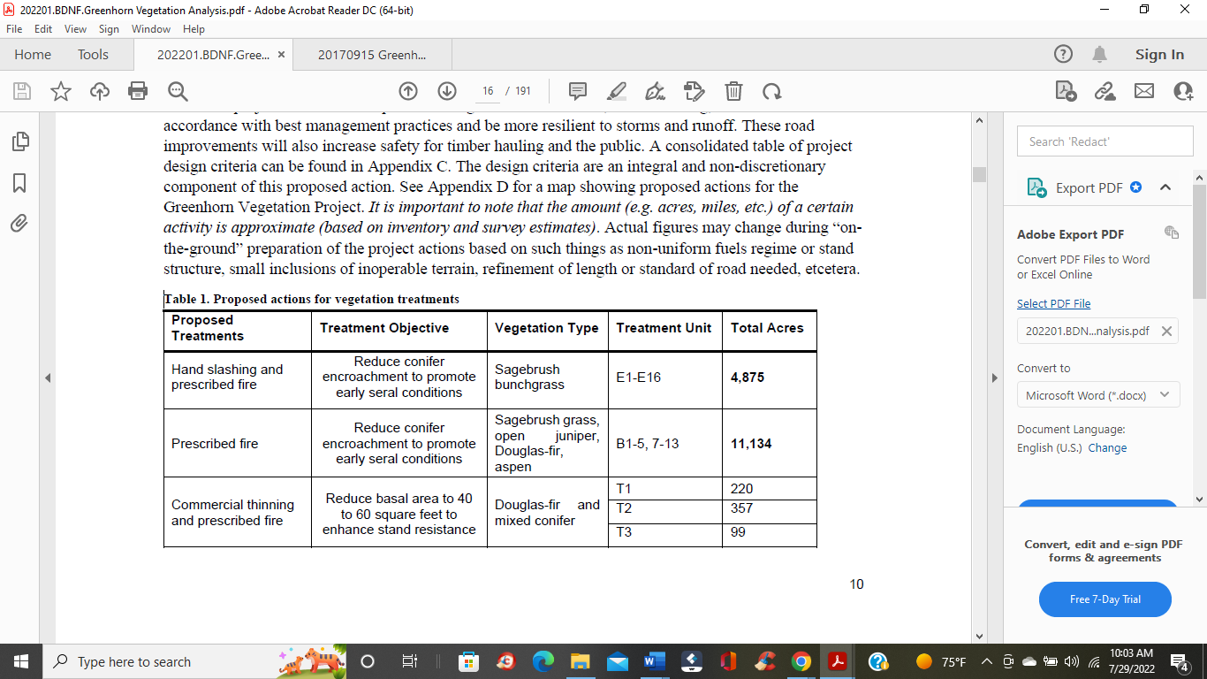

This quote mentions the harm from pinyon pine and juniper forces moving in to sagebrush habitat from lack of fire, but it also mentions harm from overgrazing, invasion of cheatgrass, and other human impacts. In another document published by the National Park Service11, they make this connection to the role of fire in sagebrush ecosystems.

*“Farming, livestock grazing, and land development has reduced sagebrush on the landscape. If land managers prevent fire from burning for too many years, trees like juniper can move in and take over. The biggest threat, however, comes from exotic plants that have moved in from other continents. Several kinds of grasses from other places have taken over the areas between and under sagebrush and made areas more vulnerable to fire. Cheatgrass, for example, dries out early in the summer and makes a thick carpet of fuel for fires. If fire burns through these areas too often, sagebrush seedlings cannot survive. If sagebrush is lost, the area can no longer support the animals (such as sage grouse and pronghorn) that depend on it for habitat.”*

In other words, there has been more consequential harm from overgrazing, invasion of cheatgrass and other exotic plants, and man’s intrusion upon the landscape than any other purpose. The greatest threat to sagebrush ecosystems is not fire or the lack of fire, but how man is managing that landscape. Science can, has and is helping us understand that role. Science is providing some new insights into the characteristics of sagebrush and providing some clues that perhaps sagebrush is more sensitive to fire than we acknowledged. The U.S. Geological Survey12 published an article entitled “Big Sagebrush Recovery After Fire Inhibited by its Own Biology. Dated July 25, 2019, this statement makes the following scientific finding.

*“Recovery of big sagebrush populations after fire is inhibited by the loss of adult plants and the limited ability of new seedlings to survive or reproduce — a limitation with negative population consequences that last for years to decades after post-fire seeding restoration efforts”-*

*“Although big sagebrush is found throughout the Intermountain West — from Montana south to Arizona — human activity, nonnative plant species invasions and wildfire have resulted in widespread loss of big sagebrush. To complicate matters, active attempts to restore big sagebrush after fires have had mixed results, even at locations that previously supported healthy populations*.”

There is no solid evidence that sagebrush is going to come back to the desired condition we seek after fire. It is best to fully understand the ecosystem we desire to change before we make that change. This is the impetuous nature of man and it has borne horrific, undesirable consequences in the past. Trying to reach sere conditions as stated in Table 1 above may only be wishful thinking on our part.

GWA questions the real intent for sagebrush burning. Perhaps it is to allow better forage for cattle grazing. We sincerely question and oppose this part of vegetative treatments.

**We Object to the Application and Definition Used in Protecting Old Growth:**

Page 18 of the EA makes some claims that GWA would like to challenge as they pertain to old growth forests.

*“The Greenhorn Vegetation project area lies within the greater Gravelly Landscape Management Area where 27.4 percent of forested stands are considered old-growth per (Bush et al. 2006) based on survey data from 2006. However, no proposed treatments occur in stands that meet the conditions for old-growth designation, per (Green et al. 1992) and therefore do not reduce the existing amount of old growth in the Project Area.”*

*“While many of the proposed treatment stands have trees that on average meet the diameter requirement, they do not on average meet the age requirement, being less than 200 years old. Because of their younger age, many stands also lack other requisite characteristics of old growth stands such as larger amounts of decay, down woody material, and snags. Surviving legacy Douglas-fir trees, as old as 500 years and with diameters up to 60 inches, are present, but with less than five trees per acre.”*

First, we find the acknowledgement that 27.4% of forested stands within the Gravelly Landscape Management Area are considered old-growth (based upon survey data from 2006 by Bush, et al) is remarkable. The fact the definition used by BDNF is applying the chronological age of 200 years just magnifies that story.

However, we must bring forth to BDNF’s attention, the recent effort by Department of Interior and Department of Agriculture to redefine old-growth based upon the Biden’s Administration Executive Order 14072. An explanation and a redefinition are in order.

This past July 14, 2022, the United States Department of Agriculture (USDA), United States Forest Service (USFS), Department of Interior (DOI), and the Bureau of Land Management (BLM) issued a request for information through the Federal Register to define mature and old growth forests. This action is a result of Executive Order (EO) 14072 released on April 22, 2022; the title of which is “Strengthening the Nation’s Forests, Communities, and Local Economies”. This EO requires USDA and DOI to establish those definitions, complete an inventory, make that publicly available, identify threats to those forests and much more in order to meet goals of the future.

As a result, GWA is supporting a redefinition of old-growth as it will apply under the new EO. We are not exactly sure how the current definition in use reads. Many national grass-root organizations and GWA are supporting a chronological age of 80 years to begin the definition of mature and old-growth forests. In lieu of this new and upcoming change in application of mature and old-growth forests, we view a new assessment is in order for old-growth upon the proposed treated lands of this project area.

One other thought before we close out this subject matter. On the same page 18, there is this claim:

*Surviving legacy Douglas-fir trees, as old as 500 years and with diameters up to 60 inches, are present, but with less than five trees per acre.*

The description of this forest may very well be classified under the new definition as old growth forests and further analysis is needed.

**Forest and Vegetation Thinning –**

To the heart of the matter, GWA questions the policy of vegetation thinning and logging in practice and in theory. For years, GWA has been stating the USFS needs to be redesigning the premise and practice of trying to fix problems of our forest with logging and thinning. It is antithetical of the USFS to try and solve the problem of our forests based upon actions of mismanagement of fire policy with continued over application of logging. Basically, the USFS is substituting one set of bad policy with another.

The USFS needs to incorporate a new policy within the Multiple Use Concept – carbon sequestration. We noticed the EA’s discussion on this subject and will comment later on in this Objection Process. But the practice of applying new rationale to use an old concept is getting old literally. All the USFS is doing, is undermining the result which they are trying to accomplish. We object to that action.

One huge mistake the USFS is making in their overall practice of forest thinning and logging is degrading ecosystem resistance. The agency is actually making matters worse instead of better by the potential removal of genetic resistance trees. This is a science which seems to be in the infancy even though the ideology of such science has been around for long periods of time. An example of this technology and science is the research of the Sitka spruce, a species living along the west coast from Alaska to California. In an article entitled *“Genetic Study in Giant Evergreens Reveals Clues to Pest Resistance”.* The article found in North Carolina State University website written by Laura Oleniacz13 published on July 12, 2021 highlights this kind of research. The first statement highlights the premise of the article:

*“Recent research into a group of giant evergreens is helping scientists better understand why some trees are able to survive in the face of insect pests, and could help foresters breed trees with the resistance necessary to survive in the face of new and emerging challenges to forest health.”*

This is the gist of our argument. We don’t know what we don’t know. Some perhaps many of these individual trees in the Greenhorn Project Area might be less susceptible to pests, disease and even warming conditions or drought from climate change.

Then there is the other argument as to why logging and thinning are bad practices; that is because we are changing the local and perhaps regional biome. There is so much new science surrounding this issue that we cannot bring all of it here, but the USFS should be aware and be willing to look outside the box rather than continue to be indoctrinated with the same old logging practices.

In an NY Times article dated July 30, 2022, Dr. Chad Hanson14 and Dr. Michael Dorsey authored an opinion piece entitled *“The Case Against Commercial Logging in Wildfire-Prone Forests*.” This is one rationale stated here:

*“The truth is that logging activities tend to*[*increase*](https://www.sciencedirect.com/science/article/pii/S0006320722000520)*, not decrease,*[*extreme fires*](https://www.mdpi.com/2673-6004/2/4/29)*, by reducing the windbreak effect that denser forests have, for example, and by bringing in highly combustible invasive grasses that are spread by logging machinery.”*

This article leads us to another science-based paper entitled *“Have western USA fire suppression and megafire active management approaches become a contemporary Sisyphus?* This science-related paper found online at the ScienceDirect.com website, dated April 2022 by Dominick A. DellaSala15, et al. states the following in their abstract. We urge the USFS and BDNF to review and read the entirety of the article and make its application known. The Abstract is in its entirety here.

*Abstract*

*“*[*Fire suppression*](https://www.sciencedirect.com/topics/agricultural-and-biological-sciences/fire-suppression)*policies and “active management” in response to wildfires are being carried out by land managers globally, including millions of hectares of mixed conifer and dry ponderosa pine (*[*Pinus ponderosa*](https://www.sciencedirect.com/topics/agricultural-and-biological-sciences/pinus-ponderosa)*) forests of the western USA that periodically burn in mixed*[*severity fires*](https://www.sciencedirect.com/topics/agricultural-and-biological-sciences/fire-severity)*. Federal managers pour billions of dollars into command-and-control fire suppression and the MegaFire (landscape scale) Active Management Approach (MFAMA) in an attempt to contain wildfires increasingly influenced by top-down climate forcings. Wildfire suppression activities aimed at stopping or slowing fires include expansive dozerlines, chemical*[*retardants*](https://www.sciencedirect.com/topics/earth-and-planetary-sciences/retardant)*and*[*igniters*](https://www.sciencedirect.com/topics/earth-and-planetary-sciences/igniter)*, backburns, and cutting trees (live and dead), including within roadless and wilderness areas. MFAMA involves logging of large, fire-resistant live trees and snags;*[*mastication*](https://www.sciencedirect.com/topics/agricultural-and-biological-sciences/mastication)*of beneficial shrubs; degradation of wildlife habitat, including*[*endangered species*](https://www.sciencedirect.com/topics/agricultural-and-biological-sciences/endangered-species)*habitat; aquatic impacts from an expansive road system; and logging-related*[*carbon emissions*](https://www.sciencedirect.com/topics/earth-and-planetary-sciences/carbon-dioxide-emission)*. Such impacts are routinely dismissed with minimal environmental review and defiance of the precautionary principle in environmental planning. Placing restrictive bounds on these activities, deemed increasingly ineffective in a change climate, is urgently needed to overcome their contributions to the global biodiversity and climate crises. We urge land managers and decision makers to address the root cause of recent fire increases by reducing*[*greenhouse gas emissions*](https://www.sciencedirect.com/topics/earth-and-planetary-sciences/greenhouse-gas-emission)*across all sectors, reforming industrial forestry and fire suppression practices, protecting carbon stores in large trees and recently burned forests, working with wildfire for ecosystem benefits using minimum suppression tactics when fire is not threatening towns, and surgical application of thinning and prescribed fire nearest homes.”*

This is at the root of our objection of forest logging and thinning. There is a better way and we urge the USFS and the BDNF to implement a more scientific approach to reducing fire risks.

**Questions of 2017-**

Before we end our Objection comments pertaining to logging, in 2017, GWA raised several questions pertaining to the application of forestry practices. We have yet to receive answers. Those questions will be posed here again in this objection. Question 3 below is supportive of discussion above. Question 4 was again mentioned within the current EA and is appropriate to ask.

1. We question the claim by the FS that timber thinning, clearcutting or pre-commercial thinning will make the forest more resilient to insect or disease infestation. We would like to have the documentation which proves that such action has the intended result. Simply where is the scientific proof that logging enhances forest health? Has this area been logged before? If so, why isn’t this forest healthy?
2. In regard to logging, we question the logging part of this project. Perhaps burning would be a better environmental option. If none of these logging proposals are in a suitable timber base, why log commercially? We could also state, if you are going to log commercially, then why wasn’t this area declared suitable for commercial logging? Unless there are benefits to wildlife (specifically bighorn sheep) we oppose timber harvesting in an unsuitable timber base.
3. The largest trees, as appropriate for the forest type, would be retained to the extent that the trees promote stands that are resilient to insects and disease. Insects, disease and dead trees/wood are part of a healthy forest.
4. If undocumented sensitive plant populations are found before or during project implementation, activities would be halted until avoidance or mitigation measures can be considered by the Forest Botanist. Sensitive species inventories should be done prior to initiation of the project.

**We Object to the Continued Operation of Grazing:**

**Historical Impacts of Grazing in the Project Area**

We want to say at the outset, that the Gallatin Wildlife Association is not anti-grazing, but neither are we in favor of a practice that continues to harm native wildlife or ecological processes on public land. In reading the EA, it seems as if this has been the norm of Greenhorn Project Area over its history. We’ll begin listing the impacts specified in the EA.

1. The statement on page 41 describes the history and previous ground conditions within the BDNF.

*“In the early 1900s, a combination of events occurred that interrupted the occurrence of fire: the settling of the West by European-Americans ended the use of fire by the American Indian; intense grazing at the turn of the century decreased light ground fuels that carried fires; and fire suppression programs initiated in the early 1900s became very effective. These events caused changes in the composition and structure of plant communities, resulting in more forested areas, denser stands of timber, and multi-storied timber stands.”*

1. In a paragraph talking about noxious weeds on page 121, there is this description of past management practices.

*“Lower elevations within the project area have a greater likelihood of invasion than higher elevation areas. This is mainly due to the associated human activities in the area such as roads, livestock grazing, recreation, and the readily available seed source from existing invasive plant species.”*

1. On page 125 in a paragraph discussing Cumulative Effects – Past, Present, and Reasonably Foreseeable Activities, it discusses those activities that have influenced the spread of noxious weeds. Table 72 helps in that effort shown below.

*“A master list of activities in project area was reviewed to determine whether any past, ongoing, or future activities had the potential to affect the outcomes of the proposed action. Past and present activities such as motorized vehicle access, invasive plant species control, and livestock grazing have influenced the spread and establishment of invasive species within and adjacent to the project area. All three have played a role to introduce new species and expand the distribution of existing species (see below).”*

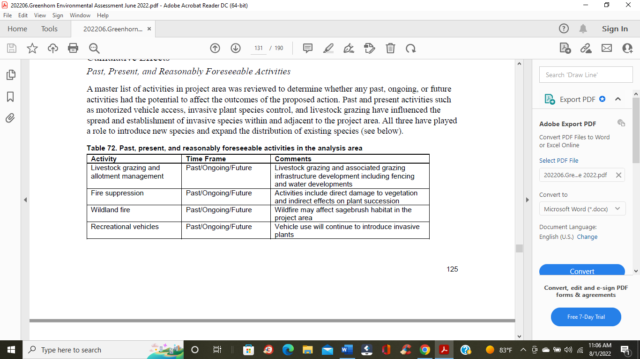

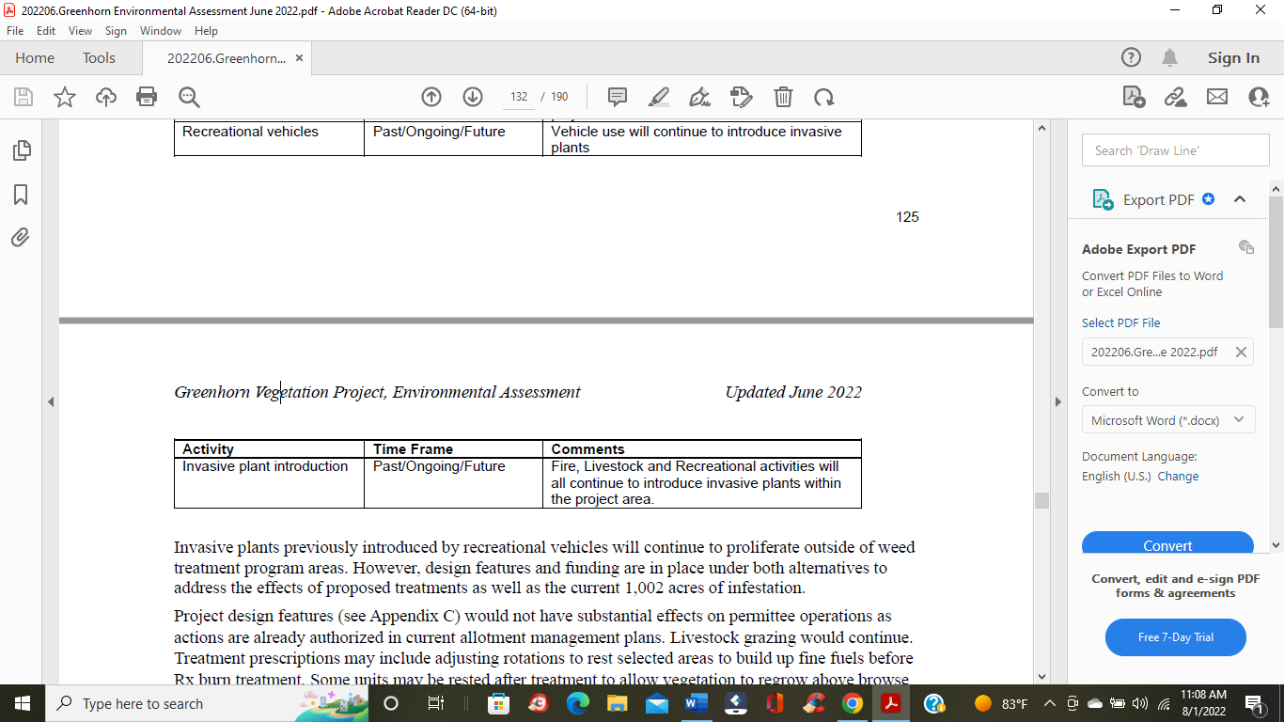

1. On page 160, there is reference to the history of grazing upon the landscape. There is this statement shown below. We are not sure what is exactly being referenced here. It is evident that the BDNF is proud of their grazing heritage upon the BDNF lands, but not sure what that does for the improvement of wildlife or the natural resources upon the ground.

*“Throughout the entire Gravelly Mountains, there are numerous visual reminders of the local grazing and ranching history and heritage.”*

1. We would like to bring to the public’s and the BFNF’s attention, the description listed in table 82 on page 147. Notice the reference to grazing at the center of the table. It mentions the following:

*“Bank alteration, channel over widening, sediment introduction, fish habitat modification.”*

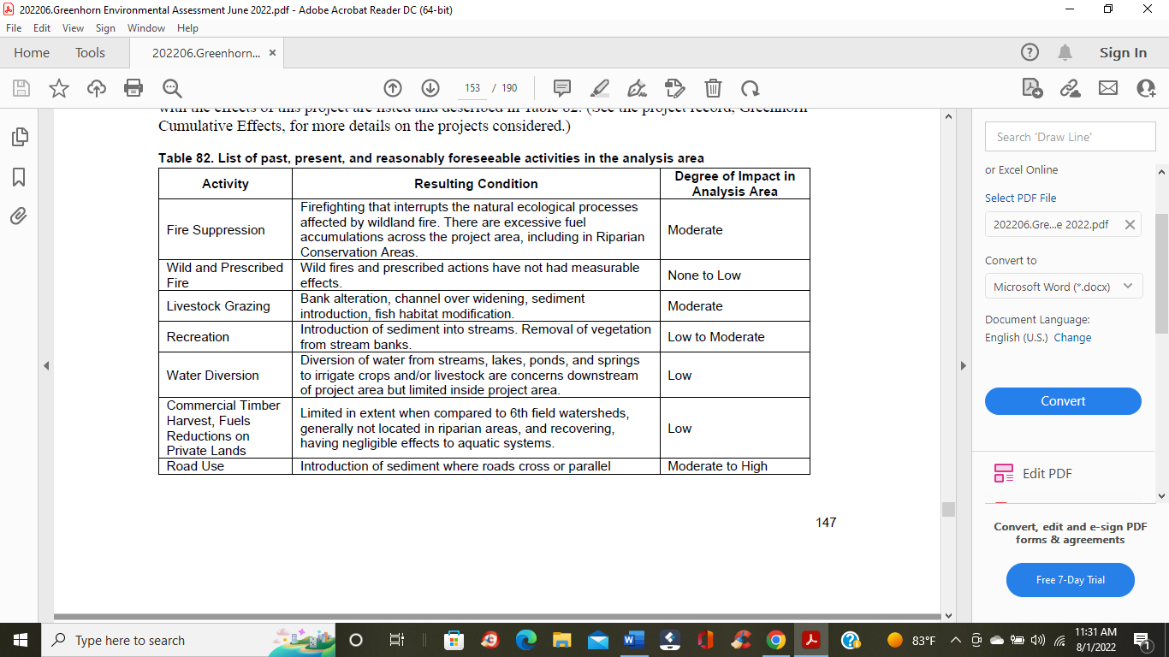

This table mentions ongoing activities that has posed moderate problems in the past with the activity of livestock grazing. Problems such as bank alterations, channel widening and sediment introduction and fish habitat modification are serious problems that need to be addressed if we are to restore proper land-use management use practices. The EA makes the assessment that business was to carry on as usual.

1. In the discussions on page 167 concerning existing conditions on inventoried roadless areas, there is this description concerning the side effects of grazing upon the landscape. This brings concern.

*“Grazing has impacted vegetation communities, especially in grasslands and riparian areas – these effects are largely unnoticeable to most forest visitors.”*

1. The last paragraph on page 148 makes the following statement pertaining to cumulative effects of proposed action and there is this statement concerning livestock grazing.

*“The effects of past and ongoing livestock grazing are the largest measurable impact to project stream conditions across the project area with exception of the Greenhorn Creek Watershed which is not part of a grazing allotment.”*

1. On page 152, a discussion unfolds about Western Cutthroat Trout (WCT). There is this statement.

*“Major threats to WCT include habitat loss caused by sedimentation and warming water temperatures in streams due to poor grazing practices, logging, mining, agriculture, residential development and non-native species hybridization and competition (MNHP 2020a).”*

1. In table 92 on page 168, the table describes existing conditions of wilderness attributes. There is this statement in relation to the natural conditions on the ground within the Sheep Mountain Roadless expanse:

*“Natural integrity has been negatively affected by grazing, range improvements, and noxious weed infestations however these are relatively minor.”*

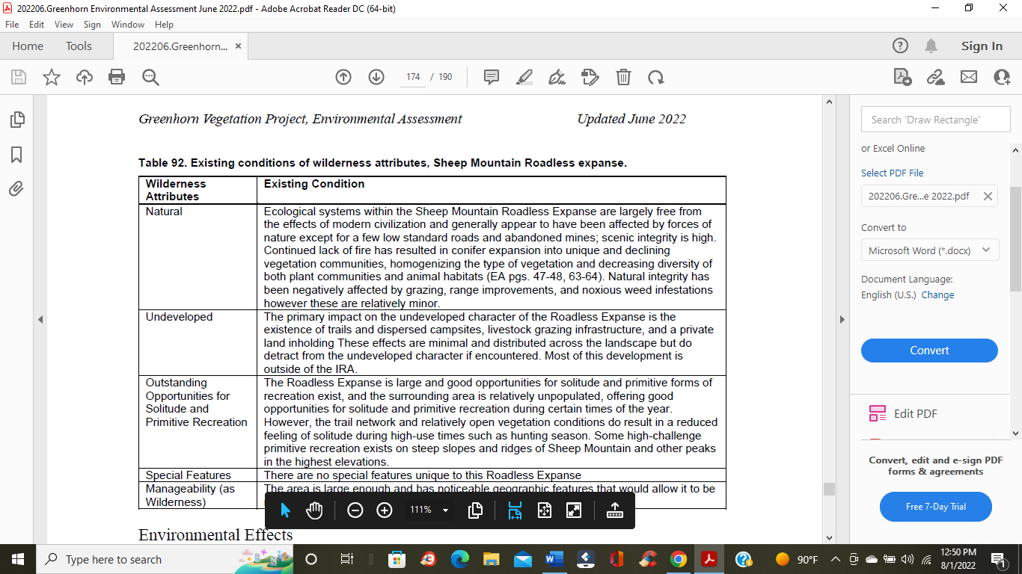

In the summation of these nine (9) references from the EA, it indicates that grazing has had an impact upon the landscape. Grazing has impacted the following:

1. Proliferation of noxious weeds-
2. Interruption to the natural progression of fire on the landscape-
3. Bank alteration, channel widening, sediment introduction, fish modification –

Numerous mentions of impacts on riparian areas and stream conditions

1. Loss of Westslope Cutthroat Trout and/or habitat-
2. Range improvements such as fencing and other infrastructure-

These are the references that we’ve found throughout the EA pertaining to the actions of grazing. In our analysis of this EA, we also wonder about what percentage of Detrimental Soil Disturbance (DSD) is present from grazing. The EA does not make this distinction, but we also know and understand that soil compaction is a result which can accompany grazing. The EA needs to make a distinction here if this is indeed the case. We believe that negative impacts from grazing are more serious and widespread than the EA is indicating. This is a concern.

At any rate, with all that being said, the EA does seem willing to minimize the role of grazing upon the landscape. The following excerpts highlight that case.

1. *“The incremental effects of present and foreseeable future activities on forested vegetation are negligible.”* Page 31
2. *“Ongoing activities such as livestock grazing, recreation, noxious weed control, and small-scale fuelwood gathering will overlap with the proposed action units, but the disturbances would be minimal and treatment units will continue to meet regional soil quality standards.”* Page 82
3. *“The direct and indirect effects of proposed treatments, with the included mitigations on livestock grazing, would not compound the incremental effects of past, present, and reasonably foreseeable future actions. Livestock grazing would continue, with grazing standards in place to protect and improve rangeland resources. Treatment units would be subject to the same grazing standards.”* Page 126
4. *“Past and ongoing activities, such as livestock grazing and recreation, are expected to continue under current and future management and will overlap with all alternatives but would result in minimal additional disturbance.”* Page 148

We have to question the role of grazing within the treatment area, in spite of these attempted reassurances listed here.

**The Role of Fencing:**

In 2017, some of our first concerns and comments were over the issue of grazing, etc. Not only does it bring up the obvious issue of impact upon our soil and water resources, riparian areas, etc., but it also brings up the issue of fencing. Historically and recently, fences have had a very substantial impact upon wildlife, whether it be impacts from killing predators or the migratory habits of other species, fencing is considered a form of habitat fragmentation. We noticed that fences and fencing was only mentioned **twice** in this EA, and neither one of those times did the EA relay our fears about the impact that fencing had upon wildlife movement. Some of our concerns 5 years ago were as you can read here. We never did receive an answer to these concerns. Until we get substantial and appropriate answers to these questions, we will continue to object to the continuous role of grazing upon the landscape.

Questions and concerns over fences and grazing from 2017. Our main concern was over the issue of fences and their related impact upon wildlife movement.

* *We have serious concerns over the issue of fencing. Fences hinder the natural movements of wildlife and places greater stress or pressures on large migratory species. Grazing places pressures on natural foliage and grasses which wildlife depend upon. Grazing of cattle does not enhance wildlife. We have not ever seen the scientific evidence that this is the case.*
* *Please explain the economic cost of building a new fence compared to the amount of money the permit holders pay to graze on public land. The scoping notice does not adequately delineate the baseline condition for the fences. The FS needs to thoroughly analyze the impacts to wildlife in the area because of the outdated fences.*

Cottonwood Environmental Law Center asked the following question in regards to fencing, grazing permits, etc., 5 years ago.

*“Cottonwood asked the facilitator to submit a comment stating the cost of the livestock grazing permits for the cattle allotments in the Greenhorn project area does not match the cost of a permit to graze on private land. We asked the facilitator to submit a comment that this project should be an example where the permit holders agree that they should not get special prices to graze on public land. The permit holders then stated that they do not get special treatment. To support their position, the livestock grazes indicated that have to pay for the fencing. Cottonwood responded that Dean Waltee, the biologist for MT Fish, Wildlife and Parks has said that several fences need to be replaced in the project area.”*

So now in the year of 2022, we ask a follow up question. What has happened with this issue? Has the fencing been replaced and if so; Who paid for the new fencing?

**Some Very Good Questions from 2017-**

The following questions are from 2017 as well and deserve an answer as they question the foundational groundwork or justification for this project. Many of these questions challenge the BDNF’s apparent necessity for action, which brings up a point; what is the driving force behind this proposed action – livestock producers or the real need for resource improvement? It seems as if livestock growers could get the most beneficial need for these actions.

1. *“How much does the cattle grazing cost the FS both economically and ecologically? An example of one ecological cost might be that if cattle eat the newly burned grass, it will not be available for elk. How does the grazing of cattle affect beavers’ ability to recolonize the area?*
2. *The permit holders also claimed that cattle kept fire out of the project area, but part of the purpose of the project is to restore fire to the project area. Please explain to what extent cattle have excluded beneficial fire from the project area.*
3. *Livestock grazing is also identified as a major cause of conifer encroachment into sagebrush grasslands and aspen stands. However, there is no discussion about modifying livestock management within the project area.*
4. *Treatments would also include riparian fencing to minimize ungulate damage to riparian areas and reduce consequent erosion, and willow planting to stabilize and maintain stream banks. So, will new fences will be built – where and how many? Will these be permanent fences? We are also concerned about some of the existing fences and the probability that they act as a barrier to wildlife movements.*
5. *Timber harvesting has occurred in the Greenhorn project area in the past, and grazing activities are ongoing. The effects of these and other activities have been considered in the existing condition and proposed treatments. The USFS has not adequately reviewed the impact of livestock use on conifer encroachment, weed infestations, degradation of aspen types and riparian areas within the project area. Also, the impact of other livestock related infrastructure on vegetation and wildlife within the project area such as fencing and water diversions/developments has not been adequately reviewed.”*

These questions and concerns concerning grazing actions need to be answered and actions taken in order to reduce negative impacts on wildlife, wildlife habitat, fisheries and all potential wildlife corridor movement before we remove our objections from this project. GWA believes conditions on the ground, those negative impacts from grazing are more detrimental than what is described in this EA. We question how conditions will improve unless practices have changed. We do not see evidence of that being the case at this moment.

GWA could present the science to prove our argument for it does exist, but we believe the argument has been made with what is contained within the EA. The current practices of grazing are not working for the betterment of wildlife or the resource overall. Something needs to change.

**Carbon Sequestration: We Oppose the Attitude. Time to Correct the Message!**

In our attempt to bring the FS to a new paradigm, part of that realization depends upon the agency understanding and acknowledging the role of carbon sequestration and the supporting science. Even though the agency states the science is true, they miss the seriousness in terms of its application. From what we’ve read, some of that recopied below, there are some serious misconceptions of the role our forest can play in the grand scheme of global dynamics. On page 32, there is this statement:

*“Public questions received during the scoping of the Greenhorn Vegetation project focused on the impacts of the treatments on carbon storage potential of the area. The importance of carbon storage capacity of the world’s forests is tied to their role globally in removing atmospheric carbon that is contributing to ongoing global warming. Meaningful and relevant conclusions on the effects of a relatively minor land management action, such as this, on global greenhouse gas emissions or global climate change is neither possible nor warranted in this case. However, this analysis recognizes that global research indicates the world’s climate is warming and that most of the observed twentieth century increase in global average temperatures is very likely due to increased human-caused greenhouse gas emissions.”*

Highlighted above is an acknowledgement the agency refuses to see the global picture, the cumulative effects of global greenhouse gas emissions in a global warming world. Not only that, but it is almost as if they astonishingly refuse to acknowledge their role in the world. We have seen this justification and rationale before. Basically saying, our little corner of the world isn’t going to make a difference. This is a poor example of leadership and a poor understanding of the cumulative effects of carbon in our atmosphere.

Continuing on- in page 32.

*“Global climatic warming is not something that is about to happen. It has been ongoing for many decades and the trend is expected to continue into the distant future, continuing to increase risks to our nation’s forests (Dale et al. 2001, Barton 2002); Breashears and Allen 2002; (Running 2006, Westerling and Bryant 2008) Littell et al. 2009; Boisvenue and Running 2010, Hicke et al. 2012).”*

In this reference, while there is truth in the statement, there also seems to be a sense of defeatism, a sense of resignation, that any action by BDNF to undertake climate change will not make a difference in the overall current carbon dynamics of the global atmosphere. GWA strongly objects to this passive acceptance of the world case scenario. For with that attitude, then it is true, there will no improvement in the world as we know it.

Finally, on page 34 under Existing Condition,

*“Over the long-term, through one or more cycles of disturbance and regrowth (assuming the forest regenerates after the disturbance), net carbon storage is often zero because re-growth of trees recovers the carbon lost in the disturbance and decomposition of vegetation killed by the disturbance (McKinley et al. 2011; Ryan et al. 2010; Kashian et al. 2006).”*

There is a naivete optimism and a misconception in the quote above. First, it is optimistic to say that “assuming the forest regenerates after the disturbance”. The BDNF is correct to say that one has to assume in such regeneration, but naive to ignore the science that states otherwise.

A couple of sources here will be presented. First GWA would like to refer the BDNF to the Abstract stated below found in Ecology Letters at Wiley Online Library. In a paper with Stevens-Rumann, Camille, S16, et al, the authors, there is a letter entitled *“Evidence for declining forest resilience to wildfires under climate change*” dated December 12, 2017.

*“Forest resilience to climate change is a global concern given the potential effects of increased disturbance activity, warming temperatures and increased moisture stress on plants. We used a multi-regional dataset of 1485 sites across 52 wildfires from the US Rocky Mountains to ask if and how changing climate over the last several decades impacted post-fire tree regeneration, a key indicator of forest resilience. Results highlight significant decreases in tree regeneration in the 21st century. Annual moisture deficits were significantly greater from 2000 to 2015 as compared to 1985–1999, suggesting increasingly unfavourable post-fire growing conditions, corresponding to significantly lower seedling densities and increased regeneration failure. Dry forests that already occur at the edge of their climatic tolerance are most prone to conversion to non-forests after wildfires. Major climate-induced reduction in forest density and extent has important consequences for a myriad of ecosystem services now and in the future.”*

One more source locally and that is found in the findings of the 2017 Montana Climate Assessment by Whitlock, Cathy, et al17. Some findings and assumptions based upon scientific evidence.

* *The speed and magnitude of climate change may mean that increased forest mortality and contractions in forest distribution will outpace any gains in forest growth and productivity over the long run, leading to a net loss of forested area in Montana.*
* In discussing range shifts and forest distribution, there is this: “*Possible faster range contraction compared to expansion, with net range reduction particularity in drier areas; no clear direction of elevational shifts; responses will be highly species and location dependent.”*

In other words, there are no guarantees that our forests will grow back either from logging or fire to the point that they once were. GWA believes it is dangerous to assume that. There are plenty of examples currently available highlighting this very case.

And finally in that latter part of the quote concerning itself with this statement:

*“net carbon storage is often zero because re-growth of trees recovers the carbon lost in the disturbance and decomposition of vegetation killed by the disturbance”*

This seems to be the rationale for a continued business as usual approach when it comes to continue the policy of logging. There needs to be a reassessment of the science. GWA could produce lists of references that will refute the above statement, but time is running out in our ability to comment, therefore we will provide one more source. In an article found on line at Mongabay.com, there is this article entitled “*Tall and old or dense and young: Which kind of forest is better for the climate?”* Written by Koberstein, Paul and Applegate, Jessica18 published in May 23, 2019 answers that question in more clarity and detail.

* *“Scientists say reforestation and better forest management can provide 18 percent of climate change mitigation through 2030. But studies appear to be divided about whether it’s better to prioritize the conservation of old forests or the replanting of young ones.*
* *A closer look, however, reconciles these two viewpoints. While young forests tend to absorb more carbon overall because trees can be crowded together when they’re small, a tree’s carbon absorption rate accelerates as it ages. This means that forests comprised of tall, old trees – like the temperate rainforests of North America’s Pacific coast – are some of the planet’s biggest carbon storehouses.*
* *But when forests are logged, their immense stores of carbon are quickly released. A study found the logging of forests in the U.S. state of Oregon emitted 33 million tons of CO2 – almost as much as the world’s dirtiest coal plant.*
* *Researchers are calling on industry to help buffer climate change by doubling tree harvest rotations to 80 years, and urge government agencies managing forests to impose their own harvest restrictions.”*

Overall, when it comes to the question of the USDA and the USFS understanding the science of climate change, we are not so sure understanding the science is the answer, for the FS is aware of the science. We believe the problem is that there needs to be a change in attitude. But perhaps it is not even just a change in attitude, but a change in a sense of responsibility, a sense of urgency, and a change in a sense of priority. It is either that or there is something else going on here that is more obtuse.

**Conclusion:**

It is time to draw these objections to a conclusion. We will summarize our objections below, but before we do, we would like to bring up the issue of what specific impacts will these effects have on and within the Sheep Mountain IRA? We are showing the map here as a reference and as any can see, much of the activity, conifer removal and prescribed fire is going to occur in this IRA. Once considered as wilderness designation, it would not be wise to negatively impact the wilderness character of this landscape. GWA and others may want to address this issue in the future.

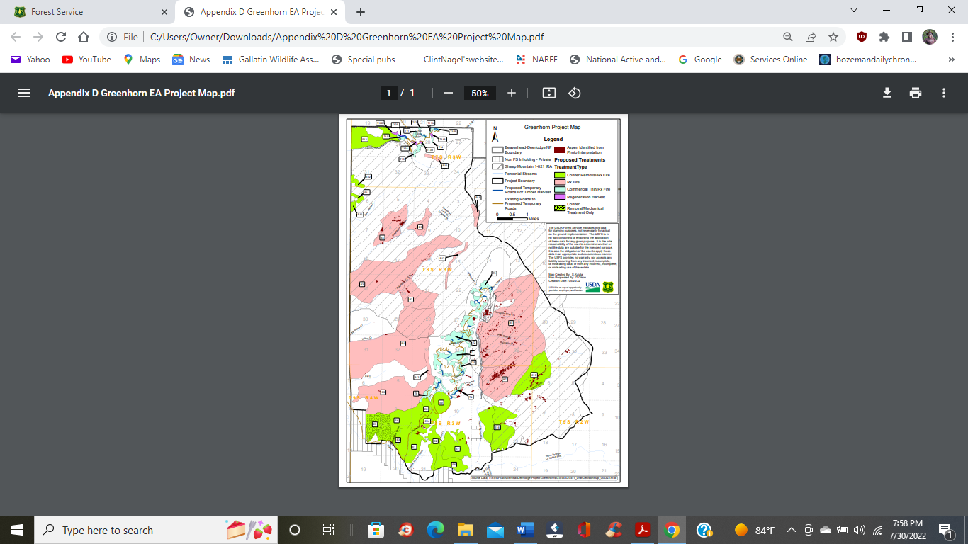

Our focus is centered upon the following issues:

Two Alternatives Approach: We Object

Our Involvement in the Collaborative Process: We Object.

Our Historical Concerns, Confusion and Objections over Habitat Enhancement of Bighorn Sheep:

Objection Over Potential Harm to Endangered, Threatened and Proposed Species:

Wolverine

Grizzly Bear

We Object over the Overriding Premise of this Forest Health Project:

We Object to the Introduction of Fire upon Sagebrush Ecosystem:

For the Purpose as Stated:

We Object to the Application and Definition Used in Protecting Old Growth:

Forest and Vegetation Thinning –

We Object to the Continued Operation of Grazing:

The Role of Fencing:

Carbon Sequestration: We Oppose the Attitude. Time to Correct the Message!

As we close out these objections, we hope to focus our discussion on many of these issues in order to make this project beneficial to the wildlife and landscape. Please accept these comments and objections in good faith and in the sincere purpose in which they were intended.

Sincerely,



Clinton Nagel, President

Gallatin Wildlife Association