

The Nature Conservancy in WV **tel** (304) 637.0160

435 Wilson Street  **fax** (304) 637.0584

Elkins, WV 26241 **nature.org**

July 30, 2021

Jon Morgan

District Ranger

Monongahela National Forest

Cheat-Potomac Ranger District

2499 North Fork Highway

Petersburg, WV 26847

Re: Comments – Upper Cheat River Project Scoping

Mr. Morgan,

Thank you for preparing a detailed scoping document for the Upper Cheat River project and the opportunity to provide comment. The forests of the Cheat District, and the north section of the Upper Cheat River project area in particular, form critical core areas of The Nature Conservancy’s (TNC) Resilient and Connected Lands Network (RCN) in West Virginia, supporting connectivity for species to move and adapt along the Central Appalachian Mountains in response to climate change. Additionally, compared to the surrounding private forests the Cheat District has some of the last remaining forested watersheds with very low overall impact from roads, mining and agriculture, highlighting the critical need to avoid development or management that could impair the regionally rare high-quality watersheds (Appalachian LCC Aquatic Avoidance).

Given the climate resilience potential and the high quality of the watershed we are excited that the Forest’s interdisciplinary team has gone through NIACS climate adaptation workbook to design management. We would like to hear more about how climate-informed planning guided timber unit site selection and practices, how vegetation management will be used for shifting species composition, and if there are opportunities to include additional future climate adapted species as part of an assisted migration effort.

TNC supports managing for the full range of age classes within a forested landscape, achieving the desired natural range of variation from early to late successional forests across dynamic forest blocks that support a range of wildlife species. The Forest Plan highlights the need to ‘maintain at least 50,000 acres of mid-late and late successional (>80 years old) mixed mesophytic and cove forest to meet habitat needs for cerulean warbler’ (Objective WF09). The Forest Plan also aims to increase the percentage of mixed cove hardwoods in the late successional age class in MP 3.0. In our analysis of forest composition and age-class structure within the Cheat River watershed (Figure 1), the forests in MP 3.0 and clustered in the Upper Cheat River project area are special because they have the highest percentage of Mesophytic and Cove forest types, both of which have greatly declined compared to their historic context. These forests also have both a lower percentage of late successional stands and a higher percentage of old growth than other parts of the watershed. Alongside actions targeting even aged hardwood regeneration, we recommend additional actions to maintain and enhance late successional and old growth forests, particularly in mesophytic and cove forests, as part of managing for a dynamic forest matrix both in the larger Cheat River watershed and in the project area. Furthermore, when we added tier 3 stream associations and climate connectivity to the analysis, we were able to identify 8 hotspots for preservation and management of late successional forests in the Cheat River watershed. 3 of the hotspots are in the Upper Cheat River project area, in MP 3.0 north of the Cheat River (Figure 1). We recommend reducing the number of conventional and cable units in the Horseshoe Run and Hile Run watersheds that correspond with hotspots 2 and 3.

Although the Forest Plan calls for more early successional forests within the NF boundary, our analysis of the entire Cheat watershed highlights the forests within the project area as hotspots for preserving and managing for late successional and old growth forest stands, particularly overlapping mesophytic and cove forests types (Figure 1). We recommend considering the extent of early successional forests within the entire watershed, and not just the project area, as the ecologically relevant scope to drive appropriate management. Furthermore, given the risk of introduction of invasive species and the risk of sedimentation in a regionally rare high-quality watersheds we recommend reconsidering the extent and placement of even-aged regeneration cuts that have been proposed. It may be possible to achieve sufficient early successional habitat within the Upper Cheat River project through uneven-aged methods identified in Forest Plan guidelines 3009-3011 for MP 3.0, and in fewer, smaller units.

As part of managing a dynamic forest matrix, accelerating late successional forests will be a critical pathway for boosting future forest climate resilience and adaptation in the RCN. While managing for early successional habitat is an important component of forest climate adaptation, providing wildlife habitat and achieving the natural range of variation in the landscape, we encourage staff to also prioritize setting aside units for structural complexity enhancements that will lead to late successional stands that have the greatest potential to store carbon and mitigate climate change ([Ford and Keeton 2017](https://esajournals.onlinelibrary.wiley.com/doi/full/10.1002/ecs2.1721); [Curtis and Gough 2018](https://nph.onlinelibrary.wiley.com/doi/full/10.1111/nph.15227)). The Nature Conservancy would have an interest in partnering with the National Forest Service and others to achieve such outcomes.

Additionally, we applaud the watershed and fisheries restoration actions proposed through this project, namely the Large Woody Material Additions, Aquatic Organism Passage Restoration, Riparian Buffer Improvements, Road Closure and Soil Restoration. We strongly support the efforts of the Forest Service, FOC and other partners in their efforts on these and other actions to enhance the ecological functions and services, climate resilience and connectivity in aquatic and riparian habitats within the Upper Cheat.

Sincerely,



Todd Miller

Director of Conservation

Figure 1. TNC’s analysis of hotspots of late successional forests with a high percentage of our priority forest types for biodiversity, tier 3 streams, and climate resilience in Cheat River Watershed.

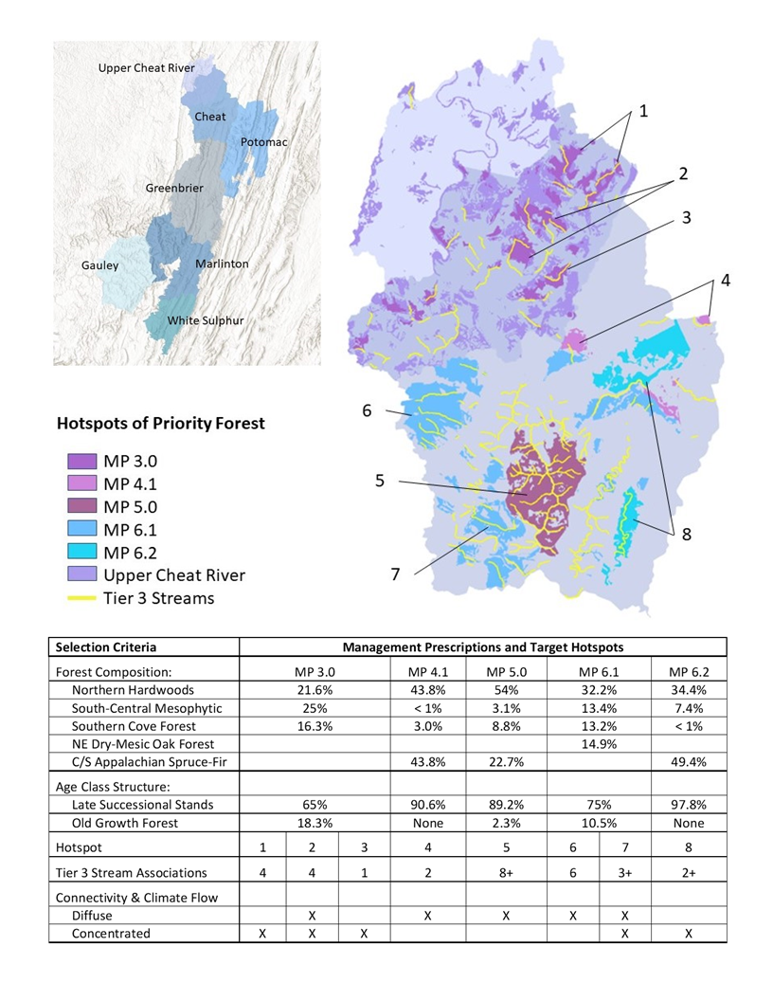

**Cheat River Watershed**

**Upper Cheat River**

**Project Area**