LACK OF EQUESTRIAN PARKING TO ACCESS TRAILS
Truck and trailer parking giving trail access to equestrians is difficult to find. Many parking lots are parked full by recreational user cars. The RFVHC is working with County and BLM organizations to plan and include equestrian parking in their projects going forward. We ask the WRNF & USFS to include this same parking initiative in all future and existing trailheads. Without parking horseback riders are unable to access trails.

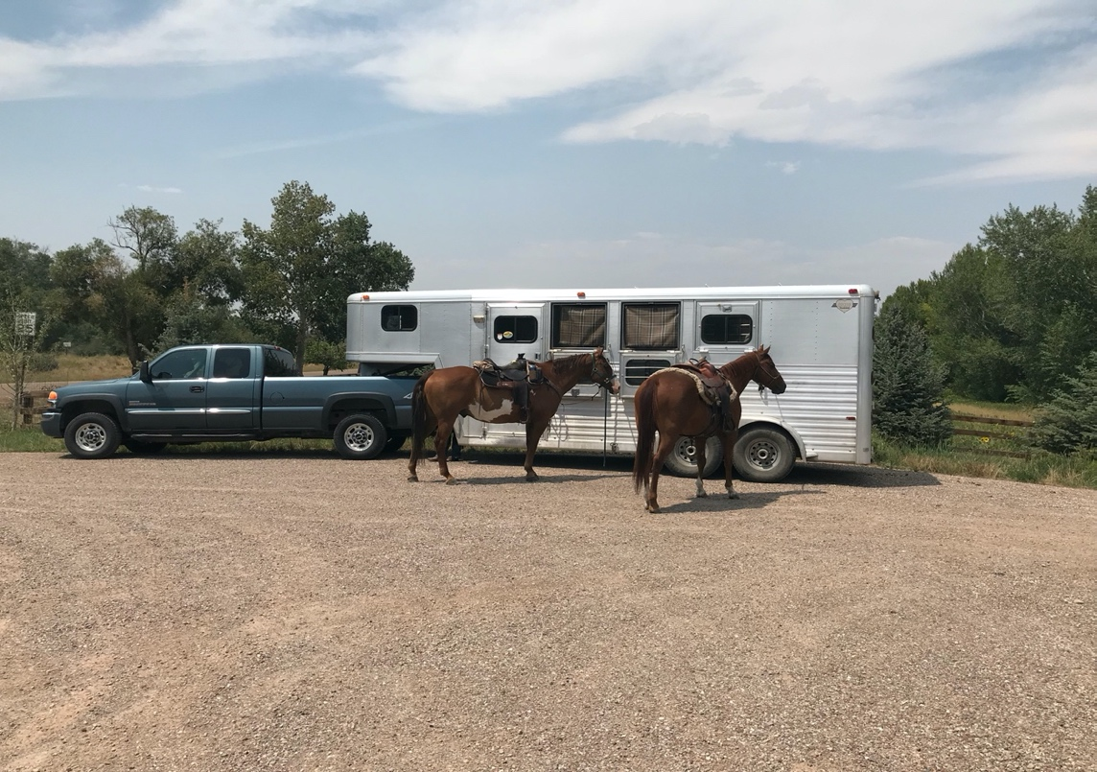

Pitkin – Eagle Glassier Parking Lot

Parking Lot Specifications and Data
An appropriate equestrian parking lot accommodates trucks and trailers as they pull in, swing around in the area, and angle park, facing out. Horse trailers are 7’8” to 8’6” wide. Tow vehicles are 6’ to 8’6’ wide. Maximum trailer height is 13’6”. Legal limit in length of a trailer is 53’. 125 feet is the bare minimum space needed to swing around modern horse trucks and trailers. Shared parking works best, when vehicles have designated parking areas separate from the horse trailers. People unfamiliar with horses may not understand that horsemen and horses need extra space by the trailer for tying, saddling and loading.
Attached to this letter is a comprehensive parking lot document that we have been given permission to use for land managers and trail groups.
For more parking information, please go to: https://www.rfvhorsecouncil.org/uploads/1/1/1/9/11199712/rfvhcequestrianparking-updated_.pdf

