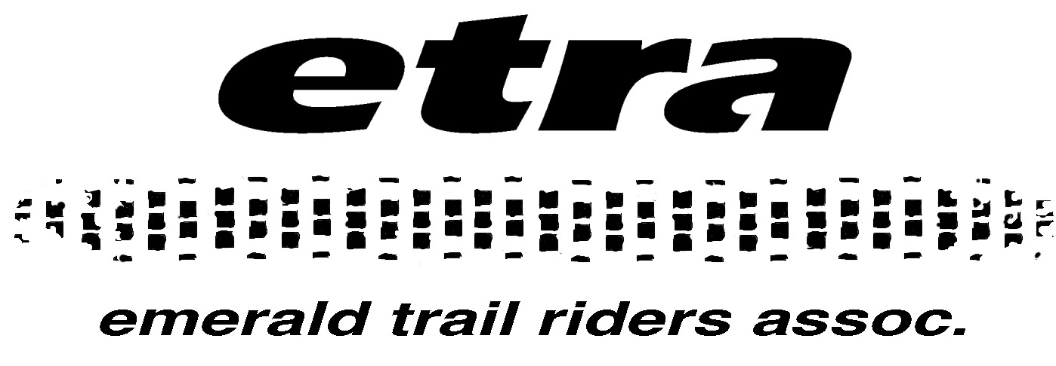

June 14, 2021

The mission of the Emerald Trail Riders Association (ETRA) is to promote sustainable, safe, and enjoyable OHV recreation. Excessive sound from Off-Highway Vehicles (OHVs) is not consistent with that mission. We are in favor of reasonable sound restrictions that are universal across Oregon, making the regulations easy for users to understand and comply with.

The 93 dBA limit within the Oregon Dunes National Recreation Area (ODNRA) should be changed to more realistic and enforceable levels. ETRA understands the Siuslaw National Forest’s (SNF) logic in proposing a 97 dBA limit on Class I and III OHVs; this is reasonable and should probably be adopted by the State of Oregon. However, today this would be inconsistent with Oregon Parks and Recreation Department’s (OPRD) website and current state law. Inconsistent sound regulations within Oregon creates confusion for users and may reduce compliance. Therefore, it is the position of the ETRA that the SNF should adopt the current standards listed on the OPRD website (<https://www.oregon.gov/oprd/ATV/Pages/ATV-Sound.aspx>) and enforce those limits throughout the ODNRA.

Hopefully, we can evolve to a standard that is a realistic measure of acceptable sound output and protects our riding areas.

Ethan Lodwig

Emerald Trail Riders Association

Eugene, OR