# Appendices

## Appendix A

Here is an image of intact habitat cores that new road construction would disturb:

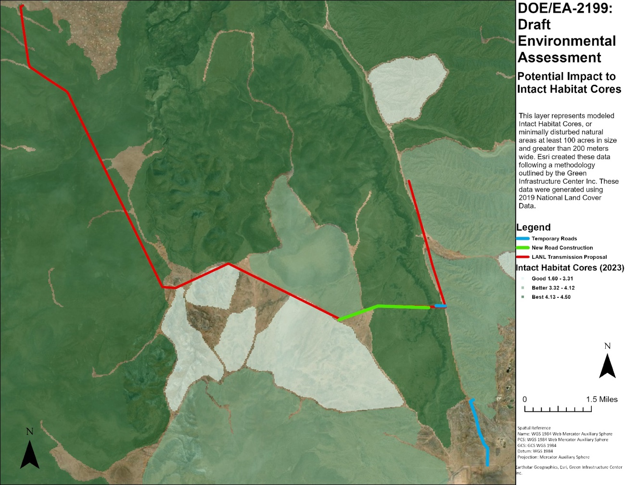

Figure 1: Potential Impact to Habitat Cores- Project Area

The new road construction would pierce some of the closest intact habitat cores to the west side of the Santa Fe area:

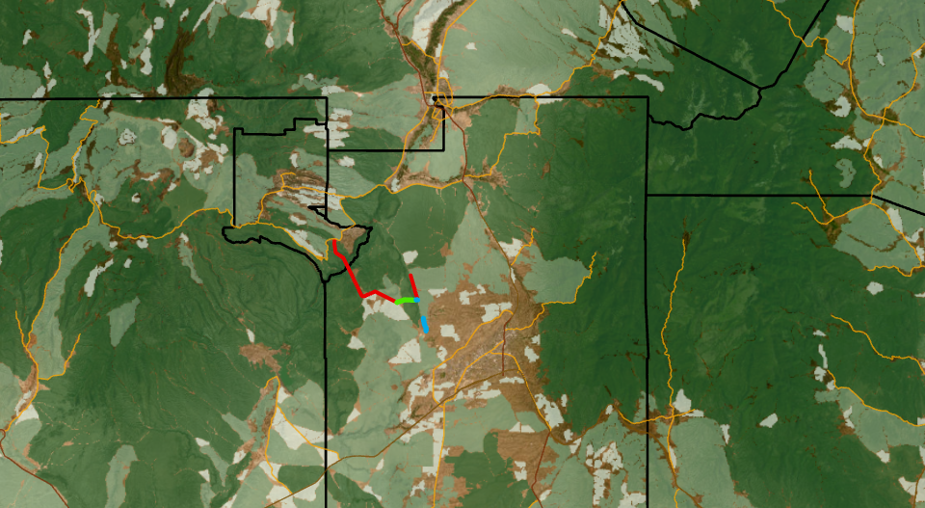

Figure 2: Potential Impact to Habitat Cores- Jemez/ SF Mtns

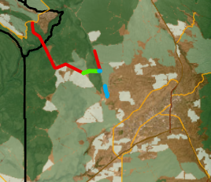

Figure 3: Potential Impact to Habitat Cores- North Rio Grande Valley

## Appendix B

Here is an image that shows the temporary road would cut through one of the most important corridors in the area (bottom right, sorry the blue road is poorly contrasted):

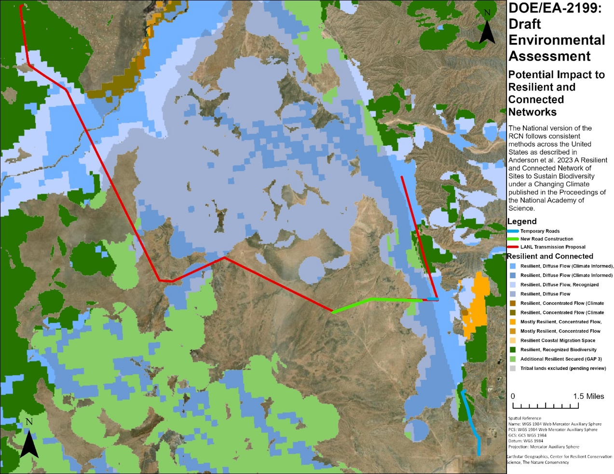

Figure 4: Resilient and Connected Networks- Project Area

The only resilient and diffuse flow that traverses the east Caja Del Rio is in the project area:

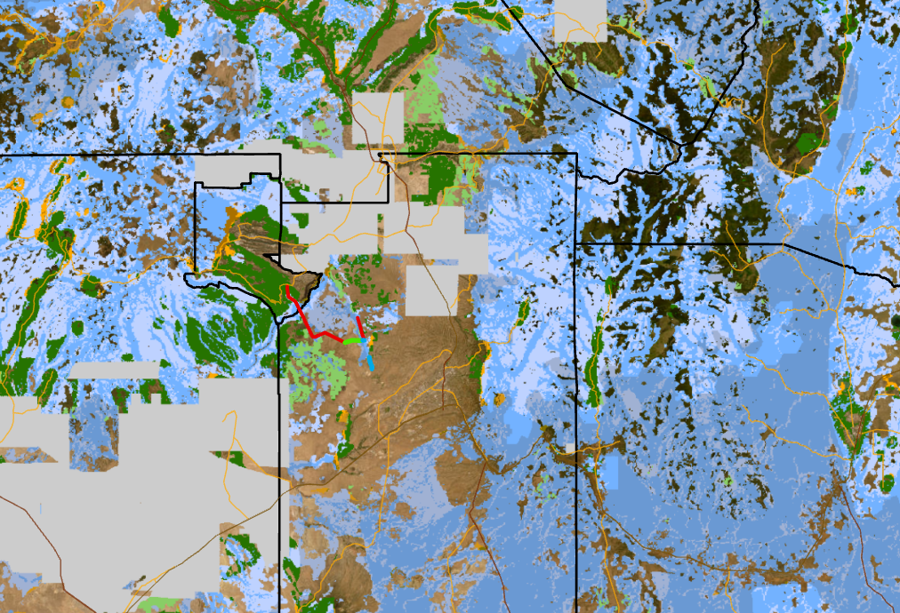

Figure 5: Resilient and Connected Networks- Jemez/ Sf Mtns

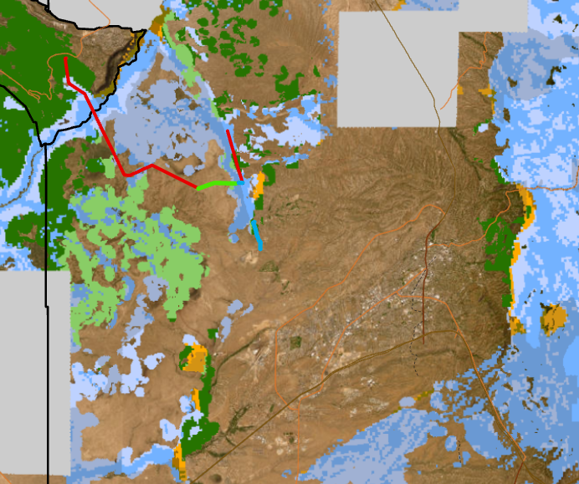

Figure 6: Resilient and Connected Networks- North Rio Grande Valley

## Appendix C

Figure 7: Piñon Jay Occurrence Probability- Project Area

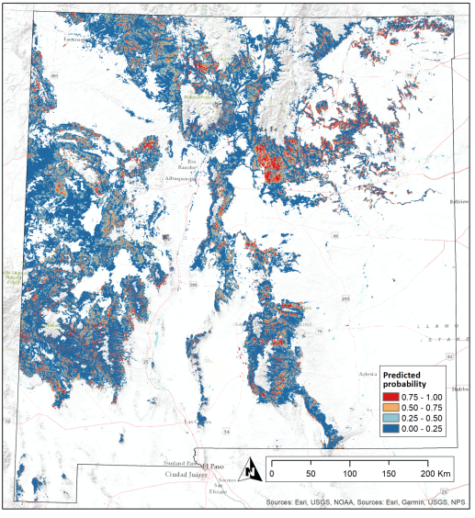

Figure 8: Piñon Jay Occurrence Probability- New Mexico

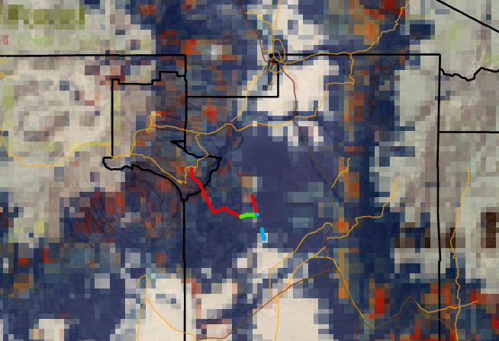

Figure 9: Piñon Jay Occurrence Probability- Jemez and SF Mtns