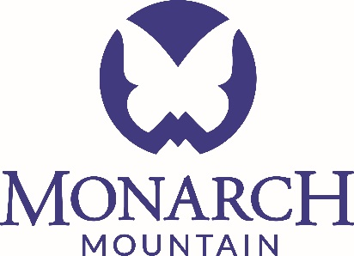

**September 18, 2017**

**Grand Mesa, Uncompahgre and Gunnison National Forest**  
2250 South Main St  
Delta, Colorado 81416

To whom it may concern,

I am writing to provide input on the GMUG Forest Revision Plan on behalf of PowderMonarch LLC, dba Monarch Mountain and Monarch Cat Skiing.

Monarch Mountain is one of the oldest ski areas in Colorado having first opened in 1939. The ski area is an essential part of the economies and recreational opportunities of Chaffee, Saguache, and Gunnison Counties. Monarch Mountain provides approximately 300 winter-seasonal jobs and 50 year-round positions. The income and tax revenues generated through this business play a significant role in these economies. As a business operating entirely on the National Forest, a percentage of all revenues generated by the ski area are paid to the US Government as usage fees. Monarch Mountain participates in the National Forest Foundation program as well through season pass sales raising thousands of dollars for forest health and restoration projects. Monarch Mountain strongly supports measures to include recreational opportunities near Monarch Pass as part of the GMUG Forest Revision Plan process.

Monarch Mountain operates entirely on USFS lands involving two separate permits. The lift served and hike-to portion of the ski area operates entirely on the San Isabel NF under a 40-year special use permit. Monarch Cat Skiing operates on both the San Isabel NF and the Gunnison NF through a multi-year special recreation permit. Monarch Mountain updated their Master Development Plan in 2011. As part of this master plan, a proposed adjustment to the SUP Boundary was included that spans into the No Name Creek drainage on the Gunnison National Forest. This area would include the addition of one fixed grip ski lift, a warming hut, and 344 acres of cut and gladed ski trails. As the Colorado population and skier visitation continues to grow, planning for increased recreational opportunities is imperative. This area is currently designated under Management Prescription 1B providing for existing and potential winter sports sites. Currently, Monarch Cat Skiing operates within this area under a Special Use Permit for Outfitting and Guiding. Planning for and continuing to designate this portion of the Forest for developed recreation is essential to include as part of the GMUG Forest Revision Plan.

US Highway 50 is an economic engine and was named the “Backbone of America” by Time Magazine. As one of the few highways that physically crosses the Continental United States from east to west, it is an integral element to consider during the GMUG revision process. One of the biggest threats to closing down this lifeline for an extended duration is a significant wildfire event along or near the summit of Monarch Pass. This area is currently experiencing a widespread spruce beetle infestation with a very high degree of mortality in the mature Engelmann Spruce stands. As part of the GMUG Forest Revision Plan, it is imperative to account for and include forest designation that would allow for significant fire mitigation efforts along this essential highway corridor.

In addition to US Highway 50 and the Monarch Mountain Ski Area, the summit of Monarch Pass includes many other noteworthy investments in infrastructure. There are vital resources that include a 230 Kv Western Area Power Transmission Line, 115 Kv Excel Energy Line, a Colorado Central Telecom/Monarch Mountain wireless internet and communications center on Monarch Ridge, the communication complex at the top of Monarch Pass, the Monarch Crest Scenic Tramway & Gift Shop, and the Excel Distribution Line that services the Monarch Mountain Ski Area and the Monarch Crest. Areas of direct concern within the GMUG and near the summit of Monarch Pass that should be considered include Agate Creek, Old Monarch Pass, and No Name Creek. Considering designation that allows fire mitigation projects in these areas to address the protection of these additional resources on Monarch Pass must be included in the Forest Revision Plan.

Monarch Mountain plans to continue our involvement in this process over the next several years. Thank you for your consideration of these comments.

Sincerely,

Scott Pressly

VP of Mountain Operations

Monarch Mountain

#1 Powder Place

Salida, CO 81201