Cheat Water Resources

Assessing Climatology and Land Cover Trends and Evaluating Flood Risk of the Cheat River

 **Technical Report**

Final – April 1, 2021

Sabine Nix (Project Lead)

McKenna Brahler

Mary Everett Fuller

Alex Rowland

***Advisors:***

Dr. Robert Griffin (The University of Alabama Huntsville)

Dr. Jeffrey Luvall (NASA Marshall Space Flight Center)

# 1. Abstract

The Cheat River, primarily located in northeast West Virginia, experiences major flooding events that negatively impact nearby communities. Poor water quality due to acid mine drainage and excess sediment loads during flood events threaten the health of communities and numerous animal species who depend on the Cheat as a primary water source. Communities in the Cheat River watershed are confronted with floods that can destroy housing, key infrastructure, and crops, and also further pollute the river. A warming climate is predicted to increase precipitation and storm severity in the region, which could increase flood frequency in the watershed. The team partnered with the Friends of the Cheat (FOC), an organization that has historically focused on mitigating acid mine drainage in the river and has recently begun to focus on proactive flood mitigation. Utilizing Landsat 5 Thematic Mapper (TM), Landsat 8 Operational Land Imager (OLI), and Shuttle Radar Topography Mission (SRTM) data, the team conducted a climatology time series analysis, monitored changes in land use and land cover change, and created flood risk and vulnerability maps to improve FOC’s flood mitigation efforts. To calculate the change in precipitation and temperature, the team used the equations of the linear trend lines based on annual averages of Preston and Tucker counties and averaged the results. These results indicated that temperature has increased by about 1.5°C and precipitation has increased by 4.2 inches between 1970 and 2020, while monthly river discharge has become more variable. At the same time, there were no detectable trends in land cover at the county level. Communities near Parsons, Masontown, Reedsville, and Eglon are among the most vulnerable to flood events based on the flood vulnerability analysis.

**Key Terms**

flood resilience, flood mitigation, remote sensing, Landsat, time series analysis, SRTM, climate, fuzzy logic

# 2. Introduction

***2.1 Background Information***

Flooding is one of the most costly and deadly natural disasters worldwide (Doocy et al., 2013; Johnson, 2020). In addition to devastating infrastructural damage, flooding leads to human displacement, crop failure, increases in disease transmission, and worsened water quality (Doocy et al., 2013). While areas most at risk for flood events have been mapped across the United States by organizations such as the Federal Emergency Management Agency (FEMA), recent studies have demonstrated that 100 and 500-year floods are increasing in frequency (Allen et al., 2020) and that many households impacted by extreme flooding do not fall within any designated FEMA floodplain (Pralle, 2019), putting unprepared communities at greater risk. In many parts of the United States, the increasing frequency and severity of flooding can be linked to changing climatic conditions (Allen et al., 2020). Warmer air and water temperatures lead to increased evaporation, which subsequently drives more extreme and variable precipitation patterns. In many regions, including large parts of the Eastern United States, these changing climatic conditions contribute to longer periods of drought punctuated by severe precipitation events, which increases the risk of flash-flooding (Trenberth, 2011). Changes to land use and land cover can also exacerbate flood risk. Impervious surfaces, such as asphalt and concrete, tend to reduce infiltration, increase runoff, and exacerbate flood-risk (Muche et al., 2019). Even converting forests to agricultural land or grassland can intensify flood risk (Muche et al., 2019).

Many of the costs associated with flood damage could be reduced by mitigation efforts that protect communities and increase flood resilience. While it is important to understand flood resilience in both urban and rural contexts, rural regions may be more severely impacted by smaller transportation networks and less access to essential services (Allen et al., 2020). Because flood response and evacuation can be limited by impacted transportation networks, understanding which regions will be left without road access during a flood event is crucial for mitigating flood impact (Allen et al., 2020). Furthermore, social connectedness is linked to higher flood resilience (Boon, 2014). This emphasizes the need for appropriate and effective ways to communicate flood risk and mitigation strategies within affected communities.

The Cheat River flows through Northeast West Virginia into Pennsylvania and has experienced numerous environmental challenges in recent decades, including frequent flooding. The river flows through Preston and Tucker Counties (Figure 1), which are largely forested, mountainous regions in the Appalachian Mountain range. Due to the steep topography in much of the counties, many towns were constructed within the floodplain of the Cheat River, which puts them at-risk for extreme flood events. The region has experienced several large floods in recent history that have not only posed significant economic challenges for residents but also damaged the community’s relationship with the river (Warnick, B., personal communication). To better understand flood vulnerability and create opportunities for flood mitigation in this region, this project studied changes in local climate, land cover, and flood vulnerability in Preston and Tucker Counties from 1950 to 2020.

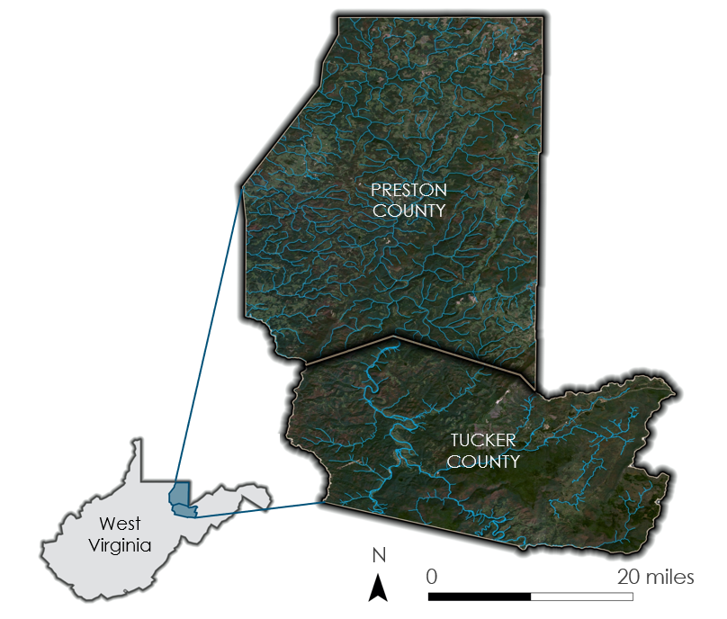

*Figure 1.* Study area map depicting Preston and Tucker counties in North-East West Virginia.

***2.2 Project Partners & Objectives***

Friends of the Cheat (FOC) was founded in 1994 in response to severe river contamination due to acid mine drainage (AMD). Since 1994, FOC has been involved in a variety of monitoring and restoration projects aimed at reducing the ecological and community impacts of AMD and has succeeded in having the Cheat River removed from the national list of impaired waterways. In recent years, FOC has expanded their work to proactively mitigate flood events in the watershed through activities such as riparian reforestation, dam removals, and community outreach. While some at FOC have experience utilizing GIS and geospatial data, the organization has limited staff and limited time to devote to proactively identify areas at risk for future flood events. This project will aid FOC to more effectively target their mitigation and restoration activities in an effort to prevent future flood damage.

To address FOC’s concerns, the team’s main objective was to assess and map flood risk and vulnerability in Preston and Tucker counties. The team defined flood risk to include any areas susceptible to flooding. Flood vulnerability focused on potential human impacts due to flooding, including road blockages and increased water contamination due to flooding near abandoned mines. The team also identified long-term trends in precipitation, temperature, and river discharge to better understand how future changes in climate may impact flooding in the region. Finally, the team quantified changes in land cover between 1994 and 2021 to assess how land cover could play a role in either exacerbating or mitigating flood risk and vulnerability.

# 3. Methodology

***3.1 Data Acquisition***

***3.1.1 Climatology Time Series***

To analyze climate trends, the team used data published by the National Oceanic and Atmospheric Administration (NOAA) under the National Centers for Environmental Information (NCEI) department. Within NCEI, the National Climate Data Center (NCDC) collects climate data for public access. Exploring the Climate at a Glance tool, the team determined that utilizing the “County” location specification would be sufficient in representing climate data for the study area. The team also decided to focus on monthly datasets so that climate trends over many years could be analyzed. The datasets that were collected are included in Table 1. The average range associated with the monthly variables and the time range selected for the yearly variables were selected to compare climatic trends from the 20th Century to the climatic trends of the beginning of the 21st Century. To analyze Cheat River trends and find possible river variable changes in correlation to climate trends, the team used data from the United States Geological Survey (USGS), focusing on data collected from the Parsons, West Virginia gauge on the Cheat River. The team chose to collect Monthly River Discharge, Yearly Peak Streamflow, and Yearly Peak Gage Height data from USGS from 1950 to 2020.

Table 1

*Sources and the variables used from the sources for the climatology time series*

|  |  |  |  |
| --- | --- | --- | --- |
| **Source** | **Years** | **Datasets** | **Use** |
| NCDC | 1950-2020 | Maximum Monthly Temperature, Minimum Monthly Temperature, Average Monthly Temperature, Monthly Precipitation Amounts, Yearly Average Temperature, Yearly Precipitation Amounts | Atmospheric climate profile and analysis of change |
| USGS | 1950-2020 | Monthly River Discharge (cubic feet per second), Average Monthly River Discharge (cubic feet per second) Yearly Peak Streamflow (cubic feet per second), Yearly Peak Gage Height (feet) | River climate profile and analysis of change |

***3.1.2 Landcover Time Series***

To analyze changes in land cover that could impact flood risk and vulnerability, the team acquired Tier 1 Level 1 imagery from Landsat 5 Thematic Mapper (TM) and Landsat 8 Operational Land Imager (OLI) between 1990 and 2020 (Table 2). The team also obtained land cover maps for 2011 and 2016 from the United States Geological Survey’s (USGS) National Land Cover Database (NLCD) from the Multi-Resolution Land Characteristics Consortium to be used as training data for the supervised classifier. Landsat 5 TM, Landsat 8 OLI, and the NLCD land cover data all have a spatial resolution of 30m. The team acquired all imagery through Google Earth Engine (GEE).

Table 2

*Satellites and sensors used in the landcover time series analysis*

|  |  |  |  |
| --- | --- | --- | --- |
| **Satellite** | **Years** | **Bands** | **Resolution** |
| Landsat 5 TM | 1990-2011 | Bands 1 through 5 | 30m |
| Landsat 8 OLI | 2013-2020 | Bands 1 through 7 | 30m |

***3.1.3 Flood Risk and Vulnerability***

To analyze the areas in Preston and Tucker counties that are most at risk for flooding, the team acquired FEMA flood plain polygons from the West Virginia State GIS Data Clearinghouse. From GEE, the team acquired NASA Shuttle Radar Topography Mission (SRTM) digital elevation data, U.S. Census Block Population data, and Landsat 8 OLI. The team acquired additional data used in the flood vulnerability maps directly from FOC. The full list of datasets included in the flood risk and flood vulnerability maps are listed below (Table 3).

Table 3

*Datasets used in the flood risk and flood vulnerability map*

|  |  |  |  |
| --- | --- | --- | --- |
| **Dataset** | **Years** | **Spatial Resolution or Scale** | **Use** |
| NASA Shuttle Radar Topography Mission (SRTM) Digital Elevation | 2000 | 30m | Elevation in flood risk map |
| Landsat 8 OLI, Bands 1 through 7 | 2020 | 30m | Land cover and Normalized Difference Water Index (NDWI) in flood risk map |
| Global 30m Height Above Nearest Drainage (HAND) | N/A | N/A | HAND in flood risk map |
| FEMA Statewide Floodplain Polygons | 2020 | 1:24000 | 100 and 500-year FEMA floodplains for flood risk map |
| TIGER U.S. Census Blocks, U.S. Census Bureau | 2010 | Variable | Population data used in flood vulnerability maps |
| Abandoned Mines, FOC | N/A | N/A | Mine data used in flood vulnerability maps |
| Roads, U.S Census Bureau | 2011 | 1:5000 | Road network used in flood vulnerability maps |

***3.2 Data Processing***

***3.2.1 Climatology Time Series***

The team organized data into data tables in Microsoft Excel from NCDC and USGS to allow for easier analysis. All temperature data was collected in Fahrenheit and was only converted to Celsius at the end of statistical analysis to provide a change in temperature in Celsius in comparison to Fahrenheit. Precipitation was collected and kept in inches.

***3.2.2 Landcover Time Series***

All Tier 1 Landsat Imagery is pre-processed to ensure consistency between sensors, which eliminated the need for further sensor calibration between Landsat 5 and Landsat 8. The team processed all data used for the landcover time series in GEE. To improve the accuracy of the land cover classifications and reduce changes in vegetation due to seasonality, the team selected all imagery between June 1st and August 31st of each study year. Next, the team cloud masked and combined images by taking the median pixel value for each band to obtain a single image for each year. The team then remapped the NLCD land cover data to combine all forest classes into a single land cover category before training the classifier and classifying the imagery.

***3.2.3 Flood Risk and Vulnerability***

The team clipped all data described in section 3.1.3 to the boundary of Preston and Tucker counties in ArcGIS Pro 2.7. To combine the variables and assess flood risk, the team converted each of the datasets into a raster with values from 0 to 1 with the Fuzzy Membership tool in ArcGIS Pro, where low values indicate higher risk and high values indicate lower risk. While elevation and height above nearest drainage could be directly converted into fuzzy membership rasters, two datasets required further pre-processing. First, the land cover classification was remapped to values corresponding to flood risk, with developed areas receiving a value of 0 to indicate that they are most at-risk for flooding, followed by barren soil, agricultural land, grassland, and forest. Then the reclassified raster could be converted into a fuzzy membership raster.

Next, the team created a raster layer representing the total flood extent. Because FEMA floodplain polygons have been shown to underrepresent the extent of flooding in previous studies (Pralle, 2019), the team combined the FEMA 100 and 500-year floodplains with the flood extent indicated by the NDWI (Equation 1). In GEE, the team cloud masked all Landsat 8 imagery between 2013 and 2020 and calculated NDWI. Next, the team combined all images by selecting the maximum pixel value at each pixel location, which functions to show the maximum flood extent because higher values in NDWI indicate water while lower values indicate a lack of water. To extract only the flooded areas, the team set a water threshold of 0.1. After combining the NDWI flood extent with FEMA floodplains in ArcGIS Pro 2.7 (Figure 2), the team used the Fuzzy Membership tool to create a raster where areas within the flood extent had a value of 0 while non-flooded areas had a value of 1. To create the combined flood risk map, the team then used the Fuzzy Overlay tool in ArcGIS Pro on the fuzzy rasters corresponding to elevation, height above nearest drainage, flood extent, and land cover.

(1)

*Figure 2.* This map depicts the flood extent calculated from NDWI and the total combined flood extent within the project area.

***3.3 Data Analysis***

***3.3.1 Climatology Time Series***

The team analyzed temperature by first calculating monthly averages using NCDC maximum and minimum values for each year in the study period. These values were then used to calculate a single overall average of monthly temperature for a subset of the study period (i.e., January 1970-1999 and January 2000- 2020). Then, the team averaged the yearly means to find an overall mean temperature of 48.98°F in Preston County and 47.37°F in Tucker County from 1950 to 2020. Using these yearly averages, the standard deviation was also calculated. The standard deviation for temperature in Preston County was 1.32°F and for Tucker County the standard deviation was 1.38°F. Using the means and the standard deviation, the team calculated a significant temperature value that is equal to the mean added to the standard deviation. For Preston County this temperature was 50.3°F and for Tucker County this temperature was 48.7°F. These temperatures provided a baseline for significant yearly temperatures. The same statistical analysis was applied at the monthly level for both counties to find the significant temperature for each month of the year. These significant yearly and monthly temperatures were used to count the number of months and years that had temperatures significantly above average.

Monthly average precipitation for each year of the study period was available through the NCDC dataset. These monthly precipitation values for each year were used to calculate an overall average of monthly precipitation for a subset of the study period (i.e., January 1970-1999 and January 2000- 2020). For Preston County, the precipitation amount was 4.202 inches and Tucker County had a precipitation amount of 4.372 inches. Using the same dataset, the standard deviation for Preston and Tucker Counties were 0.563 and 0.637 inches, respectively. The monthly average precipitation for the year was added to the standard deviation to determine a significant precipitation value for each county. Preston County had a significant monthly precipitation value of 4.76 inches, while Tucker County had a value of 5.01 inches. These precipitation values were used to count the number of years that had a monthly average amount of precipitation that was significantly above average. The same statistical analysis was applied to both counties to find significant precipitation values based on the month of the year. Those values were used to count the number of months during the study period that had significant above average precipitation amounts. Additionally, the team graphed yearly total precipitation for both counties, adding trend lines to show change over the study period. This graph was made to allow the team to calculate the average amount of additional precipitation that the study area was receiving at the end of the study period in comparison to the beginning of the study period.

For river discharge, monthly averages for each year of the study period were available through the USGS. There was only one set of discharge data used for the entire study area. The Cheat River gauge in Parsons, WV had recorded river discharge data for the years 1950 to 2019. The team used these data to calculate monthly discharge averages for each year in the study period, and then to find a single overall average for each month during the entire study period (i.e., January 1950-2019). The average monthly discharge the team calculated was 1806.4 cubic feet per second. The team then also calculated the standard deviation for monthly discharge which was 393.8 cubic feet per second. Adding the standard deviation and average together, the team calculated a significant monthly discharge value of 2200 cubic feet per second. Anything above this value was considered significant for each year. This process was also done for each month of the year to determine the number of months that had significant river discharge per year. The other river variables that were collected were used for the overall analysis of river climate and were not used for in-depth analysis or official graphing.

***3.3.2 Land Cover Time Series***

The team conducted the supervised classifications within GEE utilizing the 2011 NLCD data as training data for the Landsat 5 classifier and 2016 NLCD data for the Landsat 8 classifier. The training dataset consisted of 8,000 random points, which were then used to train a random forest classifier with ten decision trees. The team validated the classifications for 2011 and 2016 using a set of 5,000 random points and found that the overall accuracy was 81.1% for 2011 and 79.3% for 2016.

***3.3.3 Flood Risk and Vulnerability***

To determine flood vulnerability, which the team defined as affecting human-made structures or human health, the team analyzed underground mine locations, road networks, and population density on the flood risk map. To assess population vulnerability, the team conducted a weighted overlay with the census block-level population data with the flood risk map to highlight areas where high population densities would lead to greater vulnerability to flooding. To assess road and mine vulnerability, the team calculated the intersection between these layers and the flood extent. These intersecting areas were then classified as vulnerable and utilized in a series of maps.

# 4. Results & Discussion

***4.1 Climatology Time Series***

The results below show that there is an increase in the number of months and years that have significantly above average temperatures (Table 4). The graph of yearly mean temperature shows that there is an increasing trend in temperature (Figure 3). To calculate the change in temperature, the team used the equations of the linear trend lines based on annual averages of both counties and averaged the results. Overall, the team calculated that yearly mean temperatures have increased by 2.75°F (1.5°C) based on the calculated average in the study area.

Table 4

*Number of months and years in the decade that had significantly above average temperatures in Preston County and Tucker County*

|  |  |  |  |  |
| --- | --- | --- | --- | --- |
| **Decade** | **Number of Significant Months**  **Preston County** | **Number of Significant Months**  **Tucker County** | **Number of Significant Years**  **Preston County** | **Number of Significant Years**  **Tucker County** |
| 1970s | 18 | 16 | 0 | 0 |
| 1980s | 14 | 15 | 0 | 0 |
| 1990s | 21 | 20 | 4 | 3 |
| 2000s | 26 | 26 | 2 | 1 |
| 2010s | 33 | 39 | 6 | 7 |

*Figure 3.* This graph depicts the yearly average temperature time series, including a trend line to show change in climatic trends between 1970 and 2020 in Preston County and Tucker County, WV.

The results below show that there is an increase in the number of months and years that have average monthly precipitation that is significantly above average (Table 5). Looking at the graph (Figure 4), there is an increase in the precipitation average during the late spring and summer months. This conclusion can be drawn from the difference between the mean for 1970-1999 and the mean for 2000-2020 during these months. Also, late fall months have average monthly precipitation that is trending below the previous average of 1970-1999, while the winter months are maintaining approximately the same average monthly precipitation. Using the yearly total precipitation graph (Figure *A1*) and the trend line that was added to the graph, the team calculated that yearly total precipitation had increased by 4.2 inches from 1970 to 2020.

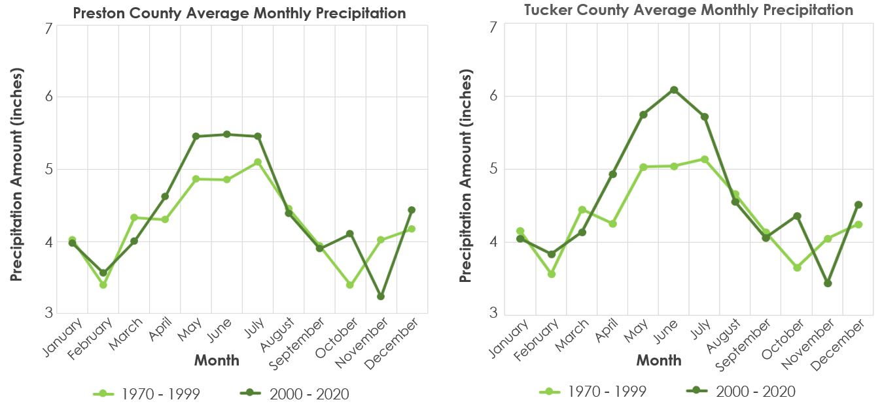

*Figure 4.* These graphs depict the monthly average amount of precipitation time series, using two different means (1970-1999 and 2000-2020) to show change in climatic trends between 1970 and 2020 in Preston County and Tucker County.

Table 5

*Number of months and years in the decade that had significantly above average precipitation in Preston County and Tucker County*

|  |  |  |  |  |
| --- | --- | --- | --- | --- |
| **Decade** | **Number of Significant Months**  **Preston County** | **Number of Significant Months**  **Tucker County** | **Number of Significant Years**  **Preston County** | **Number of Significant Years**  **Tucker County** |
| 1970s | 18 | 18 | 0 | 1 |
| 1980s | 14 | 14 | 0 | 0 |
| 1990s | 17 | 19 | 1 | 2 |
| 2000s | 15 | 17 | 1 | 1 |
| 2010s | 18 | 31 | 3 | 3 |

The results concerning river discharge show that the yearly average rate of river discharge per decade has increased very slightly (Figure 5). The biggest noticeable change in river discharge is the widening of the range of yearly discharge per decade, with the 2010s showing a much larger, higher-end range than that of the first three decades of the study. Also, the team discovered that the number of months with significantly above average discharge is increasing slowly, while the number of years with significantly above average discharge are staying close to the average number of significant years per decade (Table 6).

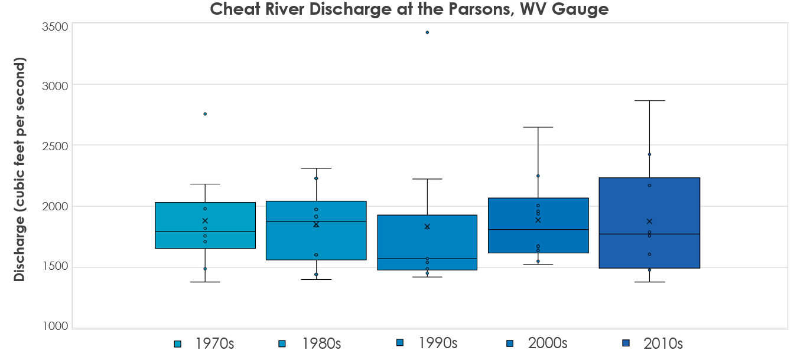

*Figure 5.* This graph utilizes box and whisker plots to show river discharge of the Cheat River at the Parsons, WV gauge, in decadal increments.

Table 6

*Number of months and years in the decade that had significantly above average mean monthly river discharge*

|  |  |  |
| --- | --- | --- |
| **Decade** | **Number of Significant Months** | **Number of Significant Years** |
| 1970s | 18 | 1 |
| 1980s | 16 | 2 |
| 1990s | 19 | 0 |
| 2000s | 23 | 2 |
| 2010s | 25 | 2 |

***4.2 Land Cover Time Series***

The land cover time series analysis demonstrated that most land cover classes have remained consistent across the study period (Figures *B1-B2*). The time series indicates that the majority of both Preston and Tucker County was covered by forest between 1990 and 2019 with very little change in developed area or cultivated cropland, which emphasizes that flooding in this region should not be linked to urban development or agricultural expansion. Instead, the time series analysis suggests that flooding in Preston and Tucker counties is likely linked more closely to geology, topography, and climate related conditions. While there are no meaningful changes in land cover across the counties as a whole, there are smaller areas of change between years that could still impact local flood risk and vulnerability at a local scale. For example, many of the towns and developed areas in this region are located near the river, often within the floodplain. While the absolute area covered by developed land is small, the concentration of developed areas within the floodplain could still contribute to increased flood risk and vulnerability.

***4.3 Flood Risk and Vulnerability***

The flood risk map shows that many of the most at-risk areas were low-lying regions near the river, due to a combination of the low elevation and height above nearest drainage, the prevalence of developed land cover, and the extent of the river's historical flood extent (Figure 6). In particular, because the flood extent was a binary 0 or 1 raster, it heavily impacted the results of the final flood risk map. One notable area of difference between the original FEMA 100 and 500-year floodplains and the NDWI flood extent calculated from Landsat 8 imagery was found near Masontown, Reedsville, and Arthurdale in North-West Preston County. While these areas were not designated as falling within the FEMA floodplains, the NDWI calculation suggested that they had been flooded at some point between 2013 and 2020 (Figure 2). While the team was not able to validate these findings, they could have implications for future flood mitigation techniques in the area if they are confirmed to be at-risk for flooding as suggested in the team’s flood risk map.

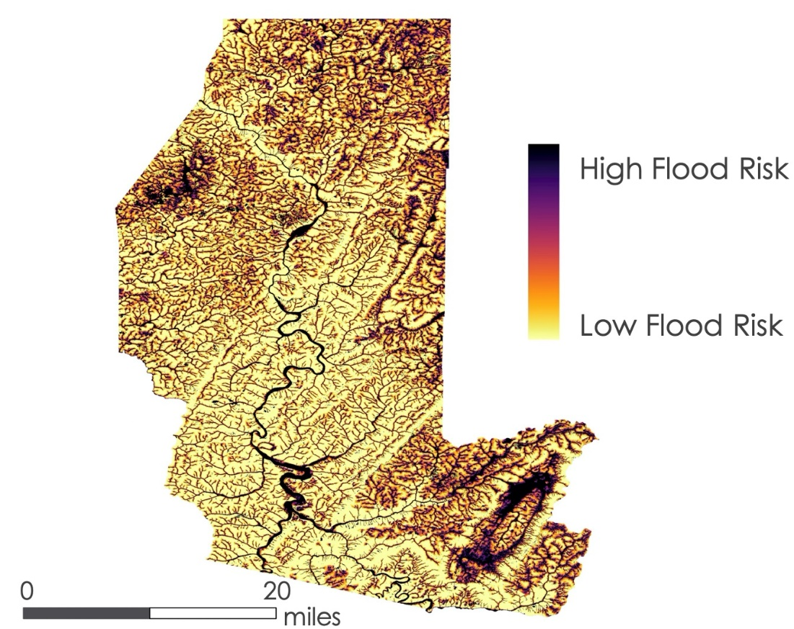

*Figure 6*. Flood Risk Map demonstrating the areas within Preston and Tucker counties most susceptible to flooding.

The vulnerability map based on population suggested that some of the most vulnerable census tracts included those near the towns of Kingwood, Parsons, and Albright (Figure *C1*). Because the population density of most of the study area is relatively low, the vulnerability map tended to show most large towns as vulnerable. However, many of the larger towns throughout the study region also tend to be located in more at-risk areas within or near the river’s floodplain, which makes them highly vulnerable.

In more rural areas, one of the major determining factors of flood resilience is the strength of the transportation network (Allen et al. 2020). With this in mind, the team analyzed road vulnerability to flooding and found that a large number of the roads throughout Preston and Tucker Counties are vulnerable, which could be due to the region’s mountainous terrain. Many roads appear to have been constructed in lower elevation areas, which makes them more vulnerable to flooding. In total, 155.3 miles of roads throughout the study area were classified as vulnerable. Some of the most vulnerable road networks were found near Parsons, Kingwood, Masontown, and Reedsville, which prompted the team to create a series of maps highlighting road vulnerability in these areas (Figure *D1-D3*).

Due to the concerns about increased flooding leading to worsened water quality due to acid mine drainage, the team analyzed mine vulnerability. While there are large areas of mining in the study region, only small sections of the mines intersected with the flood extent and were considered vulnerable (Figure *C3*). Many of the vulnerable mines are located in the region of North-West Preston county with a large area of NDWI flood extent near Masontown, Reedsville, and Arthurdale. This analysis highlights areas where flood mitigation strategies could be implemented to avoid the potentially devastating impacts of increased acid mine drainage due to flooding on river ecosystems and human health.

***4.4 Future Work***

A second term of this project could expand on the climatology analysis, to complete a more accurate climate profile. Future work could also include a more thorough validation of the land cover time series analysis utilizing aerial imagery, in addition to more precise training datasets for each classification year, which would allow for a more precise accounting of small-scale land cover changes that could impact flood risk. Furthermore, the team’s limited understanding of historical flood extent in the region could lead to potential inaccuracies in the flood risk and vulnerability maps. Future work on this project could include a more thorough validation of NDWI to verify that the areas classified within the flood extent had flooded during the study period. Further analysis of variables such as precipitation distribution over the study area, soil type, and population density at a smaller scale (rather than at the census block level) could be done. Finally, a second term of this project could validate the flood risk map through the creation of a spatially-explicit historical flood database, or utilize the flood risk map to analyze future flooding scenarios with or without the use of specific flood mitigation strategies.

# 

# 5. Conclusions

Long term climate trends demonstrate that temperature and precipitation are both increasing, while stream discharge is increasing and becoming more variable. These trends are likely to alter flood risk and vulnerability in Preston and Tucker counties, which will inform the way the community and partners plan for potentially more frequent or more severe flood events. While the climate trends are likely contributing to increased flood risk, the team did not find any substantial changes in land cover occurring at the county level. Though specific land cover classes still have varying degrees of flood risk and should be incorporated into flood planning, our land cover time series indicated that land cover transitions are likely not contributing to worsening floods. Lastly, the team’s flood risk and vulnerability maps will allow the community to better understand which areas could be targeted for future flood mitigation techniques. Transportation networks are especially important during flood events, both for evacuation and for flood response teams, the team’s analysis of road vulnerability will improve the community’s ability to respond to flooding. The team’s flood vulnerability maps also highlight the degree of overlap between high population centers and vulnerable roads. Because many towns in the study area were constructed within or near the river floodplains, they are vulnerable to flooding due to the high populations. Also, the fact that many of the major roads are likely to be impacted by flooding, reducing evacuation and response time. The information from these vulnerability maps will allow FOC and the greater community to better understand the connection between the variables contributing to flood risk and vulnerability while allowing them to better target specific areas for future mitigation measures.

# 6. Acknowledgments

* Madison Ball, Friends of Cheat
* Beth Warnick, Friends of the Cheat
* A.R. Williams, NASA DEVELOP National Program
* Dr. Robert Griffin, The University of Alabama Huntsville
* Dr. Jeffrey Luvall, NASA Marshall Space Flight Center

Any opinions, findings, and conclusions or recommendations expressed in this material are those of the author(s) and do not necessarily reflect the views of the National Aeronautics and Space Administration.

This material is based upon work supported by NASA through contract NNL16AA05C.

# 7. Glossary

**Earth observations** – Satellites and sensors that collect information about the Earth’s physical, chemical, and biological systems over space and time.

**SRTM** - Shuttle Radar Topography Mission obtains high-resolution digital elevation models on a global scale.

**NLCD** – National Landcover Database provides current and consistent landcover data of the entire United States and Puerto Rico.

**Flood Risk** – The degree to which an area is prone to flooding.

**Flood Vulnerability** – The degree to which human health or human structures will be impacted by flooding in any given area.

# 8. References

Allen, M., Gillespie-Marthaler, L., Abkowitz, M. & Camp, J. (2020). Evaluating flood resilience in rural communities: a case-based assessment of Dyer County, Tennessee. *Natural Hazards* *101*(1), 173–194. https://doi.org/10.1007/s11069-020-03868-2

Boon, H.J. Disaster resilience in a flood-impacted rural Australian town. (2014). *Nat Hazards* 71, 683–701 https://doi.org/10.1007/s11069-013-0935-0

Doocy, S., Daniels, A., Murray, S., & Kirsch, T. D. (2013). The human impact of floods: a historical review of events 1980-2009 and systematic literature review. *PLoS currents*, *5*, ecurrents.dis.f4deb457904936b07c09daa98ee8171a. https://doi.org/10.1371/currents.dis.f4deb457904936b07c09daa98ee8171a

Johnson, K.A., Wing, O.E.J., Bates, P.D. Fargione, J., Kroeger, T., Larson, W., Sampson, C., & Smith, A.  (2020). A benefit–cost analysis of floodplain land acquisition for US flood damage reduction. *Nature Sustainability3*(1), 56–62. https://doi.org/10.1038/s41893-019-0437-5

Muche, M. E., Hutchinson, S. L., Hutchinson, J., & Johnston, J. M. (2019). Phenology-adjusted dynamic curve number for improved hydrologic modeling. *Journal of environmental management*, *235*, 403–413. https://doi.org/10.1016/j.jenvman.2018.12.115

NASA JPL. (2013). NASA Shuttle Radar Topography Mission Global 1 arc second [Data set]. NASA

EOSDIS Land Processes DAAC. https://doi.org/10.5067/MEaSUREs/SRTM/SRTMGL1.003

NOAA National Centers for Environmental information. (2021 March). *Climate at a Glance: County Time Series.* https://www.ncdc.noaa.gov/cag/

Pralle, S. (2019). Drawing lines: FEMA and the politics of mapping flood zones. *Climatic Change* 152, 227–237 . https://doi.org/10.1007/s10584-018-2287-y

Trenberth KE. (2011). Changes in precipitation with climate change. *Climate Research*, *47*(1-2), 123-138. https://doi.org/10.3354/cr00953

U.S. Geological Survey. (2021 March). *NWIS Site Information for USA: Site Inventory*. https://waterdata.usgs.gov/nwis/inventory/?site_no=03069500&agency_cd=USGS

U.S. Geological Survey Earth Resources Observation and Science Center. (2012). Landsat TM Level-2 Surface Reflectance (SR) Science Product. U.S. Geological Survey. https://doi.org/10.5066/f7kd1vz9

U.S. Geological Survey Earth Resources Observations and Science Center. (2019). Landsat OLI/TIRS Level-2 Surface Reflectance (SR). Science Product. U.S. Geological Survey. https://doi.org/10.5066/f78s4mzj

# 9. Appendices

**Appendix A**

***Climatology Results***

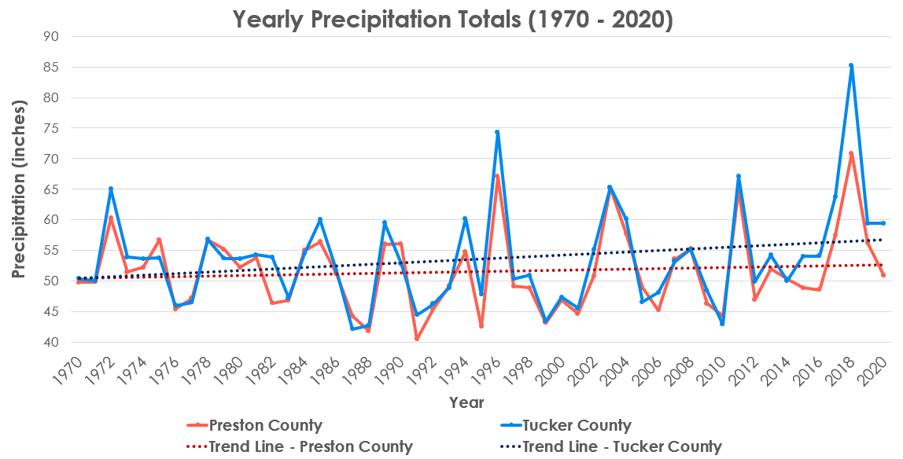

*Figure A1.* This graph shows the yearly total amount of precipitation in Preston and Tucker Counties, as well as linear trend lines for both counties to show changes in climatic trends between 1970 and 2020.

**Appendix B**

***Land Cover Results***

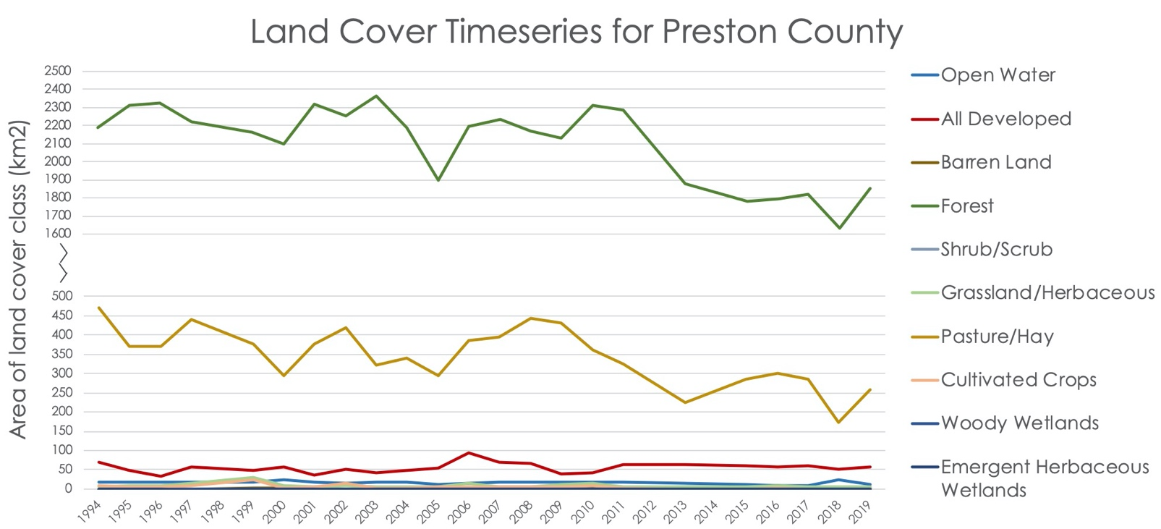

*Figure B1*. Land cover time series for Preston County.

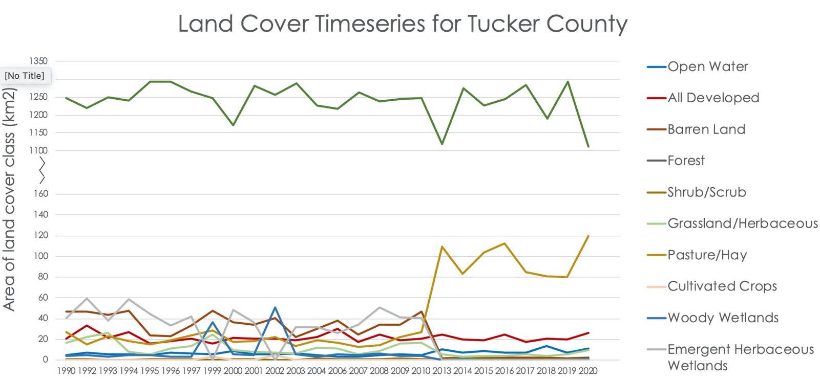

*Figure B2.* Land cover time series for Tucker County.

**Appendix C**

***Flood Risk and Vulnerability Results***

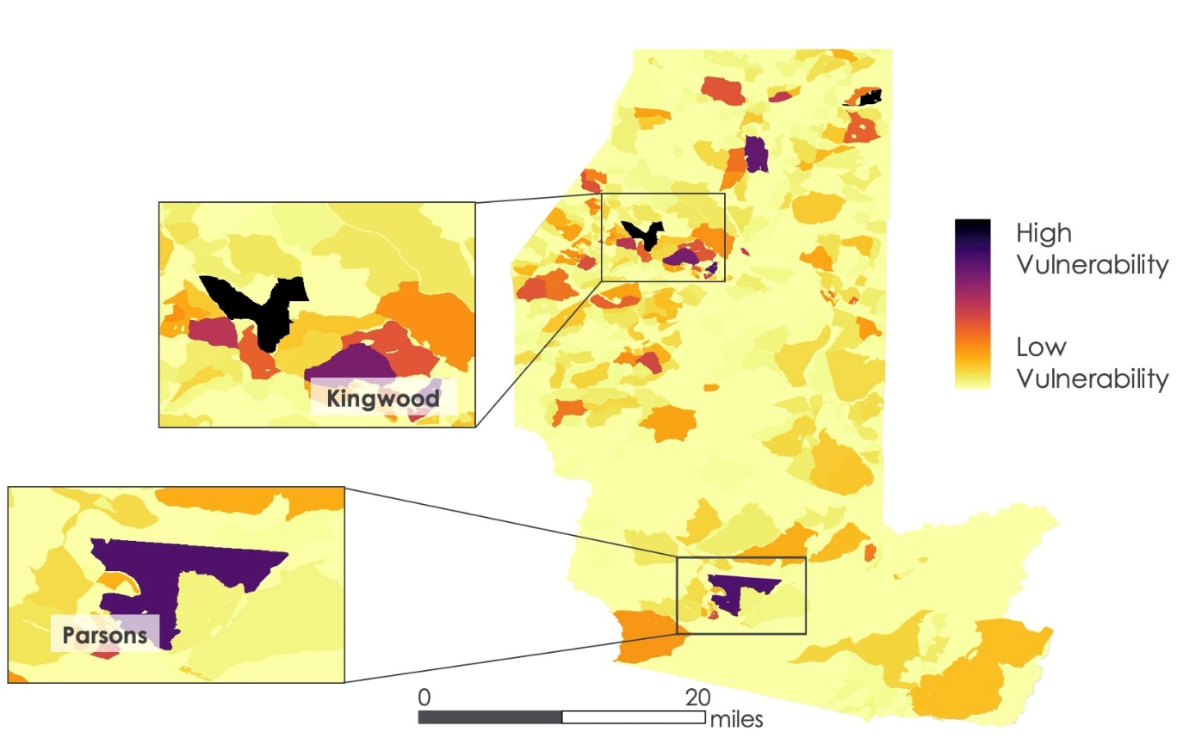

*Figure C1*. This map depicts flood vulnerability based on population density and flood risk at the census block level.

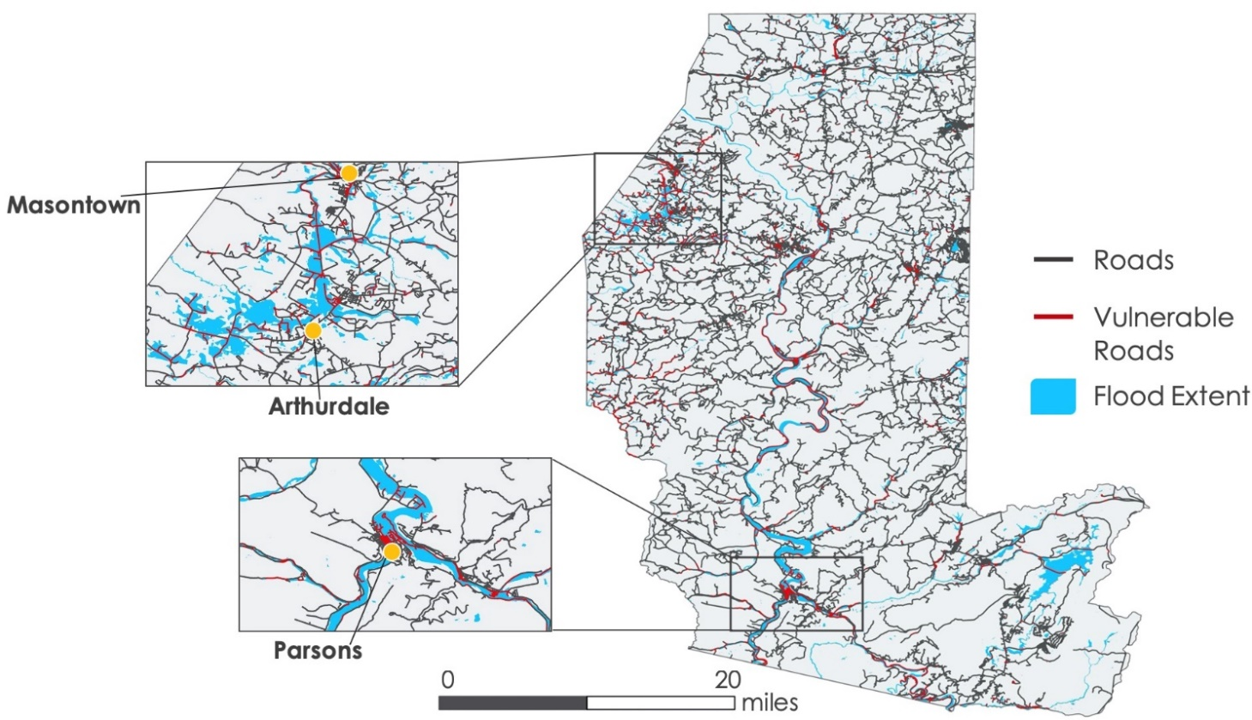

*Figure C2*. This map depicts the road vulnerability by overlaying the roads on the flood extent layer.

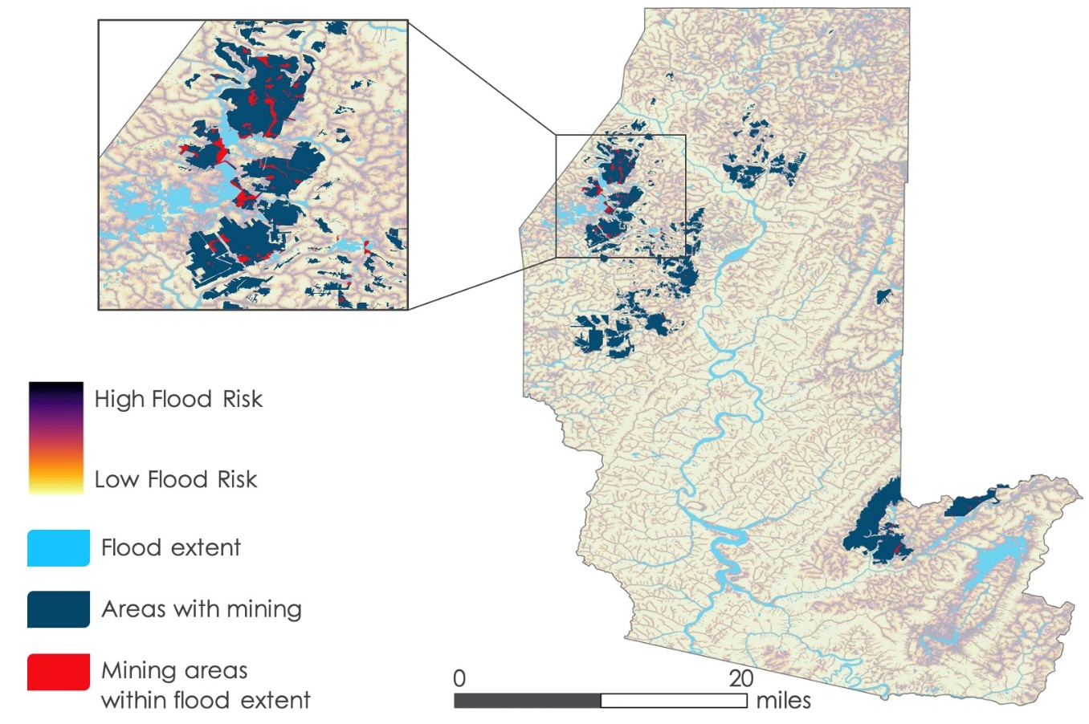

*Figure C3*. This map depicts mine vulnerability determined by intersecting underground mines with the flood extent.

**Appendix D**

***Road Vulnerability Analysis for Reedsville, Kingwood, and Parsons***

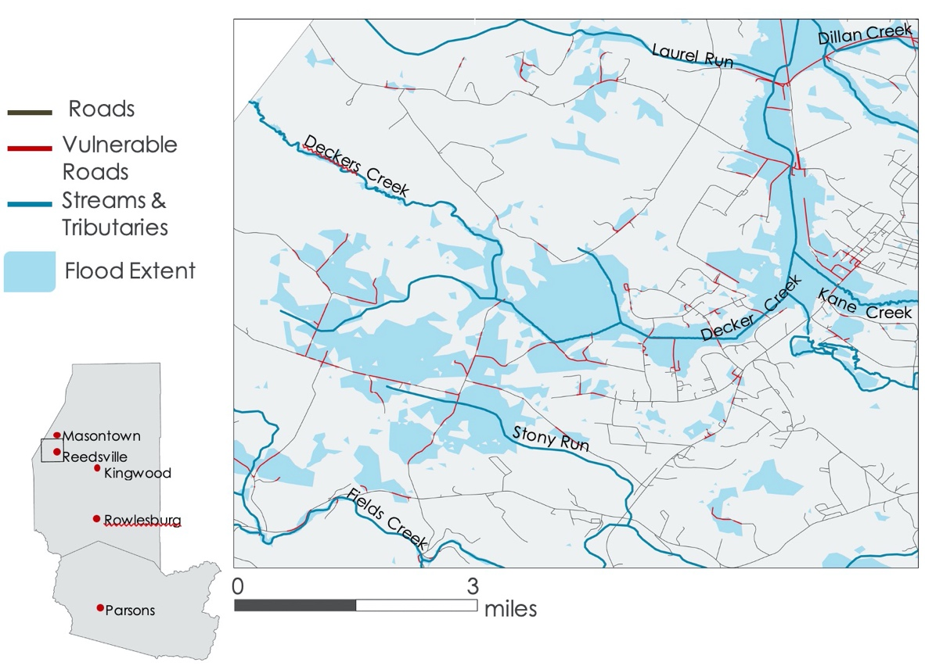

*Figure D1.* Road vulnerability near Reedsville, WV.

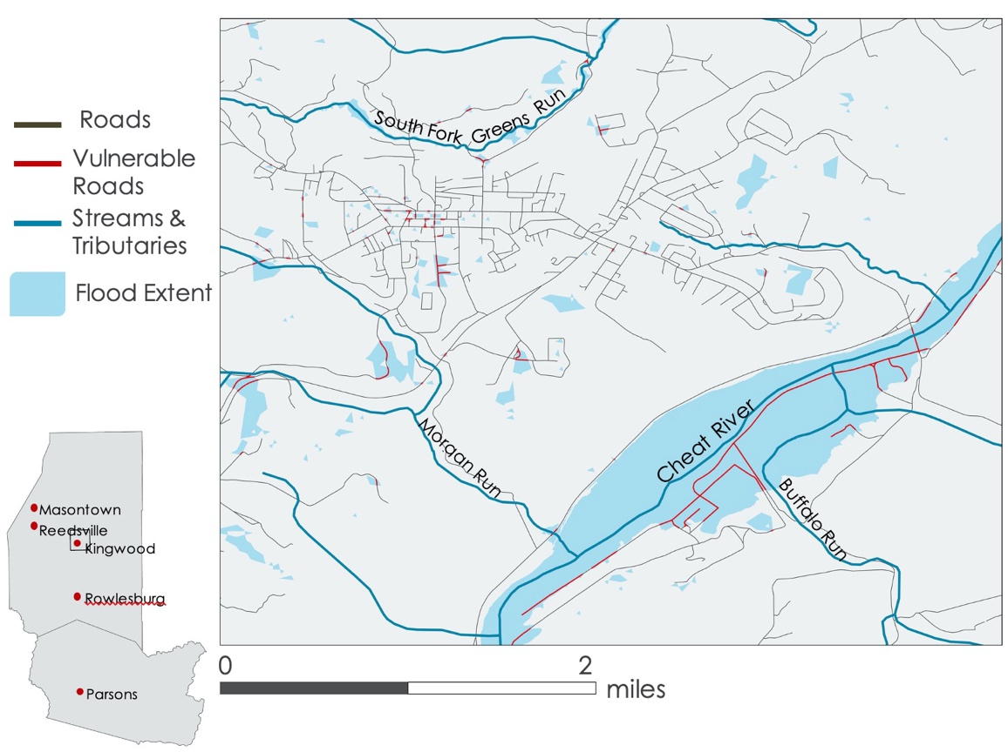

*Figure D2.* Road vulnerability near Kingwood, WV.

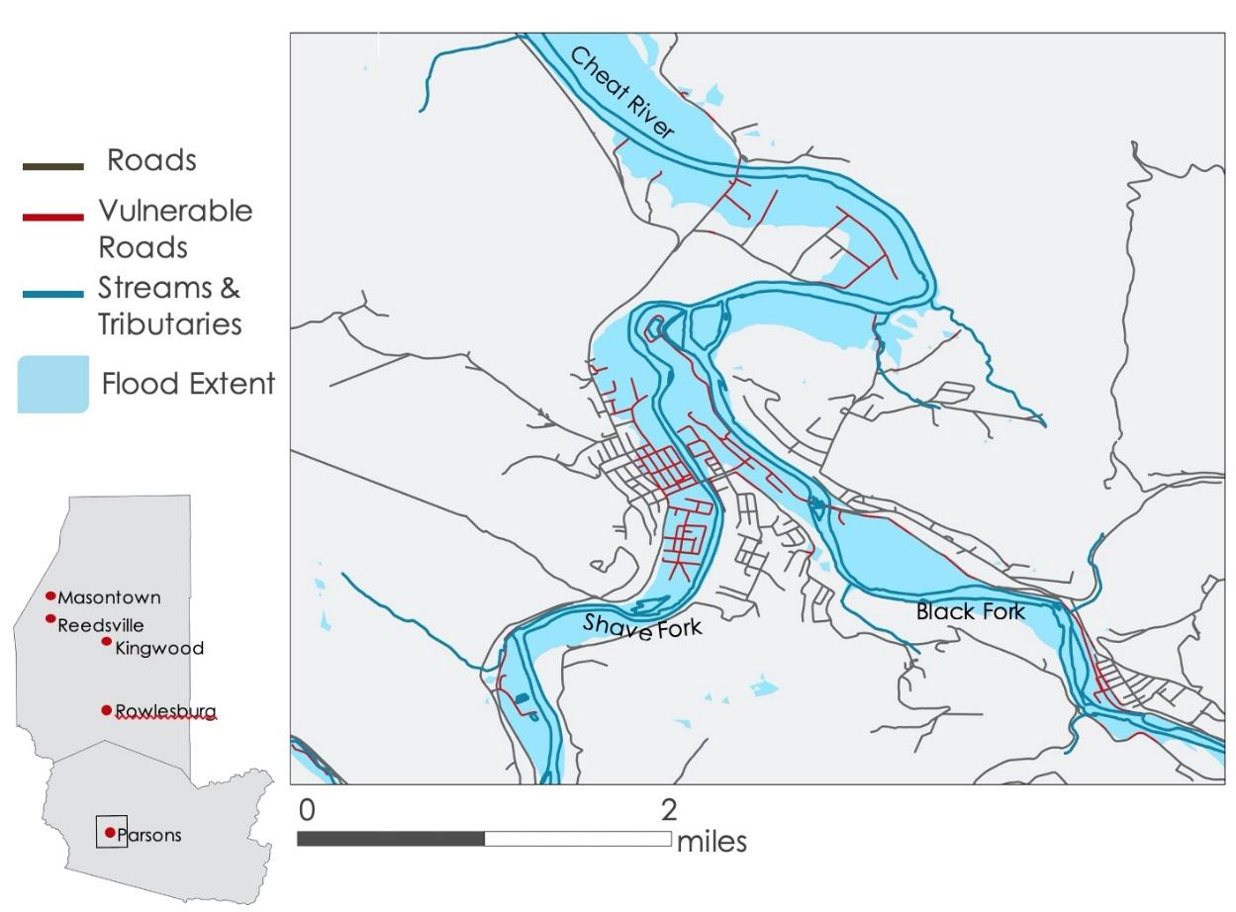

*Figure D3.* Road vulnerability near Parsons, WV.