April 15, 2021

Department of Agriculture
United States Forest Service
Apache-Sitgreaves National Forest
P.O. Box 640
Springerville, Arizona 85938
Attn: Anthony Madrid, Forest Supervisor

Submitted online electronically to:
https://cara.ecosystem-management.org/Public/CommentInput?project=18916

Re: Public Comment Letter
Heber Wild Horse Territory Plan #18916 Environmental Assessment (EA)

The goal of the Heber Wild Horse Territory Management Plan, by law, must be to preserve the herd for future generations. These wild horses come under the jurisdiction of the Wild Free-Roaming Horse and Burro ACT (WFHBA) which was unanimously passed by congress. The law states: “It is the policy of Congress that wild free-roaming horses and burros shall be protected from capture, branding, harassment, or death; and to accomplish this they are to be considered in the area where presently found [in 1971 when the law went into effect], as an integral part of the natural system of the public lands.” To ignore the laws of the United States is treasonous.

~ ~ ~

HON. RAÚL M. GRIJALVA
OF ARIZONA
https://www.heberwildhorses.com/about.html
IN THE HOUSE OF REPRESENTATIVES
WEDNESDAY, JUNE 6, 2007
· Mr. GRIJALVA. Madam Speaker, I rise today to honor Arizona 's wild horses living in the Apache-Sitgreaves National Forests.
· The residents of the State of Arizona deeply value these magnificent wild horses.
· These beautiful wild horses are truly the ``Living Symbols of the West,'' as described by the Wild Horse and Burro Act passed by Congress in 1971 to protect the wild horses of the United States .
· The Rim Country wild horses date back to mounts brought by Father Eusebio Kino, who began his 1653 mission to eastern Arizona by setting out from the lands of my constituency in southern Arizona and traveling across our State northeast to the ``borders of the lands of the Apacheria which border on New Mexico.''
· These original Spanish horses are the great ancestors of the Mogollon Rim country wild horses. They were the mighty Andalusian war horse, whose origins go back more than 28,000 years to the original Iberian horse; the magnificent Spanish Barb; and the graceful and fluid Spanish Jennet, the mount of many of the great kings of Europe; and the strong bloodlines of these original horses appear almost unchanged in our Rim wild horses 400 years later.
· Our Arizona Rim wild horses are the direct descendants of the Spanish horses prized by the conquistadors so highly that the foals were carried in hammocks to protect their legs until they were old enough to travel on the forced marches; and prized by the early cattlemen for their endurance and heart and were the very mounts of the U.S. Cavalry as they rode to protect and expand the American west.
· The Arizona Rim Country wild horses living in Apache-Sitgreaves National Forests are a most precious natural resource to be preserved for our children and grandchildren who will be able to see them for generations to come.

~ ~ ~

I, as an American tax-paying citizen, environmental researcher and lifelong visitor to our public lands including Arizona, I require that the United States Forest Service (USFS) consider my public comment very seriously and include it in the administrative record of the Heber Wild Horse Territory Environmental Assessment (EA).

The impact of ignoring or bypassing the edict of the law destroys the trust and the integrity of the United States Government to abide by a law that was passed by Congress and can only be abolished by an act of Congress. The Wild and Free-Roaming Horses and Burros Act of 1971 (WFRHBA) is an Act of Congress signed into law. Consider the following un-amended language of the 1971 law and what it means: “It is the policy of Congress that wild free-roaming horses and burros shall be protected from capture, branding, harassment, or death.” This is the law of the people of the United States and the Heber Wild Horse EA plan must follow this law – it cannot include capture and it cannot include branding and must not include any kind of harassment and especially not death – all are illegal per the Congress of the United States of America and punishable as a federal offense against the citizens of the United States. USFS policies are plans and statements that have been made by the agencies and associates and are only self-monitoring regulations and erroneously often do not follow the congressional law. Any and all policies established must be within the outline of the umbrella of the law that it is required to follow. A policy plan is nothing more than a strategy and is illegal if it does not follow the law of the United States of America.

Political pressure and corruption within the United states Forest Service (USFS).
“I became aware that political pressure has become a factor in the carrying out of some of the policies and aims of the Forest Service. This tendency is, in my opinion, one of the most regrettable things that could happen to a Service that has been so clean and clear of anything like political pollution in the past, and I earnestly hope that this tendency will be abolished before it strangles the real life out of a truly great and good Government”

EARLY DAYS IN THE FOREST SERVICE
by Albert E. Cole
Senior Ranger Deerlodge (Retired 1935)
P.O. Box 67 Deer Lodge, Montana
May 26, 1944
Volume 1 Compiled and Edited by Jessie Thompson circa 1944 U.S. DEPARTMENT OF AGRICULTURE FOREST SERVICE
Northern Region Missoula, Montana
https://foresthistory.org/wp-content/uploads/2017/02/EARLY-DAYS-IN-THE-FOREST-SERVICE-vol1.pdf

Before continuing I wish to bring to the attention of the USFS management that any employee of the Department of Agriculture that has made false statements or conceals information is subject to the following Title 18 violations which include fines and prison terms. Please keep this in your mind as you read my concerns and issues with the current, as written, Environmental Assessment (EA).

Title 18 (18 U.S.C. § 1001). Making false statements (18 U.S.C. § 1001) is the common name for the United States federal crime laid out in Section 1001 of Title 18 of the United States Code, which generally prohibits knowingly and willfully making false or fraudulent statements, or concealing information, in "any matter within the jurisdiction" of the federal government of the United States, even by mere denial 18 U.S. Code § 1519 - Destruction, alteration, or falsification of records in Federal investigations Current through Pub. L. 114-38. (See Public Laws for the current Congress.) US Code Per the US Department of Justice, the purpose of Section 1001 is "to protect the authorized functions of governmental departments and agencies from the perversion which might result from" concealment of material facts and from false material representations.

Federal regulations and policy state that wild horses and burros shall be managed as viable, self-sustaining populations of healthy animals in balance with other multiple uses and the productive capacity of their habitat (CFR 4700.0-6). By definition, this requires the USFS to manage and to allow established populations to successfully produce viable offspring which shall, in turn, produce viable offspring, and so on over the long term. The Heber Territory Management Environmental Assessment (EA) failed to explain in exact detail how the USFS proposes to preserve the herd for future generations as is required by the Wild Free-Roaming Horse and Burro ACT (WFHBA).

At its most basic level, NEPA requires that the decision-makers, as well as the public, be fully informed, i.e. "that environmental information is available to public officials and citizens before decisions are made and before action is taken." 40 C.F.R. § 1500.l(b). NEPA ensures that the agency "will have available, and will carefully consider, detailed information concerning significant environmental impacts; it also guarantees that the relevant information will be made available to the larger [public] audience." Robertson v. Methow Valley Citizens Council. NEPA requires that all relative detailed environmental information will be available and carefully considered.
In its process of development of a plan to consider the management of wild horses in the Apache-Sitgreaves National Forest, the EA failed any NEPA analysis regarding this management plan and disclosure of all environmental impacts, and consideration of reasonable alternatives. Nature is the true manager for these wild lands, flora and fauna and nature is not static and these wild horses have been under the control and effects of nature for hundreds of years and therefore the Heber Wild Horse plan and the ultimate decisions must first take into serious consideration the natural environment that has evolved over the years. Nature is not static and therefore a one-size-fits-all decision done now can not possibly fit into a plan to provide a natural occurring thriving ecological balance for the next ten years.

The USFS is required by the National Environmental Policy Act ("NEPA"), 42 U.S.C. §§ 4321, et seq., to prepare Environmental Assessments (EAs) or, if indicated, Environmental Impact Statements (EIS) for any proposed changes to public lands that may have a significant environmental impact. The law directs the agency to identify environmental concerns, consider alternatives including no action at all and take a "hard look" at the issues and minimize significant environmental impact. A significant environmental impact includes actions that are likely to be highly controversial or have uncertain effects on the quality of our lives and that affect cultural and historical resources. 40 C.F.R. §1508.27(b). These evaluations as well as land use plans are full of words but have little substance when it comes to stating why wild horses must be removed from their legally designated lands. It is often what is NOT in these documents that is most telling. The USFS failed to include the following information in the current, as written, environmental assessment.

The National Environmental Policy Act (NEPA) requires that the USFS adequately evaluate all potential environmental impacts of proposed actions. To meet this obligation, the USFS must identify and disclose to the public all foreseeable impacts of the proposed action, including direct, indirect, and cumulative impacts. Therefore, I require, but the current EA as written failed to analysis and include a thorough consideration of the following significant impacts of this action:

- impacts on the genetic viability of the Heber wild Horse Herd population,

- the social, behavioral, and physiological impacts of the stress of capture and captivity on wild horses,

- the social, behavioral, and physiological impacts of population growth control measures on wild horses,

- the impacts on the ecosystem of removing wild horses from these public grazing lands, including a comparison of the impacts of removing and/or reducing grazing by domestic livestock,

- the impacts of helicopter drive trapping on the wild horses and other wildlife,

- the impacts of water/feed trapping on the wild horses and other wildlife,

- the economic impacts of requiring taxpayers to absorb the astronomical cost of these captures and maintaining or disposal of any additional wild horses at USFS holding facilities, and

(8) the ethical impacts of a wild horse management program that takes wild horses from the open range and dooms them to a lifetime on USFS feedlots and/or being sold with no restrictions or oversight thereby exposing them to the very likely “sold to slaughter” pipeline.

The USFS is required by law to focus on protecting natural, free, wild horse populations on the range as the United States law requires and not rounding up wild horses and confining them on public or private feedlots or selling them to buyers who will sell them to eventual slaughter.

The USFS failed to provide in the EA, the actions, results, and impacts including all previous removals and those horses’ “distribution” (where sent or where sold or other location) of the horses that have previously been captured over the past fifty years [since 1971]. This includes horses known to have been killed either by unknown sources or by the USFS. In addition, I require any and all genetic testing done and the concurrent past and/or current genetic viability of the wild horse population discovered by the testing including any done during necropsy.

Significant controversy by wild horse and burro citizen preservation groups centers around the genetic viability of wild horse and burro populations. Small isolated or sub-divided populations are subject to reduced genetic diversity (Goodloe, Warren, Cothran, Bratton, Trembicki, 1991). Reduced genetic diversity can “impair vigor, fertility, and disease resistance and could limit ability to respond to environmental variation” (Beard-more 1983, as cited in Goodloe et al. 1991). Other research has shown that significantly reducing populations can result in genetic bottlenecks and within the populations there are hidden population structures that result in behavioral isolation, which further restricts gene flow (Ashley, 2004).
According to the Federal Land Policy Management Act, “wild horses and burros shall be managed as self-sustaining populations of healthy animals in balance with other uses and the productive capacity of their habitat” (FLPMA, 1976).
The USFS EA failed to provide a full environmental assessment that provided clear evidence that wild horses and burros are compromising the “thriving natural ecological balance” and not livestock grazing, hunting, OHV use, water diversions, predator removal, fire, tree removal, climate change, and inadequate management policies as the true reason for these lands if they are not reaching a thriving ecological balance. The USFS office must be equipped to show that any action to remove or disturb the wild horses population (ie. fertility controls) will not cause irreparable harm to the populations and that the plan is not based on biased and illegal planning documents in favor of livestock interests.
The EA failed to provide scientifically supported evidence that the appropriate population size is dependent on the number of breeding adults and other management considerations specific to the population (Goodloe, Warren, Cothran, Bratton,Trembicki, 1991). The International Union for Conservation of Nature or IUCN Species Survival Commission recommends a minimum of 2,500 individuals are needed to maintain a viable wild population (IUCN, 1992). Other research indicates that an “absolute minimum” of 139-185 wild horses are needed to maintain a population that undergoes several removal disturbances during a generation (Singer, Aeignefuss, 2000). This number represents an “absolute minimum” and is not an ideal population size.

The current EA failed to include equine genetics data, reports or scientific research information from the known equine genetics expert, Dr. Gus Cothran, who over the years has expressed concern regarding the genetic viability of both wild horse and wild burro herd populations. Although in my scoping letter, I provided and required the USFS Heber EA to include the following Dr. Cothran wild horse scientifically supportable genetic facts be included in the EA, the USFS concealed this important information. Please be reminded that Title 18 (18 U.S.C. § 1001). Making false statements (18 U.S.C. § 1001) is the common name for the United States federal crime laid out in Section 1001 of Title 18 of the United States Code, which generally prohibits knowingly and willfully making false or fraudulent statements, or concealing information, in "any matter within the jurisdiction" of the federal government of the United States, even by mere denial 18 U.S. Code § 1519.

“Elimination of our Wild Horses and Burros”

http://www.saveourwildhorse.com/extinction.htm

Genetic Variation in Horse Populations (excerpts)
5. **BLM Resource Notes No. 27*
NO. 27 DATE 07/20/00
By: E. Gus Cothran, PhD., Department of Veterinary Science, University of Kentucky
One of the major focuses of conservation biology and genetic management of small populations is the preservation of genetic variability. This topic is of relevance to the Wild Horse and Burro Program because the majority of wild equid populations are kept at population sizes that are small enough for the loss of genetic variation to be a real concern. Because a loss of genetic variability can lead to a reduction in fertility or viability of individuals in a population, it is critical that genetic considerations be included in management plans for wild equid populations. An important aspect of utilizing genetic information in management planning is an understanding of what is meant by the term genetic variation and how genetic variability can be measured in horse and burro populations.

Genetic variation is the amount of inheritable diversity in a population or an individual. It can be observed as morphological variation in size, conformation, or color, but we are actually concerned with variability of genes, whether we can observe an effect of this variation or not. There are several different measures of genetic variation but two of the basic ways it is expressed are heterozygosity, the proportion of genes variable within an individual, and some type of estimate of allelic diversity, such as the total number of genetic types observed within the population.

The USFS EA has failed to carefully consider its mandate (The Wild Free-Roaming Horse and Burro Act) with respect to long-term genetic viability of populations of wild horses (and burros). The federal regulations and policy state that wild horses and burros shall be managed as viable, self-sustaining populations of healthy animals in balance this is required with other multiple uses and the productive capacity of their habitat (CFR 4700.0-6).
Self-sustaining refers to the process whereby established populations are able to persist and successfully produce viable offspring which shall, in turn, produce viable offspring, and so on over the long term. The absolute size which a population must attain to achieve a self-sustaining condition varies based on the demographic and sociological features of the herd and these aspects should be evaluated on a case-by-case basis. In many cases it is not necessary that populations be isolated genetic units, but both naturally occurring and management-induced ingress and egress activity can be considered, in order to maintain sufficient genetic diversity within these populations.

Reproductive capacity is, to a large degree, dictated by the genetic fitness of a population. Generally speaking, the higher the level of genetic diversity, within the herd, the greater its long-term reproductive capacity. Inbreeding, random mating (genetic drift), and/or environmental catastrophes can all lead to the loss of genetic diversity within the population. Potential negative consequences of reduced diversity, however, may include reduced foal production and survival, as well as reduced adult fitness and noted physical deformities. Smaller, isolated populations (<200 total census size) are particularly vulnerable when the number of animals participating in breeding drops below a minimum needed level.

Federal regulations and policy state that wild horses and burros shall be managed as viable, self-sustaining populations of healthy animals in balance with other multiple uses and the productive capacity of their habitat (CFR 4700.0-6). By definition this requires the USFS to manage to allow established populations to successfully produce viable offspring which shall, in turn, produce viable offspring, and so on over the long term. The main focus of genetic management, especially for the smaller populations (<200 total census size), becomes the attempt to preserve as much of the existing genetic diversity as possible.

The Wild and Free-Roaming Act stipulates that rangeland conditions shall be carefully monitored to allow optimal viable herds of wild horses and burros in a non-prejudicial fashion. This clearly makes it illegal for the USFS to set the arbitrary, population-crippling Appropriate Management Levels (AML's) it is implying in the current Heber EA document. Care must also be taken to preserve their free-roaming life style, by eliminating the blockage or piping of public water sources and the fencing and cross-fencing of the public lands.
Across the West, wild horse herds have been decimated and continued capture and removal and any chemical or surgical procedures of the USFS authorizes and induces cause a high risk of the genetic viability of yet another wild horse herd. Given the repeated and relentless reduction of the wild horse population, the USFS failed to sufficiently analyze the direct, indirect, and cumulative impacts of and proposed reduction of the Heber wild horse herd, which are by law, in their care and under their congressionally required protection.

As required by NEPA to bring federal action in line with Congress' goals and to foster environmentally informed decision-making by federal agencies, NEPA “establishes ‘action-forcing’ procedures that require agencies to take a ‘hard look’ at environmental consequences.” Metcalf v. Daley, 214 F.3d 1135, 1141 (9th Cir.2000) (quoting Robertson v. Methow Valley Citizens Council, 490 U.S. 332, 348, 109 S.Ct. 1835, 104 L.Ed.2d 351 (1989)). The Heber EA failed to include this highly relevant and scientifically supported information in the USFS “hard look”. Additionally, these scientific research and reports that I require must become a part of the administrative record for this scoping and the upcoming Heber wild horse plan and also must be provided to the public and the decision makers.

The 2013 National Academy of Science (NAS) report states, “Management of free-ranging horses and burros is not based on rigorous population-monitoring procedures.” The USFS has not established the true population numbers of wild horses on their congressionally designated range lands because the agency has failed to provide documented proof that the proposed territory boundaries verify the historic range of the wild horses of the Apache-Sitgreaves National Forest at the time the law was passed in 1971 where America’s wild horses and burros existed in 1971 when the congressionally designated WFHBA was enacted. Therefore, there is no justification for any capture/removal or temporary or permanent sterilization of wild horses. None.

The NAS findings clearly state that the agencies who are charged with protecting wild horses and burros have failed to provide accurate estimates of the nation’s population of wild horses and burros. Therefore, the NAS cannot conclude that a state of over-population exists and or provide a recommendation for artificial management considerations such as fertility controls to control populations for which the complex population dynamics are currently unknown.

This National Academy of Science [NAS] report reviews the science, and the report goes on to say, “The Wild Horse and Burro Program has not used scientifically rigorous methods to estimate the population sizes of horses and burros, to model the effects of management actions on the animals, or to assess the availability and use of forage on rangelands.”

The NAS report continues:

- Management of free-ranging horses and burros is not based on rigorous population-monitoring procedures. Survey methods used to count animals were often inconsistent and poorly documented and did not quantify the uncertainty attached to counts.

- On the basis of information provided to the committee, the statistics on the national population size cannot be considered scientifically rigorous. The links between estimates of the national population size and its actual population surveys – the data that underlie these estimates – are obscure and procedures used to develop population estimates from counts of animals are not standardized and frequently not documented.

The NAS institute said the report lent credence to accusations that the agency has been ignoring science and grossly mismanaging the wild equines, and that it pursued policies that favored corporate livestock grazing interests over the interests of the wild horses and burros. That, it said, was in direct contradiction to the Wild Free Roaming Horse and Burro Act of 1971. National Academy of Science (NAS) report and recommendations.
http://dels.nas.edu/Report/Using-Science-Improve/13511

The USFS, per NEPA law, is required to examine a full range of alternatives in the analysis documented in an EA. Reasonable alternatives are defined as those that are economically and technically feasible, and that show evidence of common sense. The USFS failed to consider reasonable alternatives, including but not limited to:

- A very careful consideration and proof of reasoning when evaluating an AML to meet the needs of the Heber wild horses. The Interior Board of Land Appeals (IBLA) ruled that the term "appropriate management level" is "synonymous with restoring the range to a thriving natural ecological balance and protecting the range from deterioration." The IBLA concluded that "section 3(b) of the Act does not authorize the removal of wild horses in order to achieve an AML which has been established for administrative reasons, rather than in terms of the optimum number which results in a thriving natural ecological balance and avoids a deterioration of the range."

- Proof and examples of the usage and methods to determine usage of wild horses versus livestock usage. Per the unanimously passed United States 1971 Congressional Wild Horse and Burro Act, the land is to be “devoted principally although not exclusively to the wild horses and wild burros’ welfare in keeping with the multiple-use management concept of public lands.” The Heber wild horse proposal failed to be consistent with the USFS’s responsibilities under the Wild Horse and Burro Act, ensuring that the Heber wild horses are considered as “an integral part of the natural system of public lands” and prioritizing wild horses, not private/corporate non-native sheep and cattle, on this herd management/territory area. In addition, grazing of livestock on public lands is not a right – it is a privilege whereas grazing of wild horses and burros on public land herd areas is legally designated by Congress. The examples and proof that is required must include all livestock fencing and cross-fencing.

- Removal of livestock and livestock fencing which jeopardize the health and wellness of the congressionally designated wild horses on their legal lands. It is the law whether the USFS or livestock stakeholders like it or not – America was built and has survived almost two hundred and fifty years because we made laws and learned to follow these laws and our ancestors fought and died for American citizens to be able to have the laws of the United States. To ignore the laws of the United States of America is treasonous.

THE LAW
The United States of America Code of Federal Regulations states: § 4710.5 Closure to livestock grazing. If necessary to provide habitat for wild horses or burros, to implement herd management actions, or to protect wild horses or burros, to implement herd management actions, or to protect wild horses or burros from disease, harassment or injury, the authorized officer may close appropriate areas of the public lands to grazing use by all or a particular kind of livestock.

The EA failed to include an Apache Sitgreaves USFS interpretation and actions of the above federal law and failed to include actual examples of their treatment of this law and failed to justify why this law is ignored within the Apache Sitgreaves Forest including but not limited to the Heber wild horse lands.

The EA failed to include an analysis of rangeland expansion/improvements to ensure adequate forage and water resources available for a viable wild horse herd. “Proper management plans “require a strong information base,” including data on the:
- biological potential for the area;
(b) numbers and combinations of herbivorous animals that can be safety carried on the area;
(c) kinds and amounts of forage and habitat required by the animals;
(d) effects of each herbivore species (both wild and domestic) on vegetation and each other;
(e) effects on soil and hydrology; and
(f) an understanding of the economic and social values associated with the area.” (NAS 1982)

In addition, the EA failed to provide:

- All historical, current and future ten-year range monitoring and plans and scientific methods used for this monitoring.

- Any and all PZP or Gona Condarting records for the past ten years including darted mares that subsequently had a live birth foal and all darted mares that have died including basic statistics on those (age at death and reason for death) and all proposed PZP (or any other method of herd population control – including sterilization and castration) plans for the next ten-year plan. Nature is not static and therefore a one-size-fits-all decision done now can not possibly fit into a plan to provide a natural occurring thriving ecological balance for the next ten years.

- An updated and scientifically supported and defensible census of all on the range wild equine that includes all horses born and died in the past ten years and estimated age at death and cause of death. This must include the recent (last three years) killed horses found in and around the Apache-Sitgreaves National Forest.

- An updated and scientifically supported and defensible census of all off the range (previously removed) Heber wild equine that includes all horses born and died in captivity since the recent ten years of capture/removals and age at death and cause of death.

- Any and all possible alternatives to any removals or contraceptives or any form of population control (including temporary or permanent sterilization and castration).

- A no action alternative – with detailed scientific review of this alternative – both pro and con.

- A discussion and a detailed map regarding all fencing, gates and cattle guards within and bordering the Heber wild horse lands (Apache-Sitgreaves National Forest) and reason for fencing.

- A scientific discussion regarding how fencing, gates and cattle guards and gates influence the wild horses from accessing any water sources and/or forage resources and how it effects wild equine genetic variability on the Apache-Sitgreaves National Forest.

- The EA failed to include a section discussing those alternatives that were considered but rejected with a detailed explanation of the reasons for their elimination and not just respond “outside the scope”. Nothing is “outside the scope” if it affects the wild equine and their resources that are congressionally designated on these lands and the NEPA law requires that all relevant scientific information be provided to the American public and that that information be taken a “hard look” at by the decision makers and not swept under the rug.

The EA failed to provide information which explained to the public as well as to become part of the administrative record, the following:

Because the Heber Wild Horse Territory has never previously had an official plan as is required by law, but is now in the process of putting together this plan, I required in my scoping public comment letter, but the EA failed to provide, all past and current documentation, including but not limited to official surveys, notes, maps, photos, and scientifically supportable and unbiased reasoning, for the proposed boundary of the Heber Wild Horse Territory as shown in the USFS EA proposal map.

The EA failed to include the required boundary survey data including at least:
(a) who (name and/or title),
(c) where (location documentation such as the original survey data and GPS),
(d) why these particular acres are proposed as the official territory, and
(e) what explanation does the USFS have for disregarding the WH&B ACT that states ““It is the policy of Congress that wild free-roaming horses and burros shall be protected from capture, branding, harassment, or death; and to accomplish this they are to be considered in the area where presently found [in 1971 when the law went into effect], as an integral part of the natural system of the public lands.”

The FS document did state “When the territory was established in 1974, a letter from the forest supervisor to the regional forester indicated the territorial use of the area” however a copy of that letter nor any other form of documentation is provided to the public. The EA failed to include a copy of that letter nor any other scientifically substantiated proof of the legal description land survey for the potential Wild Horse “Territory”. The USFS just stating their mapped area is the official territory without complete scientific substantial proof and the survey is arbitrary and capricious and entirely illegal and in violation of federal Title 18 (concealing or falsifying information).

The scoping document did state, “Of the ten interviews completed, all interviewees who had good to extensive knowledge of the territory and area corroborated similar stories, despite numbers and dates occasionally remembered differently… etc” I found this to be interesting, but the interviewees opinions are by no means scientifically supportable and very possibly had a financial interest in these lands. These interviewees likely provided bias statements against the wild horses and in support of livestock grazing on our public lands.

From the interviewee Doy Reidhead’s “Oral History” statement, recorded on April 3, 2006, we know that at that time Doy Reidhead held the Gibson Ranch livestock grazing permit (1983-1988). The Forest Ranger and Doy Reidhead worked together to trap and remove 187 unbranded, wild horses that, per Doy Reidhead, had been on the National Forest lands since (at least) 1967. The Forest Ranger did not want the area turned into a “wild horse refuge”. The Forest Ranger would have known that horses on the National Forest lands at the time of passage of the Wild Free-Roaming Horses and Burros Act in 1971 fell under the protection of the Act, which states “It is the policy of Congress that wild free-roaming horses and burros shall be protected from capture, branding, harassment, or death; and to accomplish this they are to be considered in the area where presently found, as an integral part of the natural system of the public lands.”

This provides proof that there were wild horses within the Apache-Sitgreaves National Forest
prior to the passage of the Act and that Forest Service knowingly unlawfully authorized the removal of 187 wild horses in the 1980’s. In addition, this substantiates that a significant number of wild horses were here in 1974 when Forest Service deceptively reported only 7 horses and deceptively delineated the Heber Wild Horse Territory. This was fraud upon the American people who own the Heber wild horses. These actions clearly appear to have been done with full knowledge and intent. The USFS actions were not only illegal, but also prove that the USFS has violated federal Title 18 by concealing this information.

Link to Doy Reidhead’s Oral History Audio/Video Recording:
Oral history interview with Doy Reidhead [with transcript], April 3, 2006. - Colorado Plateau Digital Archives - Colorado Plateau Digital Collections (oclc.org)

The Forest Service EA failed to provide the raw data and actual official territory survey data done at the time of the ACT (1971) or at least at the time of the notation of the territory (1974) which are the only legal and reliable data that can be acceptable. In the absence of solid data regarding the extent of the wild horses’ presence in Apache-Sitgreaves National Forest
when the Wild Free-Roaming Horses and Burros Act of 1971 became law, it is highly suspicious and undocumented that they were present on only about just 3 percent (19,700 acres) of the District’s 818,651 acres. Restricting them so severely was without a doubt a political accommodation to local ranchers and or other resource consumers with a monetary interest. In actuality, the Apache-Sitgreaves National Forest were administratively combined in 1974 and are two million acres which are now managed as one unit from the Forest Supervisor's Office in Springerville - per the USFS website.

Due to the apparent lack of understanding in administrative procedures, the Black Mesa Ranger District and Apache Sitgreaves National Forest determined without documentation that the Heber Wild Horse Territory should be only a sliver of land of about 19,700 acres within the National Forest and ignored the 1971 WH&B ACT that clearly states: “It is the policy of Congress that wild free-roaming horses and burros shall be protected from capture, branding, harassment, or death; and to accomplish this they are to be considered in the area where presently found [in 1971 when the law went into effect], as an integral part of the natural system of the public lands.” To ignore the laws of the United States is treasonous.
Although I appreciate the two charts on page 8 of the scooping document, the populations reported as within the territory are irrelevant since the supposed territory of only about 19 thousand acres is not substantiated by any surveyed areas, as explained above. The Heber wild horses are by law all of the wild horses that wander or migrate from the National Forest including their progeny that have used lands of the National Forest on or after December of 1971 or do hereafter use these lands as all or part of their habitat. Therefore, the correct estimate of the Heber wild horses within their legal Apache-Sitgreaves National Forest
range as of 2017 was at the least within the span of 270 to 420. That range, then is the only scientific data that can be used to determine the required appropriate management level (AML).

§ 222.60 Authority and definitions.
(a) Authority. “The Chief, Forest Service, shall protect, manage, and control wild free-roaming horses and burros on lands of the National Forest System and shall maintain vigilance for the welfare of wild free-roaming horses and burros that wander or migrate from the National Forest System.” (13) “Wild free-roaming horses and burros mean all unbranded and unclaimed horses and burros and their progeny that have used lands of the National Forest System on or after December 15, 1971, or do hereafter use these lands as all or part of their habitat.”

Tables below are from the USFS:
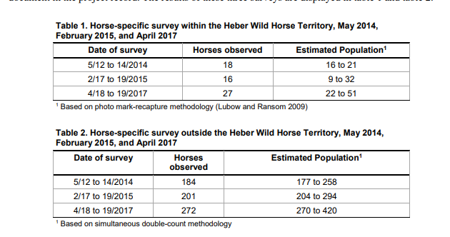
Wild horse and burro territory means lands of the National Forest System which are identified by the Chief, Forest Service, as lands which were territorial habitat of wild free-roaming horses and/or burros at the time of the passage of the Act.

Source 36 CFR § 222.60

§ 222.60 Authority and definitions.
(a) Authority. The Chief, Forest Service, shall protect, manage, and control wild free-roaming horses and burros on lands of the National Forest System and shall maintain vigilance for the welfare of wild free-roaming horses and burros that wander or migrate from the National Forest System.
Wild free-roaming horses and burros mean all unbranded and unclaimed horses and burros and their progeny that have used lands of the National Forest System on or after December 15, 1971, or do hereafter use these lands as all or part of their habitat

222.65 Protection of wild free-roaming horses and burros when they are upon other than the National Forest System or public lands.
Individual animals and herds of wild free-roaming horses and burros will be under the protection of the Chief, Forest Service, even though they may thereafter move to lands of other ownership or jurisdiction as a part of their annual territorial habitat pattern or for other reasons. The Chief will exercise surveillance of these animals through the use of cooperative agreements and as otherwise authorized by law and act immediately through appropriate administrative or criminal and civil judicial procedures to provide them the protective measures of the Act at any time he has cause to believe its provisions are being violated.

Wild Horse and Burro Territory – " . . . lands of the National Forest System which are identified by the Chief, Forest Service, as lands which were territorial habitat of wild free roaming horses and/or burros at the time of the passage of the Act." (36 CFR 222.60(b)(15))

Management Approaches for Wild Horse Territory: The Forest Service is required to administer wild horses in the Heber Wild Horse Territory in accordance with applicable laws and regulations, including but not limited to 36 CFR Part 222, Subpart D. The Forest Service is required to work with the public to develop a Heber Wild Horse Territory Management Plan to direct specific management actions for the Heber Wild Horse Territory.

The USFS is required to manage wild horses and burros “in a manner that is designed to achieve and maintain a thriving natural ecological balance on the public lands … [and] all management activities shall be at the minimal feasible level.” The WFHBA recognizes the importance of maintaining and protecting ranges where wild horses and burros may roam. It defines a range as, “the amount of land necessary to sustain an existing herd or herds of wild free roaming horses and burros … and which is devoted principally but not necessarily exclusively to their welfare in keeping with the multiple-use management concept for the public lands.” These legally protected areas are known as “herd areas” or “territories”. By regulation, wild horse and burro herd areas and territories are defined as, “the geographical area identified as having been used by a herd as its habitat in 1971.” However, in the process of drawing these boundaries, the USFS did not always realize or consider the seasonal migratory patterns of wild horses and burros, thus depriving the animals of critical habitat needs. To make matters worse, wild horses and burros have not even received the protections to which they are legally entitled in many of the originally designated wild horse and burro lands. Instead, the USFS has systematically created “territories” - parcels of land where it chooses to manage wild horses and burros based on factors such as convenience or lack of competition with livestock grazing or other commercial uses.

The Heber wild horse territory is said to count on 19,700 acres in the Black Canyon area southwest of Heber, Arizona and to have been established in 1974, three years after the 1971 passage of the Wild Free-Roaming Horses & Burros Act (WFHBA). The criterion for establishing the territory is the presence of any unclaimed, unbranded wild horses and burros at the passage of the WFHBA. Any interpretation of this law must take this to mean the wild horses’ and burros’ year-round habitat, not just where they were at the moment of the act’s passage in Congress. I sincerely question that this territory can justifiably be acknowledged as only 19,700 acres and the EA failed to provide any documentation that there was not a greater wild-horse-occupied habitat such as the entire Apache-Sitgreaves National Forest. Legal land surveys have been done and are available for over two-hundred years in the United States and there is no reason or excuse for the USFS EA to not provide this data to the public. To ignore or conceal this vital documentation is a violation of Federal Title 18. Title 18 (18 U.S.C. § 1001). Making false statements (18 U.S.C. § 1001) is the common name for the United States federal crime laid out in Section 1001 of Title 18 of the United States Code, which generally prohibits knowingly and willfully making false or fraudulent statements, or concealing information, in "any matter within the jurisdiction" of the federal government of the United States, even by mere denial 18 U.S. Code § 1519 - Destruction, alteration, or falsification of records in Federal investigations Current through Pub. L. 114-38. (See Public Laws for the current Congress.) US Code Per the US Department of Justice, the purpose of Section 1001 is "to protect the authorized functions of governmental departments and agencies from the perversion which might result from" concealment of material facts and from false material representations.

The EA failed to supply documentation of the total lands where wild horses occupied within the Apache Sitgreaves National Forest at the time of the passage of the Wild Horse and Burro Act. The agency therefore must review the proposed territory boundaries to verify the historic range of the wild horses of the Apache-Sitgreaves National Forest at the time the law was passed in 1971, America’s wild horses and burros as they existed in 1971 when the congressionally designated WFHBA was enacted.

ARBITRARY AND CAPRICIOUS
Absence of a rational connection between the facts found and the choice made. A clear error of judgment; an action not based upon consideration of relevant factors and so is arbitrary, capricious, an abuse of discretion or otherwise not in accordance with law or if it was taken without observance of procedure required by law. 5 USC. 706(2)(A) (1988).
When an agency makes a decision without reasonable grounds or adequate consideration of the circumstances, it is said to be arbitrary and capricious and can be invalidated by an appellate court on that ground.
To determine whether the Forest Service action is arbitrary and capricious, the court will determine whether the Forest Service "consider[ed] [all] of the relevant factors”.

Below is the map of the proposed Heber Wild Horse Territory which was not based upon consideration of relevant factors and so is arbitrary, capricious, and an abuse of discretion by the Apache Sitgreaves National Forest.
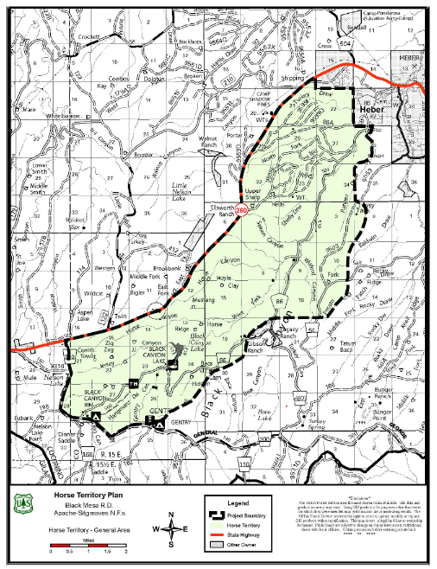
Above map suggests the Heber Wild Horse Territory is only a small portion of the actual lands designated to the wild horses by the 1971 Wild Horse and Burro ACT which states “the criteria for establishing a wild horse territory is the presence of any unclaimed, unbranded wild horses and burros at the passage of the WFHBA”.

The proposed area of the Heber Wild Horse Territory is located near the town of Heber in northeast Arizona, and is suggested but unverified as including but limited to approximately 19,700 acres within the Apache–Sitgreaves National Forest which is approximately 2,760,000 acres which run along the Mogollon Rim and the White Mountains in east-central Arizona and into the U.S. state of New Mexico.

The EA failed to acknowledge the entire legal Heber wild horse area of at least 818,651 acres of the Apache Sitgreaves National Forest as is required by the WH&B Act which states, “the criteria for establishing a wild horse territory is the presence of any unclaimed, unbranded wild horses and burros at the passage of the WFHBA”.

Per the rules of Federal Title 18, [Making false statements (18 U.S.C. § 1001)] the actual documented and verified boundary of a Heber Wild Horse Territory is a priority and an actual wild horse population and/or AML cannot be considered accurate or even worthy of significance until the USFS provides original legal documentation such as surveys with longitude and latitude of the lands occupied by wild horses at the time of the passing of the ACT of 1971. If and when actual true legal survey documentation of wild horse occupation at the passing of the Wild Horse and Burro ACT is provided to the public then at that time wild horse populations and AML can be taken into account.

The Interior Board of Land Appeals (IBLA) has defined the appropriate management level as the “optimum” number of wild horses or burros which results in a thriving natural ecological balance and avoids a deterioration of the range. (109 IBLA 119; also reference Dahl vs. Clark, supra at 592). It is usually expressed as a range of numbers. Management Area Direction Apache-Sitgreaves National Forests Land Management Plan (Admin. Change #2, August 15, 2016) 119 level. As directed in the regulations at 36 CFR 222. 61(a)(1), the goal is to maintain a thriving ecological balance within the Apache-Sitgreaves National Forests Land.

Once a legal documented boundary is set, the establishment of an appropriate management level (AML) can be proposed by formulating the range of numbers of animals that will result in a thriving natural ecological balance and avoid deterioration of the range. The higher and lower limit of the appropriate management level for horses within the Heber Wild Horse lands must be based on an in-depth analysis of population inventory, resource monitoring, and other available data.

From the EA:
“In 1974, when the Heber Wild Horse Territory was designated, it was purported there was a population of six mares and one stallion occupying the territory. Throughout the years, no actual scientific data or monitoring was documented on the population. In 1993, the population was purported to be two mares.”
[Purport definition: to have the often-specious appearance of being, intending, or claiming (something implied or inferred)]
[Specious definition: having a false look of truth or genuineness, having deceptive attraction or allure.]

Obviously, since the USFS admits “Throughout the years, no actual scientific data or monitoring was documented on the population.” then the correct estimate of the Heber wild horses within their legal Apache-Sitgreaves National Forest range as of 2017 was within the legitimate span of at least 270 to 420 wild Heber horses. That range span, then is the only scientific data that can be used to determine the required appropriate management level (AML).

A thriving natural ecological balance avoiding deterioration of the Apache-Sitgreaves National Forest lands must also include the usage and needs of wildlife as well as domestic livestock on these lands. Although domestic livestock are permitted to graze the public lands portions of the Heber wild horse herd area they are only permitted and not designated as are the wild horses. Wild horses and burros are legally DESIGNATED on a wild horse Territory (USFS) or Herd Management Area (BLM) and livestock are only PERMITTED. Definition of the word “designated” is to “set aside for” or “assign” or “authorize”. Definition of “permit” is to “allow” or “let” or “tolerate”.

The wild horse (and wild burro) lands and resources are set aside for, and assigned and authorized for, the use of wild horses (and burros) whereas the livestock is only allowed and tolerated and let to use the public range resources. While commercial livestock grazing is permitted on public lands, it is not a requirement under the agency’s multiple use mandate as outlined in the Federal Land Policy and Management Act of 1976 (FLPMA). Public land grazing clearly is a privilege not a right, while the USFS are mandated by law to protect wild horses (and burros). “Wild free-roaming horses and burros" means all unbranded and unclaimed horses and burros on public lands of the United States.

The EA failed to complete a valid and scientific assessment including the explanation of the methods used for the assessment, of the past and current animal unit months (AUMs) for the Heber wild horse area lands including AUMs for livestock, wild horses and other wildlife. This information must be evaluated and presented to the public for review and to conceal this data is a violation of the federal Title 18.

In addition, the law provides the alternative of legal reduction of private/corporate domestic livestock grazing in the Apache-Sitgreaves National forest wild horse lands, pursuant to 3 C.F.R. 4710.3-2 and 43 C.F.R. 4710.5(a), in order to accommodate the current wild horse population level. The USFS has authority to reduce livestock grazing pursuant to 43 C.F.R. 4710.5 in order "to provide habitat for wild horses or burros."

As the district court explained in Dahl v. Clark, the test as to appropriate wild horse population levels is whether such levels will achieve and maintain a thriving, ecological balance on the public lands. Nowhere in the law or regulations is the USFS required to maintain any specific numbers of animals or to maintain populations in the numbers of animals existing at any particular time with the exception of the number of wild horses on these lands at the passage of the WFHBA.

The only law that requires the USFS to maintain populations is the 1971 Congressional law. The law must be followed and the law states, “that wild free-roaming wild horses [and burros] are to be considered in the area where presently found, as an integral part of the natural ecosystem of the public lands”. Thus, an AML established purely for any USFS administrative reasons because it was the level of the wild horse and/or burro use at a particular point in time or imagined to be an advantageous population for the USFS cannot be justified under statute.

The NEPA law requires that all relevant scientific information be provided to the American public and that the information be taken a “hard look” at by the decision makers. The National Environmental Policy Act (NEPA) requires that to ensure that environmental assessment statements reflect a careful consideration of the available science, and that areas of disagreement or uncertainty are flagged rather than being swept under the carpet.

The wild horse AML being proposed for the plan must be unbiasedly evaluated to accommodate the current and future populations that are congressionally designated to live on the Apache-Sitgreaves National Forest lands. The law states, and it is within the USFS ability to study the wild horse AML for the Heber wild horses by assessing the entire legal Apache Sitgreaves National Forest land and resources within the habitat of the Heber wild horses.

By law the USFS can and should “close appropriate areas of public lands to grazing use by all domestic livestock, if necessary, to provide habitat for wild horses; to implement herd management actions; or to protect wild horses or burros from disease, harassment, or injury”. 43 C.F.R. § 4710.5. It is the United States federal law. To ignore the laws of the United States of America is treasonous.

Designated wild horse (and burro) herd area ranges are to be devoted principally to the protection and preservation of wild horses (or burros). This means that other uses may be constrained to the extent necessary to provide fully for the wild horses’ (and wild burros’) welfare. This obviously will require reductions or closure to livestock grazing regardless of the political influence or threats or bullying by the grazing permit holders or others with a financial interest in the legal wild horse and burro land. The definition "range" means the amount of land necessary to sustain an existing herd or herds [as of the passing of the ACT of 1971] of wild free-roaming horses and burros [in 1971].

The EA failed to consider alternatives that would mitigate any need to remove any of the wild horses either temporarily or permanently and the EA failed to provide the following specific data and a complete analysis of accommodation of the present wild horse without removals; pursuant to CFR 43 C.F.R. 4710.5(a).

The EA failed to include a complete and detailed breakdown of range monitoring data for at least the past ten years, including data distinguishing wild horses from wildlife and livestock impacts and the methods the USFS used to deduce their findings; all of which must be provided to the American public in the EA. Without this the EA and any subsequent action will be in violation of the NEPA requirements and thus illegal. Keep in mind that to ignore or falsify this data is a violation of Title 18. Title 18 (18 U.S.C. § 1001). Making false statements (18 U.S.C. § 1001) is the common name for the United States federal crime laid out in Section 1001 of Title 18 of the United States Code, which generally prohibits knowingly and willfully making false or fraudulent statements, or concealing information, in "any matter within the jurisdiction" of the federal government of the United States, even by mere denial 18 U.S. Code § 1519 - Destruction, alteration, or falsification of records in Federal investigations Current through Pub. L. 114-38. (See Public Laws for the current Congress.) US Code Per the US Department of Justice, the purpose of Section 1001 is "to protect the authorized functions of governmental departments and agencies from the perversion which might result from" concealment of material facts and from false material representations.

The EA failed to include the research and monitoring data and the scientific methods used to differentiate between habitat usage of wild horses versus wildlife versus livestock. This monitoring research and its subsequent report data and summary must include all information on all methods used by the USFS to determine and differentiate between wild horse usage and wildlife usage and livestock usage of forage and water usage in at least the past ten years. Details:

- Water usage designation
- Foraging wildlife
- Wild horses
- Domestic livestock
- Forage usage designation (AUMs)
- Foraging wildlife
- Wild horses
- Domestic livestock
- Water and land usage designation for all other current or likely “multiple uses” including but not limited to:
- Mining
- Geothermal
- Solar
- Wind turbine
- Oil and Gas and Coal
- Timber
- Off-highway vehicles
- Sold/leased to outside communities or individuals or companies (not used within the Apache-Sitgreaves National Forest).

The EA failed to provide the impartially analyzed following specific information and alternatives and data and scientific methods of deduction:
The reduction or termination of livestock grazing for the next ten years instead of reduction of wild horse numbers in the Heber herd area lands of the Apache-Sitgreaves National Forest. The EA failed to include the alternative of legal reduction of private/corporate domestic livestock grazing in the HMA, pursuant to 3 C.F.R. 4710.3-2 and 43 C.F.R. 4710.5(a), in order to accommodate the current wild horse population level. The USFS authority to reduce livestock grazing pursuant to 43 C.F.R. 4710.5 in order "to provide habitat for wild horses or burros." There are no restrictions on usage of this authority as it is fully available to the USFS as an option versus the policy of commencing and then continuing a cycle of perpetual roundups and removals and sterilization procedures.

The EA failed to provide a complete, valid, and scientific assessment including the explanation of the methods used for the assessment, of the past and current animal unit months (AUMs) for the Apache-Sitgreaves National Forest Heber wild horse area lands including for livestock, wild horses and other wildlife. This assessment must be evaluated and presented to the public for review and the scientifically substantiated methods used to assemble and analyze this data. The wild horse lands and resources are set aside for, and assigned and authorized for, the use of wild horses (and burros) whereas the livestock is only allowed and tolerated and let to use the public range resources. While commercial livestock grazing is permitted on public lands, it is not a requirement under the agency’s multiple use mandate as outlined in the Federal Land Policy and Management Act of 1976 (FLPMA). Public land grazing clearly is a privilege not a right, while the USFS are mandated by law to protect wild horses (and burros).

  - The EA failed to include any genetic sampling data and analysis, if any, of the Heber wild horses done within the past twenty years and if no research was done then the reasoning behind that decision including USFS’s presumption that there was not a need for such research.

  - The EA failed to provide all environmental impacts and analysis of any proposal to make or re-affirm private/corporate domestic non-native livestock grazing as the predominant use in the Heber wild horse area including all details of research studies and methods of research and results of these studies.

  - The EA failed to include an analysis of the recreational use impacts due to lost opportunities for wild horse viewing, independent research and photography, and human need for solitude and meditation; all of which are popular public activities in this Heber wild horse area, including all details of research studies and methods of research of these studies.

  - The EA failed to provide the economic impacts of the proposed action, including lost revenues, costs for capture and short term and long term or lifetime holding of horses or capture and disposal and any sterilization procedures vs. the economic benefits to American taxpayers of reducing or eliminating taxpayer subsidized livestock grazing in this area including all details of research studies and methods of research of these studies.

  - The EA failed to provide to the public, information of any and all livestock grazing allotments including but not limited to the allotment name, number of acres, number of AUMs, number of livestock number and type (cattle/sheep/other) and grazing dates as well as a map of all the grazing allotments in the Apache-Sitgreaves National Forest and in particular the mapped portion of the proposed Heber wild horse lands.

The EA failed to provide the following (text box) study (previously provided to you) be included along with the USFS’ rationalization to continue to trumpet the leasing of public lands as an economical feasible and profitable-to-the-American-public plan when, as shown in the below study, the livestock grazing “Cost Taxpayers $1 Billion Over Past Decade”.

January 28, 2015
Contacts: | Randi Spivak, (310) 779-4894, rspivak@biologicaldiversity.org  Christine Glaser, (312) 613-2164 or cglaser1812@gmail.com  Chuck Romaniello, chuckromaniello1945@gmail.com
Study: Livestock Grazing on Public Lands Cost Taxpayers $1 Billion Over Past Decade
WASHINGTON— A new analysis finds U.S. taxpayers have lost more than $1 billion over the past decade on a program that allows cows and sheep to graze on public land. Last year alone taxpayers lost $125 million in grazing subsidies on federal land. Had the federal government charged fees similar to grazing rates on non-irrigated private land, the program would have made $261 million a year on average rather than operate at a staggering loss, the analysis finds.
The study, Costs and Consequences: The Real Price of Livestock Grazing on America’s Public Lands, comes as the Obama administration prepares Friday to announce grazing fees for the upcoming year on 229 million acres of publicly owned land, most of it in the West. The report was prepared by economists on behalf of the Center for Biological Diversity.
“Public lands grazing has been a billion-dollar boondoggle over the past decade and hasn’t come close to paying for itself,” said Randi Spivak with the Center for Biological Diversity. “Livestock owners pay less to graze their animals on publicly owned land in 2014 than they did in 1981. Today the monthly cost of allowing a cow and calf to graze on federal lands is about the equivalent of a can of dog food. This damaging and expensive grazing program has been broken for years and needs to be fixed. Taxpayers, and the land we all own, deserve better.”
The federal subsidy of the grazing program goes beyond the direct costs and fees. There are vast indirect costs to grazing on federal lands, including the government killing of native carnivores perceived as threats to livestock, wildfire suppression caused by invasive cheat grass facilitated by cattle grazing, and expenditure of U.S. Fish and Wildlife Service funds from protecting other species threatened by livestock grazing. “The full cost of the federal grazing program is long overdue for a complete analysis,” the study said.
https://www.biologicaldiversity.org/news/press_releases/2015/grazing-01-28-2015.html

The EA failed to provide to the public scientifically supportable and defensible research, reports, and methods the USFS used to obtain the data for the past fifty years (since the passing of the Wild Horse and Burro Act) for the Apache-Sitgreaves National Forest including the following:
*Forage production
*Carrying capacity
*Acres allocated per Animal Unit Month
*Current and historical grazing allocations for livestock
*Temporary or extended grazing permits issued in the last 10 years
*Total available water sources in the area
*How many water sources have been fenced and why
*Miles of fencing in the area and purpose of this fencing, including detailed map
*Estimated total big game species populations in the area; list of each major species and estimated current population of each species the USFS has taken into consideration for habitat in conjunction with the Fish and Wildlife Service.
*How the USFS distinguishes wild horse use from other rangeland users and methods and results of these studies.

The NEPA law requires that all relevant scientific information be provided to the American public and that that information be taken a “hard look” at by the decision makers. The National Environmental Policy Act (NEPA) requires that to ensure that environmental assessment statements reflect a careful consideration of the available science, and that areas of disagreement or uncertainty are flagged rather than being swept under the carpet.

The EA failed to include scientifically supportable, credible, and defensible annual populations of the wild horses for the past 50 years (since the passing of the Wild Free-Roaming Horse and Burro Act. This scientific data must include but not be limited to both aerial and on the ground investigation including raw data and reports and photos and video and the names and affiliation (member of the public or USFS employee or other) of those involved with the investigations.

Below is an example of the kind of census maps (showing location of wild horses during census taking) that the EA failed to provide to the public.
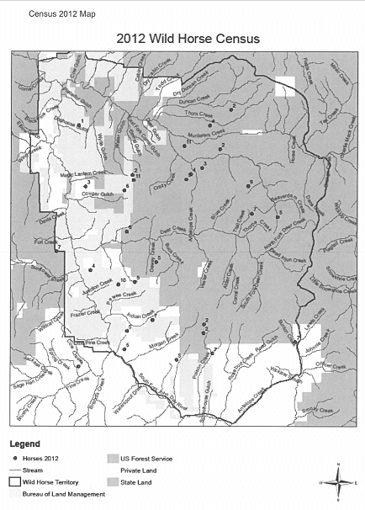

The EA failed to provide the proposed designation of the Heber wild horse area AML and scientifically supported research to determine the optimum number of wild horses that would maintain the range in a thriving natural ecological balance. The EA failed to provide evidence that the USFS have engaged in current range assessments adequate to allow the USFS to conclude that ONLY by lowering the current wild horse AML and/or removing any proposed number of wild Horses from the Heber wild horse herd would achieve that optimum number and return and maintain the range to its natural ecological balance.

BLM NEPA documents give the impression that wild horses have an exclusively negative impact on the health of the range. However, literature from wildlife ecologists suggests the opposite may be true. A healthy, free-roaming wild horse population serves to fertilize soils, suppress catastrophic wildfires, and contribute to overall ecological stability.14 Therefore, BLM’s analysis must include a discussion regarding the positive impact of wild horses. When given sufficient habitat to roam, there are many ways that wild horses actually support ecosystems on public land.15 Wild horses help spread plant seeds over large areas where they roam. They do not decompose the vegetation they ingest as thoroughly as ruminant grazers, such as cattle or sheep, which allows the seeds of many plant species to pass through their digestive tract intact into the soil that the wild horses fertilize by their droppings. 16 Additionally, other animals depend on horses to make certain resources, such as water, available. For example, in the winter horses are able to break through the ice to expose water to a variety of species.17 Wild horses also reduce dry, parched and flammable vegetation, and thus can prevent catastrophic wildfires that are on the increase. Further, their ability to build more moisture-retaining soils makes them very important in this respect, since soil moisture dampens out incipient fires and makes the air coating the earth also more moist.18 Wild horses and burros are well adapted to their habitats and fill a significant niche within the North American ecosystem.19 BLM’s NEPA analysis of wild horse management in the Pine Nut Mountains must consider the ecological impacts of this action, including the beneficial ecological role of wild horses. Because BLM has repeatedly failed to disclose to the public information about the positive ecosystem benefits of wild horses on the range, BLM must provide a comprehensive analysis of the environmental impacts of grazing by cows and sheep. Top of Form
While documentation is not the end of the NEPA process, it is important that a reasonably good job of communicating the purpose and need of the project; the values used to develop and compare alternatives; the results of [accurate] analysis for direct, indirect impacts, and cumulative impacts; and mitigation as required by relevant regulation. It provides [accurate] evidence to the public and participating agencies [showing] a commitment to, and satisfaction of the NEPA requirements. Environmental documentation must communicate clearly [and accurately] the results of project analysis and the subsequent decisions. http://www.environment.fhwa.dot.gov/projdev/qaimpact.asp
The EA failed to give a detailed explanation of any inequitable allocation of resources in the Apache Sitgreaves Heber wild horse area to livestock grazing and the agency’s response to the fact that wild horse removals can cost-effectively be avoided by accommodating the current wild horse population levels through or complete downward adjustments to livestock grazing pursuant to 43 CFR 4710.5, which states, "If necessary to provide habitat for wild horses or burros, to implement herd management actions, or to protect wild horses or burros, to implement herd management actions, or to protect wild horses or burros from disease, harassment or injury, the authorized officer may close appropriate areas of the public lands to grazing use by all or a particular kind of livestock....Closure may be temporary or permanent."

The cost to tax-paying Americans of grazing domestic livestock on public lands is heavily researched with the following results:
“The Government Accountability Office (GAO) has reported the federal government spends at least $144 million each year managing private livestock grazing on federal public lands, but collects only $21 million in grazing fees—for a net loss of at least $123 million per year”.
http://www.taxpayer.net/user_uploads/file/factsheet_Grazing_Fiscal_Costs(3).pdf

In addition to the concerns expressed above, the EA failed to address and analyze the following impacts and concerns:

- A full disclosure of whether any member of the USFS management team for this project has any personal or financial interest (including but not limited to any interest in any grazing allotment within the Apache Sitgreaves National Forest) in the proposed plan. It is imperative that the USFS ensure that there are no conflicts of interest and that it has established high scientific standards before spending hundreds of thousands of taxpayer dollars on this proposal. (see regulatory captured agency)

“Regulatory Capture” is a form of political corruption that occurs when a regulatory agency, created to act in the public interest, instead advances the commercial or special concerns of interest groups that dominate the industry or sector it is charged with regulating. Regulatory capture is a form of government failure; it creates an opening for firms to behave in ways injurious to the public. The agencies are called "captured agencies".

Government agencies tend to elevate social, cultural, and political concerns over the natural environment. Congress designed NEPA to achieve environmentally positive results through a compulsory procedural mechanism, NEPA simply prohibits uninformed, not unwise, agency decisions (Nowlin & Henry, 2008). The EA process is required to weigh the benefits versus the wild horse financial costs of the project verses the “no action” alternative.

The EA failed to explain in detail the census numbers and methods of gathering the census documentation (titles of persons gathering data and dates and where horses were located and other data such as photos) over the past 50 years (since 1971).

In addition, the EA failed to provide an explanation and documentation of the scoping document that states that a census was completed in 1974 and only found seven wild horses on the forest lands.

The EA failed to provide a copy and detailed explanation of the following FS document (# 11) where it clearly states that (“White Mt Apache Horses”) wild horses were captured and sold at public auction. This explanation must include the proof that the horses captured and sold to auction were from the nearby reservation as is stated in this document and not part of the Heber Wild Horses who were protected by the WH&B ACT. Who made that decision and was that person punished for this illegal activity and what proof does the USFS have that the captured and sold horses were actually from the reservation? If these horses truly were “reservation horses” that were found to have wondered onto public lands then why were they not returned to the reservation authorities? Who had the authority to sell them to auction? It appears that these horses were very probably part of the legally designated Wild and legally protected Heber horses that by law were to be protected. It also appears that the capture and selling to auction of these horses was the reason that the official census of 1974 showed only seven horses.

The EA failed to provide the legitimacy of this capture and removal and therefore the truthfulness that the actual population of the Heber wild horses in 1974 was only seven. Environmental Policy Act (NEPA) requires that to ensure that environmental assessment statements reflect a careful consideration of the available science, and that areas of disagreement or uncertainty are flagged rather than being swept under the carpet. Title 18 (18 U.S.C. § 1001). Making false statements (18 U.S.C. § 1001) is the common name for the United States federal crime laid out in Section 1001 of Title 18 of the United States Code, which generally prohibits knowingly and willfully making false or fraudulent statements, or concealing information, in "any matter within the jurisdiction".

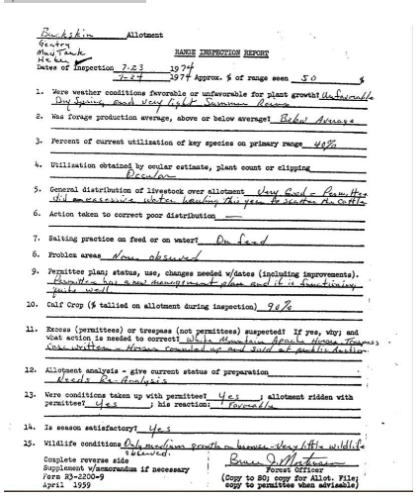

I provide here further documentation of USFS illegal activities on the Apache-Sitgreaves National Forest Heber wild horse lands:
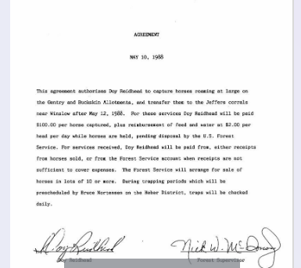

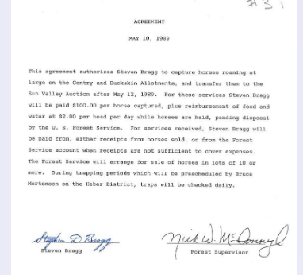

The EA failed to examine and include analysis of the rangeland to ensure adequate forage and water resources available for all wildlife in the proposal area.
“Proper management plans “require a strong information base,” including data on the:
(a) biological potential for the area;
(b) numbers and combinations of herbivorous animals that can be safety carried on the area;
(c) kinds and amounts of forage and habitat required by all the animals;
(d) effects of herbivores on vegetation and each other;
(e) effects on soil and hydrology; and
(f) an understanding of the economic and social values associated with the area.” (NAS 1982)

In addition, the EA failed to include:
- All historical, current and future ten-year range monitoring and plans.
- An updated and scientifically supported and defensible census of all on the range wildlife, including wild horses, born and died in the past ten years and age at death and cause of death. Approximation numbers are acceptable if scientifically supportable.
- A no action alternative – with detailed scientific review of this alternative – both pro and con.
- A discussion and a detailed map regarding and including all current and proposed fencing, gates and cattle guards within the proposal area and reason for the fencing.
- A scientific discussion regarding how fencing and cattle guards and gates influence the wildlife, including wild horses and burros, from accessing any water sources and forage sources and how these fences effect wildlife, including wild horses, genetic health and variability.
- The EA failed to include a section discussing those alternatives that were considered but rejected with a detailed explanation of the reasons for their elimination and not just respond “outside the scope”. Nothing is “outside the scope” if it affects the public lands and the NEPA law requires that all relevant scientific information be provided to the American public.

The NEPA law requires that all relevant scientific information be provided to the American public and that that information be taken a “hard look” at by the decision makers. The National Environmental Policy Act (NEPA) requires that to ensure that environmental assessment statements reflect a careful consideration of the available science, and that areas of disagreement or uncertainty are flagged rather than being swept under the carpet.

An EA failed to include a complete and detailed breakdown of range monitoring data for at least the past ten years, including data distinguishing wildlife and livestock impacts; all of which must be provided to the American public. Without this the EA and any subsequent action will be in violation of the NEPA requirements and thus illegal. Keep in mind that to ignore or falsify this data is a violation of Title 18. Title 18 (18 U.S.C. § 1001). Making false statements (18 U.S.C. § 1001) is the common name for the United States federal crime laid out in Section 1001 of Title 18 of the United States Code, which generally prohibits knowingly and willfully making false or fraudulent statements, or concealing information, in "any matter within the jurisdiction" of the federal government of the United States, even by mere denial 18 U.S. Code § 1519 - Destruction, alteration, or falsification of records in Federal investigations Current through Pub. L. 114-38. (See Public Laws for the current Congress.) US Code Per the US Department of Justice, the purpose of Section 1001 is "to protect the authorized functions of governmental departments and agencies from the perversion which might result from" concealment of material facts and from false material representations.

An EA failed to include the research and monitoring data and the scientific methods used to differentiate between (1) wild horses versus (2) all other wildlife versus (3) livestock. This monitoring research and its subsequent report data and summary must include all information on all methods used by the USFS to determine and differentiate between wild horse usage and wildlife usage and livestock usage of forage and water usage for at least the past ten years (although the last 50 years (date of the Wild Horse and Burro ACT).

Although there are numerous listed reasons that a valid grazing permit or preference can be reduced, cancelled or suspended by the federal agencies, those reasons can be placed in the category of either (1) the permittee's violation of the terms or conditions contained in his grazing permit, federal regulation or State or federal law or (2) damage or destruction to the forage resources. The EA failed to provide substantiated data including all damage or destruction to the forage resources, and methods to gather and prove the data, on all lands within the EA proposal be provided to the public.

The EA failed to provide the following alternatives be impartially analyzed in the upcoming EA:

- The EA failed to include substantiated data on any proposed reduction or termination of livestock grazing for the next ten to twenty years. Wild horses and burros are legally DESIGNATED on the Herd Management Areas and Herd Areas (HMA & HA) and livestock are only PERMITTED. Definition of the word “designated” is to “set aside for” or “assign” or “authorize”. Definition of “permit” is to “allow” or “let” or “tolerate”. The wild horse and wild burro legally designated lands and resources are set aside for, and assigned and authorized for, the use of wild horses and burros whereas the livestock is only allowed and tolerated and let to use the public range resources.

- While commercial livestock grazing is permitted on public lands, it is not a requirement under the agency’s multiple use mandate as outlined in the Federal Land Policy and Management Act of 1976 (FLPMA). Public land grazing clearly is a privilege not a right, while the USFS is mandated by law to protect wild horses and burros. The EA failed to provide a complete, valid and scientifically supportable assessment including the explanation of the methods used for the assessment, of the past and current and future planned animal unit months (AUMs) for the lands designated in the EA including allotments for livestock, wild horses and other wildlife be evaluated and presented to the public for review.

Unfortunately, current policies virtually give away access to valuable grazing grounds for pennies on the dollar. As the gap between market rates and the federal rate has gotten worse over time, taxpayers have been losing out on increasingly more revenue. The Federal grazing fee for 2021 will be $1.35 per animal unit month (AUM) for public lands administered by the Bureau of Land Management and $1.35 per head month (HM) for lands managed by the USDA Forest Service. Here we are again with the giant spidering tentacles of the cattle mafia trying to strongarm, coerce, and purge public lands from all of us for their own greed.

The EA failed to inform the public via the EA of the average AUM livestock grazing payment costs in the private segment of livestock grazing verses the current public lands payment. For your convenience, here is the data:
What is the average paid per month per Animal Unit (AUM) in 2018 in the REAL world?
Lowest is $9.50 (Nevada) to highest $46.00 (Nebraska)
The USFS charges $1.35 (2020) !!!
Per the Oregon Annual Stats Bulletin page 15
https://www.nass.usda.gov/.../Annual.../2019/OR_ANN_2019.pdf

Costs to administer the grazing fee program exceed the money collected, resulting in taxpayer subsidies of about $100 million per year. More than 200 million acres of federal public lands in the western United States are used for grazing cattle and sheep. Most grazing programs ― on grasslands, deserts, sagebrush steppe and national forests ― are administered by the Bureau of Land Management and the U.S. Forest Service. Less than 3 percent of the nation’s 800,000 livestock operators and cattle producers use federal grazing programs.

Federal grazing policy caters to only a fraction of the livestock industry. The vast indirect costs of grazing on federal lands include the killing of important native predators such as wolves and bears in addition to the livestock’s damage to soil and rivers. It’s a bad deal for wildlife, public lands and American taxpayers. The full cost of the federal grazing program is well overdue for a complete analysis. At the end of the day, the use of federal lands by any interest—rancher, miner, driller, should not come at the expense of federal taxpayers. No one wins when we give away the store.

The EA failed to give a detailed explanation of any inequitable allocation of resources in these lands being reviewed in the EA including livestock grazing. The cost to tax-paying Americans of grazing domestic livestock on public lands is heavily researched with the following results:
“The Government Accountability Office (GAO) has reported the federal government spends at least $144 million each year managing private livestock grazing on federal public lands but collects only $21 million in grazing fees—for a net loss of at least $123 million per year”.

Considering that almost all rangelands under USFS and BLM management fail to meet minimum ecological health standards primarily due to livestock grazing, the assumption that livestock grazing can “restore” these lands is more than highly problematic. Most ecologists would tell you that eliminating livestock production on these federal lands would do far more for their ecological health than any benefit from livestock grazing designation. Another unquestioned assumption is the premise that livestock is a “tool” to improve the ecological health of the land. A hammer is a tool as well, but if it is used to swat mosquitoes on your face, your face will suffer.

I am infuriated by the USFS proposal to conduct any surgical or chemical sterilization (including temporary and permanent) experiments on any captured wild mares or stallions or foals. These procedures are both unjustified and contrary to the core intent of the Wild Free-Roaming Horses and Burros Act (WFHBA) which clearly states, “It is the policy of Congress that [they] shall be protected from capture, branding, harassment, or death.” The key words of this law are “protected from” and THAT is the job the USFS employees are required to do. Therefore, I require the USFS cease and bring to a halt any current or future plans or attempts to proceed with these unnecessary and politically driven and dangerous and possibly deadly procedures. – The United States District Court, D. Columbia ROSEMARY M. COLLYER, District Judge. stated: “It would be anomalous to infer that by authorizing the custodian of the wild free roaming horses and burros to "manage" them, Congress intended to permit the animals’ custodian to subvert the primary policy of the statute by harassing and killing and capturing and removing from the wild the very animals that Congress sought to protect from being killed and harassed and captured and removed from the wild.” safety

The EA failed to include the following research, reports and facts to the public as is required by NEPA to take a hard look. The National Environmental Policy Act (NEPA) requires that to ensure that environmental assessment statements reflect a careful consideration of the available science, and that areas of disagreement or uncertainty are flagged rather than being swept under the carpet.

The EA failed to include the “risk of substantial and irreversible environmental consequences which may result” and “the extent to which the project might impose uncertain or unknown risks” and include all “possible potential for permanent and irreparable harm, to the individual horses as well as the entire herd and the habitat itself”. The scientific evidence makes clear that the USFS is engaged in a concerted effort to manage wild horses and burros to extinction. To reverse this, the USFS must again embrace the intent of the WFHBA, stop favoring the interests of livestock producers over the interests of wild horses and burros. The USFS is failing to fulfill its legal mandate to protect America’s wild horses and burros, as well as the public lands on which these animals reside. Instead, the agency is engaging in scientifically, ecologically, economically, and ethically questionable practices.

The NEPA law states that the public has a right to know. Since environmental conditions change over time, the National Environmental Policy Act requires environmental analysis of and public comment on plans for current and future wild horse captures or any and all actions that may occur under the auspices of this proposal. I am one of thousands of concerned American citizens who want and expect an opportunity to comment on the environmental impacts of all roundups and trapping and removals and contraception applications and sterilization procedures plans that will occur on our public lands over the future years and the EA proposal must be factually inclusive of the plans for future years. This data is required for the informed American public and the USFS decision makers to make their judgment based on all available science and thus must be available as part of the administrative record for this decision showing that all relevant scientific facts have been completely considered. I offer you this statement: The Honorable U.S. District Judge Beryl A. Howell stated in her 23-page opinion that the agency “may not simply remain studiously ignorant of material scientific evidence …”

To ignore or conceal relevant facts about the wild horse lands is a violation of the NEPA law. As required by NEPA to bring federal action in line with Congress' goals and to foster environmentally informed decision-making by federal agencies, NEPA “establishes ‘action-forcing’ procedures that require agencies to take a ‘hard look’ at environmental consequences.” Metcalf v. Daley, 214 F.3d 1135, 1141 (9th Cir.2000) (quoting Robertson v. Methow Valley Citizens Council, 490 U.S. 332, 348, 109 S.Ct. 1835, 104 L.Ed.2d 351 (1989)). The NEPA law states that the public has a right to know.

The EA failed in many respects to provide the public with an adequate explanation of the future of these wild horses in the future. The USFS cannot just use the Heber wild horse management plan as a “blank check” to use as it wishes regarding these wild animals in future years. This “blank check” syndrome provides the USFS with unrestricted authority – just the way the USFS likes it – but this is illegal. The federal government has a legal responsibility to protect our natural heritage and the federal government has a legal responsibility to follow the Congressional law [1971 Wild Horse and Burro Act] that clearly states, “All management activities shall be at the minimal feasible level”. Our great country is based on and requires our government to follow the law and to set an example for all American citizens and without this … our great country is condemned to destruction.

Please know that that the American citizens realize that the USFS EA proposed capture/removal/sterilization of wild horses is nothing more than a strategic and deadly action in the ongoing management of the American people’s wild horse for EXTINCTION. The evidence makes it clear that the USFS is engaged in a concerted effort to manage the Heber wild horses to extinction.

A program such as the proposed EA plan is biased against the very animals it is designed to protect and threatens the Heber wild horses both individually and as a wild horse herd. Our National Wild Horse and Burro Program and related federal land management policies are so flawed that the long-term survival of these animals is in serious jeopardy, as is the health of the public lands on which they reside. The US Forest Service (USFS) in the US Department of Agriculture, have lost sight of their legal mandate to “protect” wild horses.

It became obvious to me when reviewing the current wild horse management document, that clearly the agency officials have focused almost exclusively on accommodating livestock grazing and other commercial uses at the expense of the welfare of wild horses. The USFS must comply with laws and regulations governing the management of public lands and the protection of America’s wild horses and burros. The document obviously strongly favors private livestock to the detriment of wild horses as well as the health of the land.

The proposed “Appropriate Management Levels” (“AML” - the number of wild horses deemed suitable by the USFS to live on the range) are prejudiced in favor of usage for privately owned livestock usage. The proposed strategy for the future management of the Heber wild horse herd is scientifically reckless, economically unsound and ethically unjustifiable.

“…[W] ild free-roaming horses and burros are living symbols of the historic and pioneer spirit of the West … It is the policy of Congress that [they] shall be protected from capture, branding, harassment, or death’ and to accomplish this they are to be considered in the area where presently found, as an integral part of the natural system of the public lands.”

These are the words the US Congress used to describe America’s wild horses and burros in the preamble of the Wild Free-Roaming Horses and Burros Act of 1971 (WFHBA). Although the WFHBA was supported overwhelmingly by the public and passed unanimously by Congress, these majestic animals have not always been regarded so highly. Earlier in the 20th century, hundreds of thousands of wild horses and burros were slaughtered to make room for livestock on the Western frontier. This “livestock vs. wild horse and burro” battle continues into the present. While the current rate of removal of these wild animals is a far cry from the wholesale and grisly slaughter that occurred during the early 20th century, the welfare and continued survival of America’s wild horses and burros are threatened by a government program that systematically favors the interests of private ranching and livestock over those of wild horses and burros. The National Wild Horse and Burro Program and broader public land management policies are fundamentally flawed and not in the best interest of the American people, the public lands, or the very animals the agency is charged with protecting. The preferential treatment of livestock grazing, and other commercial uses has resulted in the degradation of public lands, as well as massive and unjustifiable removals of wild horses and burros from their legal home ranges.

The USFS is required to manage wild horses and burros “in a manner that is designed to achieve and maintain a thriving natural ecological balance on the public lands … [and] all management activities shall be at the minimal feasible level.” The WFHBA recognizes the importance of maintaining and protecting ranges where wild horses and burros may roam. It defines a range as, “the amount of land necessary to sustain an existing herd or herds of wild free roaming horses and burros … and which is devoted principally but not necessarily exclusively to their welfare in keeping with the multiple-use management concept for the public lands.”

In 2006, the BLM managed wild horses and burros in only 199 HMAs, encompassing 34,407,035 acres. Since passage of the WFHBA, wild horses and burros have been totally removed from nearly 20 million acres, more than half of which were under the federal jurisdiction. This acreage does not even include the thousands of acres of USFS lands, where wild horses and burros have lost additional habitat. The BLM and USFS routinely rounds-up and permanently removes wild horses and burros who have wandered outside of HMA and USFS boundaries, despite the fact that the animals may actually be within their historic and legally protected range.

In 1976, Congress passed the Federal Land Policy and Management Act (FLPMA), which amended the WFHBA and affected how the BLM and USFS administers public lands under its jurisdiction. The FLPMA requires the development of comprehensive land use plans, which reflect the principles of sustained yield and “multiple-use.” Multiple use mandates that public lands be managed “so that they are utilized in the combination that will best meet the present and future needs of the American people.” The federal government is not required to allow all uses on all lands, nor is it mandated to preserve an existing use or level of a particular use based upon economic considerations. The USFS should not permit livestock use or the level of use in areas where its ecological and economic costs outweigh its benefits. In doing so, the agency fails to account for “the long-term needs of future generations for renewable and nonrenewable resources, including, but not limited to, recreation, watershed, wildlife and fish, and natural scenic, scientific and historical values” as is mandated by law.

Nothing could be a better illustration of the agency’s abdication of its responsibility than how it has managed wild horse and burros over the years. Today, livestock grazing is allowed in virtually all wild horse and burro herd and territory lands, regardless of adverse impacts on the well-being of the animals. Moreover, the USFS has totally removed numerous herds of wild horses and burros and has set population targets so low in other herds that the survival of these animals is seriously threatened—all to accommodate private livestock and other commercial interests. As a result, the USFS’s “multiple-use” mandate has come to mean multiple livestock use. The Public Rangelands Improvement Act (PRIA), a 1978 amendment to the WFHBA, requires the USFS to maintain a current inventory of wild horses and burros and to “determine appropriate management levels (AMLs),” i.e., the number of wild horses and burros which the range can sustain. In direct contravention of PRIA, the USFS has failed to maintain current inventories of wild horses and burros.

Furthermore, though AMLs were not meant to be static, but rather to fluctuate based upon various factors (e.g., range condition or range use), the USFS rarely adjusts AMLs. Moreover, the USFS relies on population targets set in outdated land use plans—the development of which was dominated by local livestock interests in the first place. In addition to its flawed “population targets,” the USFS’s wild horse and burro population “guesstimates” have proven incorrect repeatedly. A cursory review of yearly gather schedules indicates that the numbers of animals the USFS often plans to remove is significantly greater than the numbers the agency actually removes. While there may be many reasons for such discrepancies, the most troubling is the fact that the agency has for years managed wild horses and burros without reliable census data. A significant amount of information provided to the public by the USFS is replete with ambiguities and contradictions. The lack of consistent and reliable data is just one example of the host of problems inherent in the program.

Although the WFHBA states that wild horse and burro ranges are to be managed “principally but not exclusively” for wild horses and burros, these amendments and the USFS’s close ties to the ranching and livestock industries have resulted in the unwarranted removal of wild horses and burros from areas where they are legally protected and where they must be given legal preference over domestic livestock.

Further, wild horses and burros’ free-roaming status has been seriously compromised by the construction of fences and gates crisscrossing public lands often at taxpayer expense. These fences create pastures for rancher convenience, but also effectively impede the movement of wild horses and burros, thereby preventing them from accessing habitat to which they are entitled, and which contain resources required for their very survival. However, rather than resolving the problem by removing fences that fragment wild horse and burro legal lands, the agency officials simply elect to manage wild horses and burros within the boundaries of fenced livestock grazing allotments. The Heber wild horse area of the Apache-Sitgreaves National Forest are separated into livestock grazing allotments by fencing barriers in order to control domestic livestock movements. However, these fences also restrict wild horse movements as well as other wildlife; and this is contrary to the “free roaming” lifestyle mandate for wild horses and burros under the Wild Free Roaming Horses and Burros Act (WFRHBA,1971).

The scientific evidence makes clear that the USFS is engaged in a concerted effort to manage wild horses and burros to extinction. To reverse this, the USFS must again embrace the intent of the WFHBA, stop favoring the interests of livestock producers over the interests of wild horses and burros, and allow the precautionary principle to govern its management actions. Former New Jersey Governor and then-Environmental Protection Agency Administrator Christine Todd Whitman eloquently described the need for such an approach in a speech to the National Academy of Sciences in 2001 when she stated, “policymakers need to take a precautionary approach to environmental protection …. We must acknowledge that uncertainty is inherent in managing natural resources, recognize it is usually easier to prevent environmental damage than to repair it later, and shift the burden of proof away from those advocating protection toward those proposing an action that may be harmful.”

The USFS has demonstrated repeatedly and once again demonstrates in the current Heber scoping document, that it has neither the interest nor the expertise to responsibly protect and manage the wild animals in its charge. Particularly alarming is the fact that the USFS continues to rely on outdated and deficient documents to support management actions. It also routinely fails to rigorously explore a range of reasonable alternatives to various agency actions, including, but not limited to:
• Assignment of AMLs based on current and past scientifically supported (written survey and photos and documentation) inventorying and monitoring of rangeland health in a non-livestock based “principally” and multi-use (not livestock use) management plan with a scientifically substantiated genetic viability consideration as a primary concern.
• Adjustment of livestock permits as provided for in existing regulations.
• Closure of wild horse and burro ranges to livestock grazing; The United States of America Cod of Federal Regulations states: § 4710.5 Closure to livestock grazing.
- If necessary to provide habitat for wild horses or burros, to implement herd management actions, or to protect wild horses or burros, to implement herd management actions, or to protect wild horses or burros from disease, harassment or injury, the authorized officer may close appropriate areas of the public lands to grazing use by all or a particular kind of livestock.
• Transfer of wild horses and burros to areas where they previously existed at the passage of the WH&B ACT in 1971 but from which they were completely removed or “zeroed out”.

• Protection of predators in wild horse area lands to allow natural controls to operate as provided for in the WFHBA.

All too often, the USFS ignores these alternatives, claiming that specific actions, such as round-ups, are necessary to conform with existing land use plans—many of which are dated and were developed without sufficient public involvement.

The EA failed to adequately assess the proposed sterilization plans and objective scientific evaluation and a full consideration of the impacts of capture and sterilization and “processing” will have on the wild horses – both individually and as total herds. The EA failed to assess and provide this assessment and details of the plan. NEPA requires that a “hard look” must be done on all available and relevant scientific information. The National Environmental Policy Act (NEPA) requires that to ensure that environmental assessment statements reflect a careful consideration of the available science, and that areas of disagreement or uncertainty are flagged rather than being swept under the carpet. Thus, the public and the decision makers must resist the urgings of agencies that low-probability risks of very serious harms be dismissed from consideration or that the risk is evaluated only under the agency’s favored theoretical model without considering the possibility that other credible models might be correct.

As required by NEPA to bring federal action in line with Congress' goals and to foster environmentally informed decision-making by federal agencies, NEPA “establishes ‘action-forcing’ procedures that require agencies to take a ‘hard look’ at environmental consequences.” Metcalf v. Daley, 214 F.3d 1135, 1141 (9th Cir.2000) (quoting Robertson v. Methow Valley Citizens Council, 490 U.S. 332, 348, 109 S.Ct. 1835, 104 L.Ed.2d 351 (1989)). To ignore or conceal this from interested parties is a violation of the NEPA law.

The EA failed to include the EPA information about the two pesticide immunocontraception chemicals proposed in the USFS document as follows that I provide here: 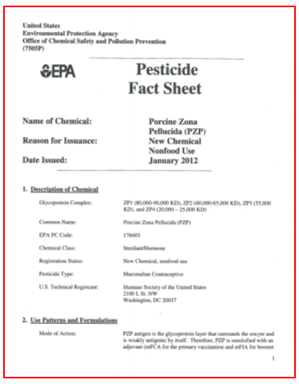

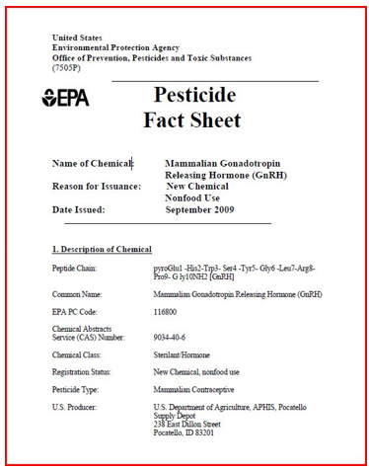

The EA concealed from the public the fact that both PZP and GonaCon are listed by the EPA as “pesticides”.

In addition, the USFS concealed from the public the definition of a vaccine vs a pesticide as provided here:
What is a “pesticide” versus a “vaccine”?
By definition, a pesticide is a product designed to destroy organisms deemed to be undesirable or noxious.
DEFINITION OF PESTICIDE:
Chemical or biological substance designed to kill or retard the growth of pests that damage or interfere with the growth or crops, shrubs, trees, timber and other vegetation desired by humans. Practically all chemical pesticides, however, are poisons and pose long-term danger to the environment and humans through their persistence in nature and body tissue. Most of the pesticides are non-specific and may kill life forms that are harmless or useful.

Definition of Vaccine:
Any preparation used as a preventive inoculation to confer immunity against a specific disease usually employing an innocuous form of the disease agent, as killed or weakened bacteria or viruses, to stimulate antibody production.
PZP and Gona-Con are NOT vaccines … they are pesticideS.

PZP Manufacturer’s Own Research Found Markedly Depressed Estrogen Secretion
In a telling study published back in 1992, the manufacturer of Native PZP, along with colleagues, reported that ” … three consecutive years of PZP treatment may interfere with normal ovarian function as shown by markedly depressed oestrogen secretion.” [6] Thus, despite all the hype about PZP being non-hormonal, the manufacturer knew that ZonaStat-H has an adverse hormonal effect, causing significantly-lowered estrogen. Thus, PZP is an endocrine disruptor. [21] The plummeting estrogen-levels may also reflect the ovarian dystrophy and oophoritis now known to be caused by PZP. Despite personally discovering negative hormonal impacts 23 years ago, PZP’s manufacturer continued to cite misinformation regarding the product’s mode-of-action and endocrine-disruptor side-effects.
PZP Causes Ovarian Cysts
In their 2010 meta-analysis, Gray & Cameron cited a number of studies that found ” … alterations to ovarian function, oophoritis, and cyst formation with PZP treatment (Mahi-Brown et al.1988, Sehgal et al. 1989, Rhim et al. 1992, Stoops et al. 2006, Curtis et al. 2007).” [4] These findings support those of Kaur & Prabha while introducing yet another adverse effect: ovarian cysts. Gray & Cameron’s review also noted that increased irritability, aggression, and masculine behavior had been observed in females following PZP-treatment.
PZP -- Endocrine Disruptor -- Elevated Testosterone -- Masculinizing Effects
Recall that PZP has endocrine-disrupting effects that result in lowered estrogen. Per the observed masculine behavior of treated mares, PZP seems to have a testosterone-elevating effect too. A deficit of estrogen alone would not necessarily manifest in the masculinization of treated females, but an excess of testosterone would. So, it appears that PZP disrupts at least two hormones: estrogen — by substantially lowering it — and testosterone — by substantially elevating it. Adverse effect: Unnatural behavior.
PZP -- Ovarian Cysts -- Elevated Testosterone -- Masculinizing Effects
As discussed above, PZP correlates with abnormal masculine behavior on the part of treated females, a side-effect likely due to elevated testosterone. But in addition to the endocrine-disruption caused by PZP, there could be a second way for testosterone levels to become elevated. Recall that PZP causes ovarian cysts.
An Internet search on “ovarian cysts and testosterone” yielded results for polycystic ovary syndrome (PCOS) in women. Interestingly, one of the symptoms of PCOS is high testosterone levels. The connection between ovarian cysts and elevated testosterone suggests that the ovarian cysts caused by PZP could — either alone or in combination with PZP’s endocrine-disruptor effects — lead to high testosterone levels in treated females, as evidenced by their masculinized behavior.

Sterilizing a wild horse or burro herd is the opposite of the intent of the 1971 Wild Free-roaming Horse and Burro Act (WFRHBA) and the federal agency’s long repeated mantra, “Healthy herds on healthy rangelands”. How can a sterilized wildlife population be considered healthy? The proposed plan violates the National Environmental Protection Act and the WFRHBA because it fails to analyze an alternative that follows the Congressional Act that states, the wild horses and burros shall be protected from capture, branding, harassment, or death’.

The EA failed to provide to the public and obviously concealed the § 4710.5 Closure to livestock grazing alternative.

The United States of America Cod of Federal Regulations states: § 4710.5 Closure to livestock grazing.
- If necessary to provide habitat for wild horses or burros, to implement herd management actions, or to protect wild horses or burros, to implement herd management actions, or to protect wild horses or burros from disease, harassment or injury, the authorized officer may close appropriate areas of the public lands to grazing use by all or a particular kind of livestock.

America’s public lands belong to all Americans and must be managed for the broader interests of the American people and not for the narrow interests of a handful of local or corporate users who personally profit from grazing non-native livestock on those lands. I am appalled that my land is being managed as if it were a private livestock feedlot rather than the common heritage of all Americans. The federal government does not own lands in the West. These are not “state lands” and not “federal lands” and not even “government lands”. They are public lands. The American people own the public lands in the West and they are to be administered on behalf of all Americans by the national government under laws and regulations.

What can be done to address the problems associated with public lands livestock grazing? There is a simple answer: end it. Get the cows and sheep off, let the wild creatures reclaim their native habitat, and send the ranchers a bill for the cost of restoration. The EA failed to include this option which should have been considered in detail and included in the EA. The National Environmental Policy Act (NEPA) requires that to ensure that environmental assessment statements reflect a careful consideration of the available science, and that areas of disagreement or uncertainty are flagged rather than being swept under the carpet.

The EA failed to consider and admit and include in the EA, the fact that livestock ranchers want wild horses eradicated from public lands in favor of sheep and cattle grazing for their personal benefit. This grazing is for the sole purpose of fattening up the unfortunate cows and sheep that are then brutally slaughtered and finally consumed. The direct link between cattle and sheep ranching with wild horse roundups is real and will continue until we intelligent humans take responsibility for our palates and refuse to financially support the industry. Wild horse captures and removals and pesticide applications and dangerous invasive surgeries would not be deemed "necessary" if not for sheep and cattle ranchers whose meat businesses bring in the money that allows them to influence policies and politicians that are corrupt.

“For private profit” private/corporate domestic sheep and cattle ranchers and the USFS’s reluctance to remove this welfare status from managing for an ecological balance on our public lands is one obvious form of USFS’s “Regulatory Capture” status. Regulatory capture is a form of political corruption that occurs when a regulatory agency, created to act in the public interest, instead advances the commercial or special concerns of interest groups that dominate the industry or sector it is charged with regulating. Regulatory capture occurs when special interests co-opt policymakers or political bodies — regulatory agencies, in particular — to further their own ends. Regulatory capture is a form of government failure; it creates an opening for firms to behave in ways injurious to the public. The agencies are called “captured agencies”.

It is more than clear that this Arizona capture/remove/sterilization EA was written with the influential private-profit interests as the priority and not the wild horses and not the public lands and not the American people and not the ecological balance of the area. This EA document clearly shows the work of a regulatorily captured agency. Under the Taylor Grazing Act (“TGA”), 43 U.S.C. §§ 315-315r, the federal government “authorized” to issue permits for the grazing of livestock on public lands “upon the payment of reasonable fees.” 43 U.S.C. § 315b. The statute further provides, however, that “the creation of a grazing district or the issuance of a [grazing] permit . . . shall not create any right, title, interest, or estate in or to the lands.” The TGA further provides that the Secretary “is authorized, in his discretion, to . . . classify any lands within a grazing district, which are . . . more valuable or suitable for any other use” than grazing, including use by wild horses.

Wild horses and burros are legally DESIGNATED on the Herd Management Area (HMA) and livestock are only PERMITTED. Definition of the word “designated” is to “set aside for” or “assign” or “authorize”. Definition of “permit” is to “allow” or “let” or “tolerate”. The Wild Horse and Burro lands and resources are set aside for, and assigned and authorized for, the use of wild horses and burros whereas the livestock is only allowed and tolerated and let to use the public range resources. While commercial livestock grazing is permitted on public lands, it is not a requirement under the agency’s multiple use mandate as outlined in the Federal Land Policy and Management Act of 1976 (FLPMA). Public land grazing clearly is a privilege not a right, while the USFS and BLM are mandated by law to protect wild horses and burros.

The “private domestic livestock for private/corporate profit” mentality is illegal when used in conjunction with legally designated wild horse and burro publicly owned land and resources and it must be stopped. Short or long-term sustainability and reducing “the likelihood of adjustments to current active livestock permits attributable to overuse of resources” of privately-owned livestock for private profit domestic livestock management is an inappropriate part of the USFS’s mission to protect the American public’s land and resources. The USFS is not in the cattle and sheep business and is not authorized to be promoting private for-profit ranchers.

Part of the challenge in decision making is in fielding the best technology. However, human nature — specifically, judgment bias — also can undermine decision-making. Biases, whether intentional or not, are part of the human condition that skews our decision-making by our own personal experiences, influences, and limitations. Each of us comes with a litany of biases that create cognitive limitations. Biased decision-making is often caused by the desire for power, status and/or financial incentives.

Citizens have the right to expect that governmental decisions will be based on consideration of what is in the best public interest, not what will most benefit the personal finances or concerns of an individual. This right is based on constitutional guarantees of common law principles and on codes of conduct mandating ethics in government. Public confidence in government depends on the integrity of its decisions, and the avoidance of bias and conflicts of interest in these various forms is no doubt a factor in establishing that confidence.

The Foundation For Ethical Behavior
Executive Order 12674
Thomas Jefferson enunciated the basic principle of public service. “When a man assumes a public trust, he should consider himself as public property.” This sentiment has been expressed by numerous others, over time becoming the familiar principle “Public service is a public trust.”
To ensure public confidence in the integrity of the Federal Government, Executive Order 12674 (as amended) forms the framework for the ethical behavior required and expected of all Federal employees. As a condition of public service, you are expected to adhere to these fundamental principles of ethical behavior.

“At the crossroads--extinction or survival ...” (excerpts below)
By United States. Forest Service, Huron-Manistee National Forests (Mich.)

“Population Viability can be thought of as the probability that, given a certain set of conditions, a population will be secure for a period of time from factors that threaten its persistence. In other words, viability is a measure of the risk of extinction, and the goal of managing for a viable population is to prevent the decline and eventual extinction of that population. A typical description of the viability of a population might say that "Populations X, given current conditions and thus-and-such management, has a 95/» probability of persistence for 100 years."

“There are many forces in nature that affect the risk of a population’s extinction, and contributors to the field have come up with subtly different ways of organizing them. Shaffer (1987) has combined these factors into four groups: genetic uncertainty, demographic uncertainty, environmental uncertainty, and natural catastrophe.”

“Genetic Uncertainty affects the amount of genetic variation found in a population's gene pool (Table 1). This genetic variation is important for several reasons. For one, the offspring of a population with greater genetic variation may be better able to survive and reproduce than the offspring of a population that has reduced genetic variation. Additionally, the ability of a population to adapt to changes in its environment depends in large part on the amount of genetic variation it has in its gene pool. These abilities to produce offspring (known as "fitness") and to adapt to change are important to a population's viability. Two phenomena are the principal causes of loss of genetic variation. These are inbreeding, where the mating of close relatives results in the loss of genetic variation, and genetic drift, where random changes in the gene pool through time result in the loss of variation. A viable population must have a large enough effective population size to avoid the effects of inbreeding and drift.”
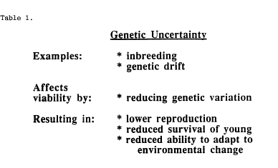
“Notice that I said effective population size rather than census population size. We normally talk in terms of census population size, which is the actual number of individuals one would count. A census, however, doesn't reflect how the population responds to inbreeding and drift. By calculating an effective population size (N), we can adjust for these factors. Basically, it takes into account the fact that not all individuals in a population contribute the same number of genes to the next generation's gene pool. In addition to inbreeding and drift, reasons for this include uneven sex ratio, unequal survival of young, and changes in population size. Imagine a simplistic example where some individuals in a population don't mate, others produce offspring that die, and those that do produce surviving offspring don't produce the same number. As a result, several individuals are not contributing to the next generation's gene pool, and some are contributing much more than the others. These factors will often translate a census population size into an effective population size half as large.”

“Population genetics gives us models for estimating the rate at which genetic variation is lost in a population (Figure 1). An effective population size of 500, according to theory, would lose only 1% of its genetic variation after ten years, 10% after one hundred years, and k0% after five hundred years. By comparison, an effective population size of 100 would lose 5% after ten years, and k0% after one hundred years. The loss of k0% of a populations genetic variation might seriously jeopardize its ability to adapt to change beyond 100 years. However, genetic uncertainty is most critical either in the short term for very small populations or in the very long term for large populations.”

“Demographic Uncertainty is the second set of factors that can threaten viability (Table 2). For any individual in a population, there is always a chance that in any year, it will die or have no surviving offspring. In a large population, this doesn't present a problem, but in a small population, the cumulative effect of this possibility can have devastating consequences. As an extreme example, there is always a chance that in a population of 20 individuals, there will be no reproduction in a certain year, or all offspring will be of one sex. Clearly, in a population that reproduced only once, this would result in extinction. However, this example demonstrates that demographic uncertainty is actually only important to the viability of very small, closed populations, since the chance of such random events decreases quickly as a population grows.”

Table 2.
Demographic Uncertainty
Examples:
* low number of offspring
* skewed sex ratio in offspring
Affects viability by:
* reducing reproductive potential of next generation
Resulting in:
* vulnerability to genetic uncertainty
* vulnerability to further demographic uncertainty

“Environmental Uncertainty is a group of influences on viability that affects the birth and death rates of entire population (Table 3). It includes such things as climatic change, reduced habitat quantity or quality, and increased predation, competition, and parasitism. Unlike demographic uncertainty, these factors influence viability independently of population size.”

“Natural Catastrophe, like environmental uncertainty, affects the birth and death rates of an entire population regardless of size. Natural catastrophes include climatic change, disease, fire, flood, drought, and windstorm. There is a general consensus that environmental uncertainty and natural catastrophe are the most critical to viability of all but very small populations, since only a very large population size or a very widely distributed population can protect against such unpredictable events.”
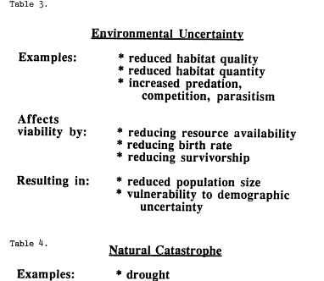
Affects viability by:
Resulting in:
Natural Catastrophe
* drought
* flood
* fire
* climatic change
* reducing habitat quality and/or quantity
* reducing population size
* vulnerability to environmental uncertainty
* vulnerability to demographic uncertainty

“All of these factors are interconnected so that they not only contribute to each other, but some may lead to others. For example, a natural catastrophe such as a drought may stimulate an event of environmental uncertainty, such as a decrease in habitat quality or resource availability. This in turn could knock a resident population down to a small size, at which point it may become susceptible to the effects of genetic or demographic uncertainty. A recent article (Gilpin and Soule, 1986) refers to this as an extinction vortex, where the influence of different factors culminates in extinction.”

Figure 2.
Drought
Diminished Resources
Smaller Population Inbreeding
Reduced Reproduction/Survival
= Extinction

“Following are Definitions of the Probability Levels Used in the Viability Rule Set (Table B-l4) (From USDA-FS, 1988)
VERY HIGH: Continued existence of a well-distributed population on the planning area at the future date is virtually assured. This is likely even if major catastrophic events occur within the population, research finds that the species is less flexible in its habitat relationships, or if demographic or genetic factors are more significant than assumed in the analysis.
HIGH: There is a high likelihood of continued existence of a well-distributed population in the planning area. There is limited latitude for catastrophic events affecting the population or for biological findings that the population is more susceptible to demographic or genetic factors than was assumed in the analysis.
MODERATE: There is a moderate likelihood of continued existence of a well-distributed population in the planning area at the future date. There is no latitude for catastrophic events affecting the population or for biological findings that the population is more susceptible to demographic, genetic, or habitat distribution factors than was assumed in the analysis.
LOW: There is a low likelihood of continued existence of a well-distributed population in the planning area at the future date. Catastrophic, demographic, genetic, or habitat distribution factors are likely to cause elimination of the species from parts or all of its geographic range during the period assessed.
VERY LOW: There is a very low likelihood of continued existence of a well-distributed population in the planning area. Catastrophic, demographic, or genetic factors are highly likely to cause elimination of the species from parts or all of its geographic range during the period assessed.”

“I'd like to leave you with a note of idealism. Notice that I have not referred to Minimum Viable Populations, which is a term you may have heard. As you can now see, a general rule is that the larger and more widely distributed the population, the greater is its viability. We used to talk about minimum viable populations, probably in part because the acronym MVP is so catchy. However, the word minimum has been dropped more recently, and not for simple semantic reasons. As Soule (1987) has pointed out, in the same way that physicians prescribe the optimal conditions for health, not the minimal ones, the resource manager should plan for a robust and bountiful population, not a minimum. The point is that population viability analysis does not provide a magic number above which a population is safe from extinction. I would encourage you to manage for robust and bountiful populations.”

~ ~ ~

The USFS states that sterilization and/or immunocontraception procedures will provide long-term beneficial effects such as maintaining or improving overall body condition, since the physical burden of pregnancy and raising a foal would not occur,” but the EA failed to adequately consider the vigor, vitality, and long-term well-being of the wild horses’ population in the wild, natural world. Sterilization and immunocontraception procedures are completely contrary to the pure core intent of the WFHBA that plainly states: “… wild horses and burros … contribute to the diversity of life forms within the nation … and shall be protected from capture, branding, harassment or death, and are to be considered in the area where presently found [signifying year-round habitat by any reasonable interpretation] as an integral part of the natural system of public lands.” The USFS EA document’s proposed sterilization projects also ignore the true meaning of the WFHBA’s “… to achieve and maintain a thriving natural ecological balance on the public lands.” Any permanent or temporary sterilization of wild mares and stallions is very unnatural and will upset the balance between and among species of plants and animals. Sterilization also ignores this same instruction to manage wild horses and burros “at the minimum feasible level.” The USFS EA failed to acknowledge that the proposal clearly violates the intent of the WFHBA and because of this and many reasons I am providing to you in this letter that changes to the EA are absolutely warranted.

The assignment of the “overpopulation” qualifier upon the wild horse populations of the Apache-Sitgreaves National Forest is not objective but based upon an arbitrary judgment that is convenient to the wild horse adversaries’ view of them. The view that the wild horses are of little value and their well-being on the public lands is insignificant and erroneousness … but there is little doubt that in the mind of the domestic livestock ranchers and the local USFS, they are to be dispensed with wherever necessary, either totally eliminated or reduced to a non-genetically viable population on the territories (USFS), i.e. “zeroed out,” or reduced to low crippled-population numbers with compromised reproductive systems.
The latter herds basically become mere token zoo-like herds lacking in that true wild vigor and exuberance that is so essential for their long-term survival and ecological adaptation. Ecological adaptation, known as “survival of the fittest”, would permit them to “fill their niche” and “play their role” in nature. But mentalities that are controlled by vested interests seem to have become totally blind to the greatness of the wild horses living freely and naturally in the ancient land of their ancestors, presences dating back many millions of years.

If there’s one message I’d like you to understand, it is that the wild horses living in their natural habitat (in this case the Arizona mountains) should not be overly restricted by fences and/or deprived of adequate resources for their survival as viable populations. They should be free to resume their age-old lifestyle and relation to the other species as nature intended. This would be a restorative, quality-of-life phenomenon, supremely important for the horses and many other species, including humankind. Honoring, rather than subverting, the noble commitment of the WFHBA, humanity would pull itself out of a rut that has grown so deep today that it threatens to engulf the whole of life on Earth. Horses thrive in natural freedom and become inspirations to all of us in so doing. This freedom is not the freedom to crassly control and manipulate, alter, and destroy our fellow co-dependent creatures. It is a freedom that recognizes the true worth of each and every kind, of each and every conscious one, and uplifts our relationships to the highest plane. This is True Freedom and a gateway to a more fulfilled and glorious life for all.

The USFS has taken an overly constricted view of the alternatives, or possibilities, that are open to the agency, as servants to the American citizens, in both protecting and managing the wild horses. The definition of Thriving Natural Ecological Balance, for example, seems to automatically exclude the possibility that the wild horse could ever achieve their own part, or role, in this. As an environmental researcher who has studied the horses in nature, I consider this to be extremely unmerited and prejudiced and extremely biased.

Why are the preparers and decision-makers ignoring Reserve Design as a pre-eminent course of action that could be adopted for the wild horses? It would allow for long-term viable, ecologically adapted, and naturally self-stabilizing populations of wild horses, but would mean biting the bullet and actually providing adequate natural resources to accommodate a much higher, truly viable mustang population. It involves the design of a bounded reserve that provides the space, water, forage, shelter, mineral sources, seasonal migratory amplitude, both vertically and horizontally, etc., within which the wild horses could fill their ecological niche. This they should do as mature social units that are not frequently broken up by violent captures and destruction of their natural family bands. Reserve Design would permit the wild horses to level their population numbers in equilibrium with available resources and within a more-or-less bounded area. Reserve Design is the benign way to proceed and honors the true meaning and intent of the WFHBA. Please consider Craig C Downer’s peer-reviewed article that explains Reserve Design in considerable detail. Sterilization is a grave transgression against these perfectly evolving wild animals. Here are the links: Article: The horse and burro as positively contributing returned natives in North America: http://www.sciencepublishinggroup.com/j/ajls doi 10.11648/j.ajls.20140201.12.

“January 13, 2021 Incident Update on Black Mesa Ranger District Horse Deaths
SPRINGERVILLE, AZ, January 13, 2021 – On Saturday, January 9th, 2021, the Forest Service provided results from the initial investigation of horse deaths, including confirmation of four deceased horses due to bullet wounds.” The EA failed to supply the public with the highly relevant Heber wild horse killings of dozens of horses within the National Forest in recent years. Concealment of this vitally important information is a violation of federal Title 18 which states: Making false statements (18 U.S.C. § 1001) is the common name for the United States federal crime laid out in Section 1001 of Title 18 of the United States Code, which generally prohibits knowingly and willfully making false or fraudulent statements, or concealing information, in "any matter within the jurisdiction" of the federal government of the United States
Although the Apache-Sitgreaves National Forest is required by federal law to protect these wild horses as well as to provide safety to all visitors to the forest, it appears that these shootings little attention has been given to this highly volatile and deadly problem.
The website states “Preparation and safety are of utmost importance while recreating in the national forest” but it is obvious that this is not what is really happening and that safety on the forest lands is not a priority of the National Forest employees.

Regarding opposition to sterilization not being supported by peer-reviewed science, I suspect there has been much filtering of what the preparers reviewed so as to support their agenda. To assist with rectifying this oversight, I provide you with the following. As part of the Administrative record I require the decision-makers read, consult and include the following peer-reviewed publications that indicate the adverse effects of sterilization upon the horses, by Veterinarian Bruce Nock. http://subliberatedhorsemanship.com.liberatedhorsemanship.com/wp-content/uploads/2019/05/Menopause-Wild-Horses-1.pdf

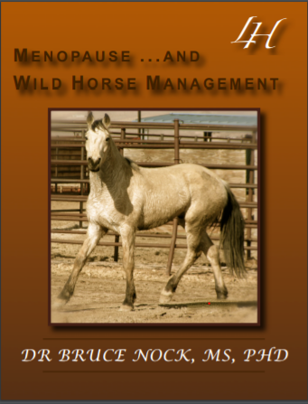

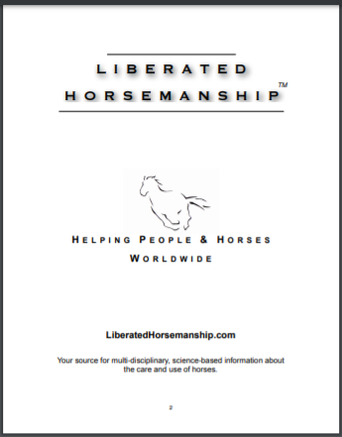

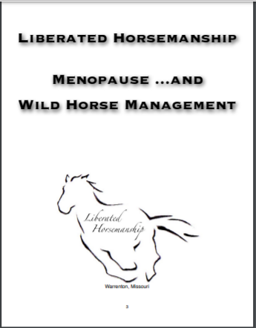

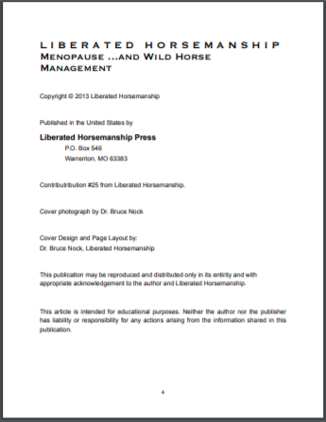

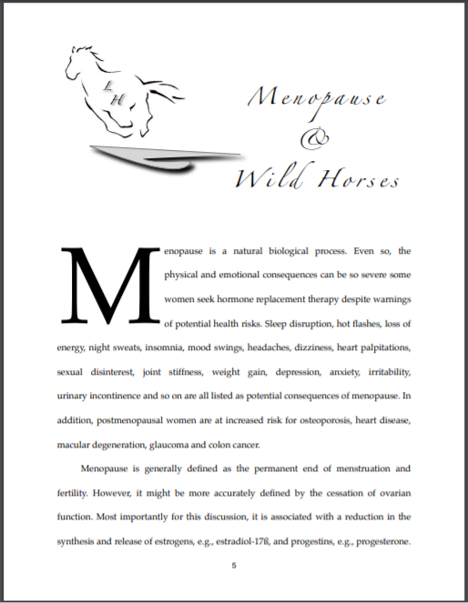

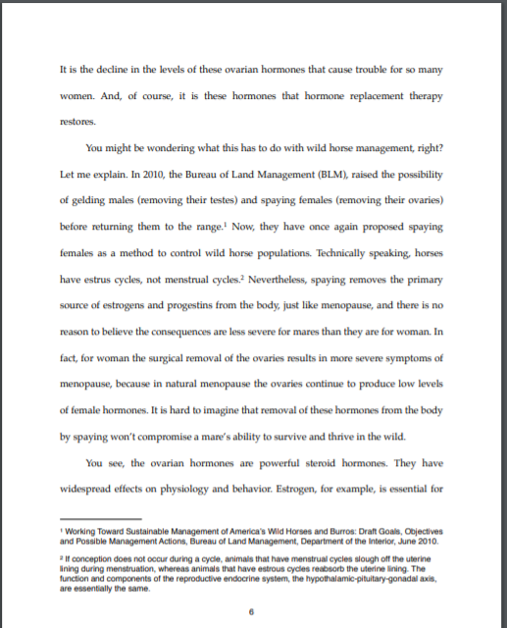

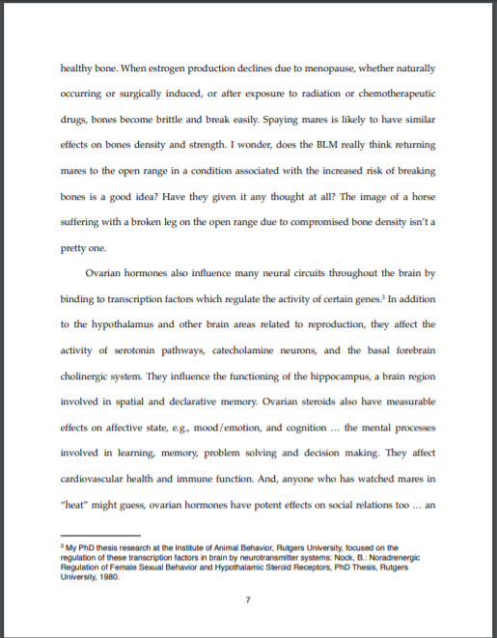

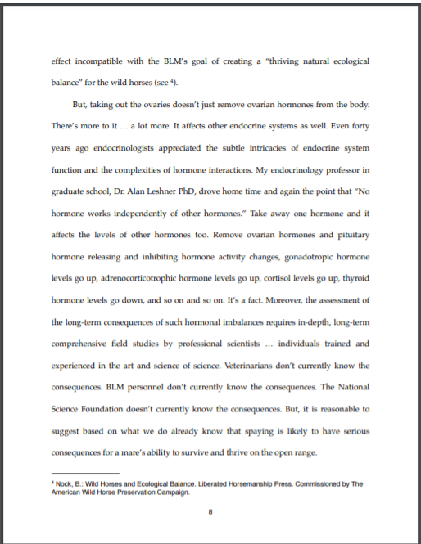

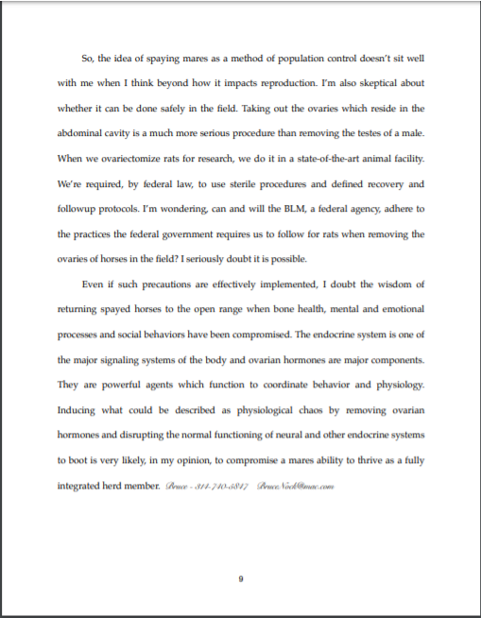

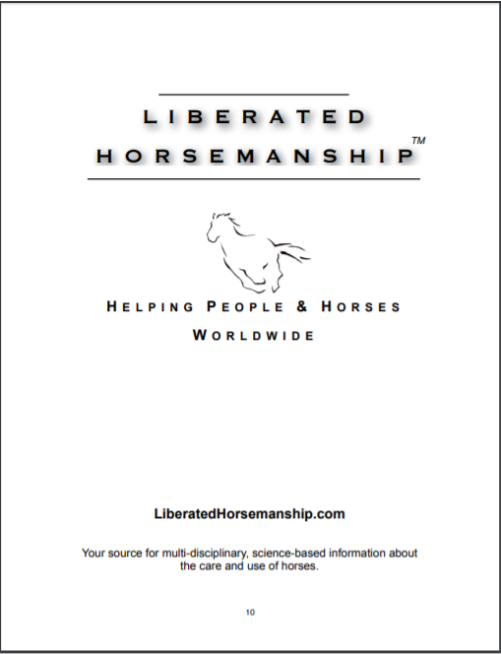

A complete environmental impact statement is certainly warranted for this project. To conduct sterilization experiments on wild mares including ovariectomies involves considerable pain and a significant probability of death and sets a dangerous precedence. This sort of experimentation on wild horses and burros is obviously illegal under the WFHBA, which clearly states that “wild free-roaming horses and burros shall be protected from capture, branding, harassment, or death.” Employing invasive drugs and surgery to interfere with the natural reproduction of the wild horses is contrary to the core intent of the WFHBA. Removal of a mare’s ovaries will have a dreadful effect on the individual wild horses in the wild, their social relations, and their natural adaptations for survival, both in present and future generations.

The EA failed to pay close attention to the 2013 National Research Council’s (NRC) admission that surgery on the wild horses carries serious risks and that all fertility control measures affect wild horse/burro physiology and behavior. This disproves your false assertion that wild horse sterilization will “improve the health of the wild horse and burro herds.” Regarding the side effects of procedures and the social and behavioral effects on the wild horses returned to the range, your dismissal of these as “outside the scope of this E.A.” is erroneous. These effects on the wild horses in the wild should be carefully examined. Why should you subject the individual mares to such ordeals involving pain, suffering and even death especially if there is compelling evidence that their alteration will adversely affect them in the wild?

This would be a sure prescription for decline and die out, as the horses are artificially imposed upon in order to accommodate the USFS-favored public lands users including ranchers, mineral and energy extractors, ORVers, and hunters. We must let nature show us what is the proper population level for the wild horses in any given area, not rashly impose our selfish and thoughtless will for the sake of financial greed that is displayed by privately owned livestock ranches and their subsequent political lobbyists.
As an experienced environmental researcher who has spent many days over the course of many years observing wild horses in the wild, I strongly urge and implore you not to proceed with the proposed, cruel and unnecessary capture and removal and temporary or permanent sterilization procedures on the Heber captured wild horses described in the Heber EA plan. Rather, work to restore more resources for larger wild horse populations on their legal lands.
This would honor the true intent of the WFHBA & the will of the American people who own these wild horses and their legal lands and resources.
Medical Malpractice Related to Unnecessary Spay Surgery on Wild Horses

Primum non nocere is a Latin phrase that translates to "first do no harm." This is the fundamental belief ingrained into doctors that, no matter the situation, their primary responsibility is to the patient. Ultimately, “first doing no harm” means that in some cases it may be better to not do something, or even to do nothing at all, rather than create unnecessary risk. Veterinary medicine is no exception to the principle of primum non nocere. Like all doctors, they are required to maintain the best interests of their patients above all else.

The ovariectomy surgery is far too invasive and will lead to many serious complications for the wild horses. I suspect the accuracy of the 2% complications from the Sheldon NWR experiments on mares being ovariectomized, as per Bower (2015). I have received reports from Carol Walker and Tracy Mohr that reveal a much larger percentage of ovariectomized mares who have died during these surgeries that are in the order of 10% or more and then in addition, the multiple unknown and undocumented deaths following these surgeries. Suffering and death is the fate that could befall many of these “patients”, the ovariectomized mares.

As stated above, the decision-makers must but have failed to seriously consider the professional recommendation of Veterinarian Dr. Bruce Nock (2013) — particularly the serious stress caused by the manhandling and manipulation of wild horses. “Wild Horses – the Stress of Captivity”.

The National Environmental Policy Act (NEPA) requires that to ensure that environmental assessment statements reflect a careful consideration of the available science, and that areas of disagreement or uncertainty are flagged rather than being swept under the carpet. Thus, the public and the decision makers must resist the urgings of agencies that low-probability risks of very serious harms be dismissed from consideration or that the risk is evaluated only under the agency’s favored theoretical model without considering the possibility that other credible models might be correct. Wild horses are wildlife, returned North American natives, and would be harmfully affected by this proposed sterilization project.

“Spaying a mare is a more complicated medical procedure than gelding, involving entering the abdominal cavity. Although there is more than one way to spay a mare, each resulting in the removal of the ovaries, the procedure tends to be painful and there can be scarey complications, such as bleeding from the ovarian artery, which can be difficult to control. … The primary reason a mare is spayed is due to medical reasons. Occasionally, a mare will develop ovarian cysts or cancerous growths that affect her hormone levels and can make her behave in unpredictable, aggressive, stallion-like ways. If systemic hormone therapies do not help, removal of the ovaries does the trick.”

Fasification of federal legal documents

Our society relies heavily on the ability to produce and exchange legitimate and trustworthy documents. As shown and explained within my public comment letter, it clearly appears that the USFS has concealed and refused to include highly relevant data which by law must be provided to the public in the environmental assessment. May I suggest you read and understand this important legal explanation of Title 18 or the United States Code regarding falsification of legal documents.

Making false statements (18 U.S.C. § 1001) is the common name for the United States federal crime laid out in Section 1001 of Title 18 of the United States Code, which generally prohibits knowingly and willfully making false or fraudulent statements, or concealing information, in "any matter within the jurisdiction" of the federal government of the United States, even by mere denial

18 U.S. Code § 1519 - Destruction, alteration, or falsification of records in Federal

investigations

Current through Pub. L. 114-38. (See Public Laws for the current Congress.)
US Code
Whoever knowingly alters, destroys, mutilates, conceals, covers up, falsifies, or makes a false entry in any record, document, or tangible object with the intent to impede, obstruct, or influence the investigation or proper administration of any matter within the jurisdiction of any department or agency of the United States or any case filed under title 11, or in relation to or contemplation of any such matter or case, shall be fined under this title, imprisoned not more than 20 years, or both.
(Added Pub. L. 107–204, title VIII, § 802(a), July 30, 2002, 116 Stat. 800.)
https://www.law.cornell.edu/uscode/text/18/1519

The USFS’ “overpopulation” determination is arbitrary and not true overpopulation. Objectively, these wild horses are very under populated and at risk. Again, who defines overpopulation and by what standards? So often this is done arbitrarily in order to accommodate the continuing monopolization of the public land natural resources by livestock, mining, energy fuel extractors and other exploitive interests in our society, and in spite of the great aesthetic value of the wild horses, their true North American native status, their great contribution to restoring and healing ecosystems, e.g. soil building, moisture retention, plant seeding, and to preventing catastrophic wildfires by eating dry flammable vegetation over broad areas. These are tremendous ecological services that can be evaluated in the billions of dollars.

Let me bring to your attention that the recent National Academy of Science (NAS) report on the Wild Horse and Burro Program determined that the BLM and USFS have no evidence of excess wild horses and burros; because these agencies have failed to use scientifically sound methods to estimate the populations (NAS, 2013). The NAS cited two chief criticisms of the Wild Horse and Burro Program: unsubstantiated population estimates in herd management areas (HMA), and management decisions that are not based in science (NAS, 2013).

The EA failed to provide to the American public the costs associated with the proposed capture and removal and sterilization procedures of the Heber wild horses. This information is required to include but is not limited to the already paid contracts with the “Southwest Decision Resources” company which per USA Spending already totals at least $131,670.00 (see below) and the $17,783. To the Arizona State University (see below). The EA also failed to estimate and list the costs the public will pay to USFS employees for this project in addition to the estimated costs both per horse and for the entire proposal to be captured and transported and fed and processed (either by a contractor and/or the USFS) for the duration of the Heber wild horse project.

Whoever knowingly alters, destroys, mutilates, conceals, covers up, falsifies, or makes a false entry in any record, document, or tangible object with the intent to impede, obstruct, or influence the investigation or proper administration of any matter within the jurisdiction of any department or agency of the United States or any case filed under title 11, or in relation to or contemplation of any such matter or case, shall be fined under this title, imprisoned not more than 20 years, or both.
(Added Pub. L. 107–204, title VIII, § 802(a), July 30, 2002, 116 Stat. 800.)
https://www.law.cornell.edu/uscode/text/18/1519

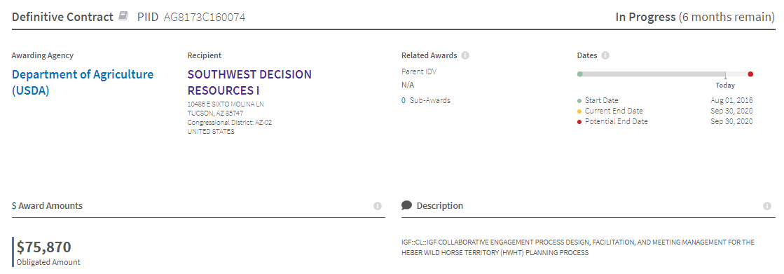
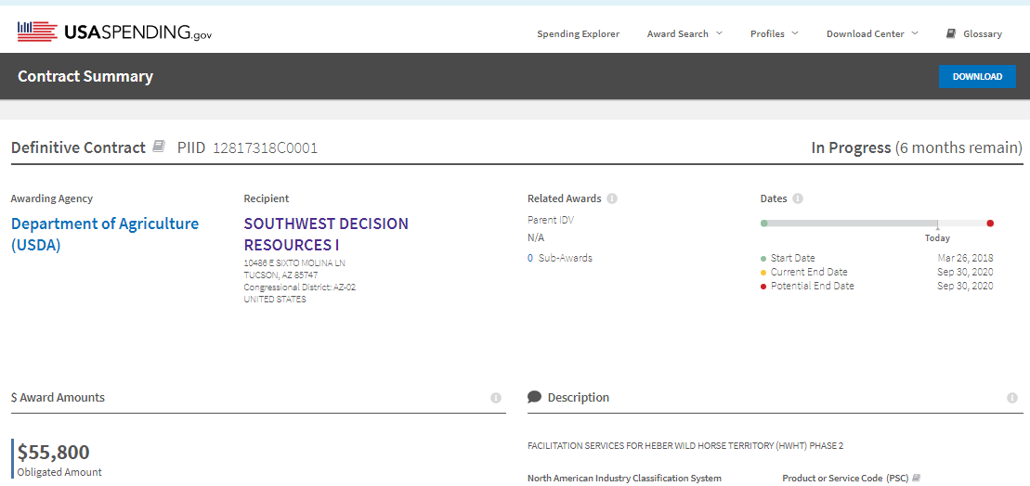
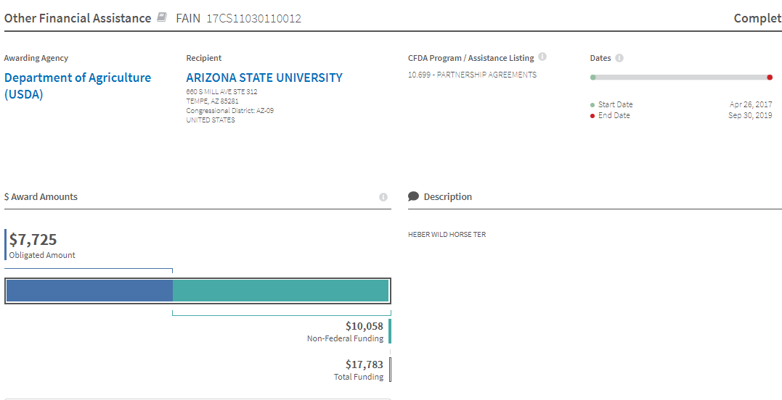

The USFS EA as currently written and published must be redacted immediately because changes to the EA are warranted for the many reasons I have detailed in my letter. The USFS EA has published tactics based on numerous unscientific and unsubstantiated statements within the EA. The USFS’s multiple-use mission is to sustain the health and productivity of the public lands for the use and enjoyment of present and future generations.

At its most basic level, NEPA requires that the decision-makers, as well as the public, be fully informed, i.e., "that environmental information is available to public officials and citizens before decisions are made and before action is taken." 40 C.F.R. § 1500.l(b). NEPA ensures that the agency "will have available, and will carefully consider, detailed information concerning significant environmental impacts; it also guarantees that the relevant information will be made available to the larger [public] audience." Robertson v. Methow Valley Citizens Council. This must be available and analyzed in the EA before a Record of Decision or Finding of No Significant Impact can be completed or published or signed.

Our public lands must be managed for all American citizens and for future generations of Americans, not just local ranchers and hunters and miners and energy exploiters and other multiple-use users. It is time for the USFS agency to stop “business as usual” steam-rolling the American public and begin to manage our public lands and public resources for all Americans. In order for USFS to abide by the law of our United States, it must adopt management strategies which will lead to the minimum feasible management as mandated by the 1971 Wild Horse and Burro Act. It is the law.

It is the responsibility of the USFS to supply the public with adequate and accurate information, scientific research, and realistic options. This is the main purpose of my public comment letter and without the USFS’s willingness to supply complete, accurate and non-politically driven information or falsify any statements or cover up data or reports, any proposed EA or decision will be unlawful.

I require that the office study and consider the comments provided and supply to the public an amended environmental assessment that provides clear evidence that only wild horses are compromising the “thriving natural ecological balance” and not livestock grazing, hunting, OHV use, water diversions, predator removal, fire, tree removal, climate change, and inadequate management policies as the true reason for these lands if they are not reaching a thriving ecological balance.
The EA is inadequate and failed to provide a full assessment of the wild horse populations on their entire legal Apache-Sitgreaves National Forest lands (see above detailed explanation).

The EA is also inadequate and failed to provide a full assessment by not considering an adjustment to the domestic private/corporate livestock usage.

The EA appears to pre-determine a solution of removing wild horses without full and adequate analysis of the livestock grazing impacts or serious consideration of cancelation or reduction in livestock AUMs or permits.
The USFS office should be prepared to show that any action to remove or disturb the wild horse population (ie. fertility controls) will not cause irreparable harm to individual wild horses and the Heber wild horse population in general and that the plan is not based on biased and illegal planning documents in favor of livestock interests. It is obvious to anyone reviewing the EA and therefore the current EA as currently written shows that changes to the EA are absolutely warranted.
As an American citizen, environmental researcher and wild horse and burro observer and a life-long visitor to the state of Arizona, I appreciate the opportunity to provide input on the proposed Environmental Assessment (NEPA) process but first let’s be clear on this major issue: the federal government does not own land in the West and the federal government does not own these wild horses. These are not “state lands” and not “federal lands” and not even “government lands”. They are public lands. The American people own the public lands in the West and they are to be administered on our behalf by the national government under laws and regulations. This land and its resources, including the wild horses and burros belong to all citizens of the United States, not the federal government and certainly not to the Forest Service.

The United States District Court, D. Columbia ROSEMARY M. COLLYER, District Judge. stated: “It would be anomalous to infer that by authorizing the custodian of the wild free roaming horses and burros to "manage" them, Congress intended to permit the animals’ custodian to subvert the primary policy of the statute by harassing and killing and capturing and removing from the wild the very animals that Congress sought to protect from being killed and harassed and captured and removed from the wild.”

"Though men now possess the power to dominate and exploit every corner of the natural world, nothing in that fact implies that they have the right or the need to do so."
- Edward Abbey "A Voice in the Wilderness"

Kathleen R Gregg
Environmental Researcher
3561 Sun Knoll Drive
Loomis, CA 95650

Cc: Other Interested Parties
Receipt and Response is Requested

