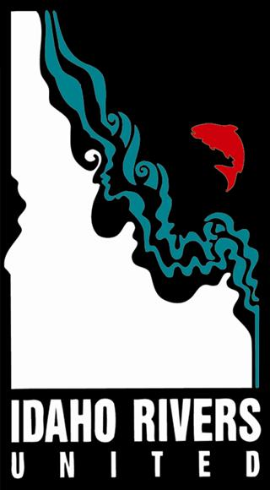
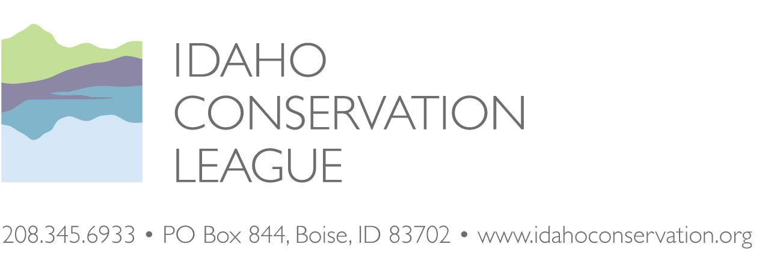
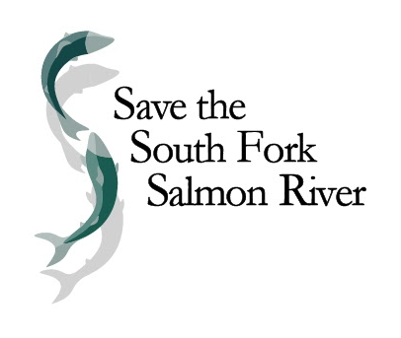

Linda L. Jackson
Forest Supervisor, Payette National Forest
500 Mission Street, Bldg. 2
McCall, ID 83638
linda.l.jackson@usda.gov

October 28, 2020

RE: Stibnite Gold Draft EIS

Dear Ms. Jackson,

Please accept these additional comments on the Stibnite Gold Draft EIS. There are several items that we wanted to comment on further.

Save the South Fork Salmon is a Valley County, Idaho, community-based non-profit organization dedicated to protecting the South Fork of the Salmon River watershed, its outstanding and remarkable natural values, and the economies that depend on those values. Save the South Fork Salmon has members that live, work, and recreate in and around the South Fork of the Salmon River and in the communities that will be impacted by the Stibnite Gold Project. Idaho Rivers United’s mission is to protect and restore the ecological integrity of Idaho’s rivers and ensure their legacy remains for generations to come. Idaho Conservation League is a non-profit organization dedicated to preserving Idaho’s clean water, wilderness, and quality of life through citizen action, public education, and advocacy. Earthworks is a non-profit organization dedicated to protecting communities and the environment against the adverse effects of hard rock mining.

Please include all of our organization’s previously submitted comments, our 2012 administrative appeal of the Golden Meadows Exploration Project, our 2013 comments and subsequent objection, and all legal filings related to our lawsuit challenging your prior approval of the Project (Idaho Conservation League and Nez Perce Tribe vs. U.S. Forest Service, et al., No. 14-cv-156-EJL (D. Idaho)) as part of the administrative record for consideration. We incorporate by reference comments by the Nez Perce Tribe, Margrit von Braun and Ian von Lindern.

Our specific comments are included below.

Sincerely,
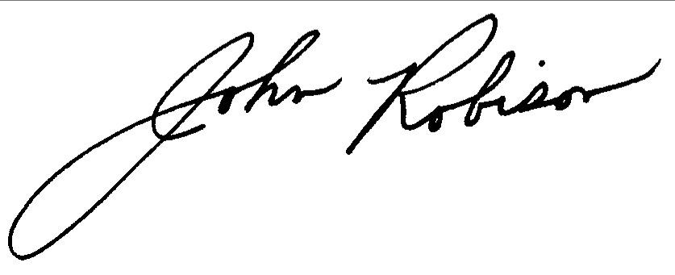
John Robison
Public Lands Director
(208) 345-6942 x 13
jrobison@idahoconservation.org

/s/
Nic Nelson, Executive Director
Idaho Rivers United
PO Box 633
Boise, ID 83701
nic@idahorivers.org
(208) 343-7481

/s/
Alan Septoff
Strategic Communications Director
Earthworks
aseptoff@earthworksaction.org
1-202-888-7844

Stibnite Gold Draft EIS Additional Comments from the Idaho Conservation League, Save the South Fork Salmon, Idaho Rivers United, and Earthworks

Antimony modeling
The DEIS did not foresee significant water quality issues with regard to antimony. Based on our review (See Appendix A, Maest Memorandum 2020), it appears that the geochemical models used to support the conclusions in the DEIS were based on using Sb oxide (SbO₂) to limit dissolved antimony concentrations. While the DEIS claims that Sb oxide would precipitate out of solution, it is not a natural form of antimony and does not precipitate under any natural conditions. If Sb oxide is not used to limit antimony concentrations in the geochemical models, our analyses show that some of the predicted antimony concentrations in groundwater would exceed relevant water quality standards. The Forest Service should correct this in a Supplemental DEIS.

Botanical resources
Bent flowered milkvetch and Sacajawea’s bitterroot require pollinators for reproduction and seed set. Their pollinators are likely dependent on adjacent habitats for shelter and food. The biology and ecology of their pollinators is unknown. Any habitat changes may have adverse impacts that have not been addressed by this document. Pollinators and seed dispersing organisms could also be directly or indirectly affected by mining operations, including releases of hazardous chemicals, pesticide applications, habitat loss, changes in behavior due to light pollution and changes in the compositions of insect communities from extensive habitat modification. These are significant shortcomings that should be addressed in a Supplemental DEIS.

We note that the Boise National Forest faced a similar issue of pollinators for Sacajawea’s bitterroot for the CuMo exploration project. Plant surveys were conducted at the time of year when this species is flowering and visible. Construction activities were not allowed during active growing and flowering periods for Sacajawea’s bitterroot in order to minimize impacts to pollinators from ground disturbance or dust.

The Forest Service recorded locations of individual plants and then created a “Plant Conservation Area” or 300’ circular buffer zone consisting of a series of concentric rings around each occurrence. Ring 1 comprised occupied habitat, Ring 2 included the outer extent of occupied habitat plus 20 meters, Ring 3 consisted of the outer extent of occupied habitat plus 100 meters, and Ring 4 included the outer extent of occupied habitat plus 300 meters.

These buffers were designated with the intention that exploration roads could be located to avoid both plants and habitat for their pollinators. No new road construction would be initially allowed in buffer rings 1-4 to the maximum extent practicable. All proposed activities in rings 1 and 2 would initially be reviewed by a USFS minerals administrator and USFS botanists.

Unfortunately, however, the Forest Service could not make assurances that individual plants or their buffers would remain protected and allowed for exploration road construction in these areas with some caveats. If the project proponent decided to construct a road through the rings, the proponents had to go through a checklist and a micrositing effort with the Mineral Administrator and botanical monitor to attempt to minimize impacts to the plants. However, the Forest Service also wanted to be sure not to endanger or materially interfere with prospecting, mining, or processing operations, etc.. If the exploration activities reached the level at which the impacts to the plants exceed those analyzed or could cause a trend toward federal listing or a loss in viability, the Responsible Official could modify the Plan of Operations and revise the supporting NEPA. Ultimately, the project was litigated over the failure to reestablish baseline monitoring for Sacajawea’s bitterroot and the project is still on hold.

For the SGP, the Payette National Forest should consider creating Plant Conservation Areas around botanical resources so that plant occurrences and habitat needed for their pollinators are conserved. The Forest Service should go the extra step and make sure that Plant Conservation Areas shall not be impacted directly or indirectly by roads or other types of infrastructure development. The main potential impacts to plants at the CuMo Project were drill pads and roads that were part of a mineral exploration program. Boise National Forest determined they had limited authority to take any measures that might interfere with prospecting and mining. However, in the case of the SGP, many of the plant occurrences are not within the SGP footprint but found along potential transportation routes and Rights of Way and cell tower locations. Because these infrastructure elements are not as site-specific as mineral resources, the Forest Service and operator have much more latitude with regard to siting them so they completely avoid plant occurrences and surrounding pollinator habitat. We recommend that the Forest Service resurvey plants, create Plant Conservation Areas around occurrences, and then propose adjustments to access roads, Rights of Ways and other infrastructure elements so that impacts can be entirely avoided.

Bonding
We believe that the bonding calculations need to be part of the NEPA analysis for all viable alternatives and that a broader discussion of the regulatory framework is needed.

For the 2014 Thompson Creek Mine Expansion DEIS, The US EPA had specifically notified the USFS that bonding must be discussed and reviewed as part of the NEPA process:

EPA believes that financial assurance is an important element of the proposed action and must be disclosed in the EIS. FA is an important component of the mitigation plan, and disclosing information on the costs and form of FA is essential for the public to understand and comment on the adequacy of mitigation, risks to the environment, and financial risks to the public. EPA believe it is not possible to fully evaluate anticipated effectiveness of the mine and reclamation plan and associated risks to the environment without this type of information. (Letter from Lynne McWhorter, EPA Environmental Review and Sediment Management Unit to Dave Rosenkrance, Challis BLM, dated September 27, 2010)

Bonding also needs to cover the costs of perpetual water treatment. The post closure supplies needed for active water treatment include 180,000 pounds/year of hydrated lime per year. It was unclear if this material would be trucked to the site, how much lime could be stockpiled from the lime kiln, how that stockpile would be managed, how long that material would last, or if there would still be a need for a small lime quarry and kiln operation post-closure the future. This information is needed for accurate bonding calculations. 1

Digital Availability of the DEIS
The lack of physical copies of the DEIS was limiting to people without internet access or availability, especially low-income families and communities of color. This is in conflict with the purpose and intent of NEPA allowing for all people the ability to review and comment on the environmental effects of proposed federal actions.

According to a report conducted by Free Press Research (Turner, S. Derek, The Impact of Systemic Racial Discrimination on Home-Internet Adoption, December 2016) , nearly half of all people in the country without home-internet access were people of color. Much of that gap was indeed the result of income inequality. People of color generally have far lower average incomes than white people, and low-income families often cannot afford to subscribe to home broadband. For example, the research showed that only 54 percent of people with annual family incomes below $20,000 had internet in their home, compared to nearly 90 percent of people with family incomes above $100,000. To ignore the established precedent of making readily available hard copies, in fact, only making one available per local community, was arbitrary and capricious on the part of the USFS and was contrary to law and the intent of NEPA.

Emergency Action Plans
The Forest Service should also design emergency plans to stabilize and safely store chemicals, equipment and infrastructure at the mine site and other logistic facilities. Note that wildfires can move very quickly, leaving limited time to prepare and evacuate. The Forest Service should define safe places away from flammable chemicals in the event the personnel have to shelter on site. Diesel fuel, propane and other flammable or hazardous materials should be stored so they are not vulnerable to direct exposure to flames or to falling embers. Contingency plans are needed to ensure that the water treatment plant facility will not be affected by any extended power outages or road closures can continue to operate as needed in the decades and centuries following mine closure.

The Thompson Creek Mine, BLM and Forest Service created an Emergency Action Plan (EAP) in the event that there was a catastrophic tailings dam failure at Thompson Creek Mine’s sand dam. While a catastrophic tailings dam failure at Stibnite Gold may be less likely than at Thompson Creek, there are other types of infrastructure at the SGP that could pose significant threats if released. These include processing ponds, chemical storage sites, and debris flows, landslides or avalanches compromising the integrity of and interacting with waste rock dumps or the tailings facility. See attachment, Appendix B, Thompson Creek Mine Emergency Action Plan.

The EAP for the Thompson Creek Mine was written for use during the operating life of the impoundment and will likely need to be modified for the long-term, post-closure phase. The EAP contains protocols for determining the emergency level, the notification and communication list, including County Emergency Services. In the event of an urgent situation, the Thompson Creek Mine EAP calls for the evacuation of the area along low-lying portions downstream of the mine and directs the public to proceed to high ground. A map of any low-lying areas that may be affected by
a catastrophic failure at SGP should be included in the Supplemental DEIS. The agencies should examine a run-out analysis under different scenarios to see how far material may travel and what type of impact that material may have on water quality and other resources. In the interest of public safety, identifying these areas ahead of time could be critically important for private property owners. The EAP for the SGP should include alerting and evacuating downstream residents recreationists in potentially affected areas.

For the Thompson Creek Mine, a modified post-closure EAP will likely be necessary. Several components of this EAP call for monitoring, pumping, backup pumping, heavy equipment, and personnel to be on site to properly manage the situation. For the SGP, the Forest Service should describe the type of infrastructure and equipment that may need to be kept on site or nearby as part of the post-closure EAP.

Stream Restoration Examples
Midas Gold proposes to reconstruct Meadow Creek across the top of a 460’ high tailings storage facility and the East Fork South Fork Salmon River across the top of the backfilled Yellow Pine pit, with the backfill consisting of waste rock associated with SGP construction. When we asked Midas Gold if they could provide examples where stream restoration projects were successfully completed over tailings or waste rock storage areas, we were directed to the following document in the DEIS appendices:

https://usfs-public.app.box.com/s/y35kam707j0560hm9n5yjcsyeb3lye9y/file/731871462285

These projects included the Mike Horse Mine, Lincoln, Montana; the North Antelope Coal Mine, Douglas, Wyoming; Republic Wetlands Preserve, Marquette County, Michigan; the El Indio Mine, Vicuna City, Chile; Clark Tailings Wetlands, Butte, Montana; The Rio Tinto Mine, Mountain City, Nevada; and the Carlota Mine, Miami, Arizona. We reviewed each of the cited projects and found that only one (the El Indio Mine, Chile) of the cited restoration projects represent relevant or comparable examples of stream mitigation or restoration. The remaining six examples are not representative of the restoration work proposed at the SGP and should not be portrayed as such.

The Mike Horse Mine restoration of Upper Bear Trap Creek was completed by first removing tailings and other contaminated soils from the restoration area to bedrock, installing a geomembrane liner, then rebuilding stream structure along the original stream course. Revegetation is the focus of the restoration efforts, and Upper Bear Trap Creek was not reconstructed over the top of tailings or waste rock storage areas. The sole relevant comparison between the SGP proposal and the Mike Horse Mine restoration efforts is the presence of cutthroat and bull trout.

The Clark Tailings Wetlands, also located in Montana, does contain tailings remains; however, the tailings facility only rises 40 feet, far short of the proposed 460’ foot high SGP tailings and waste rock storage facilities. Further, the Clark tailings were topped with additional ore processing waste from the Colorado mine. The combined mine waste was in turn capped by the construction of the Copper Mountain Sports and Recreation Complex. Emergent wetlands appear upstream of the west side of the complex. This project does not contain a stream restoration component, does not affect fisheries, and the affected waterway/wetland areas do not support ESA listed species. Further, surface and groundwater quality continue to be imparied downstream of the reclaimed area, indicating toxic materials continue to leach into water sources from the capped tailings.

The two desert mining restoration solutions also fail to provide meaningful comparative examples of a restored stream that traverses either a tailings or waste rock storage facility. The Rio Tinto Mine tailings were excavated and deposited at an on-site, lined location and Mill Creek was routed around the tailings and on-site repository. The restored Mill Creek consists of a small rock-lined, “ditch-like” feature with very little plant growth on the stream banks, leading to high stream water temperatures. Red-banded trout are found occasionally in Mill Creek, although the information we were able to obtain did provide details on the extent and health of this desert-adapted species other than presence. Similar to the Clark Tailings Wetlands, the Carlota Mine restoration of Pinto Creek consists of rerouting around the mine pit and tailings facility through native soils, and does not traverse the top of tailings or waste rock facilities. Pinto Creek does not support a fishery, nor provides habitat for ESA listed fish species. Other areas of the mine continue to discharge toxic water into the diverted Pinto Creek, resulting in poor downstream water quality. Vegetation associated with the stream bank remains sparse.

The Antelope Coal Mine restoration of Porcupine Creek consists of a stream channel underlain by a 24 m wide by 3 m deep reconstructed fill composed of at least 60% sand with a compacted clay liner separating the reclaimed alluvial aquifer from the underlying backfill. Porcupine Creek supports three non-game fish species and contains no habitat for ESA listed species. Vegetation restoration efforts consist of some planted trees and coyote willow. The paucity of streamside vegetation results in higher stream temperatures than normal. Porcupine Creek continues to exhibit high TDS and selenium concentrations, resulting in poor water quality. Again, the Antelope Coal Mine restoration efforts do not represent stream rehabilitation overlying or through tailings or waste rock storage facilities and should not be used as a comparative example for the SGP. Finally, the Republic Wetlands Reserve consists of roughly 615 acres of constructed wetlands, including grasslands unique to the Upper Peninsula of Michigan, forested wetlands, and a large lake. The wetlands were not created over the top of stacked tailings or waste rock, but over neutralized and dispersed tailings deposits. Of the seven restoration projects Midas Gold provided, the Republic Wetlands Reserve represents the most successful example of a restored and sustainable aquatic ecosystem, although it does not contain a high mountain stream over a high tailings or waste rock storage facility, nor does the Republic Wetlands Reserve provide habitat for ESA listed fish species.

The El Indio Mine restoration of the Malo River does contain elements similar to those proposed for the SGP. Both are high-elevation mine sites with snow representing the primary form of precipitation and the restoration of the Malo River did incorporate casing and moving the river during mine operations, then establishing a geomembrane and cobble-lined bed along the original river course. Pictures of the mine restoration do indicate that the Malo River runs over the top of significant tailings deposits. However, we could find no data documenting the effectiveness of the restoration efforts, the ability for vegetation to establish and grow to decrease water temperatures, nor did we find data documenting the river’s water quality and ability to sustain aquatic life. Midas Gold and the Forest Service need to acknowledge that the majority of the stream restoration examples they provide do not represent comparable restoration efforts. We recommend that the Forest Service/Midas Gold provide additional, relevant stream restoration examples that equate to the proposed actions for the SGP. Further, Midas Gold needs to provide documentation that ensures their ability to restore the East Fork South Fork Salmon River and Meadow Creek to its full functioning capacity in such a manner that it provides both access, viable habitat and water quality requirements such as temperature for various life stages of for anadromous steelhead and other fish species.

Appendix A, Maest 2020
BUKA ENVIRONMENTAL
Boulder, CO 80302 USA
303.324.6948/aamaest@gmail.com
www.buka-environmental.com

Memorandum
To: John Robison, Public Lands Director, Idaho Conservation League; Pete Dronkers, Southwest Circuit Rider, Earthworks; and Judy Anderson, private citizen
From: Ann Maest, PhD; Buka Environmental
Date: 28 October 2020
Re: Additional comment on the Stibnite Gold Project, Idaho: PHREEQC modeling of groundwater under Development Rock Storage Facilities

Additional Comment on PHREEQC Modeling
As noted in my original comments (Maest, 2020), some PHREEQE input files were released on the USDA Forest Service website on October 19, 2020, nine days before the end of the comment period.^{[1]} Given the short amount of time available to evaluate the files, I ran one input file: Stibnite DRSF GW Under DRSF_OTM_HF Flats Cover – 5%Infiltration_Ave_v0.2, which I assume is for groundwater under the Hangar Flats DRSF over time, eventually with a cover. I initially ran the file using the wateq4f.dat database and found that PHREEQC stopped running after only three of 80 simulations in the input file, due to errors related to lack of finding selected phases and elements in the database. When I reran the file using the minteqv4.dat database, the file ran through the 80 simulations, even though it had many error messages related to not finding phases, exceeding maximum iterations, numerical method failing with the chosen set of convergence parameters, and other errors.

The minteqv4.dat database does include antimony and several of the selected phases that were forced to reach equilibrium in the model, including SbO₂, which will limit predicted antimony concentrations. As noted by Nordstrom (2019), SbO₂ is one of many phases selected that are unreasonable solubility controls; in fact, SbO₂ is not a known mineral. Even though this phase does not appear to exist, it exercises a strong control on the predicted concentrations of antimony in groundwater under the DRSF in the modeling effort.

Running the input file in PHREEQC with the selections in the input file creates a separate file with the predicted results. Using the results for predicted antimony concentrations without modification, with the assumption of saturation with SbO₂, and with adsorption, I created Figure 1. The figure shows that without the forced solubility control for antimony, predicted concentrations under the DRSF would exceed the groundwater standard for all years under all conditions. Predicted results assuming saturation with SbO₂ and with adsorption are similar - both sets of results show that the predicted antimony concentrations in groundwater would never exceed the relevant groundwater standard.

Source: Output from PHREEQC modeling run for input file Stibnite DRSF GW Under DRSF_OTM_HF Flats Cover – 5%Infiltration_Ave_v0.2.
Figure 1. Predicted antimony concentrations in groundwater under the Hangar Flats DRSF over time. The dashed red line is the groundwater quality standard of 6 mg/L (DEIS, Table 3.9-2, p. 3.9-15).

The results demonstrate the uncertainty of the predictions and the influence of incorrect conceptual models – in this case, the assumption of equilibrium with an antimony phase that does not exist. A revised DEIS should present the results of the geochemical modeling efforts and use a range of predicted concentrations that would feed into the site-wide water chemistry (SWWC) model. If this were done, it is likely that some of the predicted water quality in surface water and groundwater would exceed relevant water quality standards.

6. References Cited
Maest AS, 2020. Evaluation of the Draft Environmental Impact Statement (DEIS) for the Stibnite Gold Project, Idaho, and Related Water Quality Conditions, Predictions, and Effects. Prepared for Idaho Conservation League, Earthworks, and Judy Anderson. October 27. 37pp.
Nordstrom DK, 2019. Review of MIDAS GOLD REPORTS ON SITE-WIDE WATER CHEMISTRY AND GEOCHEMICAL MODELING. 9pp.
U.S.D.A. (United States Department of Agriculture) Forest Service, 2020. Stibnite Gold Project Draft Environmental Impact Statement. August. https://cdxnodengn.epa.gov/cdx-enepa-II/public/action/eis/details?eisId=303643
Turner, S. Derek, 2016. The Impact of Systemic Racial Discrimination on Home-Internet Adoption. December.
https://www.freepress.net/sites/default/files/legacy-policy/digital_denied_free_press_report_december_2016.pdf

^{[1]} Available: https://usfs-public.app.box.com/s/y35kam707j0560hm9n5yjcsyeb3lye9y/folder/124615400518
Appendix B, Thompson Creek Mine Emergency Action Plan

See attached.

CuMo Exploration Project Supplemental Decision Notice and FONSI https://www.fs.usda.gov/nfs/11558/www/nepa/108040_FSPLT3_4528706.pdf, p. 4, 133, https://www.fs.usda.gov/nfs/11558/www/nepa/108040_FSPLT3_4106891.pdf, p. 9-12

