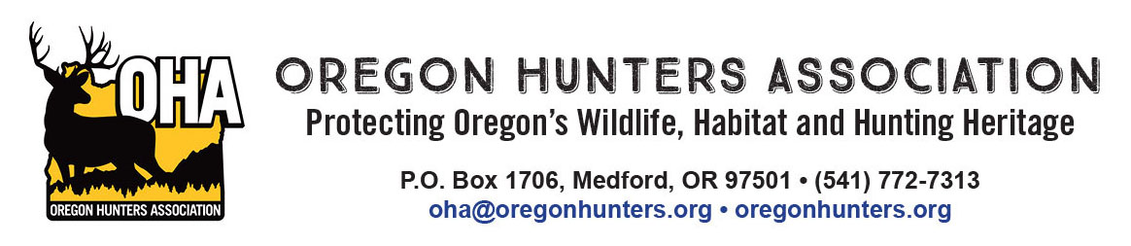

November 21, 2019

**RE: Comments: Central Cascades Wilderness, Special Recreation Permit Fee**

The Oregon Hunters Association (OHA), a 10,000-member non-profit organization, has been an active participant throughout the development of the Special Recreation Permit Fee proposal process. OHA has participated in the many meetings and has provided comments and suggestions that reflect the views and concerns of our membership.

Some of the items listed below were identified during the objection process as important components to be included in the implementation of the Final Decision. As part of the implementation process, these suggestions should be incorporated into the fee determination phase of the project, ending November 25th, 2019.

OHA, “for the record, does not support such fees.” We do have the following to offer assuming the proposal is moving forward, and submit these points:

* Creation of a volunteer pass, recognizing individuals who invest a substantial amount of time in support of wilderness stewardship;
* Acceptance of the fee structure, assuming consideration (review) of effectiveness looking ahead, implementing adaptive management policy;
* Kids 12 and under will not be required to pay the wilderness stewardship fee;
* Retaining a portion of the day use and overnight permits to be reservable at the beginning of the season, and a portion to be made available the day before;
* The Deschutes National Forest should continue to explore options for new high elevation trails outside of Wilderness to accommodate increased use on nearby public lands. Potential locations include Tumalo Mountain, Mt Bachelor and other undeveloped areas with recreational use potential.
* Trail maintenance should be a key conservation item. Monies should be invested in hiring trail crews, and partnering with other similar organizations, to help with the maintenance burden~~.~~
* Restoration efforts need to focus on high-use campsites which have decades of soil compaction and vegetation damage issues.

OHA is committed to work within our organization, and with our partnering organizations, to educate hunters to the new permit requirements and the importance of Leave No Trace and wilderness ethics.

Thank you for the opportunity to engage in constructive discussion on our precious public lands, so vital to our economy and wildland appreciation.

Sincerely,



Fred Walasavage

Chairman, Oregon Hunters Association