**Comments on the Zeppelin Project**

When I got the letter for this project, I decided to take a close look at what is occurring within the project area. You state that the project area contains 10,336 acres of FS land. Of those acres, you have plans to do some type of tree cutting on 8,631 acres. That amounts to treating 83% of the FS land in this project. I did some research on Google Earth to see what the history of timber harvesting has been within the project area. From what I can tell, there has been fairly extensive management. In the western third, it looks like there was timber sale that took place in the mid-1990’s and another sale that took place about 2005. It appears that there was some mountain pine beetle activity at that time. Some of the steeper terrain skid trails from the 1990’s are still evident on Google Earth.

In the southern portion of the project area, there is evidence of management in the 1990’s as well as a timber sale under the Steamboat Project in 2017. Again in 2021, there was additional sale activity (which sale was this?) east of Wonderland Cave (see the attached photos, I used black and white as it made it easier to see what has occurred). Indeed, there has been a lot of timber sale activity in the project area over the last 20 years or so. I am somewhat surprised by how much of the area is now considered to be at a high or very high risk for insect and disease and wildfire.

A photo of the top piles that still remain from the last timber sale.

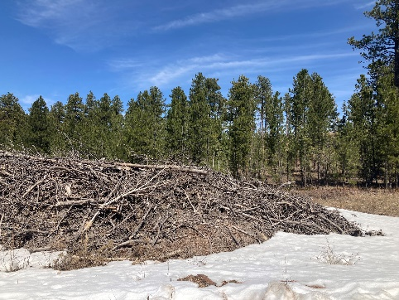

I certainly appreciate the pressure that the Forest Service is under from the timber industry, and Lawrence County and Meade County, to keep producing unsustainable amounts of timber, but I am concerned about what appears to be a trend with this project and the Chimera Project. Is this going to be the new strategy where you go back into every piece of ground and try to log on every acre possible, using the justification of the MPB and wildfire?

I understand your stated purpose and need for this project but I do have a number of concerns. I am somewhat familiar with the project area. In 2018, I hiked the entire Centennial Trail (which goes through the middle of this project area) and remember it being adjacent to and passing through a number of thinning units. I also remember the part that drops down into the Elk Creek Drainage as being very scenic. One of the more beautiful parts of the trail.

You mention that the project area is within a high-risk fireshed. I looked it up and appears that two thirds or more of the Forest has been identified as high-risk firesheds (Wildfire Crisis, Landscape Investments, FS-1187f January 2023). I ask that you explain in your EA what a Fireshed is. This is a relatively new concept and I don’t think that most people know anything about them. As I understand them, they are based on the proximity to structures and communities and the possibility of a fire starting and reaching those structures/communities. The actual forest condition is not really a component, as I understand it.

Please elaborate how you have made the determination that 77% of the ponderosa pine stands are at high or very high risk of wildfires. The BHNF is perhaps one of the most logged forests in the FS system and the Zeppelin Project area has certainly had its share of pine management. If logging alone was the answer to the fire problem, why is much of the project area, and for that matter, the Forest, now considered to be at high or very high fire risk?

I know that you have added a considerable amount of prescribed burning to this project as well as in the Chimera Project. That is great and I fully support that. The problem is that the BHNF has a terrible track record of actually following through with the implementation of prescribed burning. There was quite a bit of prescribed burning in the Steamboat Project, some within the Zeppelin Project. How much of that took place? The BHRL project contained a significant amount of prescribed burning and little if any of it has happened. BHRL also claimed that significant amounts of non-commercial thinning would occur. Much of that has also not happened. I do appreciate that the Northern Hills District has done a better job with this. It does appear, however, that on the BHNF, what usually occurs with these projects is the commercial logging and everything else is an afterthought.

Commercial thinning can be part of the solution for wildfire (I also agree that it can be helpful with MPB) but there also needs to be follow up with prescribed burning and pre-commercial thinning. Case in point….the Jasper Fire area had significant thinning within its footprint prior to the fire in 2000. And yet, that thinning hardly played any role in mitigating extreme fire behavior. Please watch this video [Jasper Fire before and after - YouTube](https://www.youtube.com/watch?v=kA6EyDMnYaA) . For all of the logging that has occurred on the BHNF over decades, there are actually very few examples where pre-treatment commercial thinning mitigated large fire behavior. Large fires typically occur here when extreme fire behavior conditions exist, and thinning alone has not proven to have much impact. In your NEPA analysis, you should be clear about the expectations for fire mitigation with this project and the likelihood that the prescribed burning will not take place at the levels proposed.

It appears that the classification of the high risk firesheds (as well as WUI, which much of the Forest has been designated as) on the BHNF is being used to justify no longer following the Forest Plan’s Structural Stage Objectives as well as suitable and unsuitable timber designations. It seems that insects and wildfire are being used to justify logging almost everywhere.

I have a number of points that I would very much appreciate you addressing in your NEPA document.

Insect/disease and wildfire risk designations

Please describe how you are determining the high risk for insect and disease as well as how you are designating pine stands to be at high or very high risk for wildfire. What are the metrics? What metrics will you use to show that you have indeed lowered the insect/disease and fire risk? Is it simply reducing stand density?

Commercial thinning

In general, what will be the thinning prescription for the thousands of acres proposed? Will you be thinning down to 60 BA or even lower? When do you anticipate that the next entry for commercial timber harvesting will be within the project area along what types of treatments? Large-scale overstory removal?

Liberation cuts

The only liberation cut I was able to visit was the one west of Wonderland Cave. This is because many of the roads within the area were currently gated. This stand appears to have a healthy understory with some scattered sawtimber sized trees. It appears that there would not be significant volume from these overstory trees and also, I don’t think they are inhibiting the growth of the understory. I am going to suggest that instead, maybe this stand would be better managed with uneven-aged management, leave the overstory and pre-commercial thin the understory. What is the age of the overstory? Are they at culmination of mean annual increment (CMAI) as required in the National Forest Management Act? If not, you must provide a rationale for exception.

See photos.

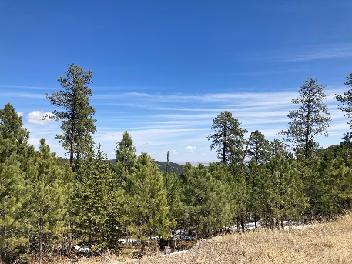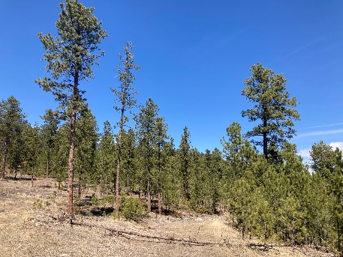

Hazardous Fuel Reduction

It appears that much of the areas that you have designated for hazardous fuel reduction are in what was the Charlie SBA timber sale. In fact, there were many large trees marked to cut that still remain as the sale was canceled. Specifically, what types of treatments do you plan to do within those areas? Will be marked trees remain? In a very limited review of the project area (due primarily due to locked gates), I did not see very many large trees like those marked to cut in the Charlie sale. I would hope that you allow those trees to remain. According to the recent Mature and Old Growth Forests report, these stands would certainly qualify as mature and quite possibly meet the requirements for old growth. Let’s let those trees remain. Cutting them will do nothing to reduce hazardous fuels.

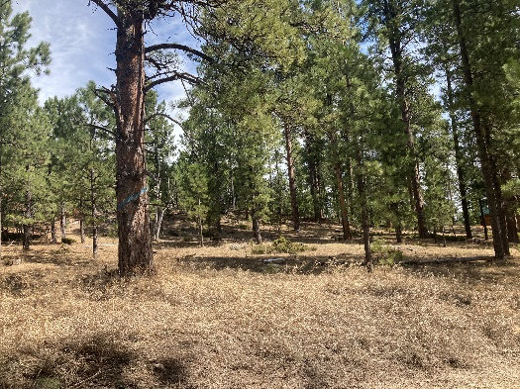

Conflicts with previous projects

The southern portion of the Zeppelin Project was within the Steamboat Project. There was quite a bit of timber harvest activity planned in the Steamboat Project within this area. There was individual tree selection, shelterwood, commercial thinning, POL, and overstory removal. How much of this actually occurred? It looks to me like the areas designated for Individual Tree Selection were cut. A lot of this seems in conflict with the proposed commercial thinning proposed in Zeppelin. Particularly since it appears that the Steamboat operations occurred around 2017, a mere six years ago. Is it already in need of additional thinning?

Pre-commercial Thinning

How will pre-commercial thinning occur on the steep slopes? What are the options and what will be the respective soil impacts?

Fuel Breaks

Please describe what will be entailed with the creation of the fuel breaks? Will this essentially just be a system of connected clearcuts or very heavy thinning? Please describe what the finished fuel break will look like and also how it will be maintained. I assume the location of this fuel break is intended to stop a wildfire progressing from the southwest towards the northwest? Is this correct? In order for a fuel break to be effective, I would imagine, it would need to be staffed by fire resources. It appears that the ingress/egress to the fuel break would be from the southwest road access. So, resources would need to approach the fuel break from the southwest and their only egress would be back through the fire? Maybe I have something wrong here.

Suitable vs. Unsuitable for timber harvesting

Please provide a map of the project area that identifies how much commercial timber harvesting will occur in areas designated as unsuitable for timber harvesting.

Structural Stage Objectives

Structural stages came about as part of the lawsuit settlement on the 1997 Forest Plan. Species viability was not addressed adequately so therefore, Phase II came out with the structural stage objectives. For years, the timber industry has said “forget about structural stages, they are just objectives after all. The goshawk will be just fine, we don’t need to worry about it.” Please reveal the impacts of this project to the Forest Plan’s Structural Stage Objectives and provide a map of the project area’s current structural stages.

In the Chimera Project’s draft EA, it stated in the goshawk section “Assuming that structural stage objectives are met Forest-wide, there would be adequate habitat for maintaining northern goshawk populations across the Forest”. The problem is, this is not happening across the Forest (particularly with 4B) and I think everyone knows that. It is not ok to not follow the SS objectives in this project while also knowing that nothing is being done about them across the Forest. The SS objectives were a driving force for the BHRL project and it now appears that they are being thrown under the bus, in the interest of providing more commercial timber harvesting.

Soil Erosion and Compaction

Steep slopes are often comprised of a thin topsoil. Will you be requiring a slash mat for the steep slope logging? Slash mats typically limit regeneration so you will have the lanes remaining treeless for quite some time. In other areas of the Black Hills where steep slope logging has been done with conventional equipment and skidders, trees do not appear to be regenerating very well. I suspect this is due to the compaction created by repeated passes. How will you deal with the issue of compaction on steep slopes?

Scenic Integrity

What will be the scenic impacts to the Centennial Trail? It appears that the fuel break will affect the trail. How will these impacts be mitigated? Much of the northeast portion of the project area appears to be fairly steep ground. Specifically, how will this area be logged? What will be the visual impact of this type of logging (numerous vertical lanes)? How do you intend to mitigate the visual impacts?

Weed impacts

Studies have shown that repeated entries in reduced timeframes is impactful to the spread of weeds. Weeds need about 15 years without disturbance to significantly work their way out of the system. Since you have had timber harvesting in the project area at least twice since 2017, how do you intend to mitigate weed impacts?

Economics

What will this project cost the taxpayer? I believe the public has a right to know this information. If this project will use an IRSC contract, what do you anticipate will be the subsidy provided to the contractor, in order to accomplish the commercial thinning in this project? What will be the cost of the associated 12.5 miles of new road construction? It appears from the location of some of the new roads (steep slopes), that the construction costs will be significant.

Effectiveness of steep slope logging in fire mitigation

I certainly saw evidence of some dense stands on steep slopes where logging has not taken place in the past. From what I saw, most of this was of low quality/value and located in areas that would be difficult to log. There are numerous rock outcrops and cliff lines throughout the project area. I anticipate that the steep slope logging in this project will be very expensive. Please carefully evaluate the effectiveness of this logging for fire mitigation. How will slash be treated? Please model the expected fire behavior pre-treatment and post-treatment with the anticipated slash treatments, and clearly display the inputs and outputs of this modeling. If this work will be costly, as anticipated, you should clearly show what the “bang for the buck” will be to the taxpayer.

Old Growth designation

Please identify how much old growth currently exists within the project area and how much additional old growth you will designate as part of this project.

Long-term Sustainability of Timber Production

What will be the impact of this project to the Forest’s clearly identified problem of unsustainable timber harvest levels?

Cumulative Effects Analysis

Please fully evaluate the cumulative effects of this project and the Chimera Project, since they are adjacent and will likely occur within the same timeframe. Also include the recent logging that occurred in the project area. What was the name of that project and what was the NEPA that authorized it? What was the purpose and need? Please identify the impacts this Zeppelin project will have on the goshawk and the Northern Long-Eared Bat.

Monitoring

Monitoring is part of the NEPA process. The Forest has not completed Forest Plan monitoring since 2014. How do you intend to conduct required monitoring on the Zeppelin Project? How will this information be made available to the public?

Summary

In the recent past, on numerous occasions across the Forest, stands were thinned under PBR and then, four or five years later, had an overstory removal under BHRL. Many of these overstory removal cuts were done before the stands had reached CMAI. Consequently, this just exacerbated the timber sustainability problem. Please don’t let that happen here. It appears that you are proposing to do an overstory removal in the Chimera Project just north of Elk Creek in a stand that was just logged in 2021. Don’t go back into Zeppelin in 4-5 years and overstory removal the place.

There are very likely some areas within this project area that could use some commercial thinning. These would probably be in areas that had previous logging in the 2000’s or the 1990’s. I suspect that much of the proposed commercial thinning on steep slopes will consist of low quality, low value material that will be difficult to log. It will be very costly and I seriously doubt it’s value in fire risk mitigation. Some of the areas I saw were very dense with little vegetation in the understory. If indeed, you do open them up, there will be a flush of new growth in the understory and then you will have that to deal with.

There are significant areas that need pre-commercial thinning. This will also be costly but is certainly needed. If the prescribed burning takes place, that would be good.

Recommendation

Here is my humble recommendation. Forget about the steep slope logging. There may be a few minor exceptions but for the most part, I believe it could just make matters worse and is certainly not worth the taxpayer dollars. Not to mention the resource impacts. Do the pre-commercial thinning and prescribed burning. Instead of the liberation cuts, consider managing those areas with uneven-aged management. Designate the Charlie SBA sale units as potential old growth, don’t cut the large trees. Don’t build the long road through the northeast part of the project. Build a fireline instead and back a prescribed fire down from the ridge to the fireline and call it good.

Please review this Summary of a new "Science You Can Use" bulletin from the Rocky Mountain Research Station: "[Can Fuel Treatments Change How a Wildfire Burns Across a Landscape?](https://www.fs.usda.gov/research/rmrs/products/sycu/can-fuel-treatments-change-how-wildfire-burns-across-landscape)" Also, if you can provide any research that shows the effectiveness of steep slope logging for fire mitigation, I would appreciate it.

Thanks for listening. I may very well be incorrect on some of my assumptions and not up to speed on some things. I tried to take a fair look at this project though. It is difficult when many of the roads are gated to get a real sense of what is going on out there. I sincerely ask that you respond to my concerns in the draft EA. You likely disagree with a number of them but please defend your rationale. Thanks for listening!

**Thank you for the opportunity to comment on the Zeppelin Project.**

**Dave Mertz**

P.S. Please see this photo series from Custer State Park (just south of French Creek) that shows thinning activities prior to the Legion Lake Fire in 2017, and what this area looks like in 2022. I don’t know what the specific prescriptions were in this area, but it is a relatively current example of the limitations of mechanical thinning regarding fire mitigation. The progression is 2004, 2010, 2011, 2017, 2022.

