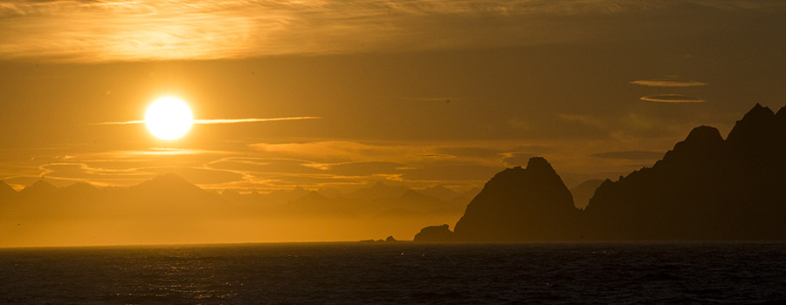

**Gulf of Alaska Keeper**

4040 Twilight Lane, Anchorage, AK 99516

Gulf of Alaska Keeper’s (GoAK) mission is to protect, enhance and conserve the water quality, habitat, and the life that depends on them in the Gulf of Alaska, including Prince William Sound (PWS). GoAK members have conceived, managed, and conducted extensive shoreline rehabilitation projects by the removal of millions of pounds of toxic plastic marine debris throughout the PWS coastal habitat. We have now cleaned over 1000 miles of shoreline within PWS and conducted nearly another 1000 miles of beach surveys by foot in the Sound. We are nationally and internationally recognized for the work we’ve done in PWS. It is fair to say that very few organizations or individuals have the breadth of experience in PWS as do GoAK members. Because of our extensive on-the-ground experience, we believe that GoAK is highly qualified to comment on the planned revisions to the 2016 Chugach Forest Management plan.

We understand and appreciate the Chugach National Forest’s effort and need to update their management plan. However, we strongly disagree with, and oppose, the revised management plan’s proposal to scale back Wilderness Study Act (WSA) protection by eliminating College Fiord, Knight Island, and Columbia Glacier areas from the WSA. At best it is a misguided policy; at worst it smells of moneyed interests trying to wrest open another chunk of public land for extractive and destructive commercial activities. And without question, such a policy change would open the land at question to mining, logging, industrial scale lodge building, and other land-based activities that would ***forever*** change the pristine wilderness characteristics of PWS. It would damage commercial, subsistence and recreational fish and wildlife resources. In addition, nowhere have logging, mining and onshore development proved compatible with salmon. PWS is one of Alaska’s greatest salmon producers year after year. Any management regime that could potentially damage that fully renewable and valuable resource is ill advised.

Because there seems to be no public demand or support for this proposal that reduces WSA protection in PWS, the questions of why now, and who is behind the proposal must be raised. This same proposal was raised in the proposed 2002 management plan revision and was soundly opposed by the public then, and ultimately rejected. Why is the Chugach Forest so adamant about changing WSA management requirements that the vast majority of the public supports? All this does is foster bad relationships between the Chugach National Forest and the majority of PWS users. And it attaches the stench of hidden impropriety to the proposed management plan revision. GoAK is not accusing the Chugach National Forest of any impropriety. In fact, we do not believe that is so and have a great deal of respect for the Chugach Forest‘s overall management and the high quality of all their personnel. We are just warning that there is a strong undercurrent of suspicion running through a broad spectrum of the public about this particular proposal. This suspicion, if allowed to fester, will undermine well established relations between the Chugach Forest and a multitude of stakeholders. Drop the proposed WSA revisions to maintain the trust and good working relationships the Chugach Forest has worked for so long to build among so many stakeholders.

There is simply no positive to the proposed WSA management plan change. It won’t save the Forest management costs, particularly if commercial activities take hold in Forest areas now protected under the WSA. It is far harder and much costlier to manage commercial activities on a forest than it is to manage a WSA indefinitely. The Forest Service, like all other federal agencies, is looking at tight and declining budgets. Why would the Chugach Forest opt for a management plan that will ultimately cost far more to implement with no reciprocal public or environmental gain?

Instead of eliminating areas from the WSA, GoAK members universally support, at bare minimum, preserving the Wilderness Study Area classification for the PWS areas currently so designated. Additionally, we recommend that the WSA classification, and the extra protection established by that classification, be extended to Montague Island. Montague Island is the largest uninhabited island in the United States. It is the most remote island in PWS and, in many ways, the PWS area most deserving of wilderness classification.

Since the opening of the Whittier Tunnel, PWS has been under assault from increased recreational use, commercial activities and onshore development. At the same time, it has become better known and more widely loved and cherished. There is minimal public support for reducing WSA protection in PWS. This is not the time to reduce management protections, but instead, increase them. The Chugach National Forest is a national treasure and all of it must be strongly protected for future generations.

**GoAK specifically recommends that:**

1) Montague Island be added to the original 1.9 million acre Wilderness Study Area (WSA) of western Prince William Sound and all of it should be recommended to Congress for designation as Wilderness and that the WSA should continue to be managed as Wilderness until it is congressionally designated;

2) The eastern Chugach - including the Copper River/Bering River/Martin Lake & River/Katalla River and watersheds - area should be protected as critical salmon and wildlife habitat and continue to allow existing use for fishers and subsistence harvesters;

3) The Chugach Forest should be withdrawn from mineral and forestry activity; and additional protective conservation acquisition areas should be identified;

4) And the [Exxon Valdez Oil Spill (EVOS) Restoration mandate](http://r20.rs6.net/tn.jsp?f=001mhzM_h9IiXqOKxGRuzpFDnAOpU98tjnpcqQinxbLrbQSssdkG5m-7xEdIhU8SLigi9E5p-0AlESqTM461uKYct2AbBh9_IAdkF3KScwbNzZG-V32YcVtGiWPMejP147h3THVt96nkpiwoa4xETz0wh-0vyMDulEUCS_JZmDAcITUkFYDeXRfcqjCz1YtKHmlDGrc99qmepUmWAS0WDRMbwPIk0Yw_IGyUHUlGKiYhhevY5ZmtkeiY2AJpKTZGXyIJdKXwDv8D-c=&c=ScmQ-YrN_04x5wH5Zfaz3garxYStEiCZ4V1wCVbUIDaGGUYKiEG8DQ==&ch=EGUtYsMDRhAUAfIu3m49uAOXZ4myA-4ORTaBC3Ixo2xiFY5-rR4Rww==) for the region must be upheld.

**The Proposed Forest Plan Revision, as written, is unacceptable and must be re-written to preserve the region more completely and managed primarily for the protection and conservation of fish and wildlife habitat as ANILCA intended.**