**Forest Carnivore Monitoring in the Southwestern Crown of the Continent:**

**2015 Progress Report**

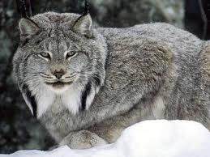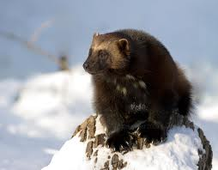

**Summary:** In 2015, we surveyed 76 grid cells using snow tracking and deployed 161 bait stations across the Southwestern Crown landscape. We detected lynx in 19 grid cells and identified 17 individuals (13 males, 4 females) through genetic sampling. We detected wolverine in 33 grid cells and identified 12 individuals (7 males, 5 females) through genetics. We did not detect any fisher in 2015. We discuss how this information can and should be used. Survey efforts are continuing in the SW Crown in the winter of 2016.

**Introduction:** In the winter of 2012, members of the Southwestern Crown Collaborative (SWCC) Wildlife Working Group began systematic, landscape-scale carnivore monitoring efforts within the Southwestern Crown-of-the-Continent (SW Crown) landscape. A previous report (available here: <http://www.swcrown.org/wp-content/uploads/2015/01/2012-2014-SWCC-Carnivore-Monitoring-Report-Final1.pdf>) summarized monitoring efforts from the first three winters, 2012-2014, and this report adds results from the winter of 2015. This monitoring project was designed to provide a baseline of the current distribution of the focal species in the SW Crown and to allow for tracking changes in that distribution over time.

The initial objectives identified for the project were to:

* Develop a better understanding of the distribution of forest carnivores, with a focus on lynx, wolverine, and fisher, across the project area, and to see if that distribution changes over the course of the Forest Service’s Collaborative Forest Landscape Restoration Program (CFLRP).
* Collect genetic material from the three focal species to establish important baseline information (individual identification and sex, sub-population genetics) and add to the existing body of knowledge of these species in the Northern Rockies.
* Better understand travel routes and coarse habitat selection for these species.
* Make a concerted effort to survey roadless and wilderness areas that have received very little survey effort to date.
* Complement ongoing research and monitoring efforts in the region, including reporting on wolf pack activity and lynx habitat mapping efforts.
* Identify “hot spots” where more intensive research could be conducted (e.g., GPS collar deployment to study specific habitat use).
* Improve the cost effectiveness of surveying forest carnivores at large scales and over time.
* Raise community awareness/increase support among partners and the general public for forest carnivore conservation.

The SW Crown carnivore project utilizes multiple non-invasive survey methods to maximize our ability to detect multiple species across a large landscape in an efficient and cost effective manner. We combine multi-species snow track surveys with non-invasive DNA collection methods (bait stations) and motion-sensor cameras. In order to standardize the approach across the SW Crown, a 5 x 5 mile grid (roughly 8 km x 8 km), which represents an area slightly smaller than an average female lynx home range, was overlaid on the entire landscape. There are 129 grid cells that at least partially intersect the SW Crown landscape (see Figure 4), and about 80 of those are fully or mostly in the SW Crown boundary. Those grid cells were targeted to conduct snow track surveys and deploy hair snare bait stations to monitor target carnivore species and meet the project objectives. Genetic samples were sent to the Forest Service’s Rocky Mountain Research Station (RMRS) in Missoula to determine species and individual.

# 2015 Survey Effort

In 2015, we surveyed a total of 76 grid cells (Table 1 and Figure 1) across 51 days in January-March. We partnered with the Bureau of Land Management to add the Garnet Mountains adjacent to the southern part of the SW Crown landscape. We deployed a total of 161 bait stations across 70 grid cells with an average of 48 days of deployment per station (Table 2).

Table 1. Snow-track survey effort from 2012-2015 for all target species.

|  |  |  |  |  |
| --- | --- | --- | --- | --- |
| Year | Number of survey days | Number of grid cellsa surveyed at least once | Total miles surveyedb | Average miles/grid cell/surveyc (range) |
| 2012 | 41 | 65 | 1115 | 3.2 (1.0 - 9.6) |
| 2013 | 51 | 73 | 1011 | 3.6 (1.0 - 10.0) |
| 2014 | 52 | 62 | 1240 | 4.0 (1.0 - 10.0) |
| **2015** | **51** | **76** | **1722** | **6.1 (1.0-22.5)** |

a There are 129 grid cells that at least partially intersect the SW Crown landscape, and 87 of those have their majority in the SW Crown boundary.

b Includes revisits to the same survey route.

c The average value used here is based on the number of miles covered on snowmobile or foot in each grid cell per survey effort, including revisits to the same grid cell.

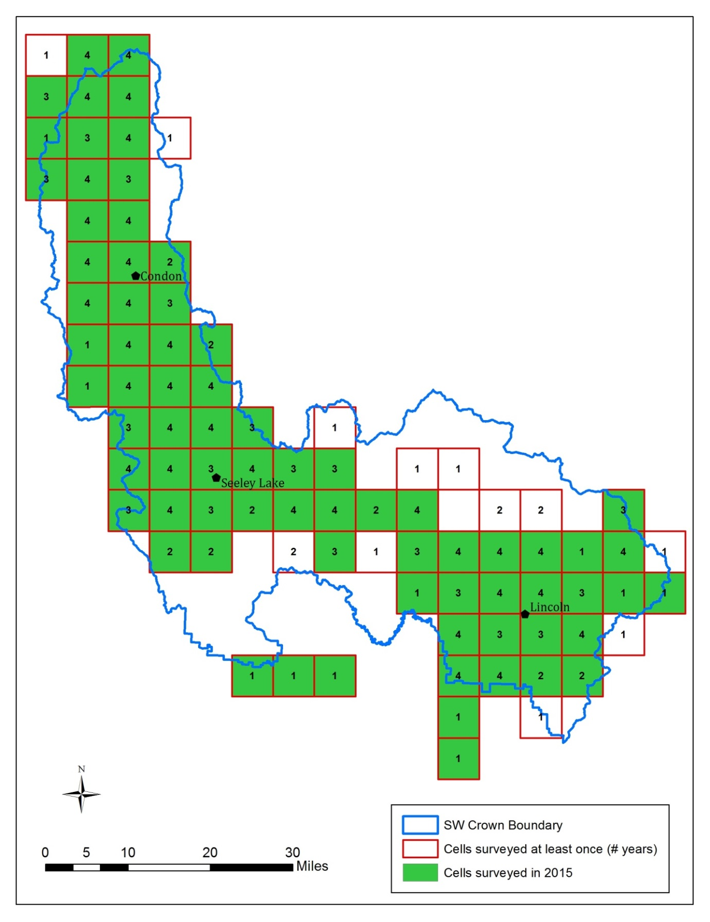

**Figure 1. Survey effort by grid cell across all years. Green cells were surveyed in 2015.** The number within each grid cell indicates the number of years that grid cell was surveyed over the four-year period of this monitoring effort.

Table 2. Summary of bait stations and hair snares deployed from 2012-2015.

|  |  |  |  |  |
| --- | --- | --- | --- | --- |
| Year | Number of bait stations or hair snares | Number of grid cellsa with at least one bait station or hair snare | Avg. number of bait stations/grid cell | Avg. number of days of bait station deployment (range)b |
| 2012 | 368 hair snares | 62 | 5.9 hair snares | 25.5 (18-46) |
| 2013 | 162 bait stations | 77 | 2.1 bait stations | 44 (19-121) |
| 2014 | 107 bait stations | 51 | 2.1 bait stations | 47 (13-87) |
| **2015** | **161 bait stations** | **70** | **2.3 bait stations** | **48 (14-170)** |

a There are 129 grid cells that at least partially intersect the SW Crown landscape, and 87 of those have their majority in the SW Crown boundary.

b Fisher hair snares were used in 2012.

# Lynx Results

In 2015, we detected lynx in a total of 19 grid cells (Table 3 and Figure 2). The total number of cells has been relatively consistent across all four years. In 2015, tracks were identified in 17 cells and two additional cells were added through bait stations. However, of the 17 individuals identified through genetic samples in 2015, four were identified strictly through samples from bait stations (Table 4). The area north of Seeley Lake continues to be the most consistent area for detections. No lynx were detected in the Garnet Mountains.

We have now identified a total of 26 unique lynx across 41 grid cells in our landscape across all years (Figure 2). All but five of these individuals are new to the RMRS genetic database (Table 4). We have identified over three times as many males as females. This may partly be due to the behavior of males and females at bait stations (e.g., females may be more cautious or males may dominate a bait station). However, genetic samples from track surveys should be unbiased in sex ratios and we still had 8 males to 4 females.

Table 3. Lynx detections in the SW Crown from 2012-2015 by detection method.

|  |  |  |  |  |
| --- | --- | --- | --- | --- |
| Year | Grid cells w/ track detectionsa | Grid cells w/ bait station detections | Total number of grid cells w/ detections (both methods) | Total number of individualsc |
| 2012 | 19 | n/ab | 21 | 4 (3m, 1f) |
| 2013 | 20 | 5 | 21 | 7 (5m, 2f) |
| 2014 | 19 | 10 | 19 | 13 (10m, 3f) |
| **2015** | **17** | **10** | **19** | **17 (13m, 4f)** |
| Total unique | 39 | 15 | 39 | 26 (19m, 7f) |

a There are 129 grid cells that at least partially intersect the SW Crown landscape. High or Moderate confidence.

b In 2012, fisher hair snares were used, which were not designed to detect lynx.

c See Table 4 for information on individuals.

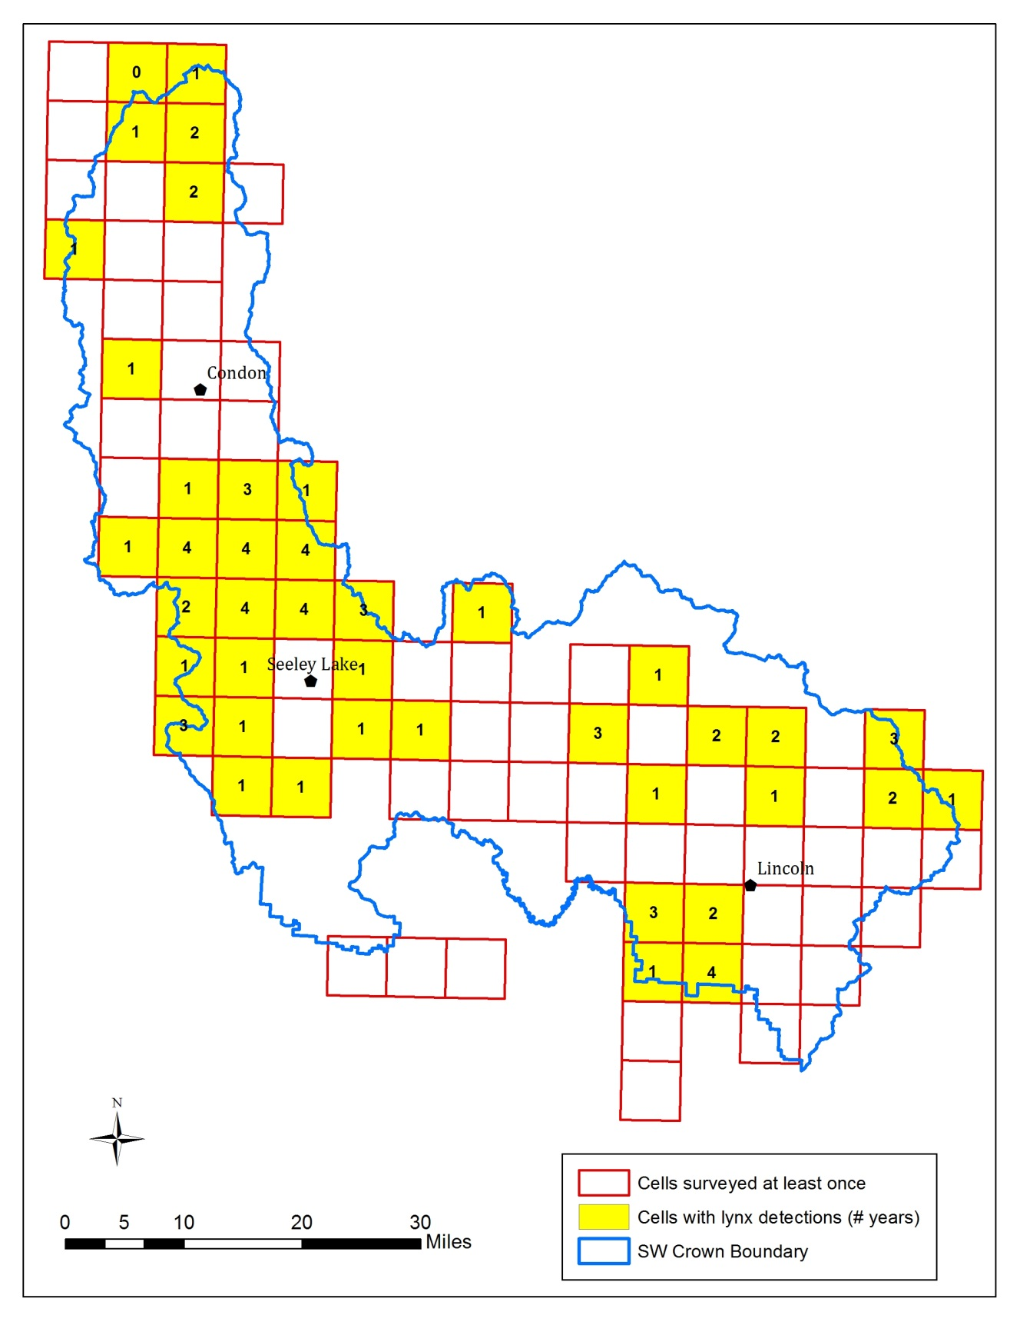

**Figure 2:** Survey effort and detections for lynx across the SW Crown from 2012-2015. Cells shaded yellow represent those with lynx detections in at least one year. Detections are from track surveys and/or bait stations. The number inside the cell indicates the number of years lynx were detected in the cell (out of a maximum of 4). Individuals could not be identified in all cells due to: samples from backtracking may not have been found, lynx in a grid cell may not have visited a bait station, or the DNA samples were of too low of quality.

Table 4. Sex, grid cell, Forest Service District, initial detection study, and method of detection of individual lynx identified through genetic samples from track surveys and bait stations 2012-2015.

|  |  |  |  |  |  |  |  |  |  |  |  |  |  |  |
| --- | --- | --- | --- | --- | --- | --- | --- | --- | --- | --- | --- | --- | --- | --- |
| Lynx ID | Sex | First Year Detected | Grid cells | District | No. Years Detected | Study First Identified | 2012a | 2013 | | 2014 | | 2015 | | Location |
| Snow track | Snow track | Bait Station | Snow track | Bait Station | Snow track | Bait Station |
| M059 | Male |  | 2163  2222 | Seeley | 3 | RMRS |  |  | 2163 |  | 2163 |  | 2222, 2163 | Rice Ridge/ Morrell/ Pyramid area |
| M080 | Male |  | 2048 2105 | Swan, Seeley | 3 | RMRS |  |  | 2105 | 2048 | 2048, 2105 | 2048 | 2048, 2105 | Sunset Ridge, Beaver Creek, Colt/Uhler Creek. Seeley-Swan divide |
| M092_M174 | Male |  | 2045 | Seeley | 2 | RMRS |  |  |  |  | 2045 |  | 2045 | Elk Meadows |
| M147 | Male |  | 2104, 2105 | Seeley | 3 | RMRS |  |  | 2104, 2105 | 2104 |  | 2104 | 2104 | Marshall Lake to Colt Uhler |
| M163 | Male |  | 2542 | Lincoln | 1 | RMRS |  |  |  | 2542 | 2542 |  |  | Dalton Mountain |
| SWCC_12_LynxM01 | Male | 2012 | 2106 | Swan | 1 | SWCC | 2106 |  |  |  |  |  |  | Lower Beaver Creek |
| SWCC_12_LynxM02 | Male | 2012 | 2446 | Seeley | 1 | SWCC | 2446 |  |  |  |  | 2446 |  | N.F. Blackfoot |
| SWCC_12_LynxM03 | Male | 2012 | 2595 2687 | Lincoln | 1 | SWCC | 2595 |  |  | 2687 |  |  |  | Web Lake to Alice Creek |
| SWCC_12_LynxF04 | Female | 2012 | 2104 | Seeley | 1 | SWCC | 2104 |  |  |  |  |  |  | Marshall Lake |
| SWCC_13_LynxM05 | Male | 2013 | 2546 | Lincoln | 1 | SWCC |  | 2546 |  |  |  |  |  | Web Lake |
| SWCC_13_LynxF06 | Female | 2013 | 2164 | Seeley | 3 | SWCC |  | 2164 |  |  | 2164 | 2164 |  | Richmond Ridge area consistently |
| SWCC_13_LynxF07 | Female | 2013 | 2055 | Swan | 1 | SWCC |  | 2055 |  |  |  |  |  | S.F. Lost Creek in Swan Range |
| SWCC_13_LynxM08 | Male | 2013 | 2164 | Seeley | 2 | SWCC |  | 2164 |  |  | 2164 |  |  | Richmond Ridge |
| SWCC_14_LynxF09 | Female | 2014 | 2045 | Seeley | 1 | SWCC |  |  |  | 2045 | 2045 |  |  | Elk Meadows |
| SWCC_14_LynxF10 | Female | 2014 | 2164 | Seeley | 2 | SWCC |  |  |  |  | 2164 | 2164 | 2164 | Richmond Ridge |
| SWCC_14_LynxM11 | Male | 2014 | 2163 | Seeley | 1 | SWCC |  |  |  |  | 2163 |  |  | Rice Ridge |
| SWCC_14_LynxM12 | Male | 2014 | 2686 2687 | Lincoln | 2 | SWCC |  |  |  |  | 2686,  2687 | 2686 |  | Alice Creek, Caddott, Bartlett |
| SWCC_14_LynxM13 | Male | 2014 | 2104  2163  2164 | Seeley | 2 | SWCC |  |  |  |  | 2104 | 2163 | 2163, 2164 | Colt/Uhler in 2014 then east across highway to Richmond/ Rice Ridge. Only highway 83 lynx crossing. |
| SWCC_15_LynxM14 | Male | 2015 | 2046 | Seeley | 1 | SWCC |  |  |  |  |  |  | 2046 | Second Creek |
| SWCC_15_LynxM15 | Male | 2015 | 2165 | Seeley | 1 | SWCC |  |  |  |  |  |  | 2165 | Clearwater Lake/Loop Road north of Richmond Ridge |
| SWCC_15_LynxF16 | Female | 2015 | 2542 | Lincoln | 1 | SWCC |  |  |  |  |  | 2542 |  | Dalton Mountain |
| SWCC_15_LynxM17 | Male | 2015 | 1993 | Swan | 1 | SWCC |  |  |  |  |  |  | 1993 | Lindy Ridge |
| SWCC_15_LynxM18 | Male | 2015 | 2104 | Seeley | 1 | SWCC |  |  |  |  |  | 2104 |  | Marshall Lake |
| SWCC_15_LynxM19 | Male | 2015 | 2105 | Seeley | 1 | SWCC |  |  |  |  |  | 2105 |  | Colt/Uhler |
| SWCC_15_LynxM20 | Male | 2015 | 2687 | Lincoln | 1 | SWCC |  |  |  |  |  | 2687 |  | Alice Creek |
| SWCC_15_LynxF21 | Female | 2015 | 2045 | Seeley | 1 | SWCC |  |  |  |  |  | 2045 | 2045 | Elk Meadows |

a In 2012, fisher hair snares were used, which were not designed to detect lynx.

# Wolverine Results

In 2015, we detected wolverine in a total of 33 grid cells (Table 5). This is similar to the previous year, though we almost doubled the number of detections through bait stations in 2015. We also identified more individuals through genetics in 2015. We have now identified 22 unique wolverine in the SW Crown landscape, all but three of which are new to the RMRS database (Table 6). Cells are distributed across all three districts, though the Mission Mountains appear to be a consistent location. No wolverines were detected in the Garnet Mountains.

Table 5. Summary of wolverine detections using both track surveys and bait stations, 2012-2015.

|  |  |  |  |  |
| --- | --- | --- | --- | --- |
| Year | Grid cells w/ track detectionsa | Grid cells w/ bait station detections | Number of grid cells w/ detections (both methods) | Number of individualsc (males, females) |
| 2012 | 9 | 2 | 9 | 1 (1f) |
| 2013 | 12 | 9 | 16 | 10 (4m,6f) |
| 2014 | 29 | 16 | 31 | 11 (5m, 6f) |
| **2015** | **24** | **27** | **33** | **12 (7m, 5f)** |
| Unique | 42 | 34 | 47 | 22 (11m, 11f) |

a There are 129 grid cells that at least partially intersect the SW Crown landscape.

b In 2012, fisher hair snares were used not multi-species bait stations.

c See Table 6 for information on individuals.

# 2015 Fisher Results

**Fisher:** Similar to years 2012-2014, no fishers were detected in the SW Crown in 2015.

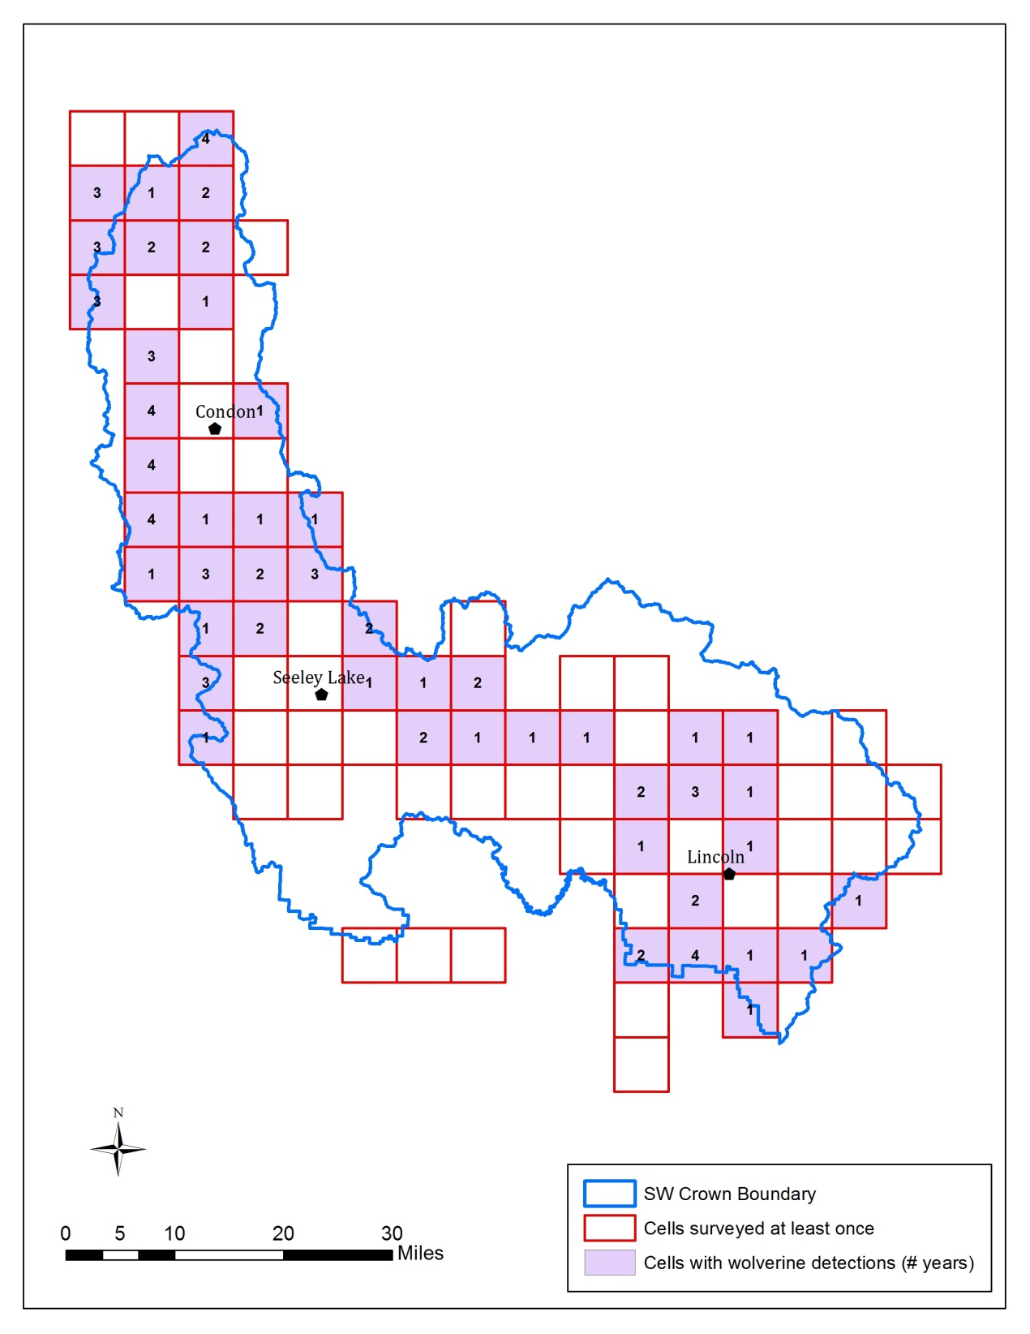

**Figure 3:** Survey effort and detections for wolverine across the SW Crown from 2012-2015. Cells shaded purple represent those with wolverine detections in at least one year. Detections are from track surveys and/or bait stations. The number inside the cell indicates the number of years wolverines were detected in the cell (out of a maximum of 4). Individuals could not be identified in all cells due to: samples from backtracking may not have been found, wolverine in a grid cell may not have visited a bait station, or the DNA samples were of too low of quality.

Table 6. Sex, grid cells, Forest Service District, initial detection study, and method of detection of individual wolverine identified through track surveys and bait stations 2012-2015.

|  |  |  |  |  |  |  |  |  |  |  |  |  |  |  |
| --- | --- | --- | --- | --- | --- | --- | --- | --- | --- | --- | --- | --- | --- | --- |
| Wolverine ID | Sex | First Year Detected | Grid cells | District | No. Years Detected | Study First Identifieda | 2012b | 2013 | | 2014 | | 2015 | | Location |
| Bait Station | Snow track | Bait Station | Snow track | Bait Station | Snow track | Bait Station |
| BDF10-M6 | Male |  | 2492 2495  2542  2639  2684 | Lincoln | 2 | WTU |  |  |  | 2542 | 2495, 2542 |  | 2492, 2542, 2639, 2684 | North of Highway 200 in 2014, otherwise we have been detecting him from Ogden east towards Stemple Pass |
| HFW10-M3 | Male |  | 2492 | Lincoln | 1 | WTU |  |  |  | 2492 |  |  |  | Ogden area south of Lincoln |
| HFW12-F7 | Female |  | 2492 2542 | Lincoln | 1 | WTU |  |  |  | 2492 | 2492, 2542 |  |  | Ogden, Dalton area south of Lincoln |
| SWCC_13_GuloM01 | Male | 2013 | 2590 | Lincoln | 1 | SWCC |  |  | 2590 |  |  |  |  | Nevada Creek area south of Lincoln |
| SWCC_13_GuloF02 | Female | 2013 | 1994 | Swan | 1 | SWCC |  |  | 1994 |  |  |  |  | Glacier Lake TH area in Mission Mountains |
| SWCC_13_GuloF03 | Female | 2013 | 1996  1997  2046  2048 2104 | Seeley, Swan | 3 | SWCC |  | 1996 | 1996, 1997 | 2104, 2046 | 2048, 2104 |  | 2048 | Piper/Cold Creek area in 2013. Then south in Sunset, Marshall Lake, Elsina country in southern Missions/Seeley-Swan divide |
| SWCC_13_GuloF04 | Female | 2013 | 1996 1997 | Swan | 1 | SWCC |  | 1997 | 1996, 1997 |  |  |  |  | Cold Creek and Piper Creek drainages in Mission Mountains |
| SWCC_13_GuloF05 | Female | 2012 | 2164  2221 2222 2545 | Seeley, Lincoln | 4 | SWCC | 2545 |  | 2164 | 2221 | 2222 | 2164 | 2164 | Dispersed from Lincoln (Copper Creek) to Seeley. Then consistent detections from E.F. Clearwater, Richmond Ridge, Pyramid, Morrell, southern Swan Range. |
| SWCC_13_GuloF06 | Female | 2013 | 1945 | Swan | 3 | SWCC |  | 1945 | 1945 | 1945 | 1945 |  | 1945 | Cedar TH in Mission Mountains |
| SWCC_13_GuloM07 | Male | 2013 | 2046 | Seeley | 1 | SWCC |  |  | 2046 |  |  |  |  | Elsina Lake area in southern Missions |
| SWCC_13_GuloM08 | Male | 2013 | 1945  1994  1995  1996 2048 2104 | Swan, Seeley | 3 | SWCC |  |  | 1994 |  | 1994, 2048, 2104 |  | 1945, 1995, 1996 | Cedar TH, Cold Creek, Glacier TH, Elk Creek, Sunset, Marshal Lake in central to southern Missions and Seeley-Swan divide. |
| SWCC_13_GuloM09 | Male | 2013 | 1947  1999  2000 | Swan | 3 | SWCC |  |  | 1947 |  | 1947 | 1947 | 1999, 2000 | Whitetail, Porcupine, Woodward in the northerly portion of the Mission Mountains |
| SWCC_13_GuloF10 | Female | 2013 | 2164 | Seeley | 2 | SWCC |  |  | 2164 |  |  |  |  | Richmond Ridge/E.F. Clearwater, southern Swan Range |
| SWCC_14_GuloF11 | Female | 2014 | 2054 2056 | Swan | 2 | SWCC |  |  |  | 2056 | 2054, 2056 |  | 2056 | Goat Creek to N.F. Lost Creek in Swan Range |
| SWCC_14_GuloF12 | Female | 2014 | 1994  1997  2056  2108 | Swan | 2 | SWCC |  |  |  |  | 1994, 1997, 2056, 2108 | 1994 | 1997 | 2014 detected in Glacier, Smith, N.F. Lost, Moore in both Swan and Mission mountains, which implies multiple Hwy 83 crossings. 2015 detections were more consistent from Glacier Creek to Piper Creek in Mission Mountains |
| SWCC_15_GuloM13 | Male | 2014 | 2108  2339 2393  2495 | Seeley, Lincoln | 2 | SWCC |  |  |  |  | 2108 | 2339, 2393 | 2495, 2339 | Detected in Smith Creek on Swan Range in 2014 then Duhnam/Lodgepole to MacCabe Creek area over to Huckleberry Pass north of Ovando and detected on Seeley and Lincoln districts in 2015 |
| SWCC_15_GuloM14 | Male | 2015 | 1994 2048 | Swan | 1 | SWCC |  |  |  |  |  | 1994, 2048 |  | Glacier Creek to Sunset Ridge, Mission Mountains |
| SWCC_15_GuloM15 | Male | 2015 | 1945  1946  1947  1999  2000 | Swan | 1 | SWCC |  |  |  |  |  | 1999 | 1945, 1946, 1947, 1999, 2000 | Cedar TH to Whitetail/Porcupine in Northern Missions |
| SWCC_15_GuloF16 | Female | 2015 | 2054 | Swan | 1 | SWCC |  |  |  |  |  |  | 2054 | Goat Creek, Swan Range |
| SWCC_15_GuloF17 | Female | 2015 | 2045 | Seeley | 1 | SWCC |  |  |  |  |  |  | 2045 | Elk Meadows, Seeley/CSKT divide |
| SWCC_15_GuloM18 | Male | 2015 | 2056 | Swan | 1 | SWCC |  |  |  |  |  |  | 2056 | N.F. Lost Creek, in northern project area in Swan Range, east of Swan Lake |
| SWCC_15_GuloM19 | Male | 2015 | 2545 | Lincoln | 1 | SWCC |  |  |  |  |  |  | 2545 | Upper Copper Creek, north of Lincoln |

a WTU is Wild Things Unlimited.

b In 2012, no wolverine track genetics samples were collected and fisher hair snares were used, which were not designed to detect wolverine.

# 2013-2014 Wolverine Relatedness

In 2015, we asked RMRS to analyze the existing (2013-2014) wolverine genetic samples for relatedness. Table 7 shows which pairs could potentially have a parent-offspring relationship. Those pairs with a “yes” share alleles at all 17 loci evaluated (which a parent and offspring would have). However, this does not necessarily mean this relationship is indeed the case (they could be siblings or cousins or unrelated), and that is why it is important to bring data and knowledge from the field (e.g., locations, cameras, individuals traveling together, etc.) when thinking about how likely these relationships would be. (“SWCC” was removed from the ID of individuals in the column headings to save space.)

**Table 7. Potential for genetic relatedness of individual wolverines identified in the SW Crown from 2013-2014.**

|  |  |  |  |  |  |  |  |  |  |  |  |  |  |  |
| --- | --- | --- | --- | --- | --- | --- | --- | --- | --- | --- | --- | --- | --- | --- |
|  | **13_GuloM01** | **13_GuloF02** | **13_GuloF03** | **13_GuloF04** | **13_GuloF05** | **13_GuloF06** | **13_GuloM07** | **13_GuloM08** | **13_GuloM09** | **13_GuloF10** | **14_GuloF11** | **14_GuloF12** | **HFW10-M3** | **BDF10-M6** |
| **SWCC_13_GuloM01** | * |  |  |  |  |  |  |  |  |  |  |  |  |  |
| **SWCC_13_GuloF02** | no | * |  |  |  |  |  |  |  |  |  |  |  |  |
| **SWCC_13_GuloF03** | no | no | * |  |  |  |  |  |  |  |  |  |  |  |
| **SWCC_13_GuloF04** | no | no | no | * |  |  |  |  |  |  |  |  |  |  |
| **SWCC_13_GuloF05** | no | no | no | no | * |  |  |  |  |  |  |  |  |  |
| **SWCC_13_GuloF06** | no | no | yes | no | no | * |  |  |  |  |  |  |  |  |
| **SWCC_13_GuloM07** | no | no | no | yes | no | no | * |  |  |  |  |  |  |  |
| **SWCC_13_GuloM08** | no | no | no | yes | no | no | no | * |  |  |  |  |  |  |
| **SWCC_13_GuloM09** | no | no | no | no | no | yes | no | no | * |  |  |  |  |  |
| **SWCC_13_GuloF10** | no | no | no | no | yes | no | no | no | no | * |  |  |  |  |
| **SWCC_14_GuloF11** | no | no | yes | no | no | no | no | no | no | no | * |  |  |  |
| **SWCC_14_GuloF12** | no | no | no | no | no | yes | no | no | no | no | yes | * |  |  |
| **HFW10-M3** | no | no | no | no | no | no | no | no | no | no | no | no | * |  |
| **BDF10-M6** | no | no | no | no | no | no | no | no | no | no | no | no | no | * |
| **HFW12-F7** | no | no | no | no | no | no | no | no | no | no | yes | yes | yes | no |

# How the data can be used

The Southwestern Crown Collaborative (SWCC) Wildlife Working Group has collected significant data on meso-carnivores, especially lynx and wolverine, throughout the Southwestern Crown landscape from 2012-2015. This information can be, and has been, used for multiple purposes. Here, we summarize some of the potential uses of this data and provide examples of how it is already being used.

1. **Effectiveness monitoring:** This monitoring project was first initiated to help the SWCC determine if the abundance and distribution of important wildlife populations changes during the implementation period of the Collaborative Forest Landscape Restoration Program (CFLRP). One of the goals of the CFLRP is to improve wildlife habitat and this monitoring project was designed to meet the desire of “effectiveness” monitoring at the landscape scale. We understand that it is difficult to connect changes in wildlife populations, especially those with large home ranges, directly to specific management actions because of many different factors (e.g., climate variability, wildfires, management actions on private land, etc.). However, monitoring population changes over time can help determine if conditions are improving or possibly deteriorating across a landscape. If we monitored only habitat components and not the species themselves, we would not know how the species was responding to current conditions. Now that we have a solid baseline of data from early in the 15-year CFLRP monitoring window, we can repeat the efforts at the end to see if conditions have improved for these species across the landscape.
2. **Project planning:** Lynx and wolverine detection locations can be used when deciding where management actions should occur. They can help identify areas of potential use by these species and where improvements to habitat may be appropriate. For example, some units being considered for treatment may be removed if regular use of the area by a species is known. Conversely, an area without observations could be considered for treatments that may improve conditions for a species.

**Example**: Bios provide an example of project planning?

1. **Effects analyses:** Observations can also be used in effects analyses for Environmental Assessments and Environmental Impact Statements conducted under the National Environmental Policy Act (NEPA). The frequency of track observations

**Example**: Bios provide an example of effects analysis?

1. **Landscape planning:** At the landscape scale, the data and results have the potential to inform a wide variety of regional management efforts. Some of these include (but are not limited to): the development of new Forest Plans under the 2012 Planning Rule; the Blackfoot and Swan Landscape Restoration Project (BSLRP) being conducted for the SW Crown landscape; the development of collaborative restoration projects by local restoration committees or the SWCC; or the evaluation of lands included in Wilderness Inventories under Chapter 70 of the 2012 Forest Planning Rule.

**Example:** These data could be used by the BSLRP ID Team as a filter for identifying potential restoration areas. Those grid cells with little to no use could be targeted for restoration and habitat improvement. Need to improve this or use another example.

1. **Regional monitoring:** Region 1 of the U.S. Forest Service is considering using our methods to expand carnivore monitoring efforts across a wider geographic area to meet monitoring requirements. We have tested and improved our methodology over several years and believe these methods could be effectively implemented through partnerships throughout the region. We have already expanded our efforts onto land managed by the BLM and will start to work on land owned by The Nature Conservancy this next year. Gathering data from a much larger region can help put local results into context: What areas are most important? Where are places of connectivity between suitable habitat?
2. **Use by other agencies:** These data can be used to inform management planning for these species by other federal and state agencies, such as the U.S. Fish and Wildlife Service (USFWS) and Montana Fish, Wildlife & Parks, which are mandated to conserve and manage wildlife populations.

**Example:** Our lynx data was recently compiled, summarized, and provided to the USFWS in response to a call for data. USFWS are reviewing the species status and our data is likely to be some of the most rigorous data available in the region.

1. **Research efforts:** These data can be used as a starting point for many different research topics.

**Examples:** Species observations can help guide researchers, including work being done by John Squires at the Rocky Mountain Research Station (RMRS), for trapping and collaring individuals to answer larger management questions. The genetics data for our landscape could be analyzed by RMRS with data from other regional efforts (e.g., surveys in Glacier National Park, the Cabinet/Purcell Mountains, and Canada) to look at gene flow in the larger Northern Rockies region.

1. **Educational and outreach efforts:** The monitoring project and its data can be used for many different educational efforts. Lessons from the field, such as learning tracks and videos from bait stations, have been shared with a wide audience and created an appreciation for wildlife species that few people get to observe. The data, at least at the grid cell scale, could potentially be used in classroom exercises.

**Examples:** Presentations to local communities such as Swan Valley Community Center, Natural History Center in Missoula, Wildlife in the West Class at Swan Valley Connections; professional conferences: MT Wildlife Society (2015), MT SAF Missoula (2015), Meso-Carnivore Monitoring Workshops (2014, 2015), multiple press articles in local and regional papers.

# Next steps

Survey efforts are continuing in the SW Crown in the winter of 2016, including on adjacent BLM lands. In addition, in 2016, surveys will be conducted by Northwest Connections on lands recently acquired by The Nature Conservancy to the southwest of the SW Crown landscape. We will likely skip surveys in the SW Crown in 2017, or significantly reduce our efforts. Surveys will likely continue on BLM and TNC lands in 2017 to continue to establish a baseline.

In the coming year, we plan to spend substantial time analyzing the data from the first four years (2013-2016, not counting the 2012 pilot year). We hope to engage the help of other biologists to develop rigorous statistical metrics for our population. We will complete a final baseline report and potentially publish the results of our efforts.