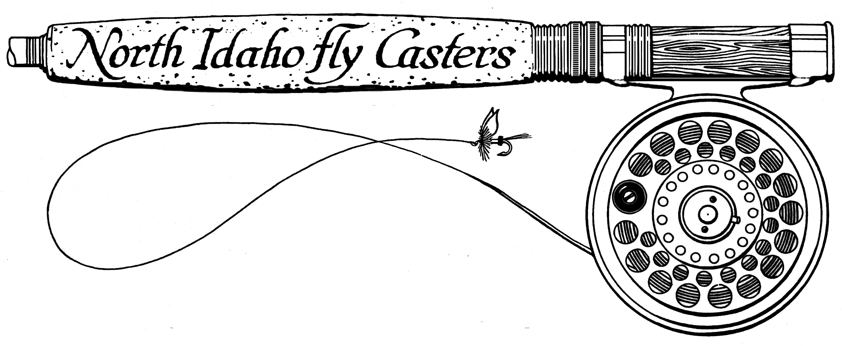

P.O. Box 1698

Coeur d’ Alene, Idaho 83816-1698

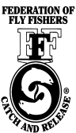

An Active Member Club of the FFF

Honey Badger Project

*Coeur D’ Alene River Ranger District*

*2502 East Sherman Avenue*

*Coeur d’ Alene, ID. 83814*

The North Idaho Fly Casters Club (NIFC) is a local fly fishing club that is dedicated to all facets of the sport of fly fishing by providing a wide range of educational, social and conservation opportunities to the fly fishing enthusiast. We have been involved in habitat restoration work with the state of Idaho and numerous federal agencies for over three decades.

The North Idaho Fly Casters are in support of the Honey Badger Project to aid in the improvement in water quality and improve aquatic habitat in the watersheds encompassed in the project area.

Our club has been actively involved in conservation projects since its inception. In 2019 the club had over 50 volunteers who picked up litter along the North Fork of the Coeur D’Alene and would like to offer our support in future years pertaining to this aquatic habitat reclamation pertaining to this project.

We would like to extend our support for the Honey Badger Project and feel that the project brings many safety and conservation benefits to this individuals in the interface area.

Sincerely,

Tom McLaughlin

Tom McLaughlin

Conservation Chairman, North Idaho Fly Casters