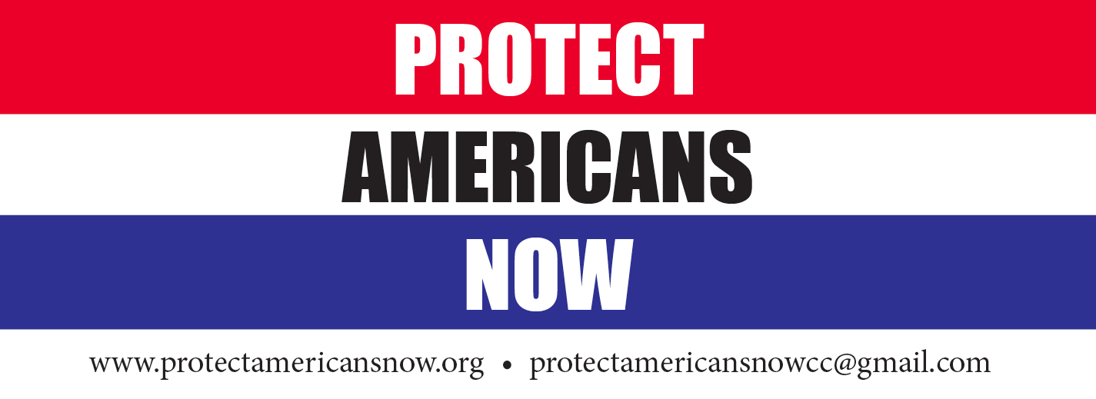
P.O. Box 1708 / Elephant Butte / NM 87901 / 505.263.2015

April 17, 2021

RE: December 2020 Proposed Rangeland Management Directives Update of the U.S. Forest Service (USFS) contained in the Forest Service Manual (FSM) 2200, Forest Service Handbook (FSH) 2209.12 and FSH 2209.16

To Whom It May Concern:
On behalf of the membership of Protect Americans Now (PAN), a non-profit organization dedicated to affecting and changing government policy, thank you for the opportunity to attempt to comment on the above captioned documents.
Unfortunately, the lack of explanation, concise detail, a red-lined document and sheer breadth of these documents made it impossible to provide meaningful comments. We respectfully request that in the future documents of this nature are made available in text and context to allow the layman to understand and comment.
Thank you for your time and attention.
Sincerely,
John Richardson
John Richardson
President

