**Grays Harbor Stumpbusters**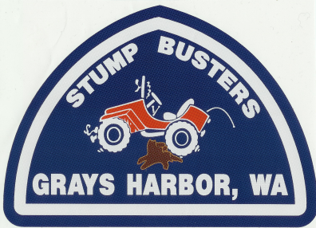

**Mailing Address: 51 Evergreen Lane, Montesano, WA 98563**

**Phone: 360-249-4186, Email: ghstumpbusters@hotmail.com**

The Olympic National Forest has been utilized for outdoor recreation by many families for decades. Those families rely upon the USFS roads for access to their favorite areas for hunting, fishing, hiking, camping, berry picking, wild life viewing, mountain biking, horseback riding, and scenic drives.

Please review following comments regarding the USFS’s proposal for changing the status of several roads.

Many of the roads proposed for decommissioning are currently closed to motorized vehicles. When these roads are decommissioned it would be helpful if it is done in a manner that still allows for people and animals to follow and cross the roadbed without obstructions. Also, leave a short section of the road intact at the junction for dispersed camping or parking at a trailhead.

The loop road 2270 should be retained for vehicle travel. This could be utilized for firefighting as well as scenic travel for those that cannot hike. The maintenance level could be reduced from ML3 to ML2 beginning at the 400 spur.

Retain as much as practical of the 2270-400 spur. This provides access to the Wynoochee Pass trail and the various trails within the national park. Sufficient parking should be provided as well.

Spur 2270-560 is used to access several trails and Discovery Lake. As is it works well. Can this be left alone for nature to reclaim? If not the please only do the minimum to decommission the road while leaving parking for the hikers.

Please leave 2270-600 as is for access to Humpnoochee Pass. This is an excellent trail for hiking and horseback riding between the West Fork Humptulips and Wynoochee drainages.

Please keep 2294 as a ML2 road from the west end to the slide near spur 480. Also retain 2294-500 as ML2.

The dispersed camping area where 2275-100 crossed the West Branch of the Wynoochee River needs to be kept open in some fashion. Perhaps a limited number of spaces for RVs could be created away from the river and sessional placement of port-a-potties could be installed for use by tent campers.

In addition to the above comments I would like to know if any thought has been given to creating opportunities for OHV users to utilize any of the roads being decommissioned?

Thank you for the opportunity to comment on the USFS’s proposed actions in the Wynoochee watershed.

Sincerely;

K J Kaivo

President, Grays Harbor Stumpbusters (a Four Wheel Drive Club)

Member, Pacific Northwest 4 Wheel Drive Association

Member, Olympic Public Access Coalition