December 2, 2019

Mr. George Ervin “Sonny” Perdue

Secretary

U.S. Department of Agriculture

1400 Independence Ave., S.W.

Washington, DC 20250

Ms. Vicki Christiansen

USDA Forest Service Chief

US Forest Service

1400 Independence Ave., SW

Washington, D.C.

20250-0003

Mr. David Schmid

Regional Forester

US Forest Service

709 W 9th St # 923

Juneau, AK 99801

RE: The Roadless Area Conservation Rule of 2001 - Document #84 FR 55522

Dear Secretary Perdue, Chief Christiansen and Mr. Schmid,

The Garden Club of America (GCA) is a national organization founded in 1913, comprised of 201 clubs representing approximately 18,000 members across the United States. The GCA actively seeks to restore, improve, and protect the quality of the environment through programs and action in the fields of conservation, civic improvements and education.

On behalf of the Conservation Committee and the National Affairs and Legislation Committees of the GCA, we write to request your continued and strict adherence to the Roadless Area Conservation Rule of 2001 (the “Roadless Rule”). We oppose granting exemptions from the Roadless Rule on a state by state basis. In particular, we oppose the elimination or reduction of protection of the Tongass National Forest, the Earth’s last remaining intact temperate forest.

Forests have been described as the lungs of the Earth. As we come to understand the profundity of the climate crisis, we must work to protect the forests we still have. Forests sequester huge amounts of carbon, clean our air of particulate matter, filter our drinking water and provide habitat for increasingly threatened and endangered species. The motto of the US Forest Service is "To sustain the health, diversity, and productivity of the Nation's forestsand grasslands to meet the needs of present and future generations.” Since 2001, the “Roadless Rule” has protected 58.5 million acres of our Nation’s forests from the encroachment of road building and the destruction brought through clearcutting and timber harvesting, fulfilling that promise. Generations to come will still be able to recreate and enjoy the beauty of our national forests because of the protection of the Roadless Rule.

The Tongass National Forest is home to the rare Sitka spruce, western hemlock, western red cedar, and Alaska yellow cedar as well as four hundred species of land and marine wildlife, including wolves, bald eagles, brown and black bears and Sitka black-tailed deer. Many are threatened or endangered species. Seven species of salmon and trout call this area home, providing the backbone of the commercial fishing industry that, along with tourism, birding, and recreation, are robust economic engines in the region.[1]

As stewards of our nation’s forests, we urge you to continue to uphold the Roadless Area Conservation Act of 2001, prohibiting the encroachment of roads and continuing to protect the last remaining intact temperate rainforest on Earth for future generations.

Sincerely,

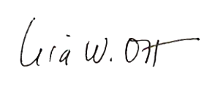

Lisa Ott

Chairman

National Affairs and Legislation Committee

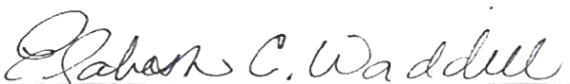

Elizabeth Waddill

Chairman

Conservation Committee

1.