Comment Regarding the Draft Environmental Impact Statement for the Land Management Plan Revision for the Nez Perce-Clearwater National Forests

Written by Pat Finnegan

April 20, 2020

Zach Peterson

Forest Planner

Nez Perce-Clearwater National Forests Supervisor’s Office

903 3rd St.

Kamiah, ID 83536

Thank you for the opportunity to comment on the Draft Environmental Impact Statement (DEIS) for the Land Management Plan Revision for the Nez Perce-Clearwater National Forests (NPCNF). I appreciate effort by the Forest Service (FS) to encourage and consider public input. I am interested in additional information about this project and would like to be added to the electronic mailing lists for this or other actions proposed for review under NEPA for the NPCNF. My email is [pmfinnegan@hotmail.com](mailto:pmfinnegan@hotmail.com).

I am concerned about certain aspects of the DEIS. In particular, I don’t agree with the apparent assumption by the FS that active management will improve ecological function. The persistence and resilience of functioning ecological processes within the plan area is most pronounced on lands protected as Wilderness, Inventoried Roadless Areas and Wild and Scenic River corridors. As illustrated and referenced in the DEIS, sound science supports reduced intervention and encouragement of natural ecological processes to sustain the valuable ecological services these lands provide.

While maintaining a viable timber industry is important to the local economy, mitigating the harmful effects of past, present and future logging and mining should form the basis of the revised Forest Plan. The potential for increased eco-tourism and recreation opportunities in a pristine, functioning ecosystem makes the area attractive to other businesses and should be a high priority consideration in the revised Forest Plan alternatives.

I also disagree with the FS assumption that the Forests encompassed by the plan need to be rescued from the effects of natural wildfire. Revised Forest Plan alternatives indicate that restoration logging should be implemented to compensate for past fire suppression and prevent large wildfires, which are now burning at unprecedented intensities over larger acreages. This paradigm argues that mixed severity wildfire can be replaced with logging and low intensity prescribed fire. These assumptions are not science based.

It is well established that mixed severity wildfire is an important driver of ecological processes within the plan area and data included in the DEIS show that fire intensities, acreage burned and fire return intervals are within the historic range of variability for the NPCNF. Differences in acreage burned and fire frequency across the plan area are illustrated by the following graphs that contrast the fire regimes between the Nez Perce and Clearwater NFs; however, significant increases in fire activity across the plan area will be required to approach a historic average due to several large, high intensity wildfires during the late 1800s and early 1900s. These fires burned natural fuel loads prior to implementation of large scale fire suppression strategies.

There is no evidence to indicate fire suppression has effectively contained or stopped fires from burning when fuel conditions and weather combine to initiate large, high intensity fires. The Forests considered in the DEIS encompass vast areas subject to long fire return intervals and high intensity fires burning through mature forests. Since the 1980s, as this natural cycle continues, fuel loads have returned to conditions that favor large, higher intensity fires when weather conditions and ignition sources combine.

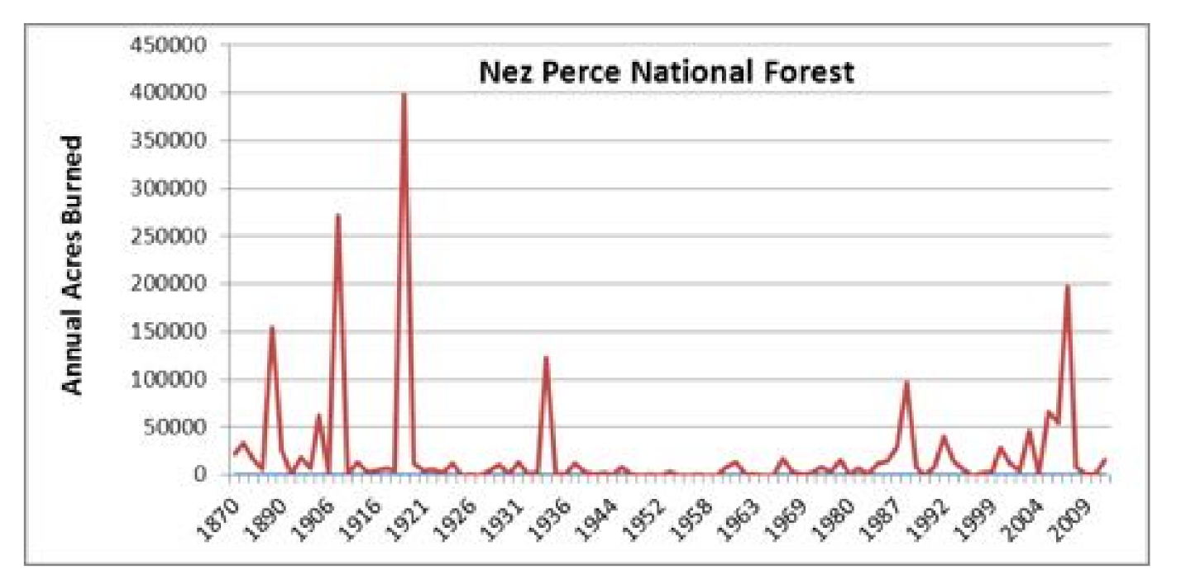

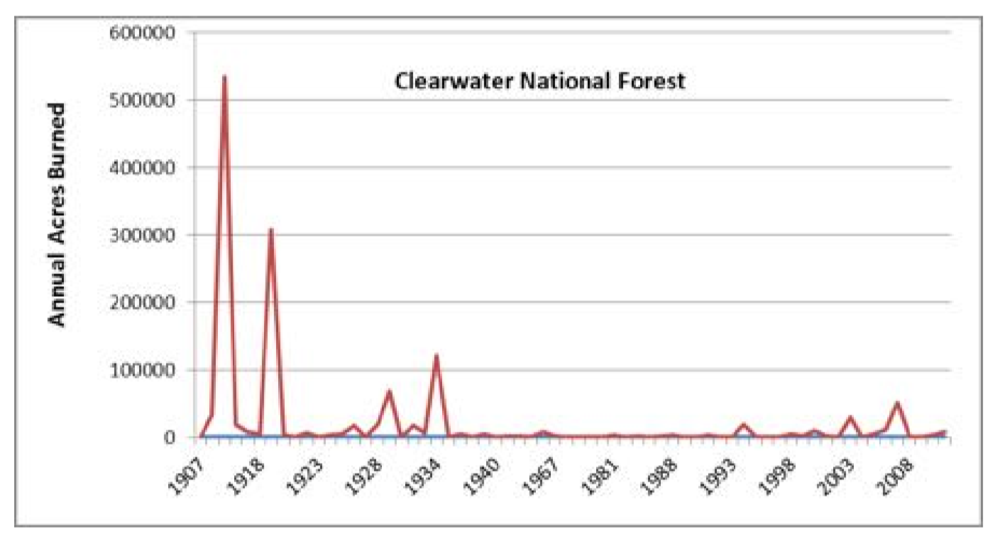

Another false assumption implies that recent fires are ‘catastrophic’ and burn with higher intensity than historic and prehistoric averages. The DEIS illustrates that even among a subset of years with the most acreage burned during a recent decade (2007, 2012, 2014 and 2015), an evaluation of burn severity shows that high burn intensity occurred on an average of less than 20% of burned acreage whereas unburned/low and moderate intensity burning occurred on an average of about 80% of acreage within respective fire perimeters.

It is known among fire ecologists and wildlife biologists that high severity burned areas create critical early seral habitat that is especially valuable to wild ungulates, such as elk. It is well established that mixed severity wildfires create and maintain the habitat mosaics that support wildlife and plant diversity in the plan area.

The snag forests that remain after high severity burning in mature forest are particularly important during all stages of forest succession that follow. These patches become the most species diverse habitats. As these forests age, falling snags stabilize steep slopes and contribute large woody debris to improve salmonid habitat in streams. In contrast with the timber industry (and Forest Service) paradigm put forward in the DEIS, a ‘healthy forest’ shows all the manifestations of Rocky Mountain ecological processes, including insect and disease outbreaks, mixed severity fire and a diverse mosaic of habitats. For a detailed discussion and reference list regarding Rocky Mountain fire ecology, please examine comments you have received regarding this DEIS from the conservation organization - Friends of the Clearwater.

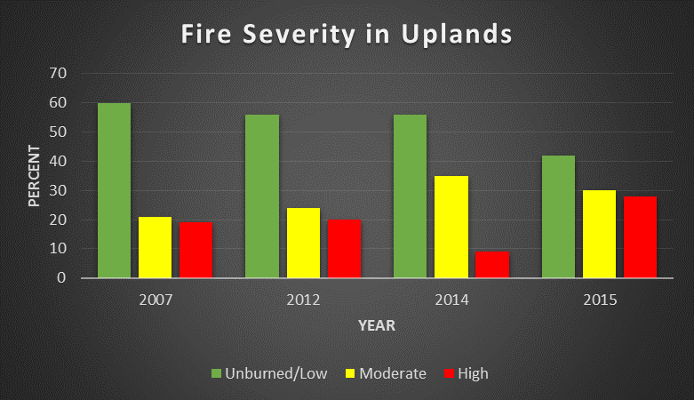

Recent studies determined that wildfires burn with higher intensity in areas that have been ‘actively managed’. This response is reasonable given that modern silvicultural prescriptions by design, accelerate the development of dense stands of merchantable timber. These practices effectively hasten the development of the next fuel load. Modern site preparation creates noxious weed infested, overstocked stands of conifers subject to moisture deficits with corresponding increases in fire intensity and rate of spread.

Climate change may diminish the fire deficit in the plan area, but the natural fire regime, if encouraged and properly managed will provide the best adaptation to maintain the diverse ecology of these lands. The resulting habitat mosaic will create resilience, whereas active management will contribute to global warming (by increasing atmospheric carbon) while degrading forest resilience and diminishing habitat quality and diversity.

According to the DEIS fire effects including post fire landslides and large woody debris recruitment to streams is beneficial to aquatic life with specific reference to threatened, endangered and sensitive salmonids. The DEIS supports this contention in its Aquatic Ecosystem Assessment:

“Floods, landslides, and debris torrents are natural events, often associated with wildfires, which are included in the disturbance regimes of many stream reaches on the Nez Perce/Clearwater National Forests. Although the short term effects may be deleterious, particularly in streams already degraded, it is believed some stream systems may be dependent on these sorts of events to sort gravels, create spawning habitat for salmonids, and recruit large amounts of woody debris in a pulse event, all of which can increase habitat complexity and productivity long term (Reeves et al. 1995; Beechie and Bolton, 1999).”

The introductory paragraph to the Management Implications section of the Assessment illustrates the contention that natural wildfire, including high intensity wildfire is largely beneficial to aquatic habitats on the Nez Perce and Clearwater NFs:

*Management Implications*

“Wildfires are one of the most significant drivers of watershed conditions across the Pacific Northwest and are a primary disturbance agent. They are likely to continue this role into the future under just about all climate change scenarios (Isaak et al. 2010). Many studies, including monitoring and inventory conducted on the Nez Perce/Clearwater National Forests, have found that over various time scales, the aquatic habitat resulting from disturbances caused by fire (even high severity fire) is more productive than similar habitats where the fire events were suppressed or altered by human influences (Reeves et al. 1995, Dunham et al. 2003, Benda et al. 2003, Rieman et al. 2003). “

Regarding responses by individual salmonids, the Assessment addresses local post fire monitoring:

“Post fire monitoring conducted on the Nez Perce/Clearwater National Forests, and in streams on the adjacent Bitterroot National Forest, suggests that harmful effects from wildfires do not persist over time. In a report from monitoring conducted in the Upper Selway on the Bitterroot National, Jakober (2002) found increased large woody debris, number of pools, residual pool volume, habitat complexity, and no evidence of long term sedimentation of fish habitat. Jakober and Dentino (2003) described similar results after long term monitoring of another fire in the Upper Selway, in addition to increased abundance of bull trout and cutthroat trout. They also documented a 2 – 3o C increase in stream temperatures but surmised this increase was not enough to preclude cold water species such as bull trout, since numbers of bull trout had increased in the years following the fire.”

In contrast, the degradation by roads largely associated with FS active management activities are specified as the most damaging to watershed condition and aquatic habitat:

“The most notable alteration of upland and riparian conditions that has influenced stream process and function across the Nez Perce/Clearwater National Forests is road development (USDA-FS 1998, USDA-FS 2001, USDA –FS 2003a, USDA-FS 2003c, USDA-FS- 1999b, Ecovista 2003). Road development has been correlated to instream conditions including substrate composition, large woody debris, and number and quality of pools on both the Clearwater and Nez Perce National Forests (USDA-FS 2003a, Huntington 1995). High levels of deposited substrate sediment and simplified habitat conditions are correlated with roaded development in watersheds, particularly in riparian areas. System roads cover an estimated 2,400 acres (600 road miles) within RCAs on the Nez Perce National Forest and an estimated 4,000 acres (1,000 road miles) within RCAs on the Clearwater National Forest. Recovery potential is limited as long as the road prism continues to exist on the landscape, although site specific improvements can be made to reduce effects, particularly those associated with streamside roads and stream crossings.”

The Assessment also recognizes the important link between roadless and wilderness areas with salmonid strongholds:

“Also well described are correlations between population strongholds of at-risk salmonids and roadless and wilderness areas. Across the interior Columbia River basin, many of the population strongholds for at-risk species occurred in areas of low road density; the higher the road density, the lower the proportion of subwatersheds that support strong populations of key salmonids (Lee at al. 1997). Empirical analysis of 3,327 combinations of known species’ status and subwatershed conditions across the interior Columbia River basin indicated that at-risk salmonids were less likely to use moderate to highly roaded areas for spawning and rearing, and if they were found in those areas, were less likely to be at strong population levels (Lee et al. 1997). More locally, Huntington (1995) found that habitat and salmonid abundance differed in managed and unroaded landscapes on the Clearwater National Forest; these findings, particularly the relationship between deposited sediment and distribution and abundance of salmonids, are consistent with the findings of Lee et al. (1997).”

According to the Assessment, monitoring pursuant to the 1987 Forest Plans, as amended by PACFISH/INFISH indicate that these plans prevented further degradation of watersheds during the monitoring period (1998-2018) and that some watersheds on the Nez Perce NF are showing improvement. From the Assessment, it is apparent modest improvement occurred due to extensive road decommissioning, reduced logging, riparian area fencing and other restoration activities. The Assessment mentions two specific streams in the South Fork Clearwater River subbasin where significant improvement was noted. The mentioned streams, Red River and Newsome Ck. encompass critical habitat for ESA threatened species including bull trout and Snake River steelhead. They are also important habitat for FS sensitive species including westslope cutthroat trout, spring salmon, Pacific lamprey and pearlshell mussel. The Assessment states:

“**For the Nez Perce National Forest**, an improving trend is indicated by both Forest Plan monitoring substrate data at managed sites, as well as PIBO data, particularly in the South Fork Clearwater subbasin. At Forest Plan monitoring sites in managed watersheds, decreases in cobble embeddedness were evident from 1988 to 2016. Most notable among these decreases were sites in Red River and Newsome Creek, which had moratoriums on additional sediment producing activities (e.g. timber sales) until they had recovered to desired conditions established in the last planning effort. Cessation of large scale development combined with watershed restoration activities initiated in the early 1990s and continuing through 2016 (especially those associated with removal of chronic sediment sources), reduced overall sediment yield. This reduction is correlated with improved substrate conditions.”

The FS should be commended for this, however concerns arise because all the alternatives except the ‘No Action’ alternative call for increased logging activity. Such increases will require additional road construction and intensive maintenance on existing roads to withstand increased use for log hauling. These will compound the direct detrimental effects of timber harvest.

I am pleased to see the FS is considering the needs for high quality elk habitat that is undisturbed by human activity. However, the value of predation in maintaining the long term persistence of elk and their habitat was not considered. In particular, simple observation and scientific studies indicate that the presence of wolves and other predators disperse elk throughout their habitat allowing increases in hardwood species that provide both forage and cover for elk. In some areas, predator induced changes in elk habitat use included a cascade of ecological benefits that improved the overall condition of riparian areas. These changes brought higher songbird densities and improved salmonid habitat.

Given known activity of grizzly bears on both the Clearwater and Nez Perce NFs during 2019, and the verified grizzly mortality in Kelly Ck. during 2007, the FS fails to meet its obligation to consider effects on the grizzly bear, a threatened species under the ESA. Due in part to the conservation work of the FS, lands within the plan area represent some of the best grizzly bear habitat in North America. With increased bear use of the NPCNF, the need to develop food and garbage storage regulations and phase in an effective enforcement strategy is paramount.

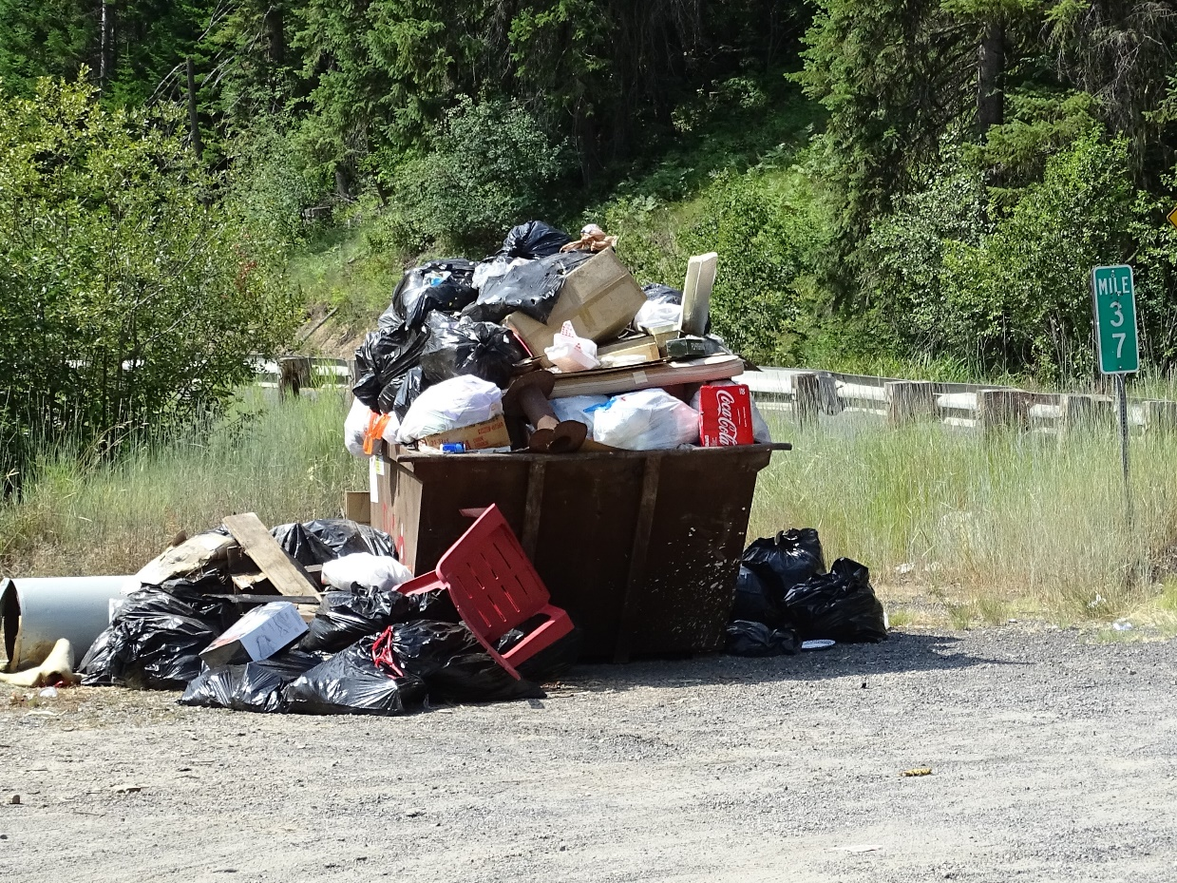

Photo of refuse disposal site at pullout near the Junction of Newsome Ck. Rd and State Hwy 14, along the South Fork of the Clearwater River. Taken by Pat Finnegan 7/29/19.

In consideration of the comments above I have several recommendations. These are listed below.

1. Treat all suitable grizzly bear habitat as occupied habitat.
2. Require that possible effects on grizzly bears and their habitat be addressed for all management activities.
3. Pursuant to grizzly bear management, develop and implement food and garbage storage capacities across the entire planning area.
4. Phase in enforcement of food and garbage storage regulations.
5. Maintain allowable timber harvest volumes at or below the 1987 Forest Plan. levels for both Forests (50-60 mmbf).
6. Retain a bond for 100% noxious weed eradication on all timber sale areas within 2 years of harvest completion.
7. Increase road obliteration targets for all watersheds in a declining condition pursuant to PACFISH/INFISH monitoring.
8. Do not allow timber harvest in any watershed in a declining condition pursuant to PACFISH/INFISH monitoring.
9. Ban new road construction. Fully obliterate all temporary roads used for management activities.
10. Adopt the aquatic monitoring standards and objectives developed for the amended 1987 Forest Plans pursuant to PACFISH/INFISH.
11. Retain the Sensitive species lists developed for and added to the 1987 Forest Plans.
12. Develop and implement stringent monitoring and recovery strategies for all designated Sensitive species.
13. Recommend all Inventoried Roadless Areas as Designated Wilderness.
14. Ban timber harvest in any Inventoried Roadless Area, Wild and Scenic River Corridor or Recommended Wild and Scenic River Corridor.
15. Recommend all 89 rivers determined to be free flowing and possessing at least one outstandingly remarkable value for Wild, Scenic and/or Recreational status.
16. Encourage and manage every natural fire for resource benefits while protecting human life and property.

Thank you for your attention to my comments.

Sincerely,

/s/ Pat Finnegan

Principal Investigator and Consultant

Bluwater Solutions LLC

Natural Resource Protection

107 Rocky Point Lane

Grangeville, ID 83530

[pmfinnegan@hotmail.com](mailto:pmfinnegan@hotmail.com)

2084514332